SPORT AND RECREATION VICTORIA

Community Sports Infrastructure
Acknowledgement and Publicity Guidelines

June 2023

TABLE OF CONTENTS
1. ACKNOWLEDGEMENT AND PUBLICITY GUIDELINES 3
1.1 Acknowledging the Victorian Government’s funding investment 3
1.2 Confidentiality of funding until a public announcement is made 3
1.3 Prominent display of Victorian Government signage at openings, launches and events 3
1.4 Event opportunities and invitations 3
1.5 Written acknowledgement 4
1.5.1 Award submissions 4
1.5.2 Social media 4
1.5.3 Digital and printed materials 5
2. SITE SIGNAGE REQUIREMENTS 6
2.1 Grant Funded and Loan Supported Projects 6
2.2 Victorian Government fence wrap 6
3. VICTORIAN GOVERNMENT SIGNAGE REQUIREMENTS 7
3.1 Standard Sigange Requirements 8
3.1.1 During construction 8
3.1.2 Completed projects 8
3.2 Community Support Fund (from Dept. of Treasury and Finance) 9
3.2.1 During construction 9
3.2.2 Completed projects 9
3.3 Female Friendly Facilities projects/Streams 10
3.3.1 During construction 10
3.3.2 Completed projects 10
3.4 Local Sports Infrastructure Fund (2021-22) 10
3.4.1 During construction 11
3.4.2 Completed projects 11
3.5 Country Football and Netball Program (all rounds) 12
3.5.1 During construction 12
3.5.2 Completed projects 12
3.6 Victorian Asian Cup Legacy Fund 12
3.6.1 During construction 13
3.6.2 Completed projects 13
4. BRAND VICTORIA LOGOS 14
4.1 Official colours and correct logo usage 14
4.2 Logo usage and placement 15
4.3 Sizing and dimensions 15
4.4 How to access the Brand Victoria logo 15
4.5 More information 15

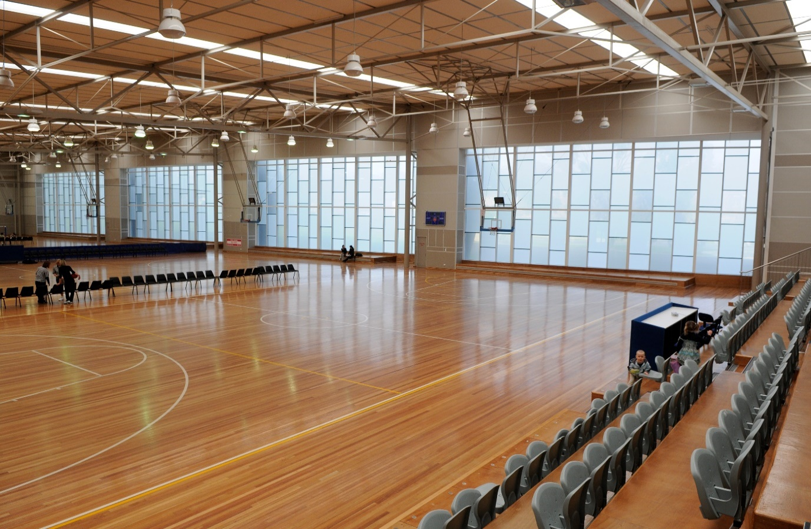
1

1.

ACKNOWLEDGEMENT AND PUBLICITY GUIDELINES

Acknowledging the Victorian Government’s funding investment
The Victorian Government has invested over $1.6 billion into community sport and active recreation infrastructure since 2014. These investments are part of the Victorian Government’s strong commitment to sport and active recreation, gender equality and encouraging all Victorians to obtain the benefits of being physically active.
Recipients of Victorian Government investment into community infrastructure, made through Sport and Recreation Victoria (Sport and Recreation Victoria), are required to acknowledge the Victorian Government in publications, events, promotions, media, social media, capital works signage and all forms of publicity.
Important to the success of government’s on-going partnership with funded organisations is the acknowledgement of financial investment provided by the Victorian Government.
These Acknowledgement and Publicity Guidelines are an attachment to the Grant Agreement for community sport and active recreation infrastructure projects and form part of the obligations of funded organisations in delivering projects. These guidelines provide information and direction to assist funded organisations meet their obligations through a range of investment programs managed by Sport and Recreation Victoria.

Confidentiality of funding until a public announcement is made
Once approved, funding outcomes remain strictly confidential until the Minister for Community Sport or a representative has publicly announced the funding.
Sport and Recreation Victoria is responsible for coordinating participation by the Minister for Community Sport or a representative in these announcements, which may be in person or through media release. Sport and Recreation Victoria will contact your organisation to make arrangements for any Ministerial announcement.

Prominent display of Victorian Government signage at openings, launches and events
Victorian Government signage or banners may be required to be displayed at openings, launches and other events supported by the government.
If required, Victorian Government banners will either be provided by Sport and Recreation Victoria at the event (through your primary contact), or can be borrowed and returned to Sport and Recreation Victoria after the event, with your organisation responsible for organising collection and prompt return, or through alternative arrangements by negotiation.

Event opportunities and invitations

Funding recipients are required to invite the Minister for Community Sport to participate in milestone events associated with any project including ground-breaking ceremonies, construction inspections and photo opportunities.
When your organisation intends to officially open a project that has received investment your organisation is required to invite the Minister for Community Sport to participate in the official opening.
Adequate notice of at least 8 weeks is required when inviting the Minister to an event. When inviting the Minister you must provide several date and time options for review. Once the date and time is confirmed by the Minister’s Office, your organisation will be required to work with Sport and Recreation Victoria to coordinate the Minister’s (or representative) role in the event.
When inviting the Minister for Community Sport to events, please follow these steps.
Step 1: At least 8 weeks prior to your proposed event, email the Hon Ros Spence, Minister for Community Sport at ros.spence@minstaff.vic.gov.au (and cc your Sport and Recreation Victoria primary contact) with the following details:
- Project name and location
- Victorian Government investment
- Total project cost and funding program
- Role for the Minister (for example, speech, ribbon cutting, plaque unveiling, ground breaking, site walk through)
- Provide at least 3 potential dates and times for the event.*
*Please identify where any potential dates align with club activities. For example, season commencement activities, club training or match day activities.
Step 2: Once the event is confirmed, Sport and Recreation Victoria will work with your organisation on the details of the event, including logistics and proceedings.

Written acknowledgement

Award submissions
Funding recipients are required to obtain Sport and Recreation Victoria’s approval prior to submitting for an award. The Victorian Government, including Sport and Recreation Victoria, must also be recognised as project partner in award submissions for funded projects. This approval can be obtained through your Sport and Recreation Victoria contact. This requirement applies to funding recipients and consultants engaged to deliver the project. The Victorian Government should be recognised through any media activities (including social media) should an award be received.
For regional, state or national sport and recreation events being hosted as a result of an infrastructure investment made by the Victorian Government, recognition of the investment should endeavour to be made at the event. This can be achieved through speeches, ceremonies, signage, announcements, social media or media releases.

Social media

Funded organisations can showcase projects and create greater visibility and recognition through social media platforms. If promoting your project via social media your organisation is required to acknowledge the support of the Victorian Government.
To acknowledge the Victorian Government’s support on social media platforms, it is recommended your organisation uses the following phrases:
- During delivery: The [name of program/s/projects/s/] are/is supported by the Victorian Government.
- During or post-delivery: [Name of organisation] acknowledges the support of the Victorian Government.
- Post-delivery: The [name of program/s/projects/s/] was/were supported by the Victorian Government.
When creating a social media post use the following handles to support cross-promotion of your project:
- @vicgovau
- @sportandrecvic
- @vicgovdjpr
- @changeourgame
- @aaaplayvic
You can also share or retweet your Sport and Recreation Victoria funded project related posts from:
- twitter.com/sportandrecvic
Link to web stories on:
- sport.vic.gov.au
Link your disability specific opportunities on:
- aaavic.org.au
- Facebook Access
- for All Abilities – AAA Play
Social Media Obligations for Contractors and Consultants
Organisations are required to ensure project contractors and consultants acknowledge the Victorian Government’s investment through their own social media posts on all relevant platforms.
It is the organisation’s responsibility to ensure appropriate recognition which may include the approved phrases and handles from
Section 1.5.2 above.

Digital and printed materials

Organisations are required to acknowledge the Victorian Government’s investment in public information including, but not limited to published or printed materials, strategies, websites, presentations, or speeches. Examples include:
- Planning Projects including facility feasibilities, municipal and regional strategies
Include Victorian Government logo and written acknowledgement statement to be included in the final publication/s.
- Printed and electronic documents, reports, brochures for funding projects
Logo and written acknowledgement statement placed where appropriate.
- Posters
Logo and written acknowledgement.
- Videos
Logo and written acknowledgment in credits, end slides or another appropriate part of the production.
- Websites
Logo and written acknowledgment where appropriate. The acknowledgement only needs to occur on relevant pages for the funded project.
- Media releases
Written acknowledgement identifying the Victorian Government’s investment and funding source.
- Events (speeches/launches/ openings)
Verbal acknowledgment by representatives of funded organisations.
- Banners (for events)
Display banners (where practical) accompanied by acknowledgment in programs/invites/websites related to the event (where practical).

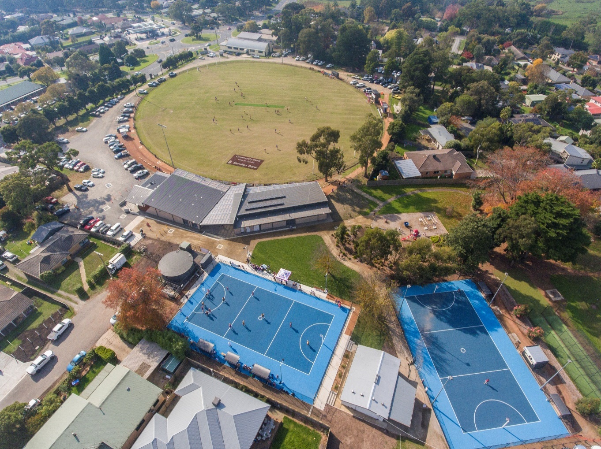
2
Photography by Josh Braidner (Jingle Creatixe) courtesy of Yarra Ranges Council

SITE SIGNAGE REQUIREMENTS

Grant Funded and Loan Supported Projects
Signage forms an important part of your organisation’s funding obligations. In many cases, the approval and installation of construction and permanent signage forms part of funding agreement milestones.
Example all signs can be found in Section 3. Please note, these designs are for indicative purposes only. They are not artwork and should not be used to reproduce the logos.
Construction signage (during construction)
All construction signage for Victorian Government funded projects should meet the following requirements:

- For projects with grants of $500,000 or less or
loans with $3 million or less
- The minimum size of signage must be
420 mm (H) x 595 mm (W).
- For projects with grants of $500,001 or more or
loans over $3 million
- The minimum size of signage must be
1 m (H) x 2 m (W).

All construction signage designs must be endorsed by your Sport and Recreation Victoria primary contact. Paper or card printed and laminated signage is not suitable.
Plaques/Permanent signage (completed projects)
All permanent signage/plaque designs must be endorsed by your Sport and Recreation Victoria primary contact. Paper or card printed and laminated signage is not suitable.
Plaques acknowledging the completion of projects must be installed permanently and not removed. Please contact your Sport and Recreation Victoria representative if installed permanent signage has been identified for removal, replacement and/or relocation.

Victorian Government fence wrap
For some larger projects, organisations are required to display fence wrap (of approximately 8 metres) acknowledging the Victorian Government’s contribution where stipulated in Funding Agreements.
Fence wraps are produced using mesh and are designed to be attached to 1.8-metre-high construction fencing (usually temporary fencing) using cable ties with eyelets positioned every metre. The signs should be vertically centred on the fence in a prominent position for the community to see at the site.
Sport and Recreation Victoria will produce and provide the fence wrap to organisations for installation by your organisation or your building contractor. If still in good condition at the completion of a project, your organisation may return the fence wrap to Sport and Recreation Victoria.

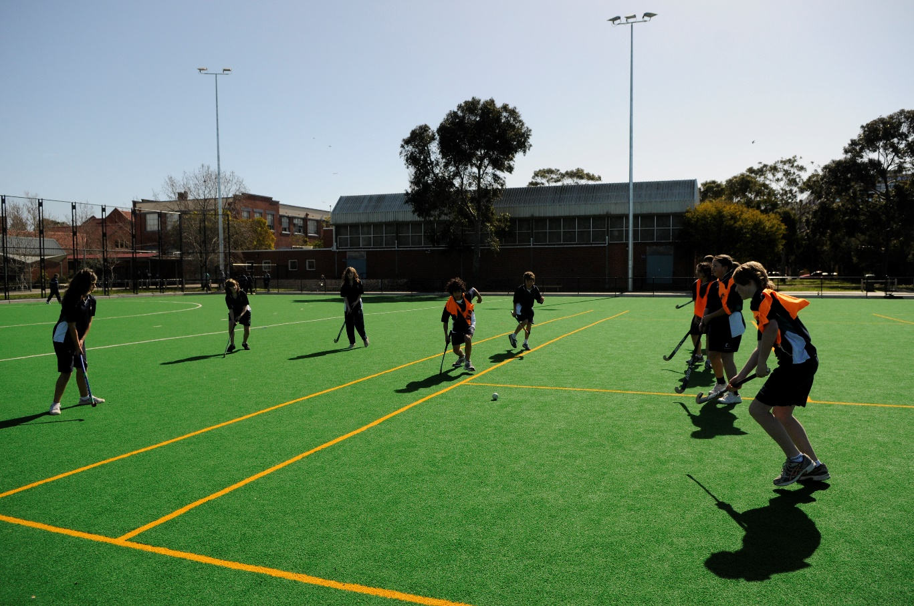
3

VICTORIAN GOVERNMENT SIGNAGE REQUIREMENTS
Signage requirements for Victorian Government funding programs are managed by Sport and Recreation Victoria. Most funding programs have Standard Requirements however some have Specific Requirements.
The table below lists all current funding programs in alphabetical order. Please click on the relevant section to determine the signage requirements for your program and project:
Funding programs/streams | Sections | Specific or Standard
Better Indoor Stadiums Fund | 3.1 | Standard
Community Cricket Program  - including Community Facilities and Metropolitan Cricket and Community Centres | 3.1 | Standard
Community Motorsport Program | 3.1 | Standard
Community Sports Infrastructure Fund  - including Unique Initiatives and Priority Projects  - excluding Female Friendly Facilities projects/streams - see Section 3.3 | 3.1  3.3 | Standard  and Specific
Community Sports Infrastructure Loans Scheme | 3.1 | Standard
Community Sports Infrastructure Stimulus Program | 3.1 | Standard
Community Support Fund (funded via the Department of Treasury and Finance) | 3.2 | Specific
Country Football and Netball Program (all rounds) | 3.5 | Specific
Election Commitment Projects (pre-2018) | 3.1 | Standard
Female Friendly Facilities projects/streams, funded from the:  - Community Sports Infrastructure Fund - Female Friendly Facilities stream (all rounds)  - Female Friendly Facilities Fund (all rounds)  - Local Sports Infrastructure Fund - Female Friendly Facilities stream (all rounds) | 3.3 | Specific
Golf Infrastructure Fund | 3.1 | Standard
Local Community Sport and Recreation Projects | 3.1 | Standard
Local Sports Infrastructure Fund (2020-21 and 2022)  - excluding all Female Friendly Facilities projects/streams - see Section 3.3  - excluding LSIF 2021-22 - see Section 3.4 | 3.1  3.3  3.4 | Standard  and Specific
Local Sports Infrastructure Fund (2021-22)  - Female Friendly Facilities stream project must include logos from Section 3.3 | 3.4  3.3 | Specific
Local Sports Grants | 3.1 | Standard
Priority Projects | 3.1 | Standard
Strategic Projects | 3.2 | Specific
Victoria Asian Cup Legacy Fund | 3.6 | Specific
World Game Facilities Fund | 3.1 | Standard

3.1 STANDARD SIGNAGE REQUIREMENTS

3.1.1 During construction
The size of all signage must adhere to the size requirements outlined in Section 2.
During construction a temporary (but sturdy) sign must be installed in a prominent location visible to the community acknowledging the contribution of the Victorian Government with the text and logos below.
The [Project Name] is being developed by [list organisation/s, for example, council and/or club name] in partnership with the Victorian Government.
Project:
Funding Partners:
Project Description:
Completion:
Total Project Cost:
Information:

Council/Partner
Logo Here
Project Name, Location
Partners/Contribution
Description of works
Month/Year
$Cost
Website

3.1.2 Completed projects
Organisations must install a permanent plaque acknowledging the contribution of the Victorian Government, for all completed projects. Plaques must use the text (or similar version) and logo below in a scale appropriate to the project.
For projects where the Minister or Victorian Government representative is opening the facility:
This facility was officially opened by [insert Minister/member name] on [insert date] and was built/developed/delivered by
[list organisation/s, for example, council and/or club name] in partnership with the Victorian Government.
Council/Partner
Logo Here
For projects where a Victorian Government representative is not present:
This facility was built/developed/delivered by [list organisation/s, for example, council and/or club name] in partnership with the Victorian Government.
Council/Partner
Logo Here

Please note that there may be specific circumstances where the Victorian Government requests alternative signage to those indicated in the examples above. This will be negotiated with the funded organisation through a specific request made by Sport and Recreation Victoria, if required.
Important: Artwork for all draft signage and plaques must be provided to your Sport and Recreation Victoria primary contact for approval prior to production and installation. Funded organisations should allow sufficient time to have signage approved by Sport and Recreation Victoria and prior to formal events that include the Minister for Community Sport or Victorian Government representative.
Requirements for events, promotions and social media
Please refer to Section 1 for information and details related to events, promotions and social media.

3.2 Community Support Fund (FROM Dept. of Treasury and Finance)
This funding program has specific signage requirements. Please ensure all specific text and logo requirements are met.

3.2.1 During construction
The size of all signage must adhere to the size requirements outlined in Section 2.
During construction a temporary (but sturdy) sign must be installed in a prominent location visible to the community acknowledging the contribution of the Victorian Government with the text and logos below.
The [Project Name] is being developed by [list organisation/s, for example, council and/or club name] in partnership with the Victorian Government through the Community Support Fund.
Project:
Funding Partners:
Project Description:
Completion:
Total Project Cost:
Information:

Project Name, Location
Partners/Contribution
Description of works
Month/Year
$Cost
Website

Council/Partner
Logo Here

3.2.2 Completed projects
Completed projects must install permanent acknowledgment of the contribution of the Victorian Government using the text and logo below in a form (for example, permanent sign or plaque) and scale appropriate to the project.
For projects where the Minister or Victorian Government representative is opening the facility:
This facility was officially opened by [insert Minister/member name] on [insert date] and was built by [list organisation/s, for example, council and/or club name] in partnership with the Victorian Government through the Community Support Fund.
Council/Partner
Logo Here
For projects where a Victorian Government representative is not present:
This facility was built/developed/refurbished by [list organisation/s, for example, council and/or club name] in partnership with the Victorian Government through the Community Support Fund.
Council/Partner
Logo Here

Please note that there may be specific circumstances where the Victorian Government requests alternative signage to those indicated in the thresholds above. This will be negotiated with the funded organisation through a specific request made by Sport and Recreation Victoria.
Important note: Artwork for all draft signage and plaques must be provided to your Sport and Recreation Victoria primary contact for approval prior to installation. Funded organisations should allow sufficient time to have signage approved by Sport and Recreation Victoria and made prior to formal events that include the Minister for Community Sport or Victorian Government representative.
Requirements for events, promotions and social media
Please refer to Section 1 for information and details related to events, promotions and social media.

3.3 Female Friendly Facilities projects/Streams
Female Friendly Facility projects/streams have specific signage requirements. Please ensure all specific text and logo requirements are met. The below signage requirements apply to Female Friendly Facilities projects funded from the:
- Female Friendly Facilities Fund (all rounds)
- Community Sports Infrastructure Fund - Female Friendly Facilities stream (all rounds)
- Local Sports Infrastructure Fund - Female Friendly Facilities stream (all rounds)

3.3.1 During construction
The size of all signage must adhere to the size requirements outlined in Section 2.
During construction a temporary (but sturdy) sign must be installed in a prominent location visible to the community acknowledging the contribution of the Victorian Government with the text and logos below.
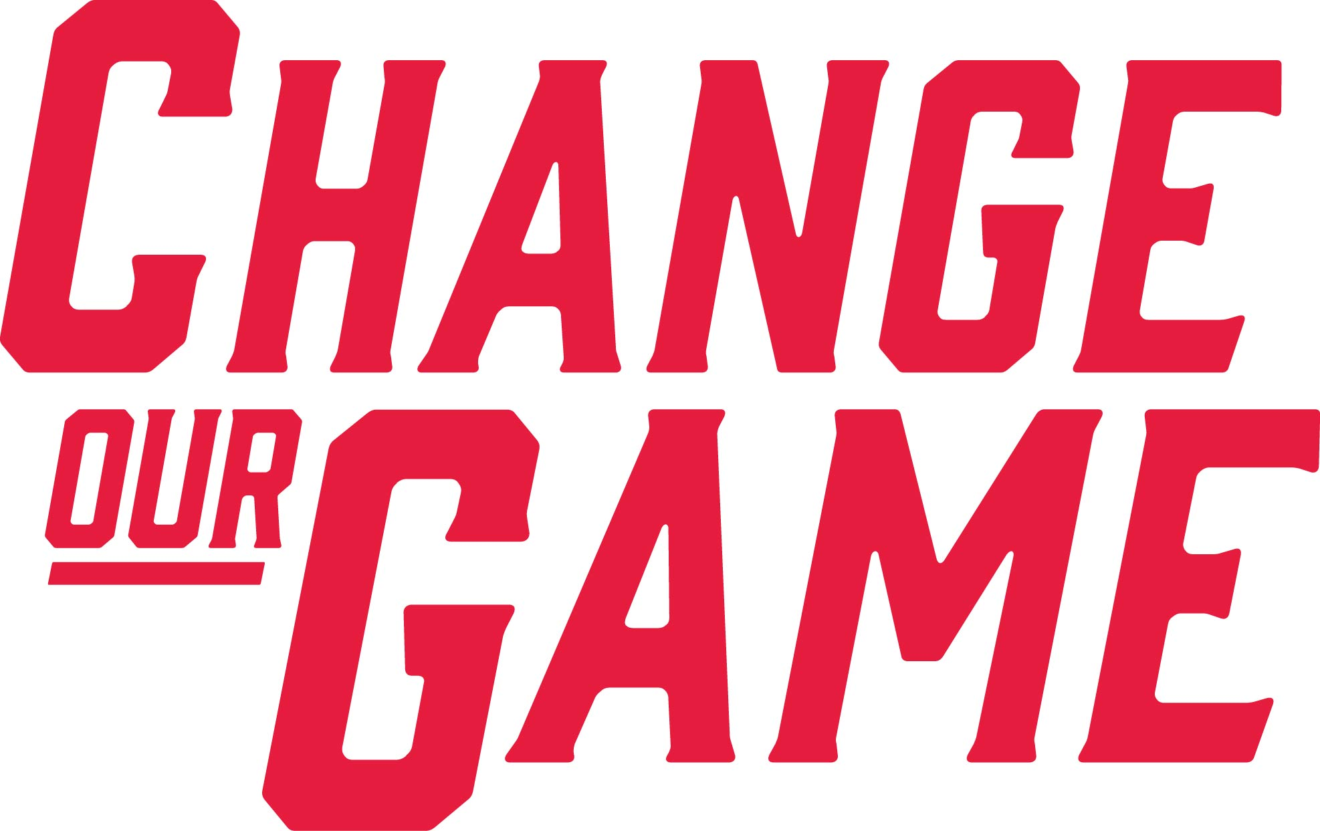
The [Project Name] is being developed by [list organisation/s, for example, council and/or club name] in partnership with the Victorian Government.
Project:
Funding Partners:
Project Description:
Completion:
Total Project Cost:
Information:

Council/Partner
Logo Here
Project Name, Location
Partners/Contribution
Description of works
Month/Year
$Cost
Website

3.3.2 Completed projects
Completed projects must install permanent acknowledgment of the contribution of the Victorian Government and Change Our Game initiative using the text and logo below in a form (for example, permanent sign or plaque) and scale appropriate to the project.

For projects where the Minister or Victorian Government representative is opening the facility:
This facility was officially opened by [insert Minister/member name] on [insert date] and was built by [list organisation/s, for example, council and/or club name] in partnership with the Victorian Government.
Council/Partner
Logo Here
For projects where a Victorian Government representative is not present:

This facility was built/developed/refurbished by [list organisation/s, for example, council and/or club name] in partnership with the Victorian Government.
Council/Partner
Logo Here

Please note that there may be specific circumstances where the Victorian Government requests alternative signage to those indicated in the thresholds above. This will be negotiated with the funded organisation through a specific request made by Sport and Recreation Victoria.
Important note: Artwork for all draft signage and plaques must be provided to your Sport and Recreation Victoria primary contact for approval prior to installation. Funded organisations should allow sufficient time to have signage approved by Sport and Recreation Victoria and made prior to formal events that include the Minister for Community Sport or Victorian Government representative.
Requirements for events, promotions and social media
Please refer to Section 1 for information and details related to events, promotions and social media.

3.4 Local Sports Infrastructure Fund (2021-22)
This funding program has specific signage requirements. Please ensure all specific text and logo requirements are met.

3.4.1 During construction
The size of all signage must adhere to the size requirements outlined in Section 2.
During construction a temporary (but sturdy) sign must be installed in a prominent location visible to the community acknowledging the contribution of the Victorian Government with the text and logos below.
The [Project Name] is being developed by [list organisation/s, for example, council and/or club name] in partnership with the Victorian Government through the Community Support Fund.
Project:
Funding Partners:
Project Description:
Completion:
Total Project Cost:
Information:

Council/Partner
Logo Here
Project Name, Location
Partners/Contribution
Description of works
Month/Year
$Cost
Website

3.4.2 Completed projects
Completed projects must install permanent acknowledgment of the contribution of the Victorian Government using the text and logo below in a form (for example, permanent sign or plaque) and scale appropriate to the project.
For projects where the Minister or Victorian Government representative is opening the facility:
This facility was officially opened by [insert Minister/member name] on [insert date] and was built by [list organisation/s, for example, council and/or club name] in partnership with the Victorian Government through the Community Support Fund.
Council/Partner
Logo Here
For projects where a Victorian Government representative is not present:
This facility was built/developed/refurbished by [list organisation/s, for example, council and/or club name] in partnership with the Victorian Government through the Community Support Fund.
Council/Partner
Logo Here

Please note that there may be specific circumstances where the Victorian Government requests alternative signage to those indicated in the thresholds above. This will be negotiated with the funded organisation through a specific request made by Sport and Recreation Victoria.
Important note: Artwork for all draft signage and plaques must be provided to your Sport and Recreation Victoria primary contact for approval prior to installation. Funded organisations should allow sufficient time to have signage approved by Sport and Recreation Victoria and made prior to formal events that include the Minister for Community Sport or Victorian Government representative.
Requirements for events, promotions and social media
Please refer to Section 1 for information and details related to events, promotions and social media.

3.5 Country Football and Netball Program
This funding program has specific signage requirements. Please ensure all specific text and logo requirements are met.

3.5.1 During construction
The size of all signage must adhere to the size requirements outlined in Section 2.
During construction a temporary (but sturdy) sign must be installed in a prominent location visible to the community acknowledging the contribution of the Victorian Government with the text and logos below.
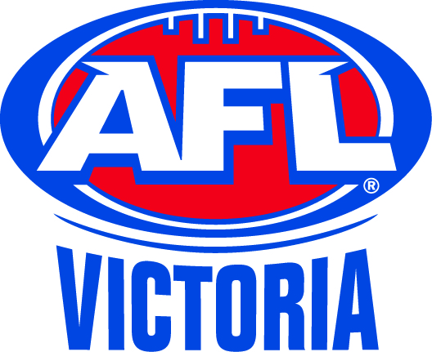
The [Project Name] is being developed by [list organisation/s, for example, council and/or club name] in partnership with the Australian Football League, Netball Victoria and AFL Victoria and the Victorian Government.
Project:
Funding Partners:
Project Description:
Completion:
Total Project Cost:
Information:

Council/Partner
Logo Here
Project Name, Location
Partners/Contribution
Description of works
Month/Year
$Cost
Website

3.5 .2 Completed projects
Completed projects must install permanent acknowledgment of the contribution of the Victorian Government, the AFL, AFL Victoria and Netball Victoria using the text and logo below in a form (for example, permanent sign or plaque) and scale appropriate to the project.

For projects where the Minister or Victorian Government representative is opening the facility:
This facility was officially opened by [insert Minister/member name] on [insert date] and was built by [list organisation/s, for example, council and/or club name] in partnership with the Australian Football League, Netball Victoria and AFL Victoria and the Victorian Government.
Council/Partner
Logo Here
For projects where a Victorian Government representative is not present:
This facility was built/developed/refurbished by [list organisation/s, for example, council and/or club name] in partnership with the Australian Football League, Netball Victoria, AFL Victoria and the Victorian Government.
Council/Partner
Logo Here

Requirements for events, promotions and social media
Please refer to Section 1 for information and details related to events, promotions and social media.
The logo and appropriate acknowledgement of the Victorian Government, the AFL, AFL Victoria and Netball Victoria contributions is to be included on invitations for events associated with the funded project.
The Victorian Government, the AFL, AFL Victoria and Netball Victoria are to be given the opportunity of having a representative attend all significant events associated with the funded project.
All promotional/information material such as leaflets, brochures and advertisements (including invitations to launches/openings) for the funded project must include the text and logos. Colour publications should use colour logos.
Any press releases/announcements must acknowledge the source of funding and include the supplied logos.

3.6 Victorian Asian Cup Legacy Fund
This funding program has specific signage requirements. Please ensure all specific text and logo requirements are met.

3.6.1 During construction
The size of all signage must adhere to the size requirements outlined in Section 2.
During construction a temporary (but sturdy) sign must be installed in a prominent location visible to the community acknowledging the contribution of the Victorian Government with the text and logos below.
The [Project Name] is being developed by [list organisation/s, for example, council and/or club name] in partnership with Football Federation Australia and the Asian Cup 2015 Legacy Fund and the Victorian Government.
Project:
Funding Partners:
Project Description:
Completion:
Total Project Cost:
Information:

Council/Partner
Logo Here
Project Name, Location
Partners/Contribution
Description of works
Month/Year
$Cost
Website

3.6.2 Completed projects
Completed projects must install permanent acknowledgment of the contribution of the Victorian Government, Football Federation Australia and the AFC Asian Cup using the text and logo below in a form (for example, permanent sign or plaque) and scale appropriate to the project.

For projects where the Minister or Victorian Government representative is opening the facility:
This facility was officially opened by [insert Minister/member name] on [insert date] and was built by [list organisation/s, for example, council and/or club name] in partnership with Football Federation Australia, Asian Cup 2015 Legacy Fund and the Victorian Government.
Council/Partner
Logo Here
For projects where a Victorian Government representative is not present:
This facility was built/developed/refurbished by [list organisation/s, for example, council and/or club name] in partnership with Football Federation Australia, Asian Cup 2015 Legacy Fund and the Victorian Government.
Council/Partner
Logo Here

Requirements for events, promotions and social media
Please refer to Section 1 for information and details related to events, promotions and social media.
The logo and appropriate acknowledgement of the Victorian Government and Football Federation Australia’s contributions is to be included on invitations for events associated with the funded project and each organisation is to be given the opportunity of having a representative attend all significant events associated with the funded project.
All promotional/information material such as leaflets, brochures and advertisements (including invitations to launches/openings) for the funded project must include the text and logos. Colour publications should use colour logos.
Any press releases/announcements must acknowledge the source of funding and include the supplied logos.

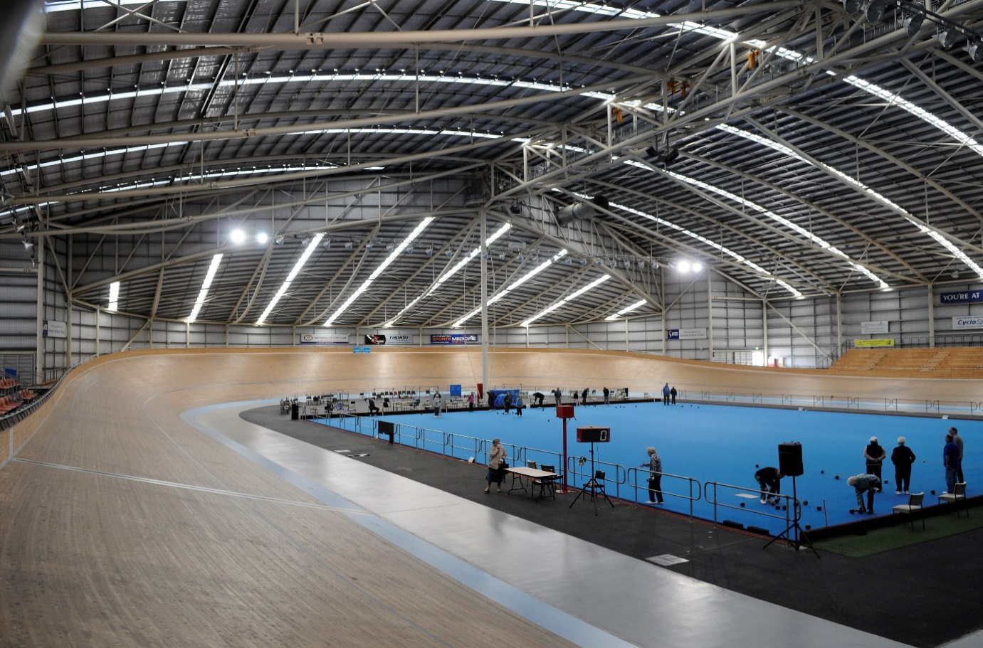
4

BRAND VICTORIA LOGOS
The Brand Victoria logo is the primary branding device of the Victorian Government. It replaced the previous Victorian Government logo from 2015 and should be used for all new acknowledgements.
✗ ✓

Where a logo acknowledgement by a funded organisation is required, the guidelines outlined below for using the Brand Victoria logo must be followed.
Under no circumstances should funded organisations alter these logos or copy and paste the logo from this or any other Victorian Government publication or website.
There are variations on how the logo is to be used depending on what an organisation is publishing or printing.

4.1 Official colours and correct logo usage
To maintain the consistent use of the Victoria State Government logo.
The preferred colour usage is either Government Blue (PANTONE 2945 – Hex #004c97) or BLACK.

The area surrounding the text and triangle should reveal the underlying background colour and should not default to white on a coloured background. It should never appear with a white box around it.
For reasons of clarity and impact, consideration should be given to the appropriate contrast between the background and the logo.
Where the background is a solid and/or dark colour, use a white logo.
Logos cannot be stretched or distorted in any way – the ratio between width and height measurements should always be kept the same.
CORRECT – WHITE LOGO | CORRECT – REVERSED OUT HIGH CONTRAST BACKGROUND | CORRECT- WHITE BACKGROUND
INCORRECT – WHITE BOX | INCORRECT – LOW CONTRAST | INCORRECT - DISTORTED

✓
✗
✗
✗
✓
✓

4.2 Logo usage and placement
The visual style of the organisation receiving the funding should be the primary brand of the publication or website.
The partner organisation’s logo should be placed to the left of the Brand Victoria logo, if possible, and clear space left around it.

Clear space is an exclusion zone surrounding a logo where no other text or graphic may appear and should allow enough space to visually separate logos. The clear space should constitute 50% of the width/height of the logo itself.
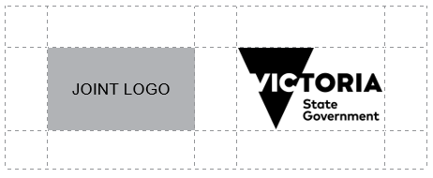

4.3 Sizing and dimensions
Minimum size for logo usage is that it should be 10 mm in height.

4.4 How to access the Brand Victoria logo
To access the logo please contact your Sport and Recreation Victoria primary contact.
If your organisation is unsure about when and how the logo should be used, or any queries related to design of signage, please contact your Sport and Recreation Victoria primary contact.
Should council receive funding for a project that requires alternative signage to those described in these guidelines, Sport and Recreation Victoria can negotiate these guidelines on a case-by-case basis.

4.5 More information
Department of Jobs, Skills, Industry and Regions
Please contact your Sport and Recreation Victoria primary contact if you require additional information or assistance on any of the funding publicity and acknowledgement requirements.
These guidelines are subject to change.
To receive this publication in an accessible format please phone the National Relay Service on 13 36 77.
Authorised and published by the Victorian Government.
June 2023.
© State of Victoria. Except where otherwise indicated, the images in this publication show models and illustrative settings only, and do not necessarily depict actual services, facilities or recipients of services. This publication may contain images of deceased Aboriginal and Torres Strait Islander peoples.

