Schedule of Use

Fact Sheet

What is a Schedule of Use?

A schedule of use is a basic summary of a facility’s current and proposed user groups, activity types and scheduling. This document can serve as a valuable tool in your discussions with clubs and potential user groups, and demonstrates the impact the proposed development will have on participation.

What should be included in a Schedule of Use?

Depending on the type of facility and the groups that use it, a schedule of use should be created for summer and winter seasons. All organisations that access the facility should be included in the schedule and all groups included in the proposed schedule should provide a letter of support indicating how that group will benefit from the project.

How do we create a Schedule of Use?

A schedule of use template is provided on the Sport and Recreation Victoria website for your use. The template is a guide only and you are free to develop your own method of outlining the anticipated use of a new/upgraded facility.
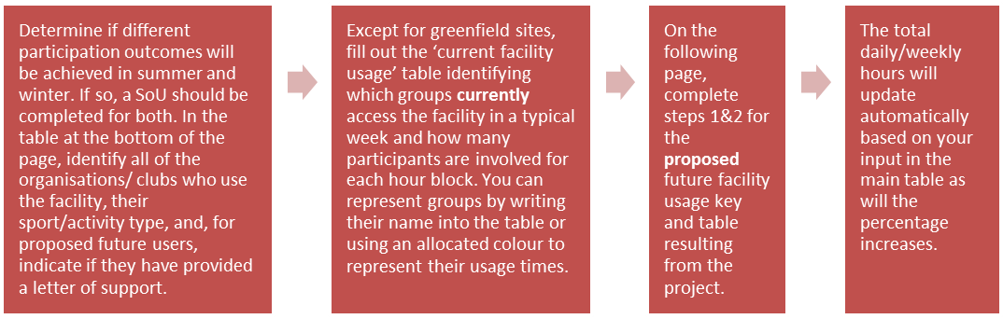
Who do I contact for further clarification?
For further information on the Schedule of Use, please contact your sport and recreation representative.

To receive this publication in an accessible format please phone the National Relay Service on 13 36 77.
Authorised and published by the Victorian Government, 1 Treasury Place, Melbourne.
© State of Victoria, June, 2015. Except where otherwise indicated, the images in this publication show models and illustrative settings only, and do not necessarily depict actual services, facilities or recipients of services. This publication may contain images of deceased Aboriginal and Torres Strait Islander peoples.

