This fact sheet outlines how to acknowledge funding support from the Department of Jobs, Precincts and Regions under the funding initiative.
Format of acknowledgement
Organisations must acknowledge the Victorian Government’s funding support for events funded under the Access for All Abilities initiative in all published materials.
Acknowledgement is required in the following materials related to your event:
- Videos – the joint Access for All Abilities and Victorian Government logo and written acknowledgement in credits, end slides or another appropriate part of the production
- Print and electronic documents (reports, brochures etc.) – the joint Access for All Abilities logo and Victorian Government logo and written acknowledgement statement placed where appropriate
- Posters – the joint Access for All Abilities logo and Victorian Government logo and written acknowledgement
- Websites – written acknowledgement statement (see next section) and the joint Access for All Abilities logo and Victorian Government logo. The acknowledgement only needs to be on the pages containing information on the funded activity
- Media releases – written acknowledgement statement
- Speeches/launches/conferences – verbal acknowledgement, display of banners (if provided and where practical) and signs and logo acknowledgement in programs/invitations and websites.
Please note: No acknowledgement is required for general administrative notices or messages such as weekly newsletters relating to operational aspects of the organisation. These guidelines are focused on publications that directly relate to events/programs funded by the Victorian Government through the Access for All Abilities initiative.
Written acknowledgement statement
Any written acknowledgement statement in published or printed materials associated with the funded event/program should include one of the statements below:
- The [name of event/program/project] was/were supported by Access for All Abilities, an initiative of the Victorian Government.
- The [name of event/program/project] are/is supported by Access for All Abilities, an initiative of the Victorian Government.
- [name organisation] acknowledges the support of Access for All Abilities, an initiative of the Victorian Government.

Access for All Abilities logo
The joint Access for All Abilities and Victorian Government logo must be displayed, and not separated (that is, the Access for All Abilities logo is not to be used on its own).

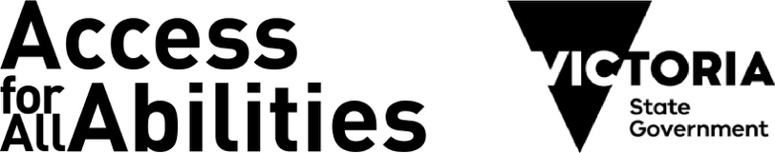
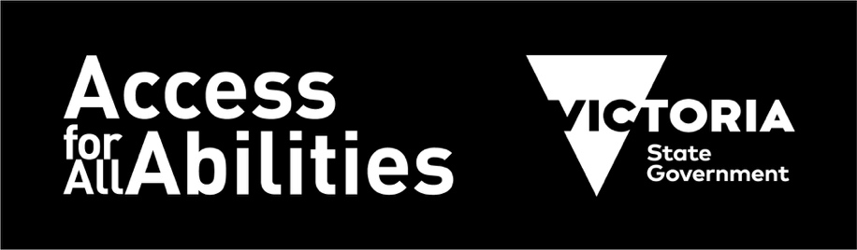
Logos cannot be stretched or distorted in any way – the ratio between width and height measurements should always be kept the same.
Where the background is a solid dark colour, use a white logo.
The visual style of the organisation receiving the funding should be the primary brand of the publication of website.
Clear space:
To maintain the clarity and integrity of all logos, a minimum ‘clear space’ must be observed in all applications.
Clear space creates an invisible frame that is a minimum area surrounding the logo that must remain free of any visual element.
Wherever possible, apply additional clear space beyond the minimum requirements.

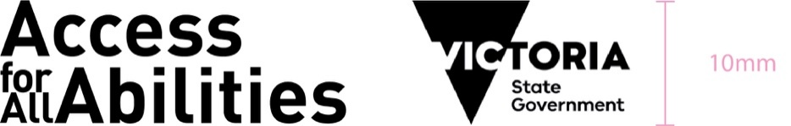
Print applications:
The clear space for print applications is at least 50 per cent of the height of the Access for All Abilities or Vic Government logo.
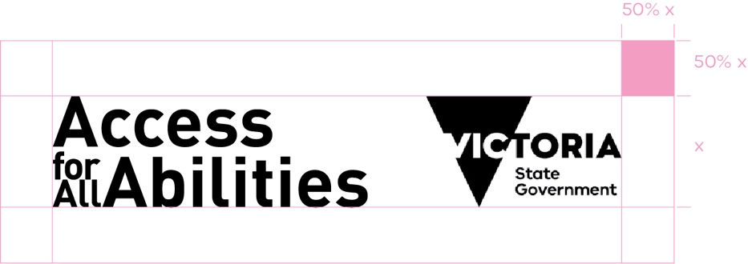
Approval:
We request that all print and digital collateral pertaining to the funded event/program that contains the Access for All Abilities and State Government logo is sent via email to sportprograms@sport.vic.gov.au for approval.
All efforts will be made to respond immediately however, we ask you allow for three working days for a written response.
Social media:
Where possible and appropriate, we ask all funded organisations to tag Access for All Abilities in any posts promoting the event/program prior, during and post activation.

Please use the following handles to keep us in the loop and for cross-promotion opportunities
Twitter
@vicgovau
@sportandrecvic
@vicgovdjpr
@aaaplayvic
@ChangeOurGame

You can also share or retweet your Together More Active funded project related posts from
https://twitter.com/sportandrecvic
Link to web stories on
www.sport.vic.gov.au
Link your disability specific opportunities on
https://aaavic.org.au/
Facebook Access for All Abilities – AAA Play

Hashtags:
Using hashtags are a great tool to use when you’re looking to reach a wider audience when you post. We suggest that the following hashtags are used in your posts relating to the activation.
Primary:
#TogetherMoreActive
#AAAPlayVic
Secondary:
#Accessibility
#Diversity
#Inclusion

Further information
Please email Sport and Recreation Victoria if you have any further questions relating to the acknowledgment guidelines at sportprograms@sport.vic.gov.au

Authorised by Sport and Recreation Victoria
Department of Jobs, Precincts and Regions
1 Spring Street Melbourne Victoria 3000
Telephone (03) 9651 9999
© Copyright State of Victoria,
Department of Jobs, Precincts and Regions 2021
Except for any logos, emblems, trademarks, artwork and photography this document is made available under the terms of the Creative Commons Attribution 3.0 Australia license.
To receive this publication in an accessible format email

