Aboriginal Sport Participation Grant 2023-24 Round 1: Frequently Asked Questions (FAQ)

FAQ’s - Aboriginal Sport Participation Grant

What is the purpose of the Aboriginal Sport Participation Grant (ASPG) program?
The Program will assist Victorian Aboriginal communities to increase participation in sport and active recreation. Grants under the Program will be provided to successful:
•teams, clubs and associations to participate in Aboriginal sporting carnivals and tournaments.
•individuals, teams, clubs and associations to purchase uniforms and/or equipment;
•individuals to travel to and pay for accommodation expenses for athletes and coaches related to regional, state and national competitions or representative teams.

What has changed?
- Category 1 – Junior Teams will now be eligible for $2,500 per team
- Category 3 - Applications open: September 2023 and will remain open until funding allocation is exhausted.
- Outcomes to be notified: within 4 weeks from the application submission date.
- Eligible uniforms and equipment must be purchased between September 2023–February 2024 (for Round 1) and February 2024–August 2024 (for Round 2).

How often and how many applications organisations can submit?
- Eligible organisations can submit multiple applications across all categories.
- Eligible organisations can apply for up to 10 multiple teams or individuals under one application.
- Under category 1 and 3 a separate application must be submitted for each specific sporting event. (For example, an eligible organisation is sending two teams to the national basketball carnival and 3 teams to the national netball carnival. In this scenario 2 applications must be submitted, one application per carnival.)

What will not be funded?
- Funding will not be provided to an organisation that has been named in an application, or receives a Notice of Redress Liability, unless they have joined or intend to join the National Redress Scheme (Scheme). For more information on the Scheme please visit the NRS website.

What supporting documentation is needed?
- Provide a break-down of costs using quotes prepared within the past twelve (12) months for the purpose of the grant. The quote must detail how the grant funds will be spent on travel and accommodation costs. See question 7 for detailed information on quotes.

- Declaration letter for organisations using a third-party grant writer.

- Who can apply and how much funding is available?

Aboriginal individuals and teams that are not affiliated with a club or association can apply for a grant in categories 1 and 2 but must have an arrangement with an auspicing body to manage the grant funding on their behalf through a funding agreement with Sport and Recreation Victoria.

Aboriginal Community groups that are not incorporated may also apply for a grant for their community members (Aboriginal individuals or teams) but must have an incorporated association or non-for-profit acting as an auspicing body to manage the funding on their behalf through a funding agreement with Sport and Recreation Victoria.

Incorporated sporting clubs and associations or Aboriginal Community Controlled organisations may apply for a grant on behalf of the members (Aboriginal individuals or teams) and will be expected to manage the funding through a funding agreement with Sport and Recreation Victoria.

For further information on Auspice organisations please refer to Attachment 1 of the
program guidelines.

- Please note that individuals or teams that are not affiliated with a club or association must contact the Aboriginal Programs team advising they require an auspice.

- The Aboriginal Programs team will refer the individual or team onto a suitable auspicing body to manage the funding on their behalf and provide support and information on the process.

How much funding can organisations receive?
Category | Maximum grant amount available
CATEGORY 1 – Aboriginal sporting carnivals and tournaments  Grants of up to $2,500 per junior team and $1,500 per senior team, are available to eligible applicants to pay for travel and accommodation costs to participate in Victorian or national Aboriginal sporting carnivals and/or tournaments. | Junior Teams $2,500  Senior Teams $1,500
CATEGORY 2 – Uniforms or Equipment - Grants of up to $1,000 per team and up to $250 per individual, are available to eligible applicants, for the purchase sporting uniforms and/or equipment. | $1,000  $250
CATEGORY 3 – Athlete Participation Support - Grants of up to $750 per individual (including athletes and coaches) are available to eligible applicants, to pay for travel and accommodation costs to compete or train in regional, state and national competitions or representative teams. | $750

- What information will you need to provide as part of your application?

Quotes
All applications must provide a quote that has been prepared within the past 12 months for the purpose of the grant. The quote must include full details of what will be purchased, individual costs and total costs, and all associated project costings. This must be provided when you are submitting your application.
All applications are eligible to apply during January 2023 – September 2023

Type:
- Formal quote or email quote addressed to individual, team or association
- Can be a website/shopping cart screen shot
Tax invoices and receipts must:
- Be dated three (3) months prior round eligibility dates (September 2023–February 2024 for Round 1 and February 2024–August 2024 for Round 2)
Must include:
- details of item type
- number of items to be purchased
- individual and total cost of items to be purchased
- details of supplier/company/website

Below is an example quote:
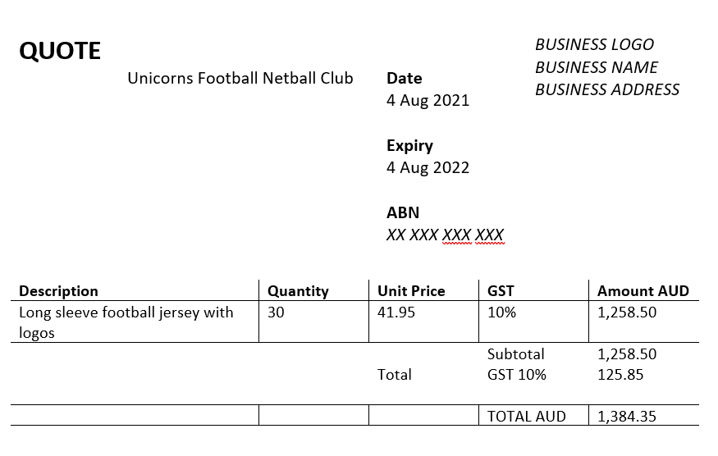

For organisations:

Declaration letter for organisations using a third-party grant writer
Where organisations use a third-party grant writer a declaration letter on club letterhead acknowledging they have reviewed and accept the content of the application submitted must be submitted with applications.

Letter of Support and/or Confirmation of registration
Applications not from an Aboriginal Community Controlled Organisation or an organisation from the list in Attachment 1 can provide a letter of support from their local Aboriginal community or Traditional owner group.

Will applicants be required to match funding?
No. This is not required.

What are the significant dates for the ASPG grant program?
Round 1
Applications open: September 18th 2023

Applications close: October 20th 2023
Outcomes to be notified: December 2023

Round 2 –2023-24
Applications open: March 1st 2024
Applications close: April 2nd 2024
Outcomes to be notified: June 2024
Category 3
Applications open: September 2023 and will remain open until funding allocation is exhausted.
Outcomes to be notified: within 4 weeks from the application submission date.

10. How do applicants submit an application?

To apply, go to the Sport and Recreation Victoria website. https://sport.vic.gov.au/grants-and-funding/our-grants/aboriginal-sport-participation-grant-program
Make sure you have the information you need on hand and click on ‘Start new application’ to submit your application through Grants Online. You will receive an Application Reference Number when you submit an application online. Please quote your Application Reference Number in all correspondence relating to your application.
Applicants can attach documents to an online application as long as they are in an acceptable file type (Word, Excel, PDF, JEPG and PNG) and don’t exceed the maximum file size of 5MB.
When submitting an application online, applicants should check carefully to ensure all their attachments have been uploaded.
Once an application has been submitted it cannot be edited. If revisions are required, a new application must be submitted, and the old application must be withdrawn.
Any attachments that are unable to be opened will not be considered during the assessment process.

Attachments cannot be provided via email and must be submitted with the online application.

11. Who can I contact for further information?

For further information Please email the Aboriginal Programs email address as listed below. A member of the team will assist you.
Email: Aboriginal.programs@sport.vic.gov.au
Open Monday - Friday, 9am - 5pm except public holidays

