What is a Project Governance Framework?

A Project Governance Framework is the management framework within which project decisions are made. This document outlines the project structure for project governance of Sport and Recreation Victoria funded projects. Effective governance ensures that the organisation’s project remains aligned to organisational objectives, and is delivered efficiently and effectively.

Key Project Stakeholders
The key project stakeholders are:
Organisation | Role/Responsibility | Key Contacts
X  X  X  X | Principal  Key stakeholder  Funding contributor  Tenant | X  X  X  X
Sport and Recreation Victoria  X | Key stakeholder  Funding contributor | X  X
X  X | Landlord  Asset owner | X  X

Project Governance
In order to ensure that project is managed in a manner that minimises risk for all partners and also provides them with adequate input, the following Project Governance Framework has been put in place.

Example of a Project Governance Framework
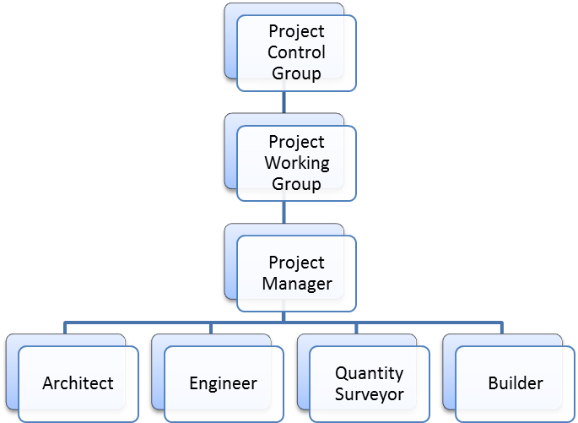

Terms of Reference
Project Control Group (PCG)
The Project Control Group will act as a high level steering committee responsible for ensuring that the project outcomes are achieved and that project budget, time and quality criteria are achieved.
The key functions of the PCG are to:
- monitor the overall delivery of the project against project outcomes;
- monitor the procurement processes, expenditure and project budget;
- monitor the program; and
- monitor the quality of the works.
Project Working Group (PWG)
The Project Working Group is responsible for the management of detailed issues related to the Project and to provide recommendations to the PCG on key project issues for decision making.
Project Manager
(INSERT NAME) has been appointed as the Project Manager, to manage the project on behalf of the Principal and to coordinate and supervise consultants through preliminary design phases, manage the procurement processes, oversee project budget and oversee the construction contract. Please update contact details below
Phone number
Email address
Project Consultant Team
The Project Consultant Team will include the architect, design consultants and quantity surveyor required to complete the design documents ready for tender.
Project Reference Groups
Project Reference Groups will be established to facilitate input into the planning and design of the new facilities, usually from user groups or the community.
Committee | Membership | Meeting Frequency
Project Control Group | Sport and Recreation Victoria  X  X | Monthly
Project Working Group | Sport and Recreation Victoria  X  X | Fortnightly
Project Reference Group | Stakeholders and authorities as required | As required

To receive this publication in an accessible format please phone the National Relay Service on 13 36 77.
Authorised and published by the Victorian Government.
© State of Victoria, 2019. Except where otherwise indicated, the images in this publication show models and illustrative settings only, and do not necessarily depict actual services, facilities or recipients of services. This publication may contain images of deceased Aboriginal and Torres Strait Islander peoples.

