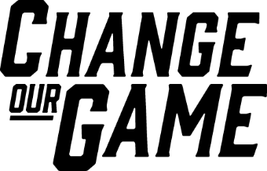

The Conversation of Sport

Representation of Women in Sports News Coverage

2023-24
Contents
Foreword 3
01 The Research 4
Scope of Study 4
02 Balance 7
2.1 Coverage of Sports News by Gender 7
2.2 Coverage by Month 9
2.3 Coverage by Sport 10
2.4 Coverage by Women’s and Men’s Sport 12
2.5 Coverage by Month – by Sport 16
2.6 Coverage by Sporting Team 17
03 Portrayal 19
3.1 Leading Topics 19
3.2 Narratives 23
3.3 Imagery 27
04 The Media 29
4.1 Bylines 29
4.2 Sources 31
4.3 Media Organisations – Coverage 35
4.4 Media Organisations – Bylines 36
4.5 Print Media 37
4.6 Online Media 40
4.7 Radio News 43
4.8 Television News 46

The purpose of this study is to extend the evidence base for, and analyse trends and changes in, the coverage of women’s sport and women in sport in Victoria, to advocate for improved representation moving forward.
The Victorian Government proudly acknowledges Aboriginal people as the First Peoples and Traditional Owners and custodians of the land and water on which we rely. We acknowledge the ongoing leadership role of the Aboriginal community on gender equality and the prevention of violence against women. As First Peoples, Aboriginal Victorians are best placed to determine a culturally appropriate path to gender equality in their communities.

Foreword
The visibility of women in sport is fundamental to its growth, and a more equal society. The promotion of women and girls in all aspects of sport, including through sports media, is essential to driving positive change at both an elite and community level.
Strong representation of women in sports media allows teams, leagues, and individual athletes to build their fanbases, attract sponsors, and fully professionalise. It also helps to dismantle the limiting stereotypes, norms and expectations influencing opportunities for women and girls in sport and beyond.
This is the second year release of The Conversation of Sport, and I hope it will continue to drive the conversations required to change the sports media ecosystem by providing independent and transparent data regarding the current coverage of women in sports media.
At present, the widespread underrepresentation of women persists. However, this release also contains widespread and positive improvements across media types, regions and media organisations, as well as increases in opportunities for women as journalists and presenters. While outcomes were strongest during the FIFA Women’s World Cup 2023, pleasingly these trends were observed across the year too. While these improvements can’t be taken for granted, and there is more work to be done, they show that the industry itself sees the value in making them.
The Victorian Government is committed to levelling the playing field for women and girls in sport. While I acknowledge the progress made, I look forward to continued action to reduce the visibility gap for women in sport in Victoria.
THE HON ROS SPENCE MP
Minister for Community Sport
- The Research

Scope of Study
This study analysed sports news coverage available in Victoria, Australia, in 2023-24.
This is the second annual report on the representation of women in sports news coverage in Victoria.
The first report, The Conversation of Sport: Representation of Women in Sports News Coverage 2022-23, established a baseline of coverage of women’s sport and women in sport in Victoria.
Completed by global media monitoring firm Isentia, this new study is based on a representative sample of at least 100 sports news items per day, for each month from 1 July 2023 to 30 June 2024, with a total sample size of more than 39,900 individual pieces of media.
This study involved human analysis of media coverage mentioning sport that was aired or published in Victoria during the 12-month period.
Each mention of gender in an item, whether referring to an individual, a team or a sport, was analysed and coded by a team of human researchers.
The analysis of gender also extended to all sources present in coverage as well as the journalist or presenter.
The sample excludes the live broadcast of sport, social media coverage, owned publications of sporting organisations, subscription tv news, and coverage relating to the racing of horses and other animals.
Where available, this study compares analysis of sports news coverage in Victoria from 2022-23.
Media type – share of coverage
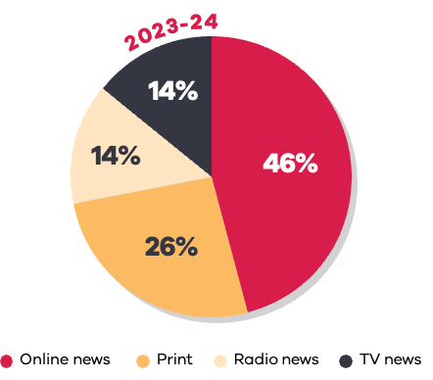
Media type category | Share of coverage
Online news | 46%
Print | 26%
Radio news | 14%
Television news | 14%

Media type – share of location
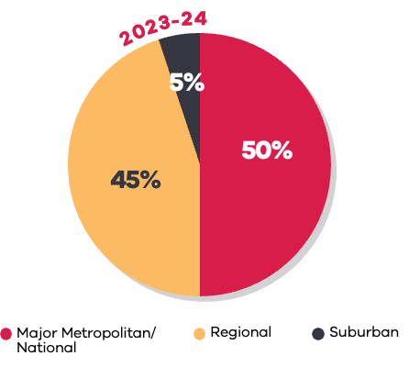
Location | Share of coverage
Major metropolitan/national | 50%
Regional | 45%
Suburban | 5%

- Balance
This section outlines the overall presence of women in sports coverage. Balance is the main measure used throughout the report, which is the percentage of all sports news stories that are focused on women’s sport.
  - Coverage of Sports News by Gender
Coverage of women in sports media in 2023-24 increased from the previous year.
The study found that 20% of all sports news stories were focused on women’s sport, compared to 75% on men’s sport.
This is an increase from 15% coverage of women’s sport in the previous year.
Of all women’s sport coverage across the year, 3% was on the FIFA Women’s World Cup 2023, with the remaining 17% of coverage on other women’s sport.
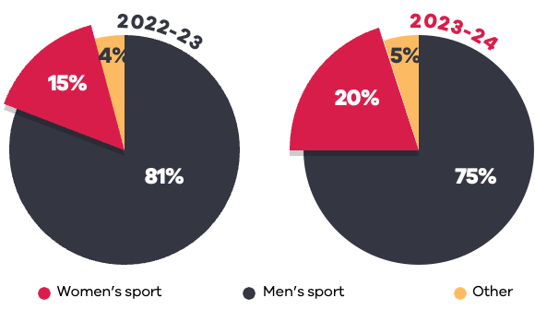
Gender | 2022-23 | 2023-24
Women’s sport | 15% | 20%
Men’s sport | 81% | 75%
Other | 4% | 5%

During the period of the FIFA Women’s World Cup 2023, 31% of sports news was focused on women’s sport, with 20% specifically on the FIFA Women’s World Cup.
‘Other’ includes No Gender (for example a sport-wide focus), Multiple Genders (for example AFL and AFLW are mentioned), Transgender (if mentioned or self-identified) and Non-Binary (if mentioned or self-identified).
The period of analysis for the FIFA Women’s World Cup 2023 was 15 July 2023 to 25 August 2023.
While underrepresentation continued, coverage of women’s sport increased across all media types and most locations.
Print continued to be the strongest platform for coverage of women’s sport.
Major metropolitan and national media recorded the most significant increase in coverage of women’s sport, based on coverage location.
Comparison by media type
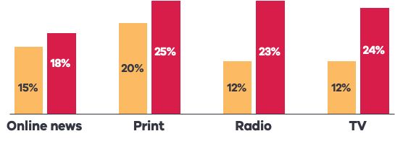
Media type category | 2022-23 | 2023-2024
Online news | 15% | 18%
Print | 20% | 25%
Radio | 12% | 23%
Television | 12% | 24%

Comparison by coverage location
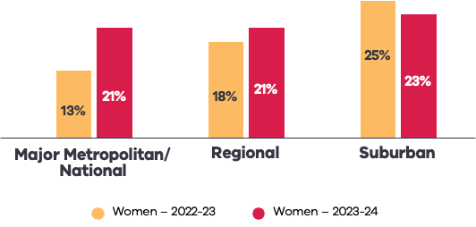
Region | 2022-23 | 2023-2024
Major metropolitan/national | 13% | 21%
Regional | 18% | 21%
Suburban | 25% | 23%
Data for ‘Other’, including No Gender or Multiple Genders, is excluded from this data.
  - Coverage by Month
Media coverage of women’s sport was consistently higher in 2023-24 compared to the previous year.
The proportion of coverage focused on women peaked in July and August 2023, when the FIFA Women’s World Cup 2023 tournament was taking place, however growth was not limited to this period.
Across 2023-24, each month had either the same or higher coverage of women’s sport than the same month in the previous year.
Outside of the FIFA Women’s World Cup 2023, November had the highest coverage of women’s sport across both years.
Gender split of coverage by month
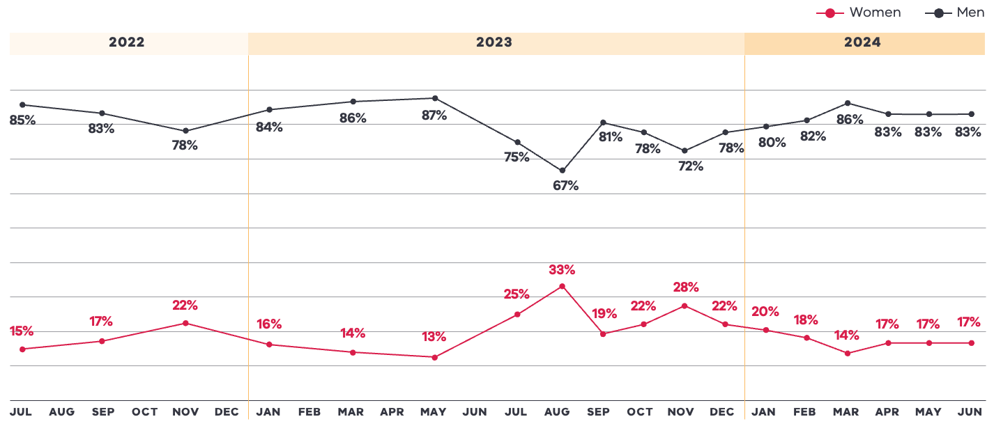

Year | Month | Men % | Women %
2022 | Jul | 85% | 15%
2022 | Sep | 83% | 17%
2022 | Nov | 78% | 22%
2023 | Jan | 84% | 16%
2023 | Mar | 86% | 14%
2023 | May | 87% | 13%
2023 | Jul | 75% | 25%
2023 | Aug | 67% | 33%
2023 | Sep | 81% | 19%
2023 | Oct | 78% | 22%
2023 | Nov | 72% | 28%
2023 | Dec | 78% | 22%
2024 | Jan | 80% | 20%
2024 | Feb | 82% | 18%
2024 | Mar | 86% | 14%
2024 | Apr | 83% | 17%
2024 | May | 83% | 17%
2024 | Jun | 83% | 17%
Data for ‘Other’, including No Gender or Multiple Genders, is excluded from this data.
The sampling methodology changed from bi-monthly in 2022-23 to monthly in 2023-24.
  - Coverage by Sport
14 of the top 20 sports increased the representation of women’s sport coverage in 2023-24 compared to 2022-23.
The top 5 sports accounted for 79% of overall sports news coverage in 2023-24, compared to 78% in 2022-23. Women’s coverage represented an average of 19% of coverage across the top 5 sports.
Out of the top 20 sports by coverage, 6 sports had at least gender balance (>40%) coverage.
Coverage of women’s football (soccer) increased significantly in 2023-24. This was due to coverage of the FIFA Women’s World Cup 2023, which had 20% share of overall coverage during the World Cup period.
Gender split of coverage of top 20 sports
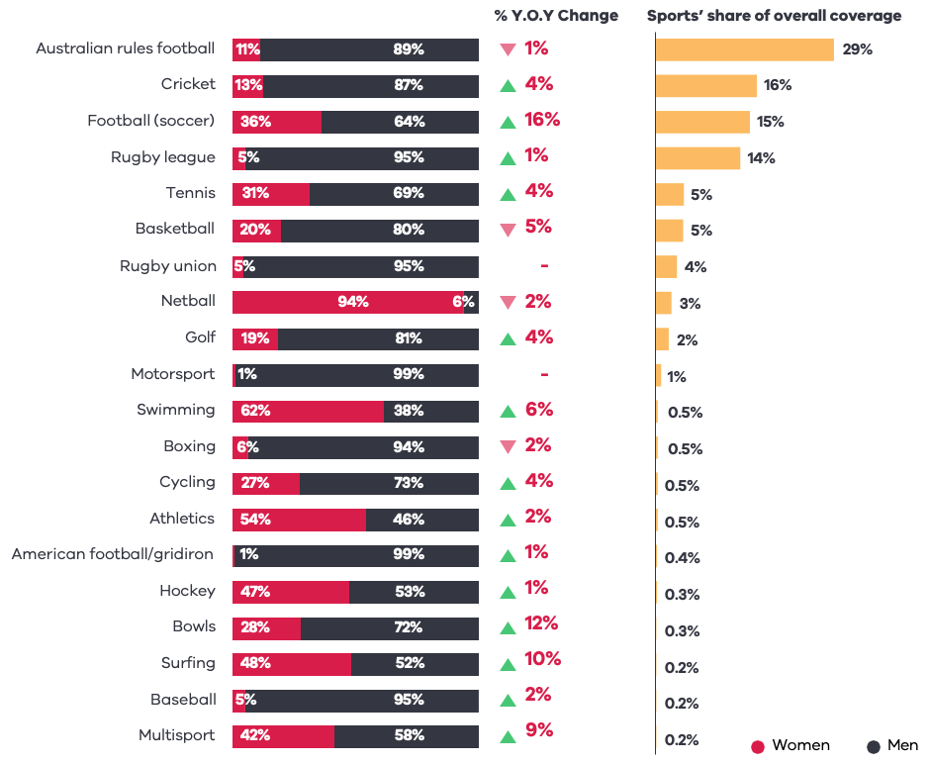
Sport | Women % | Men % | % YOY change | Direction | Share of overall coverage
Australian rules football | 11% | 89% | 1% | Down | 29%
Cricket | 13% | 87% | 4% | Up | 16%
Football (soccer) | 36% | 64% | 16% | Up | 15%
Rugby league | 5% | 95% | 1% | Up | 14%
Tennis | 31% | 69% | 4% | Up | 5%
Basketball | 20% | 80% | 5% | Down | 5%
Rugby union | 5% | 95% | – |  | 4%
Netball | 94% | 6% | 2% | Down | 3%
Golf | 19% | 81% | 4% | Up | 2%
Motorsport | 1% | 99% | – |  | 1%
Swimming | 62% | 38% | 6% | Up | 0.5%
Boxing | 6% | 94% | 2% | Down | 0.5%
Cycling | 27% | 73% | 4% | Up | 0.5%
Athletics | 54% | 46% | 2% | Up | 0.5%
American football/gridiron | 1% | 99% | 1% | Up | 0.4%
Hockey | 47% | 53% | 1% | Up | 0.3%
Bowls | 28% | 72% | 12% | Up | 0.3%
Surfing | 48% | 52% | 10% | Up | 0.2%
Baseball | 5% | 95% | 2% | Up | 0.2%
Multisport | 42% | 58% | 9% | Up | 0.2%
Data for ‘Other’, including No Gender or Multiple Genders, is excluded from this data.
% YOY Change refers to the change in balance of women’s sport coverage from 2022-23.
  - Coverage by Women’s and Men’s Sport
Football (soccer) had the highest share of coverage for women’s sports, which doubled from 2022-23.
This page shows the share of voice for major sports by coverage in women’s sport and coverage in men’s sport.
Team sports continued to receive the highest share of voice for coverage across women’s and men’s sport.
Cricket increased its share of coverage across both women’s and men’s sport in Victoria from 2022-23.
Australian rules football remained high across both the coverage of women’s and men’s sport.
Individual and team success can drive media engagement. This is clearly demonstrated in the success of the Matildas during the FIFA Women’s World Cup 2023 tournament.
Women’s sports share of voice
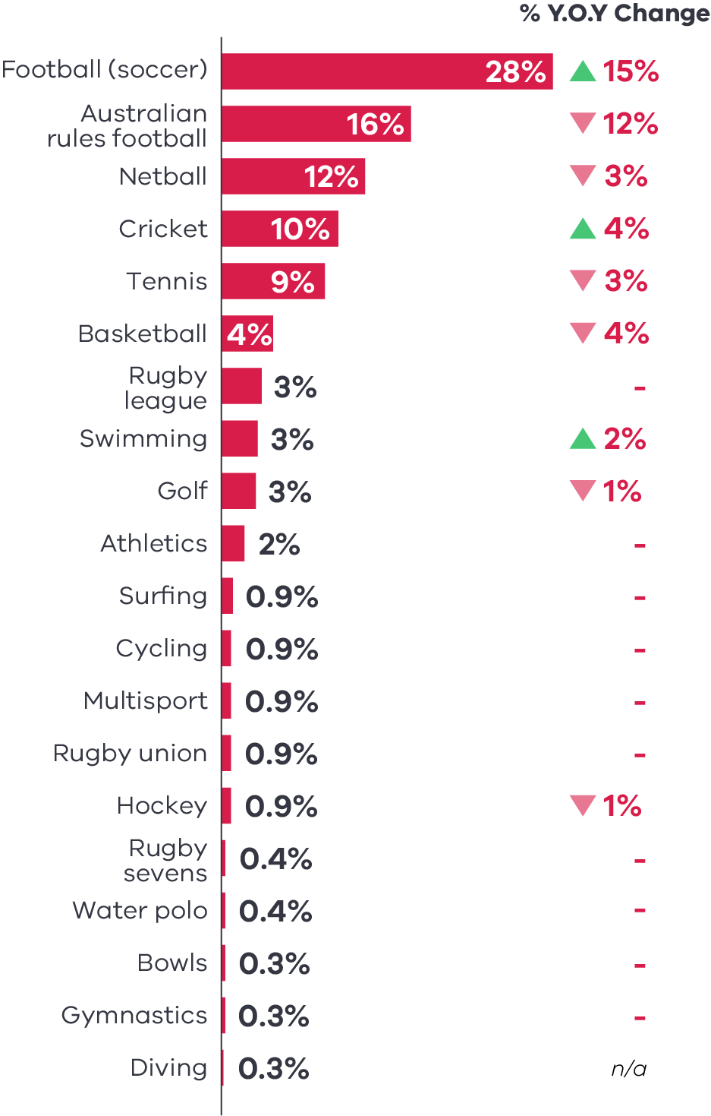
Sports | Women % | % YOY change | Direction
Football (soccer) | 28% | 15% | Up
Australian rules football | 16% | 12% | Down
Netball | 12% | 3% | Down
Cricket | 10% | 4% | Up
Tennis | 9% | 3% | Down
Basketball | 4% | 4% | Down
Rugby league | 3% | –
Swimming | 3% | 2% | Up
Golf | 3% | 1% | Down
Athletics | 2% | –
Surfing | 0.9% | –
Cycling | 0.9% | –
Multisport | 0.9% | –
Rugby union | 0.9% | –
Hockey | 0.9% | 1% | Down
Rugby sevens | 0.4% | –
Water polo | 0.4% | –
Bowls | 0.3% | –
Gymnastics | 0.3% | –
Diving | 0.3% | n/a

Men’s sports share of voice
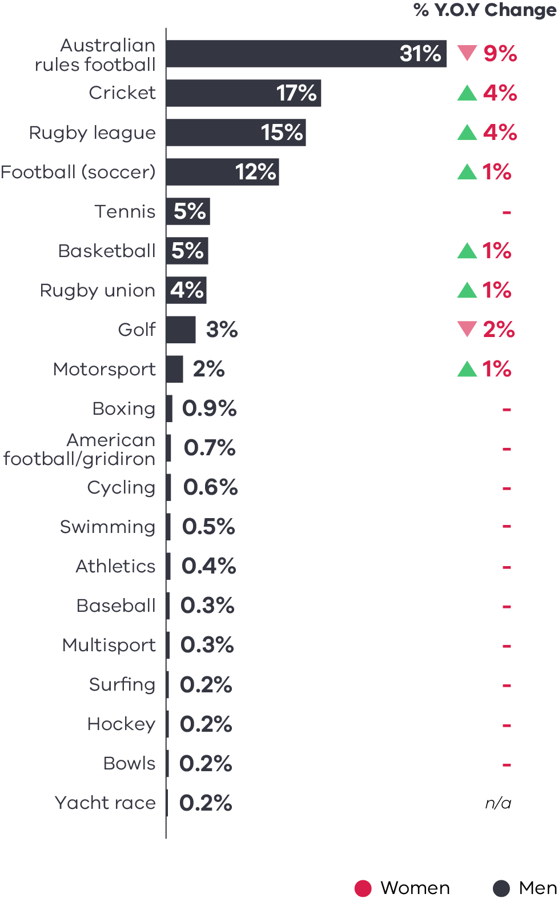
Sports | Men % | % YOY change | Direction
Australian rules football | 31% | 9% | Down
Cricket | 17% | 4% | Up
Rugby league | 15% | 4% | Up
Football (soccer) | 12% | 1% | Up
Tennis | 5% | –
Basketball | 5% | 1% | Up
Rugby union | 4% | 1% | Up
Golf | 3% | 2% | Down
Motorsport | 2% | 1% | Up
Boxing | 0.9% | –
American football/gridiron | 0.7% | –
Cycling | 0.6% | –
Swimming | 0.5% | –
Athletics | 0.4% | –
Baseball | 0.3% | –
Multisport | 0.3% | –
Surfing | 0.2% | –
Hockey | 0.2% | –
Bowls | 0.2% | –
Yacht Race | 0.2% | n/a
% YOY Change refers to the change in women’s and men’s share of voice from 2022-23.
Some of the change in each sport’s share of voice between 2022-23 and 2023-24 could be attributed to the change in sampling methodology from bi-monthly to monthly.
  - Coverage by Month – by Sport
Media coverage by sport reflects the seasonality of sporting events, competitions and leagues across both women’s and men’s sports.
These charts show the share of coverage for leading women’s sports and men’s sports over 2023-24, based on all mentions of gender within a media story.
Share of coverage for leading women's sports Share of coverage for leading men’s sports
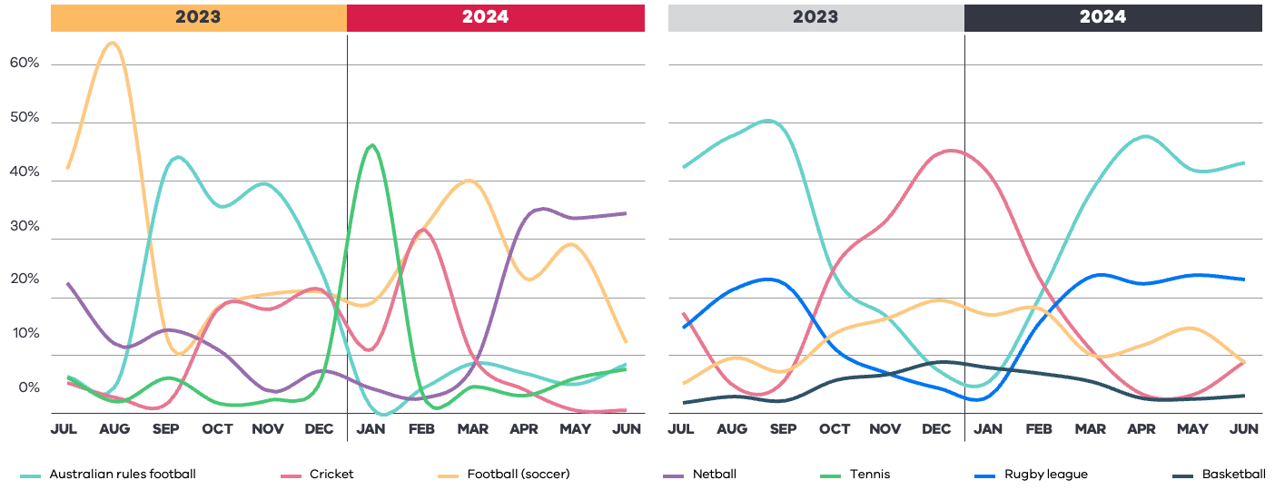
Share of coverage for leading women’s sport
Year | Month | Football (soccer) | Australian rules football | Netball | Cricket | Tennis
2023 | Jul | 42% | 6% | 22% | 5% | 6%
2023 | Aug | 63% | 6% | 12% | 3% | 2%
2023 | Sep | 12% | 43% | 14% | 2% | 6%
2023 | Oct | 18% | 35% | 11% | 18% | 2%
2023 | Nov | 21% | 39% | 4% | 18% | 2%
2023 | Dec | 21% | 24% | 7% | 21% | 6%
2024 | Jan | 19% | 1% | 4% | 11% | 46%
2024 | Feb | 32% | 4% | 2% | 32% | 3%
2024 | Mar | 40% | 9% | 8% | 9% | 5%
2024 | Apr | 23% | 7% | 33% | 4% | 3%
2024 | May | 29% | 5% | 34% | 0% | 6%
2024 | Jun | 12% | 8% | 34% | 1% | 8%

Share of coverage for leading men’s sports
Year | Month | Australian rules football | Cricket | Rugby league | Football (soccer) | Basketball
2023 | Jul | 42% | 17% | 15% | 5% | 2%
2023 | Aug | 48% | 5% | 21% | 10% | 3%
2023 | Sep | 49% | 6% | 22% | 7% | 2%
2023 | Oct | 23% | 26% | 11% | 14% | 6%
2023 | Nov | 17% | 33% | 7% | 16% | 7%
2023 | Dec | 7% | 45% | 4% | 19% | 9%
2024 | Jan | 6% | 41% | 3% | 17% | 8%
2024 | Feb | 20% | 23% | 16% | 18% | 7%
2024 | Mar | 38% | 11% | 24% | 10% | 5%
2024 | Apr | 48% | 3% | 22% | 12% | 3%
2024 | May | 42% | 3% | 24% | 15% | 2%
2024 | Jun | 43% | 9% | 23% | 9% | 3%
The data on this page uses visibility as a measure, which captures all mentions of gender within a media item, such as athletes, teams, coaches, administrators. All mentions within the media item are included through this measure.
  - Coverage by Sporting Team
Despite the increase in coverage of women’s sport, men’s AFL teams dominated team-based coverage.
The Matildas had the third highest share of coverage across sporting teams and was the only women’s team in the top 10.
Top 10 Teams: 2023-24
Rank | Team | Sport | Gender | Rank Change (2022-23)
1 | Australian Men’s Cricket Team | Cricket | Men | Up (#2)
2 | Collingwood Magpies | Australian rules football | Men | Up (#3)
3 | Matildas | Football (soccer) | Women | Up (#95)
4 | Melbourne Demons | Australian rules football | Men | Up (#5)
5 | Brisbane Lions | Australian rules football | Men | Up (#6)
6 | Carlton Blues | Australian rules football | Men | Up (#8)
7 | Geelong Cats | Australian rules football | Men | Down (#1)
8 | Port Adelaide Power | Australian rules football | Men | Up (#19)
9 | Richmond Tigers | Australian rules football | Men | Down (#7)
10 | Sydney Swans | Australian rules football | Men | Down (#4)
Over the FIFA Women’s World Cup 2023 period, the Matildas received 2.6 times more coverage than any other team. Second was the Australian Men’s Cricket Team, which played in 2 Ashes tests over that period.
The data on this page uses visibility as a measure, which captures all mentions of gender within a media item, such as athletes, teams, coaches, administrators. All mentions within the media item are included through this measure.
- Portrayal
This section analyses the differences in how women and men are reported through topics, language and images.
It focuses on three areas:
- The topic or focus of a story
- The main narratives coming through in sports news reporting
The nature of images used
In each area, portrayal of women and men athletes is compared.
  - Leading Topics
There remained an overrepresentation of results and performance in the coverage of women’s sport, with positive indications towards greater balance in coverage overall.
This chart shows the relative difference in the leading topics mentioned in reference to women’s sport and men’s sport, for both athletes and teams.
The skew towards results and performance reflects a continued lack of depth of coverage for women’s sport compared to men’s sport coverage.
For example, across both 2022-23 and 2023-24, women’s coverage was more likely to be limited to news of results and performance, whereas men’s sport received more coverage regarding training and preparation, on-field behaviour and fitness/injury. However, the strength of this skew softened in 2023-24.
While the gap narrowed, men athletes continued to have more space for advocacy within sport.
Gender differences in leading topics of coverage
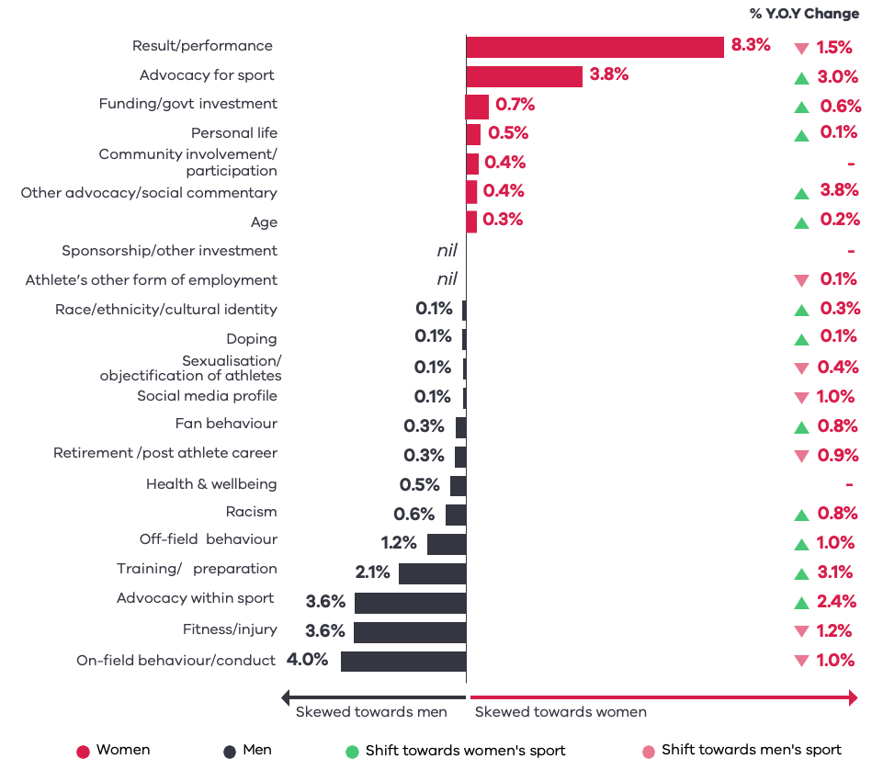

Topics | % Skewed towards men | % Skewed towards women | % YOY Change | Direction
Result/Performance |  | 8.3% | 1.5% | Down
Advocacy for Sport |  | 3.8% | 3.0% | Up
Funding/Govt Investment |  | 0.7% | 0.6% | Up
Personal Life |  | 0.5% | 0.1% | Up
Community Involvement/Participation |  | 0.4% | –
Other Advocacy/Social Commentary |  | 0.4% | 3.8% | Up
Age |  | 0.3% | 0.2% | Up
Sponsorship/Other Investment | nil | nil | –
Athlete’s Other Form of Employment | nil | nil | 0.1% | Down
Race/Ethnicity/Cultural Identity | 0.1% |  | 0.3% | Up
Doping | 0.1% |  | 0.1% | Up
Sexualisation/Objectification of Athletes | 0.1% |  | 0.4% | Down
Social Media Profile | 0.1% |  | 1.0% | Down
Fan Behaviour | 0.3% |  | 0.8% | Up
Retirement/Post Athlete Career | 0.3% |  | 0.9% | Down
Health and Wellbeing | 0.5% |  | – | Up
Racism | 0.6% |  | 0.8% | Up
Off-Field Behaviour | 1.2% |  | 1.0% | Up
Training/Preparation | 2.1% |  | 3.1% | Up
Advocacy Within Sport | 3.6% |  | 2.4% | Up
Fitness/Injury | 3.6% |  | 1.2% | Down
On-Field Behaviour/Conduct | 4.0% |  | 1.0% | Down
% YOY Change refers to the change in gender difference from 2022-23.

  - Narratives
There was stronger recognition of the achievements, talent and hard work in the narrative of women’s sport compared to men’s sport.
This chart below shows the relative difference in leading narratives mentioned in reference to women’s sport and men’s sport (both athletes and teams).
Women continued to be more likely described with traits as quiet achiever, hard worker and punching above their weight. However, there was an increase in women being described as talented, match-fit and having high integrity.
There was no longer a noticeable difference between men’s and women’s sport in relation to news stories that discussed high performance expectations and being well liked/popular.
Men’s sport continued to have more narratives that reflected upon their performance and behaviour. For example, men’s sport being described as troubled, struggling, disappointing and lacks integrity.
Gender differences in leading narratives of coverage
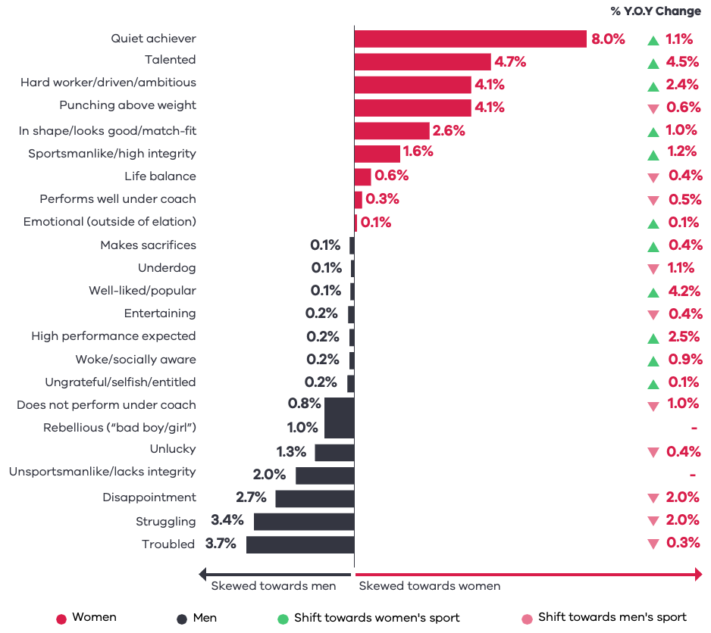

Topics | % Skewed towards men | % Skewed towards women | % YOY Change | Direction
Quiet Achiever |  | 8.0% | 1.1% | Up
Talented |  | 4.7% | 4.5% | Up
Hard Worker/Driven/Ambitious |  | 4.1% | 2.4% | Up
Punching Above Weight |  | 4.1% | 0.6% | Down
In Shape/Looks Good/Match-Fit |  | 2.6% | 1.0% | Up
Sportsmanlike/High Integrity |  | 1.6% | 1.2% | Up
Life Balance |  | 0.6% | 0.4% | Down
Performs Well Under Coach |  | 0.3% | 0.5% | Down
Emotional (Outside of Elation) |  | 0.1% | 0.1% | Up
Makes Sacrifices | 0.1% |  | 0.4% | Up
Underdog | 0.1% |  | 1.1% | Down
Well-Liked/Popular | 0.1% |  | 4.2% | Up
Entertaining | 0.2% |  | 0.4% | Down
High Performance Expected | 0.2% |  | 2.5% | Up
Woke/Socially Aware | 0.2% |  | 0.9% | Up
Ungrateful/Selfish/Entitled | 0.2% |  | 0.1% | Up
Does Not Perform Under Coach | 0.8% |  | 1.0% | Down
Rebellious (“Bad Boy/Girl”) | 1.0% |  | –
Unlucky | 1.3% |  | 0.4% | Down
Unsportsmanlike/Lacks Integrity | 2.0% |  | –
Disappointment | 2.7% |  | 2.0% | Down
Struggling | 3.4% |  | 2.0% | Down
Troubled | 3.7% |  | 0.3% | Down
% YOY Change refers to the change in gender difference from 2022-23.

  - Imagery
Women were less likely to be depicted in images in sports news, which is a reversal of the previous year.
Results show that women were also less likely to be depicted in images showing action and in portrait images.
There continued to be no evidence of sexualised images being used, whether driven by athletes or not.
Gender differences in imagery
Women were 4% less likely to be depicted in images in 2023-24, compared to 4% more likely in 2022-23.
Gender Differences in Image Types
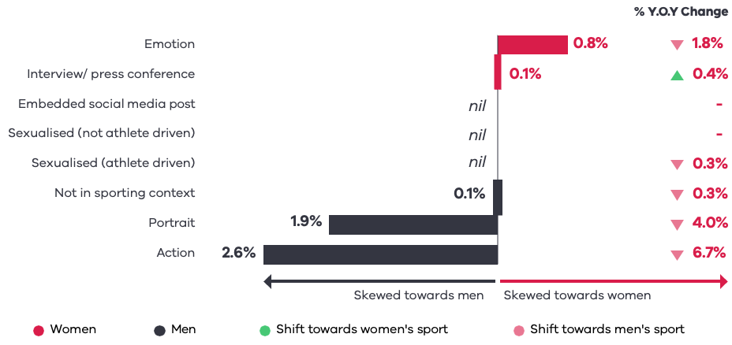

Topics | % Skewed towards men | % Skewed towards women | % YOY Change | Direction
Emotion |  | 0.8% | 1.8% | Down
Interview/Press Conference |  | 0.1% | 0.4% | Up
Embedded Social Media Post | Nil | Nil | –
Sexualised (Not Athlete Driven) | Nil | Nil | –
Sexualised (Athlete Driven) | Nil | Nil | 0.3% | Down
Not In Sporting Context | 0.1% |  | 0.3% | Down
Portrait | 1.9% |  | 4% | Down
Action | 2.6% |  | 6.7% | Down
% YOY Change refers to the change in gender difference from 2022-23.

- The Media
This section looks at the gender balance and bylines across media types, organisations and outlets.
This section also examines sources that were quoted in a media story, to establish whether there was any reliance on specific types of sources.
  - Bylines
The study revealed an increase in women’s opportunities as journalists or presenters of sports news.
In 2023-24 there was a 26% increase in sports news stories by women journalists or presenters compared to the previous year, with women having the opportunity to contribute 1 in 3 sports news stories. This growth was predominantly driven by television news.
There was a 62% increase in sports news stories on women’s sport by men journalists or presenters compared to the previous year.
Byline gender breakdown
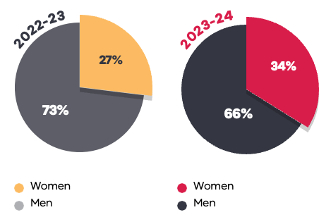
2022-2023
Byline Gender | Total
Women | 27%
Men | 73%

2023-2024
Byline Gender | Total
Women | 34%
Men | 66%

Byline gender breakdown by men’s and women’s sports content
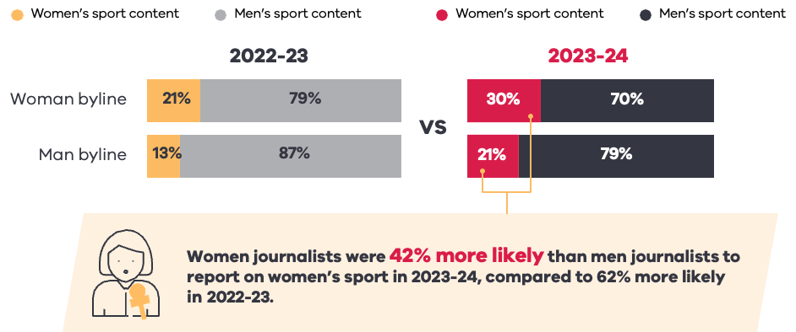
2022-2023
Gender | Women's Sport Content | Men's Sport Content
Women Byline | 21% | 79%
Men Byline | 13% | 87%

2023-2024
Gender | Women's Sport Content | Men's Sport Content
Women Byline | 30% | 70%
Men Byline | 21% | 79%

Women journalists were 42% more likely than men journalists to report on women’s sport in 2023-24, compared to 62% more likely in 2022-23.
Data for ‘Other’, including No Gender or Multiple Genders, is excluded from this data.
Byline includes the author of print or online articles, as well as reporter, newsreader or presenter of broadcast programs. A byline is not attributed for all media items, with this data only reflecting items with a named byline.
  - Sources
Overall, women continued to be significantly underrepresented as sources of comment on sport in the media.
Women were slightly more likely to be a source for comment on women’s sport in 2023-24, compared to the previous year. This outcome was due to the overall increase in women’s sports coverage.
Women were 11 times more likely to provide comment on women’s sport than providing comment on men’s sport (excluding athletes as sources), compared to 13 times in 2022-23. This reflects an increase in men commenting on women’s sport in 2023-24.
Overall sources gender balance
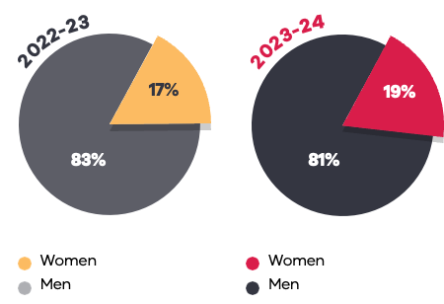
2022-2023
Sources Gender | Percentage
Women | 17%
Men | 83%

2023-2024
Sources Gender | Percentage
Women | 19%
Men | 81%

Sources of content on sport (excluding athletes as sources)
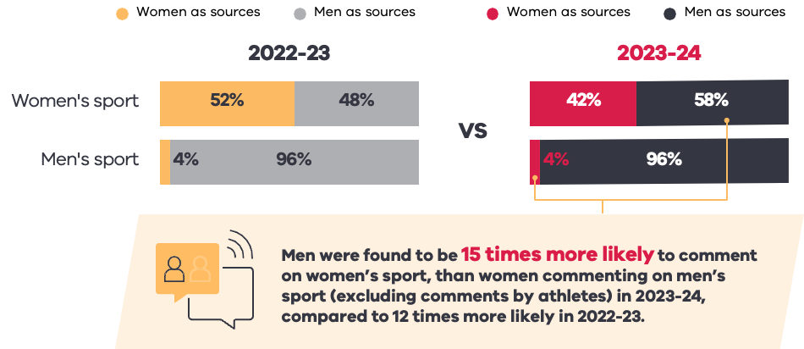
2022-2023
Gender | Women as Sources | Men as Sources
Women’s sport | 52% | 48%
Men’s sport | 4% | 96%

2023-2024
Gender | Women as Sources | Men as Sources
Women’s sport | 42% | 58%
Men’s sport | 4% | 96%

Men were found to be 15 times more likely to comment on women’s sport, than women commenting on men’s sport (excluding comments by athletes) in 2023-24, compared to 12 times more likely in 2022-23.
Data for ‘Other’, including No Gender or Multiple Genders, is excluded from this data.
Sources are those quoted directly or indirectly in a media item, including official sources (athletes, coaches, officials, administrators) and unofficial sources (for example, fans).
Coaches – a role dominated by men – increased as a source of comment on women’s sport in 2023-24.
Athletes were less likely to comment on themselves or their team, and men coaches became a more common source of quotes. During the FIFA Women’s World Cup 2023, coaches were prominent as a source of comment, being 21% of sources of comment on women’s sport.
Sources quoted in women’s sport coverage
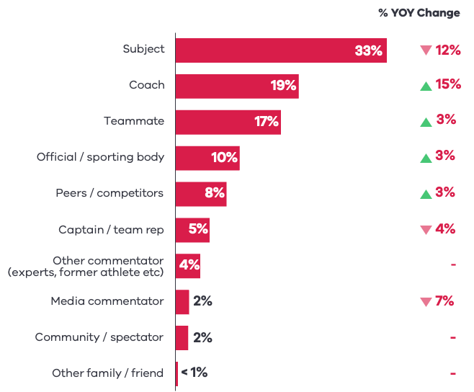
Sources Relationship | % Women's Sport | % YOY Change | Direction
Subject | 33% | 12% | Down
Coach | 19% | 15% | Up
Teammate | 17% | 3% | Up
Official/Sporting Body | 10% | 3% | Up
Peers/Competitors | 8% | 3% | Up
Captain/Team Rep | 5% | 4% | Down
Other Commentator (Experts, Former Athlete, Etc) | 4% | –
Media Commentator | 2% | 7% | Down
Community/Spectator | 2% | –
Other Family/Friend | <1% | –

Sources quoted in men’s sport coverage
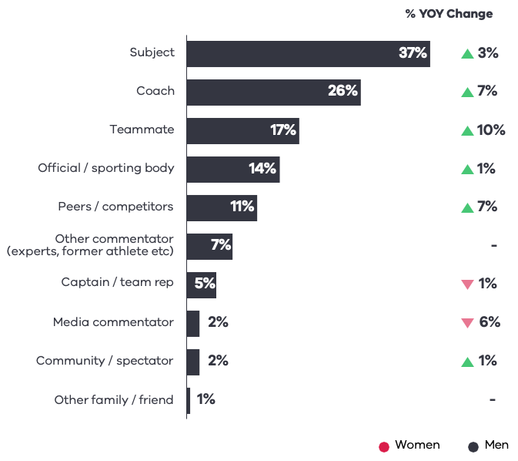
Sources Relationship | % Men's Sport | % YOY Change | Direction
Subject | 37% | 3% | Up
Coach | 26% | 7% | Up
Teammate | 17% | 10% | Up
Official/Sporting Body | 14% | 1% | Up
Peers/Competitors | 11% | 7% | Up
Other Commentator (Experts, Former Athlete, Etc) | 7% | –
Captain/Team Rep | 5% | 1% | Down
Media Commentator | 2% | 6% | Down
Community/Spectator | 2% | 1% | Up
Other Family/Friend | 1% | –
Data for ‘Other’, including No Gender or Multiple Genders, is excluded from this data.
Sources are those quoted directly or indirectly in a media item, including official sources (athletes, coaches, officials, administrators) and unofficial sources (for example, fans).
% YOY Change refers to the change in sources from 2022-23.
  - Media Organisations – Coverage
This study found that most of the top 10 media organisations recorded improvements in coverage of women’s sport, compared to the previous year.
The Australian Broadcasting Corporation, Seven West Media, Southern Cross Austereo and Ten Network Holdings recording the biggest increases.
During the FIFA Women’s World Cup 2023, both the Australian Broadcasting Corporation and Seven West Media had gender balance in sports news coverage in Victoria (50% and 49% respectively).
Top 10 Media Organisations – Sport News Coverage by Gender
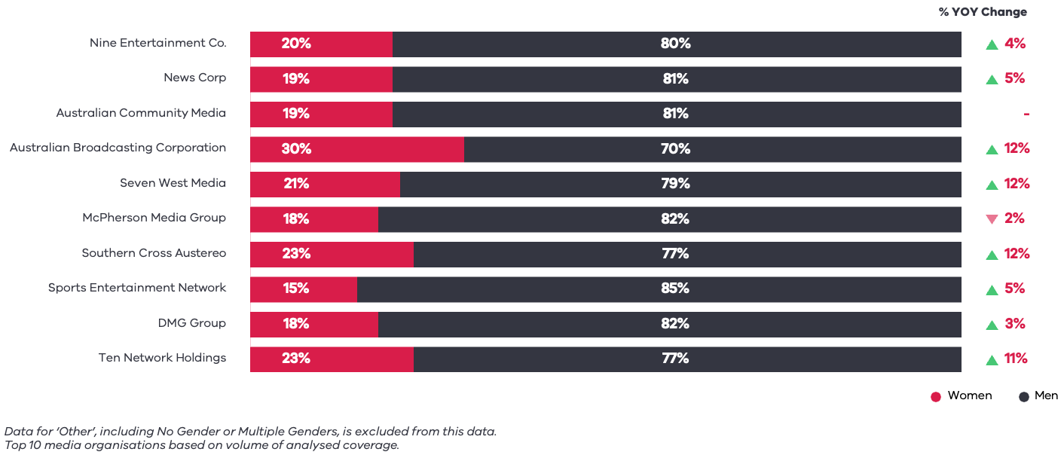
Media Organisation | Women % | Men % | % YOY Change | Direction
Nine Entertainment Co. | 20% | 80% | 4% | Up
News Corp | 19% | 81% | 5% | Up
Australian Community Media | 19% | 81% | –
Australian Broadcasting Corporation | 30% | 70% | 12% | Up
Seven West Media | 21% | 79% | 12% | Up
Mcpherson Media Group | 18% | 82% | 2% | Down
Southern Cross Austereo | 23% | 77% | 12% | Up
Sports Entertainment Group | 15% | 85% | 5% | Up
DMG Group | 18% | 82% | 3% | Up
Ten Network Holdings | 23% | 77% | 11% | Up
Data for ‘Other’, including No Gender or Multiple Genders, is excluded from this data.
Top 10 media organisations based on volume of analysed coverage.
% YOY Change refers to the change in balance of women’s sport coverage from 2022-23.
  - Media Organisations – Bylines
The study found that opportunities for women journalists or presenters of sports news increased in 2023-24 across the majority of media organisations.
Media organisations with television outlets performed the strongest in bylines by women.
Top 10 media organisations – coverage by gender of journalist
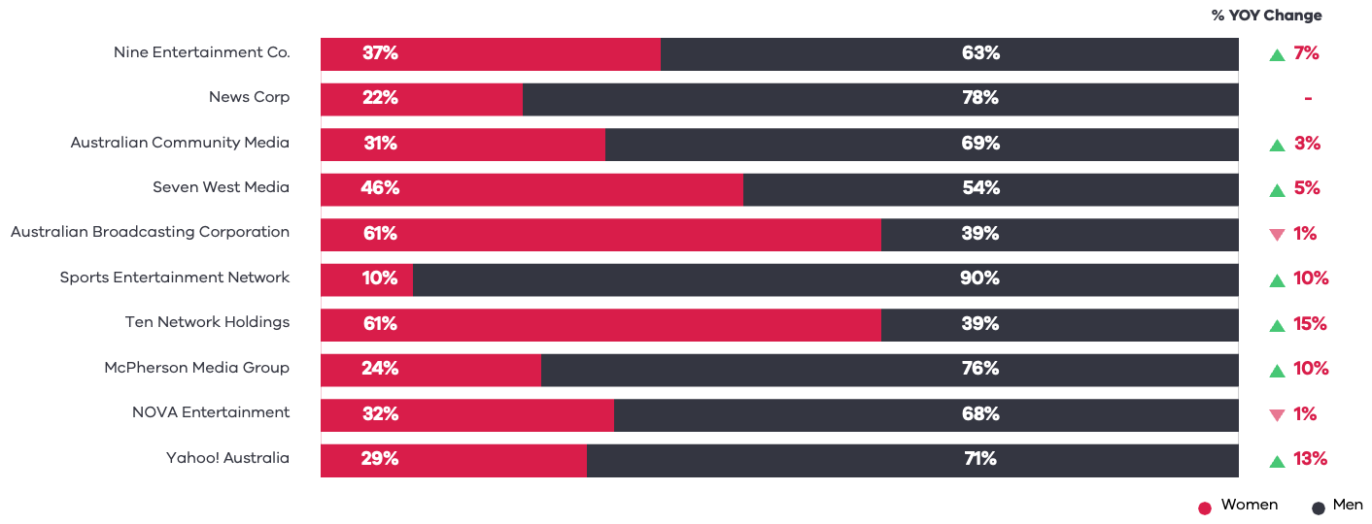
Media Organisation | Women Byline % | Men Byline % | % YOY Change | Direction
Nine Entertainment Co. | 37% | 63% | 7% | Up
News Corp | 22% | 78% | –
Australian Community Media | 31% | 69% | 3% | Up
Seven West Media | 46% | 54% | 5% | Up
Australian Broadcasting Corporation | 61% | 39% | 1% | Down
Sports Entertainment Group | 10% | 90% | 10% | Up
Ten Network Holdings | 61% | 39% | 15% | Up
McPherson Media Group | 24% | 76% | 10% | Up
NOVA Entertainment | 32% | 68% | 1% | Down
Yahoo! Australia | 29% | 71% | 13% | Up
Data for ‘Other’, including No Gender or Multiple Genders, is excluded from this data.
Bylines includes the author of print or online articles, as well as reporter, newsreader or presenter of broadcast programs. A byline is not attributed for all media items, with this data only reflecting items with a named byline.
Top 10 media organisations based on volume of analysed coverage.
% YOY Change refers to the change in women’s bylines from 2022-23.
  - Print Media
These charts show the overall gender coverage, by month and by the top 10 media outlets ranked by volume, for print sports news.
Gender coverage breakdown in print media
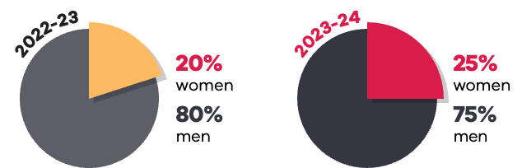
Year | Women | Men
2022-2023 | 20% | 80%
2023-2024 | 25% | 75%

Gender byline breakdown in print media
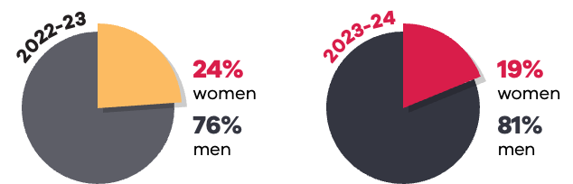
Year | Women | Men
2022-2023 | 24% | 76%
2023-2024 | 19% | 81%

Gender split of print coverage by month
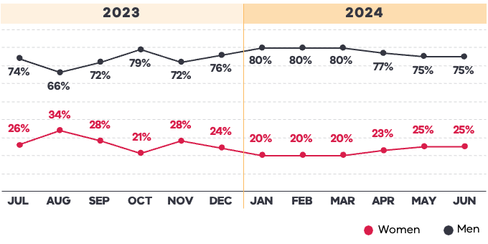
Month/Year | Women | Men
Jul 2023 | 26% | 74%
Aug 2023 | 34% | 66%
Sep 2023 | 28% | 72%
Oct 2023 | 21% | 79%
Nov 2023 | 28% | 72%
Dec 2023 | 24% | 76%
Jan 2024 | 20% | 80%
Feb 2024 | 20% | 80%
Mar 2024 | 20% | 80%
Apr 2024 | 23% | 77%
May 2024 | 25% | 75%
Jun 2024 | 25% | 75%

Print – Top 10 Media Outlets
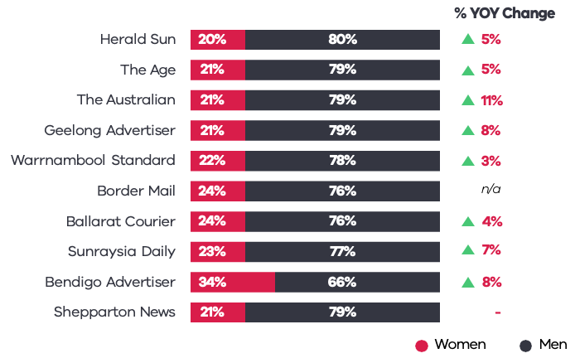
Media Outlet | Women | Men | % YOY Change | Direction
Herald Sun | 20% | 80% | 5% | Up
The Age | 21% | 79% | 5% | Up
The Australian | 21% | 79% | 11% | Up
Geelong Advertiser | 21% | 79% | 8% | Up
Warrnambool Standard | 22% | 78% | 3% | Up
Border Mail | 24% | 76% | n/a
Ballarat Courier | 24% | 76% | 4% | Up
Sunraysia Daily | 23% | 77% | 7% | Up
Bendigo Advertiser | 34% | 66% | 8% | Up
Shepparton News | 21% | 79% | –
Data for ‘Other’, including No Gender or Multiple Genders, is excluded from this data. The share of voice for print media is 26%.
% YOY Change refers to the change in balance of women’s sport coverage from 2022-23.
  - Online Media
These charts show the overall gender coverage by month and by the leading media outlets ranked by volume, for online sports news.
Gender coverage breakdown in online media
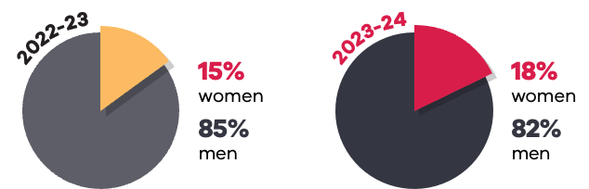
Year | Women | Men
2022-2023 | 15% | 85%
2023-2024 | 18% | 82%

Gender byline breakdown in online media
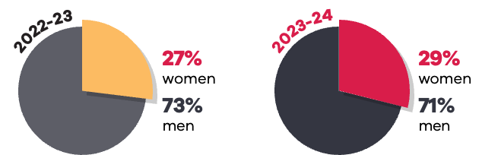
Year | Women | Men
2022-2023 | 27% | 73%
2023-2024 | 29% | 71%

Gender split of online coverage by month
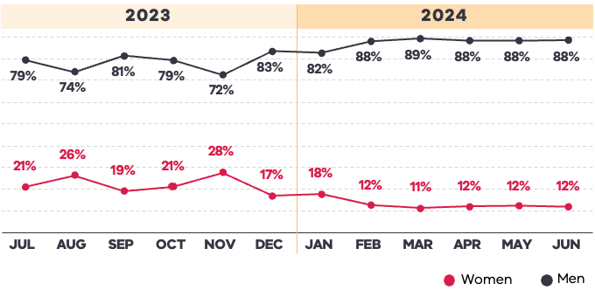
Month/Year | Women | Men
Jul 2023 | 21% | 79%
Aug 2023 | 26% | 74%
Sep 2023 | 19% | 81%
Oct 2023 | 21% | 79%
Nov 2023 | 28% | 72%
Dec 2023 | 17% | 83%
Jan 2024 | 18% | 82%
Feb 2024 | 12% | 88%
Mar 2024 | 11% | 89%
Apr 2024 | 12% | 88%
May 2024 | 12% | 88%
Jun 2024 | 12% | 88%

Online – Leading Media Outlets
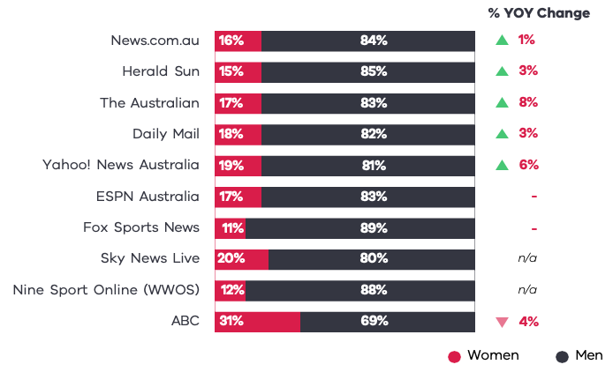
Media Outlet | Women | Men | % YOY Change | Direction
News.com.au | 16% | 84% | 1% | Up
Herald Sun | 15% | 85% | 3% | Up
The Australian | 17% | 83% | 8% | Up
Daily Mail | 18% | 82% | 3% | Up
Yahoo! News Australia | 19% | 81% | 6% | Up
ESPN Australia | 17% | 83% | -
Fox Sports News | 11% | 89% | -
Sky News Live | 20% | 80% | n/a
Nine Sport Online (WWOS) | 12% | 88% | n/a
ABC | 31% | 69% | 4% | Down
Data for ‘Other’, including No Gender or Multiple Genders, is excluded from this data. The share of voice for online media is 46%.
% YOY Change refers to the change in balance of women’s sport coverage from 2022-23.
Selection of leading online media, ranked by share of voice.

  - Radio News
These charts show the overall gender coverage, by month and by the top 10 media outlets ranked by volume, for radio sports news.
Gender coverage breakdown in radio news
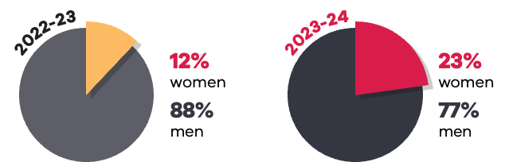
Year | Women | Men
2022-2023 | 12% | 88%
2023-2024 | 23% | 77%

Gender byline breakdown in radio news
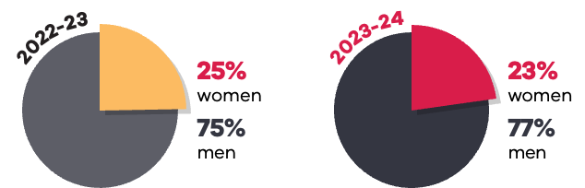
Year | Women | Men
2022-2023 | 25% | 75%
2023-2024 | 23% | 77%
Gender split of radio coverage by month
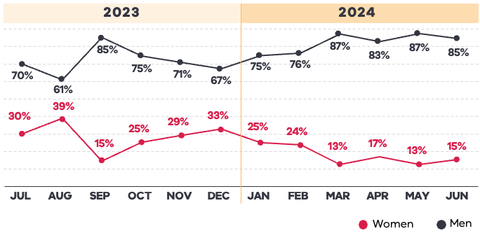
Month/Year | Women | Men
Jul 2023 | 30% | 70%
Aug 2023 | 39% | 61%
Sep 2023 | 15% | 85%
Oct 2023 | 25% | 75%
Nov 2023 | 29% | 71%
Dec 2023 | 33% | 67%
Jan 2024 | 25% | 75%
Feb 2024 | 24% | 76%
Mar 2024 | 13% | 87%
Apr 2024 | 17% | 83%
May 2024 | 13% | 87%
Jun 2024 | 15% | 85%

Radio – Top 10 Media Outlets
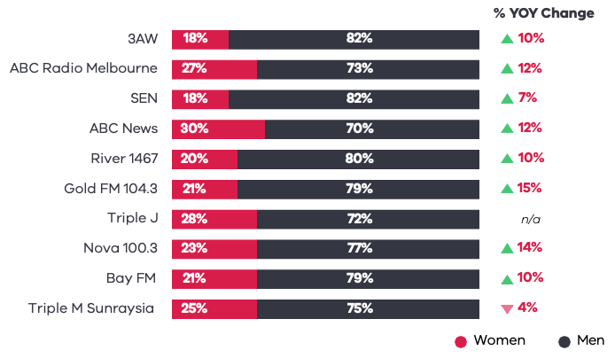
Media Outlet | Women | Men | % YOY Change | Direction
3AW | 18% | 82% | 10% | Up
ABC Radio Melbourne | 27% | 73% | 12% | Up
SEN | 18% | 82% | 7% | Up
ABC News | 30% | 70% | 12% | Up
River 1467 | 20% | 80% | 10% | Up
Gold FM 104.3 | 21% | 79% | 15% | Up
Triple J | 28% | 72% | n/a
Nova 100.3 | 23% | 77% | 14% | Up
Bay FM | 21% | 79% | 10% | Up
Triple M Sunraysia | 25% | 75% | 4% | Down

Data for ‘Other’, including No Gender or Multiple Genders, is excluded from this data.
The share of voice for radio news is 14%.
% YOY Change refers to the change in balance of women’s sport coverage from 2022-23.

  - Television News
These charts show the overall gender coverage, by month and by the top 10 media outlets ranked by volume, for television sports news.
Gender coverage breakdown in television news
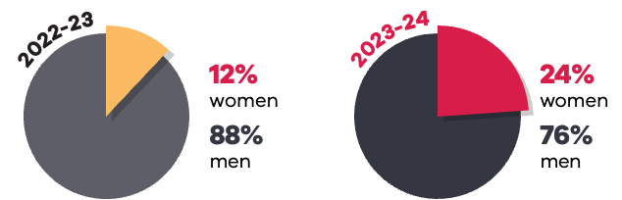
Year | Women | Men
2022-2023 | 12% | 88%
2023-2024 | 24% | 76%

Gender byline breakdown in television news
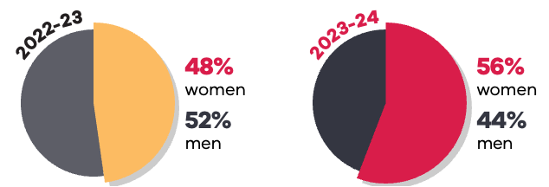
Year | Women | Men
2022-2023 | 48% | 52%
2023-2024 | 56% | 44%
Gender split of television coverage by month
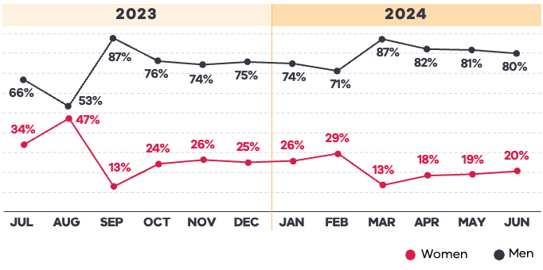
Month/Year | Women | Men
Jul 2023 | 34% | 66%
Aug 2023 | 47% | 53%
Sep 2023 | 13% | 87%
Oct 2023 | 24% | 76%
Nov 2023 | 26% | 74%
Dec 2023 | 25% | 75%
Jan 2024 | 26% | 74%
Feb 2024 | 29% | 71%
Mar 2024 | 13% | 87%
Apr 2024 | 18% | 82%
May 2024 | 19% | 81%
Jun 2024 | 20% | 80%

Television – Top 10 Media Outlets
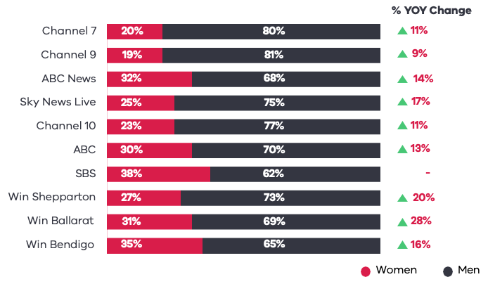
Media Outlet | Women | Men | % YOY Changes | Directions
Channel 7 | 20% | 80% | 11% | Up
Channel 9 | 19% | 81% | 9% | Up
ABC News | 32% | 68% | 14% | Up
Sky News Live | 25% | 75% | 17% | Up
Channel 10 | 23% | 77% | 11% | Up
ABC | 30% | 70% | 13% | Up
SBS | 38% | 62% | -
WIN Shepparton | 27% | 73% | 20% | Up
WIN Ballarat | 31% | 69% | 28% | Up
WIN Bendigo | 35% | 65% | 16% | Up

Data for ‘Other’, including No Gender or Multiple Genders, is excluded from this data.
The share of voice for television news is 14%.
% YOY Change refers to the change in balance of women’s sport coverage from 2022-23.

