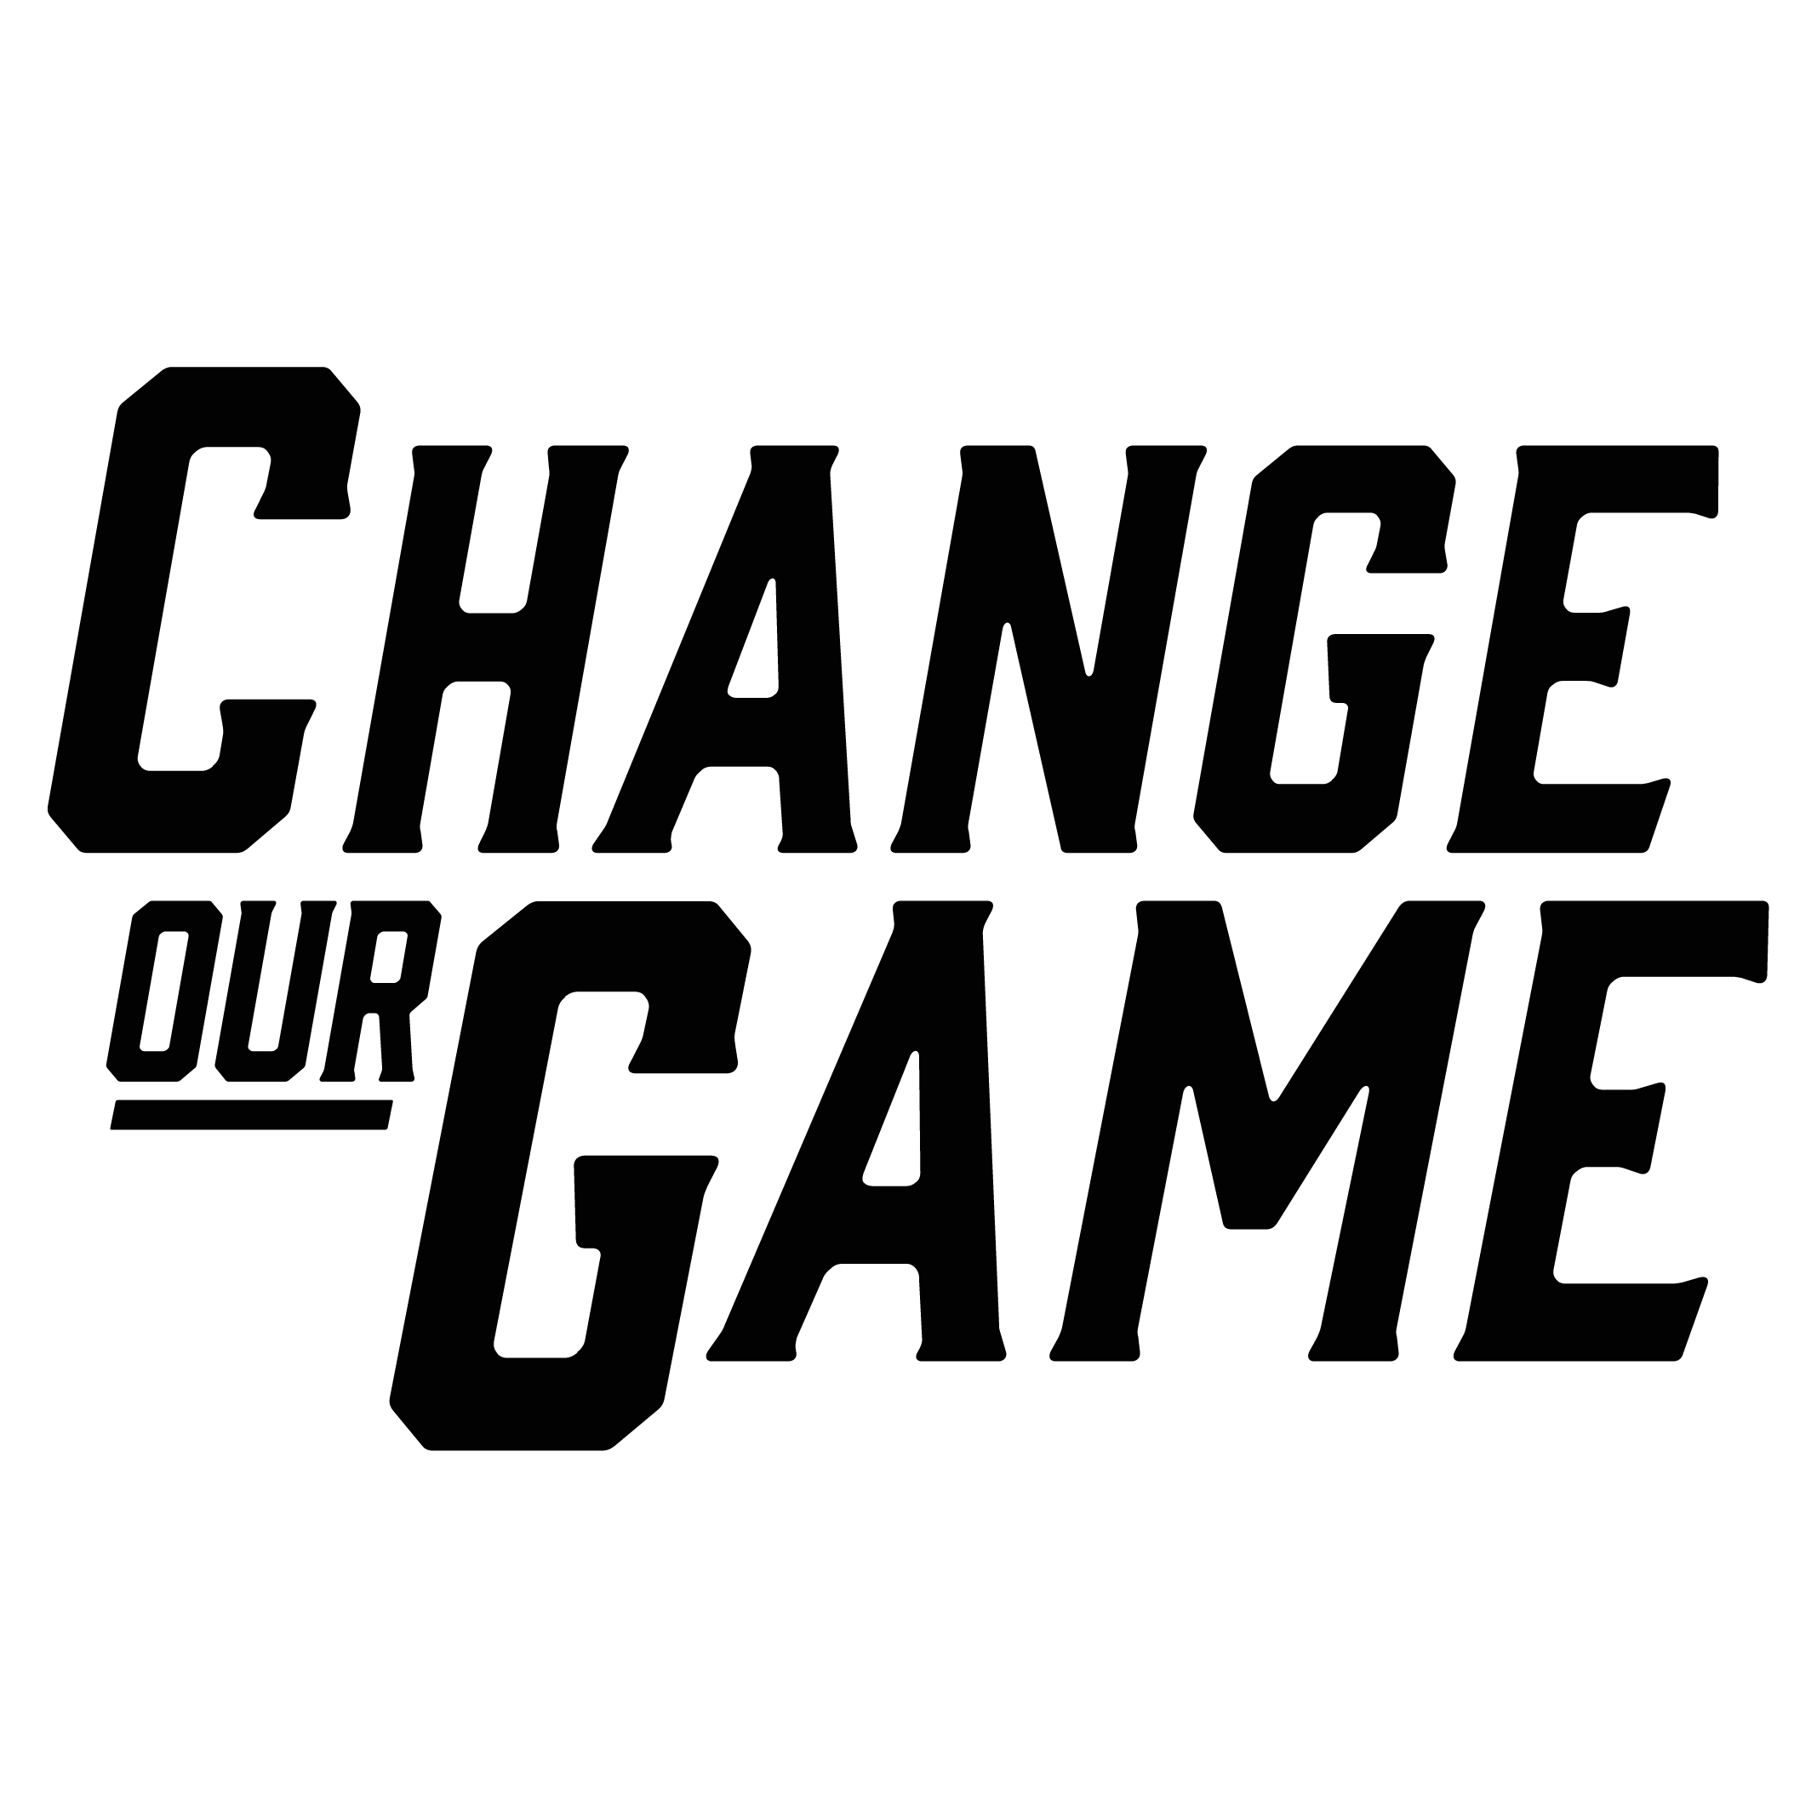

In the game: Enabling Muslim girls to play sport and be active

RESEARCH SUMMARY

Introduction
The experiences of Muslim girls and women participating in sport and physical activity are diverse, and can be influenced by a range of factors, including social, cultural, religious and economic factors.
This summary outlines key findings from research that examined barriers to participation in sport and physical activity by Muslim girls, and highlights opportunities and solutions to overcoming these barriers.
RMIT Social and Global Studies Centre undertook the research, working with families at an Islamic school located in Melbourne’s north to understand parents’ attitudes, namely mothers, and how they play a critical role in facilitating or inhibiting their daughters’ participation in sport.
The research explored the reasons and circumstances that affect parents’ decisions to facilitate their daughters’ participation in physical activity and sports. This included parental attitudes as well as broader social, cultural, religious, and economic factors that lead to these attitudes.
Importantly, the research identified opportunities and proposed practical solutions to address current barriers, which involve a collective approach and understanding with support from families, girls, schools, council and community sporting clubs.
By building greater understanding of the cultural context for Muslim girls and their families, workable solutions can be determined to address these, whilst building an inclusive and safe community sporting club.
Participant Rina on adapting the AFL uniform to suit her religious beliefs,
“I felt okay with it, it was a normal thing to me. And seeing other girls participate, wearing clothing like me, that kind of just helped me too”. She continued, “the program, it’s a multicultural thing. So, there are girls from every single background. And there were two other Muslim girls who were also wearing a scarf like me”.

Understanding barriers and parental attitudes around Muslim girls playing sport
Muslim girls face a range of barriers to participating in sport and physical activity. These can be individual, such as appropriate sporting uniform, through to social and cultural barriers, such as discrimination.
Muslim parents play an important role in their daughters’ participation, with some girls seeing parents as the barrier to their participation in sport. Parents have a range of beliefs and reasons for facilitating, enabling or inhibiting their daughters’ participation in sport and physical activity.
Below is an outline of the key barriers and challenges for Muslim girls in playing sport identified through this research:
“I can see that the community is running so many programmes, like free swimming classes, and the golf club is there, the tennis club is there. …Because we see other parents also participating, that also encourages us to participate, and the timing is suitable. Once we drop off the kids, then we can go for all these activities”.
 | Muslim mothers | Muslim girls
Social | Experiences of social exclusion, which make sport inaccessible to Muslim girls and women.  The lack of representation of Muslim women and girls in sport in general contributes to the idea that they do not belong.  Racism and discrimination experienced by some exacerbates notions of not belonging.  The hijab worn by women and girls makes them visible targets for overt and covert forms of racism and micro-aggression.
Cultural | For some parents, the dominant presence of alcohol in the sports field and at the sporting club impacted their decision to avoid those environments, including social activities.  Some parents place a priority on academic studies for their daughters over participation in sport and physical activity. Pursuing high grades to secure desirable tertiary education takes precedence over sport, which is seen as leisure, extra-curricular activity. | Lack of options or flexibility in sporting uniforms for Muslim girls, particularly in relation to wearing the hijab.  Lack of girls sport teams in the local area.  Parental attitudes were the barriers to some girls’ participation in sport.
Financial | Cost of membership, uniforms, equipment and transport were a barrier for some parents, who were left to choose between education or sport for their children.

Approaches to support Muslim girls to play sport
There are many enablers to supporting Muslim girls play sport, and working together is important to effectively address barriers to their participation.
The recommendations below form a multifaceted approach which brings together girls, families, schools, communities, council, sport clubs, and policymakers to collectively enable more Muslim girls to participate in sport and physical activity.

Muslim women and girls’ participation in sport policy and practice
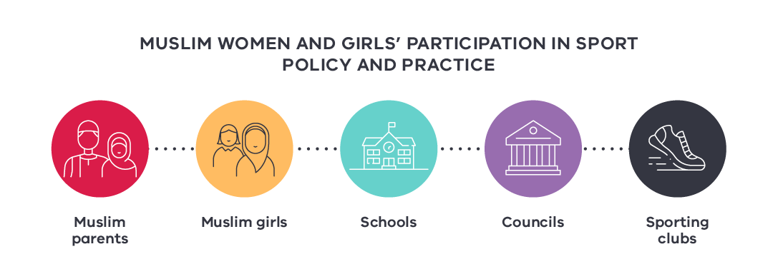

Muslim parents

Role: Enabler
Families have lived experience and can build understanding of others regarding cultural barriers and enablers to participate.

Recommendations:
Actively participate in the sporting club, either participating in sporting programs and/or taking up administrative roles within the club
Build understanding of the benefits of girls playing sport – wellbeing and academic performance
Work with clubs to share experiences and actively support positive changes by clubs to address barriers to girls’ participation, such as appropriate uniform options.

Schools

Role: Connector
Schools are culturally and socially safe places and a can be point for community connection beyond children’s education.

Recommendations:
Utilise the ‘physical, cultural and social’ safety of schools, to facilitate working together with communities, local council and local sporting clubs
Build trust with parents to build support for girls’ participation in sport
Provide education and promote participation in sport to parents to highlight that sport and physical activity contributes to better health and academic performance.
Invest time and resources in establishing a trusting relationship between the school and local council, eg. through a community engagement officer role at the school to promote participation of Muslim women and girls in sport and work directly with the sports inclusion officer at the local council.
Offer free or low-cost programs on the school grounds for girls, including those delivered by clubs.
Engage Muslim women athletes (in hijab) to visit the school to talk to young girls about the paths they have taken to engage in sport.
Promote the financial supports available for sport participation to parents, for example via the ‘Get Active Kids’ program.

Muslim girls

Role: Participant
Girls understand what motivates or inhibits them from playing sport and connecting with their peers.

Recommendations:
Support parents’ understanding of the academic and well-being benefits of playing sport.

Sporting clubs

Role: Deliverer
Clubs provide sport participation, volunteering and social connection opportunities for girls and their families.

Recommendations:
Work with parents and girls to provide flexible uniforms and develop inclusive policies, that include wearing the hijab. Including a variety of culturally appropriate uniform options that have official club logos can help create a sense of inclusion and belonging.
Work with parents to provide inclusive social activities, and foster understanding of cultural considerations, such as club social activities where alcohol is consumed.
Provide education sessions through the club, to address racism and Islamophobia and promote a safe social and cultural space for Muslim girls.
Offer ‘come and try programs’ for mothers to participate in, to address the stigma and sense of social exclusion, through engaging them to play the sport.
Connect with local schools, a safe point of connection with families and to offer free or low-cost participation programs to girls on the school grounds.
Provide work experience opportunities at the club for Muslim girls, to introduce them to roles other than as players and as an introduction to the sport industry.
Provide families with financial support, where the club can, or promote financial support options available for families who cannot afford to pay the fees and purchase the necessary equipment and appropriate sportswear for girls to play, such as via the Get Active Kids’ program.

Sporting clubs

Role: Deliverer
Clubs provide sport participation, volunteering and social connection opportunities for girls and their families.

Recommendations:
Work with parents and girls to provide flexible uniforms and develop inclusive policies, that include wearing the hijab. Including a variety of culturally appropriate uniform options that have official club logos can help create a sense of inclusion and belonging.
Work with parents to provide inclusive social activities, and foster understanding of cultural considerations, such as club social activities where alcohol is consumed.
Provide education sessions through the club, to address racism and Islamophobia and promote a safe social and cultural space for Muslim girls.
Offer ‘come and try programs’ for mothers to participate in, to address the stigma and sense of social exclusion, through engaging them to play the sport.
Connect with local schools, a safe point of connection with families and to offer free or low-cost participation programs to girls on the school grounds.
Provide work experience opportunities at the club for Muslim girls, to introduce them to roles other than as players and as an introduction to the sport industry.
Provide families with financial support, where the club can, or promote financial support options available for families who cannot afford to pay the fees and purchase the necessary equipment and appropriate sportswear for girls to play, such as via the Get Active Kids’ program.

Acknowledgements
The Victorian Government proudly acknowledges Aboriginal people as the First Peoples and Traditional Owners and custodians of the land and water on which we rely.
We acknowledge the ongoing leadership role of the Aboriginal community on gender equality and the prevention of violence against women. As First Peoples, Aboriginal Victorians are best placed to determine a culturally appropriate path to gender equality in their communities.
This is a summary of research carried out by RMIT University, In the game: Overcoming barriers and attitudes towards the physical activity outcomes of Muslim girls on the fringes of Melbourne (Boz, R, Halilovich, H; 2022). This research was funded by the Victorian Government, through the Change Our Game Research Grants Program.

