

The effects of sport uniform policy changes to girls and women
The current study expands from an initial project conducted in 2020 to identify what uniforms make adolescent girls feel comfortable and confident to play sport. Initial project findings revealed girls prefer choice of uniforms that make them feel comfortable and not overexposed; clothing that fits well and is not unisex; dark coloured pants/shorts; and uniforms made from appropriate materials. Sport uniforms were perceived as a barrier to play sport.
In the quest to identify the effects to girls and women before and after recent sport uniform policy/regulation changes, the following study was conducted.

Our case studies
Swimming Victoria actively adopted the new national swimwear policy where individuals can choose swimwear they feel comfortable in during competition. Netball Victoria actively promoted their uniform by-law to encourage Associations to change uniform regulations to enable club choice of teams to wear shorts or skirts during competition. In a similar ituation Cricket Victoria encouraged Associations to change to coloured uniform regulations.
A sample of 44 girls and women who recently changed their competition uniform as a result of the amended policy/regulations completed a survey to share their thoughts.

The effects to girls and women
The change in uniform:
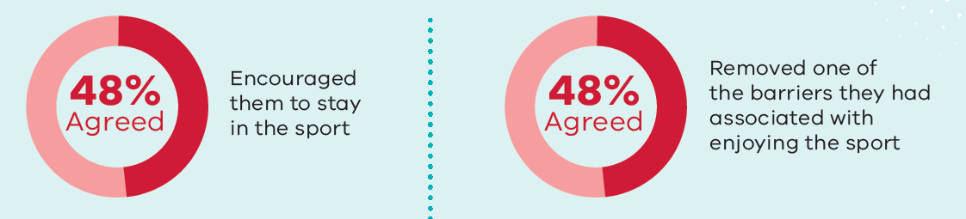
Specific feelings associated with changing their sport uniform enabled girls and women in particular to feel more confident (41% increase), happier (34% increase) and less self-conscious (30% reduction) when playing sport.
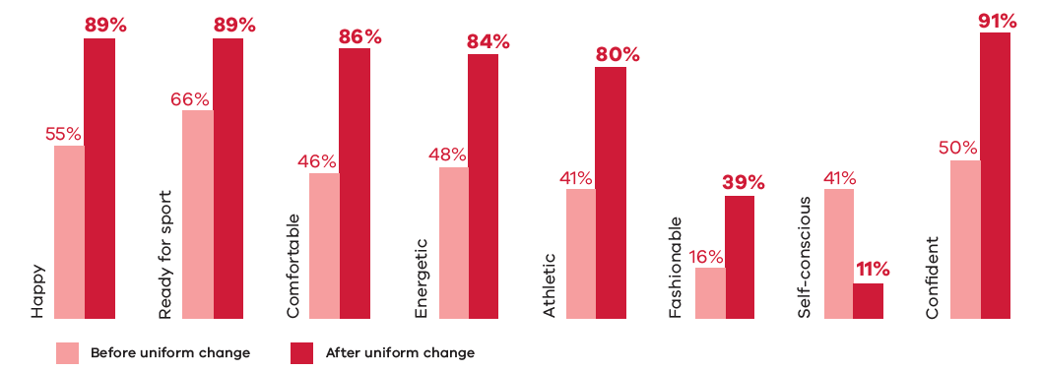
“Allowed to wear a swimsuit that covers and not have my whole body on show”
-
“We used to wear white pants for cricket which was awkward and embarrassing if you got your period. Now we can choose to wear black pants which makes me feel much better to have that choice”
-
“The inclusion of shorts is great”
This research project was supported through the Change Our Game Research Grants Program. To find out more about the Change our Game initiative and to join our community of change makers visit www.changeourgame.vic.gov.auhttp://www.changeourgame.vic.gov.au/

