
Balancing the Board: Benefits of having gender balance on state sport and active recreation boards
Research Summary

Introduction
Having gender diversity on boards of sporting organisations contributes to more effective decision making, communication, positive culture and better risk management.
A diverse representation on boards also brings an understanding of the diverse needs of its members and reflects the diversity of the Victorian community.
Prioritising gender diversity on boards means that merit-based appointments are made from the significant experience and skills of current and emerging women leaders across the state.
The Victorian Government’s Balance the Board policy aims to increase the representation of women on boards across Victoria’s sport and active recreation sector.
This summary outlines key findings from research undertaken by Deakin University, with funding from the Victorian Government’s Office for Women in Sport and Recreation, which aimed to determine the impact of the Balance the Board policy on the governance of sport and active recreation organisations.

Victoria leading the way through Balance the Board policy
Through its nation-leading Balance the Board policy, the Victorian Government has driven structural and cultural change to address barriers to gender equality across the community sport and active recreation sector.
Under Balance the Board, all recognised sport and active recreation bodies must have a minimum of 40% women directors on their board to be eligible for Sport and Recreation Victoria community sport funding.
Balance the Board responds to Recommendation 3 of the 2015 Inquiry into Women and Girls in Sport and Active Recreation, which recommended mandating a 40% minimum quota for all funded sport and active recreation organisations.
From 2017 to 2023, the proportion of sport and active recreation bodies with gender balanced boards increased from 45% to 94% across more than 100 sport and active recreation organisations.
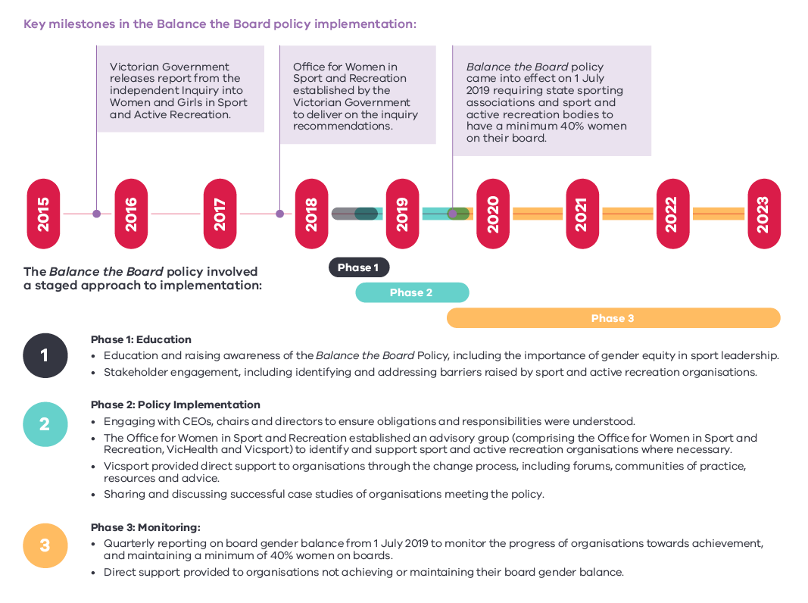
Figure 1. Timeline for implementing Balance the Board Policy in Victoria

Navigating the diversity in governance of sport and active recreation organisations in Victoria
Implementing the policy presented a range of challenges for sport and active recreation organisations.
The education and policy implementation approach had to consider the diversity across the sector in terms of organisations’ board composition, governance arrangements, organisational policies and commitment to change.
The findings from this research considered where organisations were prior to the policy implementation, the varied and diverse challenges organisations faced, the support they required and the strategies that were most effective for them in achieving a gender balanced board.
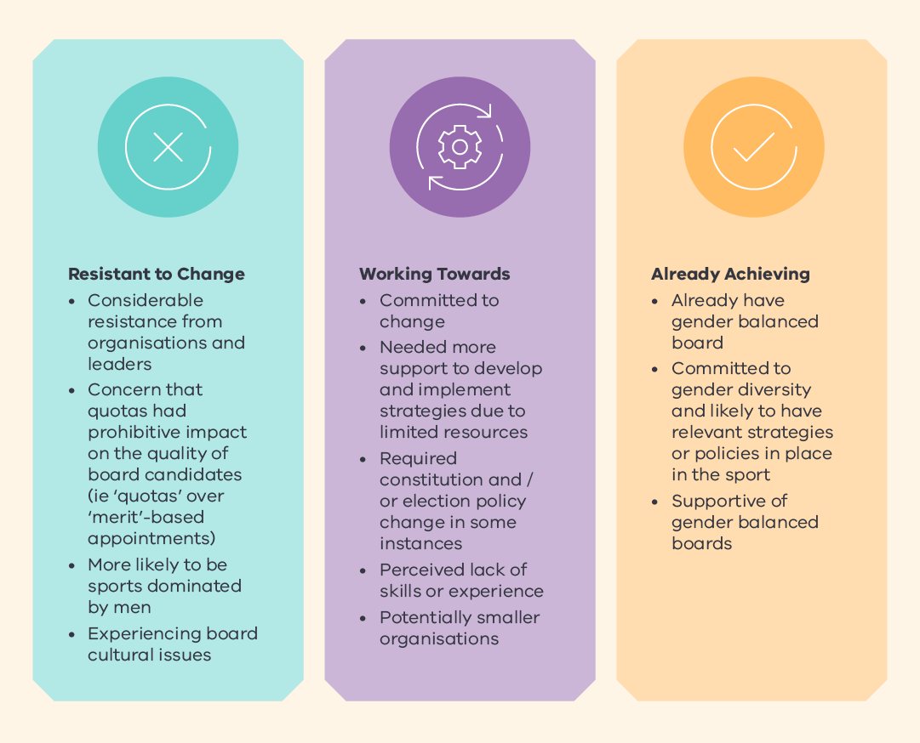
Figure 2. Sport and active recreation organisations varied in their position of having a gender diverse board

Research aims and key insights
The research aimed to determine the impact of the policy on the following areas within sport and active recreation organisations:
Process: the process organisations went through to achieve gender balanced boards, including challenges experienced and strategies employed.
Performance: the impact of increasing the proportion of women on boards on board performance.
Experiences: the impact of increasing the proportion of women on boards on directors’ experiences in boardrooms.

Key research insights

Achieving gender balance on boards:
Substantial increases in women’s board representation were achieved: From 2017 to 2023, the number of sport and active recreation bodies with gender balanced boards increased from 45% to 94% across more than 100 sport and active recreation organisations.
Achieving the target of at least 40% women on boards was a difficult process for many organisations, requiring effort and commitment: Organisations worked hard to implement strategies over time to attract and retain women on their boards, overcoming challenges and operating in resource constrained environments.
The sport and active recreation sector worked collaboratively to achieve gender balanced boards: The Office for Women in Sport and Recreation, Sport and Recreation Victoria, Vicsport, VicHealth and sport and active recreation organisations collectively contributed to achieving board gender balance, in a collaborative way.
Leaders of sport and active recreation organisations, often men, were key in driving change and supporting women’s board representation: The attitude of organisation leaders towards women’s board representation was crucial and contributed to the inclusion of women on boards, particularly by valuing the skills and abilities of women directors.

Policy outcomes:
Board processes became more professionalised in response to steps taken to attract and retain women on boards: Structured and professional recruitment strategies were used to target women, which served to provide a more professionalised approach to board processes including board operations, elections, and appointments.
Women directors brought key experience and skills to boards which enhanced board dynamics and decision-making: Women directors often bring skills including governance, strategic planning, leadership, sport knowledge, and risk management. Women directors were found to positively impact board culture and dynamics, diversity management, strategic planning, and board processes.
Having a critical mass of women on boards improved the experience of women directors: As the proportion of women on boards increased, women directors felt welcomed and valued, and more comfortable asking questions and contributing to board discussions and decisions.

Strategies to attract and retain women to boards
The research found that most sport and active recreation organisations implemented several strategies to attract and retain women on their board.

Strategies implemented by organisations
The research showed that the most common strategies used by organisations and those that were identified as most effective were:
Structured recruitment:
  - ensuring language in position descriptions was appealing to women
  - positions were advertised outside the organisations
  - a skills matrix was used to actively target women.
Constitutional reform:
  - reviewing the eligibility criteria for elected directors, including requirements for being a member and the level of sport representation achieved (thereby increasing the pool of eligible women)
  - having staggered rotations or increased appointed director numbers
  - enabling direct appointment of suitable women to boards.
Increasing opportunities for women to participate:
  - the positive effect of increasing participation for women and girls in the sport, from grassroots to elite, was seen as a long-term strategy, which would lead to a wider pool of available women for leadership roles (including coaches, committee members, volunteer roles and board director positions).
Board culture reform:
  - for organisations to reset the ideology and culture of the board, for example, establishing acceptable board behaviours (e.g. codes of conduct)
  - the Chair encouraging directors to respectfully share their views
  - professional boardroom culture through appointing directors with governance experience.
Board flexibility:
  - offering flexibility to all directors, not specifically women, including where and when the board meetings were held.
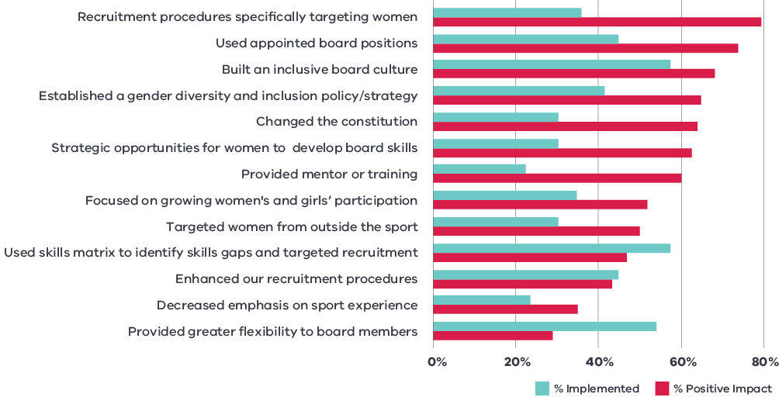
Figure 3. Strategies implemented and the impact (Survey)
Respondents to quantitative survey (n=109) of CEOs, Chairs and Directors of Victorian State Sporting Associations / State Sport and Recreation Bodies

Organisational challenges
Organisations experienced a range of challenges in recruiting and retaining women on their boards.
The most common challenges identified from organisations (CEO, chair, director) were:
Sports dominated by men: having lower representation of women as members led to having a small pool of women to fill elected director vacancies.
60% of survey respondents acknowledged that operating in sport dominated by men was a key challenge when it came to increasing women’s representation on boards.
Prohibitive constitution and / or election policies: constitution rules presented challenges to balance boards (for example, number of director positions) and volunteer sports with fewer resources needed support in making constitutional changes.
51% of survey respondents stated board training and accreditation requirements were prohibitive and 20% stated constitution and / or election processes were prohibitive.
Perceived lack of skills or experience: women discounted their skills and felt underqualified to fill director roles and there was a lack of awareness of women’s transferable skills.
26% of survey respondents indicated that a lack of skills or experience (real or perceived) amongst women directors was a challenge for their organisation.
Lack of time to commit to a board role: perception that the workload and time commitment of a director position was excessive or burdensome, prohibited women applying, in particular young women with family, work and / or sport commitments.
72% of survey respondents stated the perceived workload and time commitment associated with a board director role was a challenge in achieving gender balance.
Board cultural issues and resistance to change: sports with traditional attitudes, resistance to diversity and were considered unwelcoming to women faced challenges in making changes
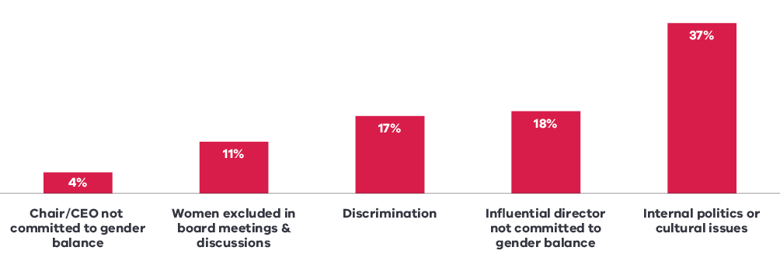
Figure 4. Challenges organisations faced in balancing the board related to inclusion (Survey)
Respondents to quantitative survey (n=109) of CEOs, Chairs and Directors of Victorian State Sporting Associations / State Sport and Recreation Bodies

Perception of inclusion by women
Women’s experiences of inclusion were challenged at times in some organisations by internal politics or cultural issues of organisations. In addition, women experienced more regular and consistent questioning about their ‘merit’ (i.e. skills, abilities, qualifications, knowledge and suitability) compared with men.
Most women experienced feeling welcome and valued on boards, which was supported through having a critical mass of women on boards and CEOs and board chairs that fostered environments where women felt comfortable to ask questions and contribute to board discussions and decisions.

Role of men in providing an inclusive environment
Women’s perception of their inclusion on boards was lower to that of men’s perceptions of women’s inclusion.
69% of women directors indicated that women’s voices were heard on their board to a great extent (compared to 81% of men).
Men recognised women directors were valued for their skills and abilities and the importance for women directors to impact all aspects of the business.
Some men recognised the importance of allyship and their responsibility to be supportive and inclusive of women on boards.

Impact of the policy on organisation governance
Findings from the research indicated a range of impacts to the governance of sport and active recreation organisations.

Perceptions of the policy
Many organisations recognised that the government mandated quotas for boards approach was needed to bring about meaningful change across the sector. This included making gender balanced boards a priority and establishing a clear minimum requirement for the number of women on boards.
Having the policy being driven from state government, rather than at the organisational level, did support organisations:
in their approach to communicating with their members the rationale for change
to focus on how they would implement changes to their governance; and
to attract more women on their board in a shorter timeframe than what may have been achieved otherwise.
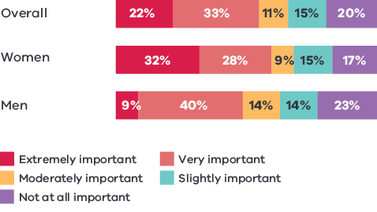
Figure 5. Importance of the policy for driving women’s leadership on your board
80% of survey respondents indicated the Policy was important in driving women’s leadership on their sporting boards (55% saw it as extremely or very important).
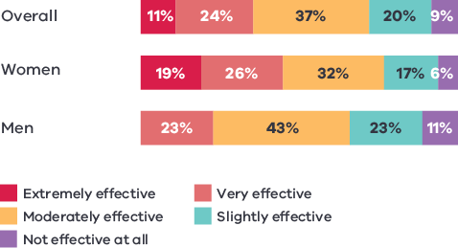
Figure 6. Effectiveness of the policy for driving women’s leadership in Victorian sport and active recreation
81% of survey respondents indicated the Policy had been effective in driving women’s leadership in the Victorian sport and active recreation sector (45% of women saw it as extremely or very effective, compared to 23% of men).
Respondents to quantitative survey (n=109) of CEOs, Chairs and Directors of Victorian State Sporting Associations / State Sport and Recreation Bodies

Board performance
The increased proportion of women on boards was shown to positively contribute to:
Board performance: positively impacting the effectiveness of a board of directors in executing its roles and responsibilities.
Board dynamics: positively impacting board culture and dynamics; a substantially higher proportion of women (71%) reported that the presence of more women on the board positively impacted board culture and dynamics, when compared with men (45%). Further research findings indicated improved communication between directors and a more respectful boardroom climate.
Board decision making: facilitating effective decision making, through greater representation of women’s unique perspectives, and a more methodical, considered, formalised approach to decision making.
57% of women survey respondents reported possessing board and governance skills compared with 37% of men.

Board functions
Gender diversity on boards contributed to boards performing their core functions more effectively, including:
Risk management: women have led boards to pause and assess potential outcomes to a greater extent before making decisions and also focusing on risk assessments.
Risk management was a key skill reported by 40% of women survey respondents, compared to 14% of men.
Strategic planning and policy making: women have brought attention to strategic planning processes, and have elevated child safety and diversity issues as strategic priorities for organisations.
Survey respondents indicated more balanced boards enhanced strategic planning (31%) and enhanced policy and regulation management outcomes (27%)
Communication and stakeholder engagement: women have assisted organisations to take a more empathic and thoughtful approach to communication, including considering how messages were delivered, particularly when sensitive matters were involved.
CEO supervision: women on boards were perceived to bring a calming, compassionate and considered influence on CEO performance management, creating an environment that supports CEO performance.
Respondents to quantitative survey (n=109) of CEOs, Chairs and Directors of Victorian State Sporting Associations / State Sport and Recreation Bodies

Recommendations: for sport and active recreation organisations and boards
The research identified a range of strategies organisations can consider to support gender diversity on its board.

Consider strategies to recruit and retain women to boards
Engage in structured recruitment processes: skills matrix, position description with inclusive language, formal advertising of positions internally and externally
Use appointed positions to target relevant women candidates
Make necessary constitutional changes to support gender balance
Establish a gender diversity and inclusion policy / strategy
Increase opportunities for women to participate and engage at various levels of the sport to build a pipeline of potential future leaders
Build an inclusive board culture
Provide flexibility to board members.

Adopt approaches which reflect where your organisation is on its journey

All organisations can implement changes to support gender diversity

Considering taking action to balance your board
Connect with other organisations that have recently increased the proportion of women on their boards and hear about their experiences
Seek support from Vicsport or the Office for Women in Sport and Recreation to receive tailored support to suit your needs
Review your constitution; make relevant changes to reduce barriers to recruiting women
Use skills matrix to identify board skills gaps and guide targeted recruitment
Use appointed board positions to recruit new women to your board

Maintaining 40% women on your board
Continue to target women in recruitment efforts: look both within and outside of your sport for potential candidates
Provide opportunities for women in your sport to develop board skills
Increase opportunities for women to participate and engage in the sport
Provide flexibility to all board members
Build / maintain an inclusive board culture

Beyond balanced boards
Consider new opportunities for gender balance in the sport, including:
Greater representation of women at the executive level in your organisation
Target other aspects of diversity on your board (including intersectionality)
Review and set targets for gender diversity within club / association committees
Develop gender diversity and inclusion action plans to support women and girls in your sport

Create an inclusive environment for women on boards
The chair taking steps to foster respectful communications between board members
Having in place and enforcing a board code of conduct or charter that determines acceptable standards of conduct and behaviour
Having a critical mass of women on the board (40%) to improve the experience of women and ensure women do not feel marginalised or excluded in board meetings and discussions
Board recruitment being based on the skills required for the board (using a skills matrix), and women candidates are recognised for the skills they bring, rather than their gender
Men in leadership positions are encouraged to recognise the powerful role they can play in supporting gender diversity within sport.

Reflections for governments

Streamline communication and support to organisations regarding the policy
The research identified the importance of having clear communication regarding the Balance the Board policy and its approach to implementation. This included consistent information provided to organisation through key sector partners in Vicsport, VicHealth and the Office for Women in Sport and Recreation, which included key timelines and application of the policy in sport and active recreation organisations eligibility for funding.
Providing a range of education, information and practical support for sport and active recreation organisations was important to reflect the diversity of organisations in their approach to working towards a gender balanced board.
Key approaches in the education phase of the policy implementation included:
running education forums and communities of practice to support organisations
developing supporting resources for organisations to work through the change process
providing tailored advice, support and strategies to organisations
specific focus on constitutional change, board skills audits, and director recruitment procedures to encourage women to apply.
The research indicated that organisations would have benefited from more developed resources available across the sector (such as board position advertisement, guides on gender inclusive language, strategies for attracting more women on boards) and a clearer plan for sector communication and education prior to the Balance the Board policy being announced.

Monitor progress towards and achievement of the policy
The research identified that monitoring the progress of sport and active recreation organisations, both individually and across the sector, in working towards the minimum 40% women on boards requirement was critical to the ongoing success of the policy.
The monitoring enabled organisations to be held to account for making progress towards a gender balanced board, and in identifying those organisations who required targeted support to achieve or maintain that balance.

Acknowledgements
The Victorian Government proudly acknowledges Aboriginal people as the First Peoples and Traditional Owners and custodians of the land and water on which we rely. We acknowledge the ongoing leadership role of the Aboriginal community on gender equality and the prevention of violence against women. As First Peoples, Aboriginal Victorians are best placed to determine a culturally appropriate path to gender equality in their communities.
This is a summary of research conducted by Deakin University, Balance the Board (Phillips, P., Rowe, K., Reddan, S., McLeod, J., Raw, K., Swanson, S; 2023).
This research was funded by the Victorian Government, through the Change Our Game Research Grants Program.

