Does lighting outdoor sports facilities help the general public to be more active?
  - Phase 1: Knowledge Review
Prepared for Sport and Recreation Victoria
May-June 2025
Prepared for:

Kate Stewart
Sport and Recreation Victoria
E kate.stewart@ecodev.vic.gov.au

Marianne Mateer
Sport and Recreation Victoria
E marianne.x.mateer@sport.vic.gov.au

Prepared by:

Raluca Petrut
Director, Research
E raluca.petrut@secnewgate.com.au

Cat Banks
Senior Director
E cat.banks@secnewgate.com.au

Leanne Lim
Senior Research Executive
E leanne.lim@secnewgate.com.au

DISCLAIMER In preparing this report we have presented and interpreted information that we believe to be relevant for completing the agreed task in a professional manner. It is important to understand that we have sought to ensure the accuracy of all the information incorporated into this report. Where we have made assumptions as a part of interpreting the data in this report, we have sought to make those assumptions clear. Similarly, we have sought to make clear where we are expressing our professional opinion rather than reporting findings. Please ensure that you take these assumptions into account when using this report as the basis for any decision-making. The qualitative research findings included throughout this report should not be considered statistically representative and cannot be extrapolated to the general population. This project was conducted in accordance with AS: ISO2025:2019 guidelines, to which SEC Newgate Research is accredited. This document is commercial-in-confidence; the recipient agrees to hold all information presented within as confidential and agrees not to use or disclose, or allow the use or disclosure of the said information to unauthorised parties, directly or indirectly, without prior written consent. Our methodology is copyright to SEC Newgate Research 2025.

Objectives and Approach

Background
Previous research conducted by SEC Newgate and Sport and Recreation Victoria (SRV) found that barriers to physical activity amongst Get Active Victoria’s target population (inactive women aged 35-65 who would like to be more active) include a lack of time around work, childcare and/or other responsibilities. While this group may have more time to be active in the evening and early morning, barriers to doing so include feeling unsafe in dark and/or empty outdoor areas.
Some research participants felt that lighting would help improve the accessibility of venues such as outdoor sports facilities to enable them to be active after dark. However, there are numerous other factors (such as motivation) which also come into play when deciding if, when and how to be active, which must also be taken into consideration.

Objectives
The key objective of this knowledge review is to understand what current evidence exists as to the impact lighting of outdoor sports facilities has on active recreation levels amongst the general community (i.e. aside from those using the facilities for organised team sports).
In conducting the review, we sought to test two contrasting hypotheses:
- That the community would use these facilities more if they were well-lit in the evening/early morning; or
- That lighting of outdoor sports facilities does not impact use amongst the general community.

Approach
We took two approaches to gathering information:
    - Literature review. A desktop review of seven publicly available reports and articles was undertaken to explore existing knowledge about the impact of sports facilities lighting on active recreation levels amongst the general community. The full list of documents reviewed can be found in the Appendix. We note that a fairly extensive online search was conducted but evidence from literature is limited, and what currently exists doesn’t necessarily focus on sporting facilities specifically, but rather on outdoor spaces more generally.
Search parameters were agreed with SRV prior to the research commencing. Research from Australia was the key focus, though we also looked for reports from other jurisdictions including China, the UK, the US, Canada and Singapore. We looked at reports published from 2000 onwards and written in English, and used Google Scholar to source these reports.
    - Council interviews. SRV identified three councils that had piloted or implemented night lighting at sports facilities in their respective local government areas during the darker months: Greater Bendigo City Council, Maroondah City Council, and Wyndham City Council. SEC Newgate conducted interviews with representatives from each of these councils via videoconference. Interviews lasted 45 to 60 minutes, and councils also shared some visuals, promotional materials and – in one case – an evaluation of their trial.

Four Key Insights from the Knowledge Review
In a nutshell, the review indicates that lack of lighting is a key barrier to exercising at night – but one which can be overcome

    - The literature review found that lighting is a key barrier to exercising at night, but yielded little information on whether lighting of sports facilities has actually been shown to lead to increased usage by the general community for physical activity. We expanded the scope of the literature review to physical activity in outdoor spaces more generally, focussing on findings that may have particular relevance to the purposes and parameters of this research.
    - The council interviews reflected some findings from the literature review, but also added specific information relevant to the impact of lighting facilities at night in Victoria on their usage. The experience of these councils suggests that the barrier can be overcome by a combination of lighting, lighting design and choosing to light those sports facilities that are well-activated during the day, with easy access to public transport, ample parking and additional facilities.
    - Findings are general, and research with Get Active Victoria’s target audience is lacking.

Insight 1
Lighting sports facilities is seen to be a critical part of encouraging physical activity.

Insight 2
Current usage of sports facilities in Australia amongst women and gender-diverse people is low.

Insight 3
Other factors that impact outdoor physical activity include elements within the general environment, access to other facilities, foot traffic, and a sense of belonging.

Insight 4
All three councils considered their respective programs successful and have continued (or expanded) offering these programs.

Key Insights In Detail

Insight 1: Lighting sports facilities is seen to be a critical part of encouraging physical activity. Safety is a pre-requisite to exercising outdoors in the dark, with lighting the most influential factor in perceptions of safety. Lighting design is an important consideration and influence on safety.
Physical activity behaviour shifts across seasons amongst those who are active for recreational purposes (e.g. runners, dog walkers). In warmer months they are typically active at dawn and dusk. In winter, this behaviour changes with people sometimes simply not being active at all due to a perception that it is unsafe to be out in the dark¹.
Research amongst night-time exercisers in China found that physical environment plays a decisive role in outdoor night-time physical activity, with up to 90% of participants citing lighting conditions of the location as being the main factor influencing exercising at night².
There are gender differences when it comes to lighting preferences, with men preferring strong levels of illumination to meet the demands of sports (e.g. basketball), and women preferring lights and light fixtures that offer the most coverage and visibility of their activity paths². Generally however, insufficient lighting is seen to make preferred activity locations unsuitable for exercising at night² , but lighting which is too intrusive can also be an issue.
"I feel that the brightness of the lights at the exercise location greatly affects me. […] I clearly noticed that when the lighting is good on Fridays, I walk twice as long.“².
"Previously, I walked under a bridge, circling around the nearby street park. There was a stretch where ground lights would shine directly into my eyes, which was very uncomfortable. I really dislike walking that segment, but I can't avoid it"².
Similarly, research amongst Western Australian adolescents found that parks with lighting around courts and fitness equipment are six times more likely to be ‘high use’ for physical activity rather than ‘low use’, though it does not specify whether this is only for organised sport or also for general physical activity³.
Naturally, safety tends to be a top-of-mind concern when it comes to exercising in public spaces and/or outdoors, and there is plenty of research that points to poor lighting being a barrier for outdoor physical activity due to safety concerns. These concerns are heightened at dawn/dusk and after dark periods, and amongst women^{1, 2, 4}.
In the data collected by YourGround (2021) ¹, poor lighting was the main reason (58% of all ‘unsafe’ pins) why outdoor spaces in Victoria were marked as ‘unsafe’ for physical activity. While this mainly referred to a lack of lighting infrastructure, it also included poor maintenance of existing lights, inconvenient time
controls (e.g. being dependent on organised sports), and poorly designed lighting systems (too bright or spaced too far apart). At parks, lighting was considered one of the most important factors for physical activity compared to other factors such as amenities, maintenance, and landscaping. Participants also considered lighting very important at sports facilities. For some, if lights were only activated during organised sports, it meant safety was not guaranteed at other times. It also meant that safety was not guaranteed further away from the lights.
A survey⁴ completed by over 4,850 NSW residents showed that most women do not feel safe in public areas (which included outdoor playing fields and courts and public sports facilities) after dark, that lighting is the most important factor influencing the routes people choose to take in public spaces, and that increasing feelings of safety in public areas would result in people being more likely to walk more and go out after dark more.
Nearly half of the places that were specifically tagged as ‘safe’ for outdoor physical activity were only considered safe during daylight hours, with participants stating they would not access them after dark. Lighting was a reason provided for 47% of ‘safe’ pins in Victoria, and a reason for spaces being considered safe at any time¹.

Insight 2: Current recreational usage of sports facilities in Australia amongst women and gender-diverse people is low.
Research indicates that usage of outdoor sports facilities for physical activity amongst women and gender-diverse people in the general community is relatively low (at any time of day). Research by YourGround (2021, 2024) in Victoria¹ and NSW⁷ used online spatial surveys and crowdsourcing to map the outdoor spaces where women and gender-diverse people exercise and their perceptions of safety of these places, through dropping ‘pins’ in public spaces they were exercising at to indicate whether they felt safe or unsafe.
The data collected indicates that sports facilities do not appear to be well-frequented by women and gender-diverse people for recreational physical activity, as demonstrated by far fewer pins placed in these areas compared to those placed at parks or on main streets. For example, of all the different open space subcategory locations in NSW, parks received 46 safe pins and 97 unsafe pins, and sports fields or courts only received 4 safe pins and 3 unsafe pins, suggesting that women and gender-diverse people do not use sports fields or facilities for physical activity often.
However, some other research in WA and Melbourne found that parks that also have sports courts (including multi-sports, volley and basketball) may increase visitor counts and engagement in physical activity^{5,6}.
Overall, it appears that women and gender-diverse people do not seem to be using these spaces for physical activity much compared to parks and main streets, but the evidence does not tell us why. It could be that they simply do not consider these facilities as places they could use, or that they avoid them for other reasons.

Insight 3: Other factors that impact outdoor physical activity include elements within the general environment, access to other facilities, foot traffic, and a sense of belonging.
While there is limited research on factors influencing the use of outdoor sports facilities by the general community, research shows that several environmental elements help attract people to outdoor areas more generally. This includes green spaces, a well-maintained space, and the presence of other facilities.
For adolescents, high park use for physical activity was associated with six other features: presence of a skate park, walking paths, barbecues, picnic table, toilets, lighting around courts and fitness equipment, and presence of over 25 trees. We note that many of these (presence of a skate park, walking paths, and lighting around courts and fitness equipment) provide further opportunities for physical activities^{1, 2}.
Having well-designed outdoor spaces that draw other people in is important. When others use outdoor spaces it increases participants’ sense of safety through positive passive surveillance and having people around to help in case of emergency^{1, 2,4}.
Sense of belonging can play a critical role in physical activity and has been demonstrated to directly influence emotional engagement and involvement with activity environments ². It was also noted by one Council that perception of ownership of sports facilities may be a likely barrier to using such spaces (see p.9 of this report). Su et al., (2024) found that young men prefer to be active in areas where their peers are also present/active whereas older women prefer to be active within their own neighbourhoods as this allows them to be alongside neighbours/acquaintances and enhances their sense of security and belonging. This suggests that implementing lighting at outdoor sports facilities may have a greater impact on physical activity levels of younger men unless other steps are also taken to encourage women (particularly those who are older) to these venues.

Insight 4: All three councils considered their respective programs successful and have continued (or expanded) offering these programs.
    - All councils had noted more people using the facilities at night for general physical activity – one council (Bendigo) has also conducted a more formal evaluation of this
    - No council had received any complaints from sports clubs or local residents
    - Promotion was felt to be a key part of success
Detailed findings overall and per council can be found on the following pages.

“In the absence of this program, none of those groups would be able to go out and play because they don’t have a booking. This is a more welcome and inclusive way to provide that access because they know it’s for community use, they don’t feel like they’re jumping on the back of club activity.”

“Primarily the cost has really just been through the promotion, but if you do a value per dollar of what we used for the campaign vs. the number of people using it, then I would consider it very successful and over time that will only continue because word will continue to spread. I feel it absolutely does what we are wanting to achieve – offering a space that is safe for that age group and for women.”

“There are people on it every night. It is supporting people that are walking, dog walkers, people socialising, jogging and running, and some receiving personal training.”

Key Findings from the Council Interviews: In Detail
Key advice and learnings from across the interviews are:
    - Facilities need to be easy to access in a range of ways – e.g. located in residential areas, have parking or public transport nearby, have flat paths for prams or wheelchair users. One council had previously promoted extended lighting at a sports oval, but uptake was much lower due to paths being uneven and the pilot was stopped after a year. The finding is supported by Su et al., (2024) noting convenience influences night-time physical activity behaviour.
    - Lighting spaces that are already well-activated and used throughout the week would be more effective in encouraging physical activity at these locations at night. Visible use during the day increases perceptions of safety and willingness to use after dark when lighting is present. Similarly, outdoor sports areas with additional amenities and facilities (e.g. outdoor fitness equipment, multiple types of courts) are also considered more attractive.
    - Promotion of the hours/program is important to increase awareness and usage of the facilities during the hours offered. This includes investing in proper graphic design, postcards, using social media, and making promotional materials look professional. There was a recommendation that prior to rolling out promotional materials, an area scan of the catchment should be done to understand the diversity of the community and design materials that would promote and encourage use amongst that audience (e.g. CALD communities). One council found that users tend to be those who live nearby (59% of users surveyed lived within 2km of the sports facility).
    - One council noted that perception of ownership (the extent to which people feel they are allowed to use them) is a likely barrier to using the facilities. This council stressed the importance of showing everyone that they are welcome and that it is a space to share. This is supported by findings from Su et al., (2024) demonstrating that sense of belonging is an influencing factor of night-time exercise behaviour.
    - Sports facilities tend to be used within a 2-3 hour window after dark. As a result, councils deemed that an expansion of the program to more sites (or more days) rather than extending the hours at existing sites would provide greater value. There is currently little to no demand for morning usage.
Details of each Council’s winter lighting project are presented over the following pages.

Council interviews – Maroondah City Council

Context
- Aim and target audience: To promote walking at night at Croydon Town Park, primarily amongst women aged 30-60 years old
- Sports facility: An athletics track with a usable pitch in the middle, typically used by various sporting clubs. The public is able to use it if a sports club hasn’t booked it (typically during the day but some pockets at night). This was chosen because it was a well-lit space, close to parking, well activated (i.e. lots of people using the space), had good sight lines (no nearby trees), and a wide walking path. Close to Croydon station, bus stops, and has lots of parking options.
- Date of project: 2021 - present
- How project started: Two main prompts: (1) People not having much opportunity to be active during COVID; the athletics track was a place that was outdoors, allowed people to social distance, and was well lit and flat so accessible to many. (2) Research from Council’s physical activity strategy and speaking to people in Maroondah about reasons they were/weren’t exercising, as well as data through the Get Active Victoria campaign, showing that 30-60 year old women are the least physically active due to reduced opportunities, primarily lack of time, not being able to be active until later in the day, and not feeling safe to do so in the dark.

How it works
- Operational logistics: Currently runs once a week for 3 hours (Thursday evening from 5.30 – 8.30PM). NB This lighting project wasn’t a new program / didn’t add new hours or times the sports facility was available to the public at night. Rather, sports clubs would book the track during winter and Council would promote these already-lit night-time hours. Lights can be turned on and off at the track but also remotely through a computer program, which a Council employee is responsible for. Has not required lighting of other aspects in addition to the facility (e.g. parking, nearby streets).
- Funding: Funded by operational budgets – costs are minimal because promoted hours are those where the lights are already on and being used. Costs are more for promotion of these hours.
- Promotion: Primarily through social media, but also through postcard drops in the local area and at leisure facilities, digital screens at leisure facilities, and promotion at active events.

Outcomes
- Impact and evaluation: This program has achieved what Council intended it to – to offer a space that is safe and suitable for the target audience of women aged 30-60 years old. It has been able to do this with minimal impact to costs by utilising times lights are already on. Visual checks show that approximately 20-30 people use the athletics track on these nights. There have been no complaints or issues amongst the community or from sports clubs.
- Continuation / expansion of project: The project has run from 2021, and Council is looking at implementing it at another sports facility in the area, pending installation of lighting that can be turned on/off remotely. If in the future there wasn’t already a booking and a night was available for the public to use, Council would be happy to turn the lights on for that time period in order to continue the program (and did this during COVID when there were no sports clubs using it).

Council interviews – Wyndham City Council

Context
- Aim and target audience: To provide a space for residents who want to play sports in a less formal setting/environment, e.g. socially/on an ad-hoc basis rather than as part of an organised sports club, particularly for people who might face cost barriers to participation (generally younger people aged 15-25 years old).
- Sports facilities: The program is rolled out across six facilities. The facilities comprise a range of grounds including soccer pitches, cricket ovals, and multi-use synthetic fields. All are in residential areas, are walkable within a certain catchment, and have car parks.
- Date of project: 2018 - present
- How project started: Council knew that this was something the community wanted: through feedback directly from social groups that they wanted a space they could play in after dark; from cancelled booking requests from groups once they found out the cost of lighting; and from feedback form clubs about people from the community using the field while they were using it.

How it works
- Operational logistics: Currently runs for one or two nights a week, generally for around 2 hours. The dates and times are planned around existing sports club bookings for winter. Council will look at the gaps and try to get a spread of hours across the week so people can go to different reserves on different nights, across different suburbs. The hours promoted are purely for community use, there are no organised sports activities happening at this time. Lights are on an automatic timer; they would need to check settings/reset if there are power outages. No additional lighting has been required (e.g. parking, nearby streets).
- Funding: The Council subsidises the lighting costs. If a sports club is paying the overall bill for the lights, the cost of the lights for the hours of the program will be calculated and the sports club will be reimbursed for that.
- Promotion: Promoted through the council website, a series of Facebook posts that gets boosted at the start of each year, signage at venues with the times, and newsletters.

Outcomes
- Impact and evaluation: Council considers this program successful as it provides an avenue for people that wouldn't otherwise be able to participate and has been well received by the community. They have seen good numbers using and sharing the facilities, and have not had complaints from residents about lights being on and no one using the field. They have also not had pushback from sports clubs as they are not dictating when clubs can train, and have invested in new lighting in some spaces on condition the community can use it too.
- Continuation / expansion of project: The project has run from 2018 and now includes six sports facilities. If there was feedback that too many people were using the facility, Council would be open to offering this program at another facility in the vicinity.

Council interviews – Greater Bendigo City Council

Context
- Aim and target audience: To support local residents, particularly women, in being more active at a time convenient to them.
- Sports facility: A junior-sized oval typically used for organised sports, with a synthetic walking and jogging track on its perimeter, situated in Ewing Park. The park sits in an urban environment with a walking and cycling trail, and multiple sports facilities (cricket, basketball half court with netball net, rebound wall with tennis, football, netball and cricket markings, skate park, and fitness equipment); multi-sport is part of the intention and attraction of the site. Parking is available and the bus stop is nearby. Previously, it wasn’t generally used for anything other than organised sport and sometimes by dog-walkers.
- Date of project: 2021 - present
- How project started: The 2019 Active Living Census showed that the largest barrier to being physically active for many local residents was being time poor, with women’s participation during dark hours in winter lower due to not feeling safe. Council had also heavily invested in redeveloping the park environment and infrastructure and as part of this ran an activation program to encourage use, which included the after dark lighting project in which oval lights were turned on in the evening from June to September.

How it works
- Operational logistics: Currently runs every day of the week from April to September from 5.30 – 8PM. Junior sports clubs have scheduled use of the oval some nights of the week, during which time the community can only use the surrounding track. A benefit of this site is that no senior clubs use it during winter, and junior sports club usage concludes by 5:30pm or 6:30pm depending on the night of the week. The City also considers that using sites that have a senior men’s sporting club (winter sport) onsite is a strong barrier to women and gender-diverse people using the space.
- Lights run on an automatic timer. Lighting used to start slightly later in the evening but was brought forward so people could come right after work – as going home first might mean people don’t end up coming back out again. Has not required lighting of other aspects in addition to the facility (e.g. parking, nearby streets), and spill light from the oval is enough to light the fitness equipment and half-court basketball court. The YMCA and leisure centre also holds a six-week group fitness program using the fitness equipment at this park once a week between July and August, during the extended lighting hours.
- Funding: Council covers the cost of the power, spending approximately $800 for the winter.
- Promotion: Through social media posts, information through the local community, quarterly magazine that goes to every household, and an article in the paper.

Outcomes
- Impact and evaluation: This program has achieved its objectives of supporting residents in being more active after dark.
- From the outset, observationally, both the track and the oval have been used for physical activity amongst the community.
- A formal evaluation⁸ of the lighting trial (a combination of an online survey and observational data) was conducted in June-Sept 2021, and concluded that “The Ewing Park Oval Activation Pilot was successful in meeting its objective of increasing community members’ use of lit areas of Ewing Park after dark from April to September”. Council has shared this report with Sport and Recreation Victoria and the other participating councils. In summary, the evaluation showed:
  - People used the facility who otherwise would not have done so.
  - Most use was amongst younger men (25-34 years old) and women (35-49 years old).
  - They felt the lighting provided them with an opportunity to exercise outdoors after dark which did not otherwise exist; they also reported an increase in feelings of safety and wellbeing
  - This usage then continued into the summer months of 2021.
  - Cost per user for Council was low, at $0.41 per user across the trial period.
- In addition, there have been no complaints or issues voiced by the community or sports clubs.
- However, despite the local community being culturally and linguistically diverse, less than 1% of users identified as Aboriginal and Torres Strait Islander and 98% as speaking English as their main or first language. Council speculates that this is due to generic promotional materials being used that may not target CALD communities.
- Continuation / expansion of project: The project has run since 2021, and will continue. The City is looking at alternative sites to replicate the Ewing Park experience by providing another outdoor space specifically lit for active recreation during winter. In the interim, it has been trialling usage of existing overflow lighting at other sites as part of the Lights On project: https://www.bendigo.vic.gov.au/about-us/news-and-media/outdoor-under-lights-fitness-sessions-offer

Two important lessons to call out!
- The evaluation indicates that once people formed the habit in winter, they continued to use the oval to be active into summer.
- It also shows lower use by older people and CALD communities, suggesting targeted promotional materials may be more effective.

Examples of promotional materials

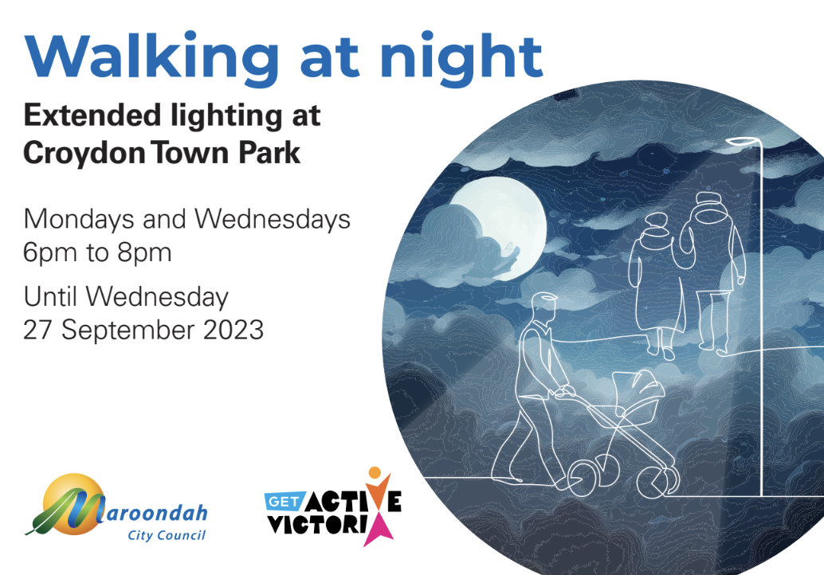
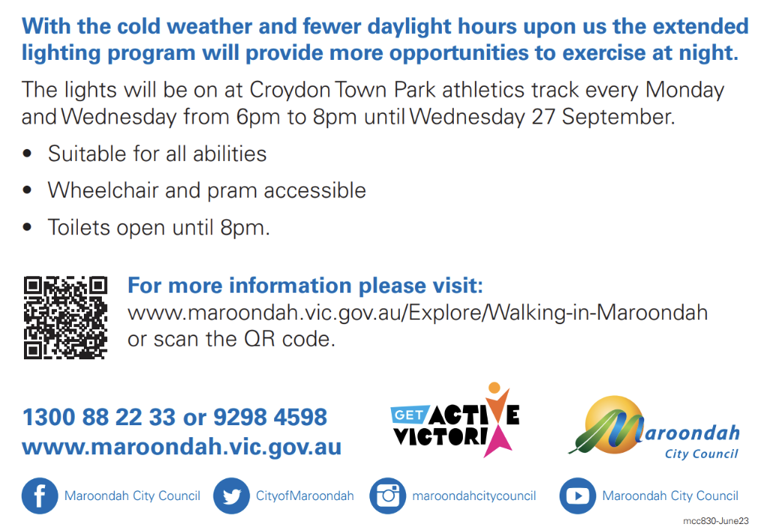

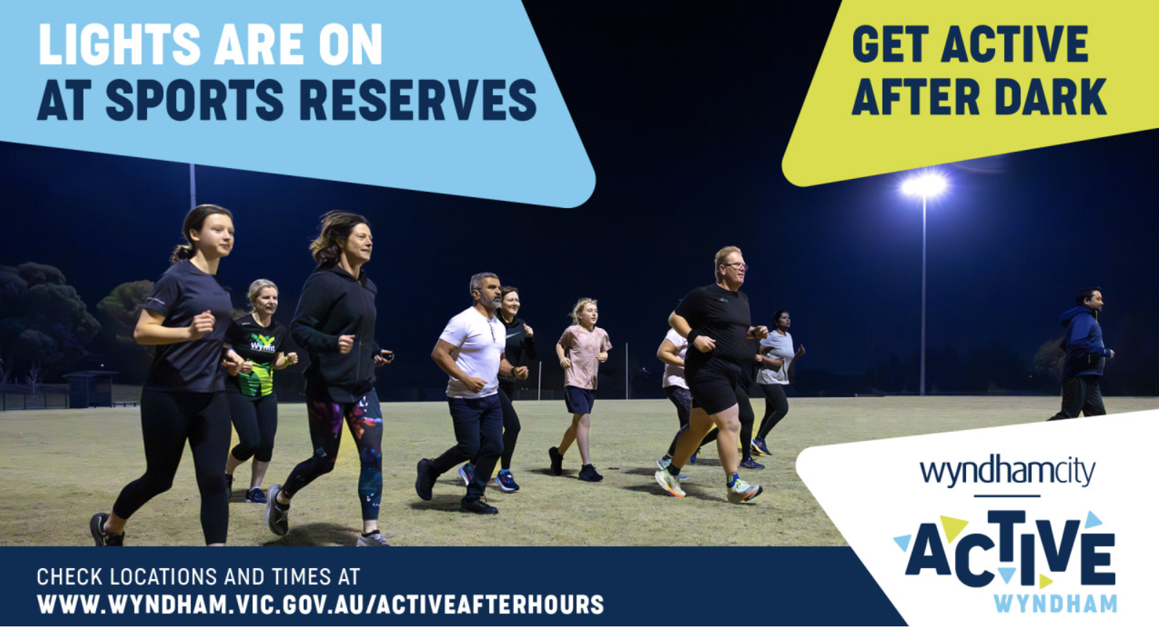
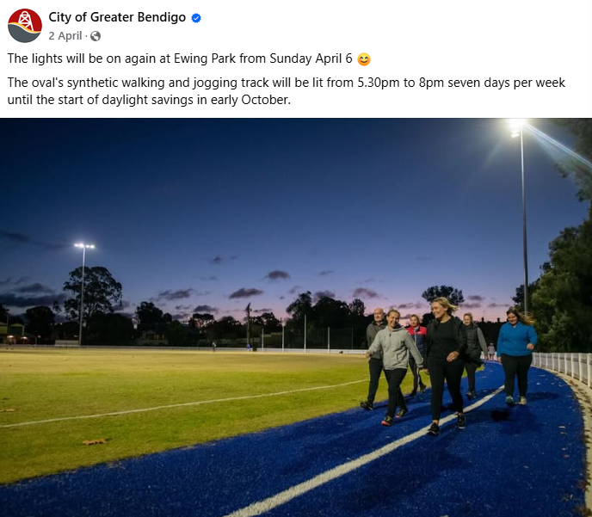

Implications for Phase 2

To recap:
Insight 1: Lighting sports facilities is seen to be a critical part of encouraging physical activity.
Insight 2: Current usage of sports facilities in Australia for recreational purposes is low amongst women and gender-diverse people.
Insight 3: Other factors that impact outdoor physical activity include elements within the general environment, access to other facilities, foot traffic, and a sense of belonging.
Insight 4: All three councils considered their respective programs successful and have continued (or expanded) offering these programs.

The literature suggests that safety is a pre-requisite to exercising outdoors when it’s dark, and that feeling unsafe is linked to a lack of lighting (and potentially other factors).
There is very little evidence from the literature review of barriers to increasing recreational activity at sport facilities other than feeling unsafe. There is also minimal evidence of motivators.
For the best chance of additional lighting projects to be successful, the sporting facilities chosen should seek to meet as many of the following elements as possible:
- High density neighbourhoods
- Easy access via public transport / active transport
- Ample parking available
- Well-activated/used during the day
- Other facilities present beyond an oval: cricket, basketball, and tennis courts, skate park, fitness equipment, etc.
To further encourage increased recreational use of the facilities after dark, any new lighting initiatives should be well promoted in the community via social media, letter drops (including in language that reflects the community mix), digital screens and council newsletters.

Gaps and Next Steps:
The literature review combined with the council interviews suggests that increased lighting can be effective in increasing physical activity. This indicates that hypothesis A – “the community would use these facilities more if they were well-lit in the evening/early morning” – is correct.
In particular, the highly-promising anecdotal evidence from the three councils interviewed should encourage others to consider similar trials.
Noting the evidence in the literature is somewhat limited, and there is no specific focus on Get Active Victoria’s target, there is an opportunity for SRV to conduct some additional primary research which hears directly from the target group of inactive women aged 35-64, as well as the general population, to explore in more detail their specific needs, expectations and concerns around using facilities if lit.
If possible, it would also be of value to include research with some people who have used these facilities at night in the council trials, to understand what specifically triggered them to give it a go, their experiences, behaviours and what they would say to encourage others.
This could be done via an online community, or via a small series of accompanied walks with researchers and participants.
[Note: this Phase 2 research has since been conducted and the report is available from SRV.]

Sources

- Matthewson, G. et al. (2021). YourGround Victoria Report, YourGround Vic. Available at: https://drive.google.com/file/d/1Lhy9GPNpDgUXY_-k_hONTRLENF7a0axG/view (Accessed: 06 May 2025).
- Su, Y. et al. (2024) ‘Gender differences in the effects of urban environment on Nighttime Exercise Behaviours: A qualitative study’, Frontiers in Psychology, 15. doi:10.3389/fpsyg.2024.1465737.
- Edwards, N. et al. (2015) ‘Associations between Park features and adolescent park use for physical activity’, International Journal of Behavioral Nutrition and Physical Activity, 12(1). doi:10.1186/s12966-015-0178-4.
- Safer Cities Survey Report: | Transport for NSW (2023) Safer Cities Survey Report. Available at: https://www.transport.nsw.gov.au/system/files/media/documents/2023/Safer-Cities_Survey-Report_0.pdf (Accessed: 06 May 2025).
- Leavy, J.E., Jancey, J. and Crawford, G. (2022) ‘Build and they will come: A follow‐up evaluation of Outdoor Exercise Equipment in Western Australia’, Health Promotion Journal of Australia, 33(S1), pp. 334–339. doi:10.1002/hpja.588.
- Veitch, J. et al. (2021) ‘Understanding the impact of the installation of outdoor fitness equipment and a multi-sports court on park visitation and Park-based physical activity: A natural experiment’, Health & Place, 71, p. 102662. doi:10.1016/j.healthplace.2021.102662.
- Matthewson, G., Larin, T. and Kalms, N. (2024) Yourground NSW Baseline Insights Report, YourGround NSW Baseline Insights Report. Available at: https://dcj.nsw.gov.au/documents/legal-and-justice/our-commissioners/YourGround_NSW_Monash_University_XYX_Lab_June_2024_rev.pdf (Accessed: 06 May 2025).
- City of Greater Bendigo. (n.d.) Project Evaluation Report.

Contact
SEC Newgate Australia Pty Ltd ABN 38 162 366 056
Level 17, 35 Collins Street
Melbourne VIC 3000
T +61 3 9611 1800
E: melbourne@secnewgate.com.au
W: secnewgate.com.au

