Will lighting outdoor sports facilities help Victorians to be more active?
  - Research into the impact of lighting on the use of public sports facilities for non-sports activity by the general community
  - Phase 2: Community Research
Prepared for Sport and Recreation Victoria
Final 23 July 2025
Prepared for:
Kate Stewart
Sport and Recreation Victoria
E kate.stewart@ecodev.vic.gov.au

Marianne Mateer
Sport and Recreation Victoria
E marianne.x.mateer@sport.vic.gov.au

Prepared by:
Cat Banks
Senior Director
E cat.banks@secnewgate.com.au

Leanne Lim
Senior Research Executive
E leanne.lim@secnewgate.com.au

DISCLAIMER In preparing this report we have presented and interpreted information that we believe to be relevant for completing the agreed task in a professional manner. It is important to understand that we have sought to ensure the accuracy of all the information incorporated into this report. Where we have made assumptions as a part of interpreting the data in this report, we have sought to make those assumptions clear. Similarly, we have sought to make clear where we are expressing our professional opinion rather than reporting findings. Please ensure that you take these assumptions into account when using this report as the basis for any decision-making. The qualitative research findings included throughout this report should not be considered statistically representative and cannot be extrapolated to the general population. This project was conducted in accordance with AS: ISO2025:2019 guidelines, to which SEC Newgate Research is accredited. This document is commercial-in-confidence; the recipient agrees to hold all information presented within as confidential and agrees not to use or disclose, or allow the use or disclosure of the said information to unauthorised parties, directly or indirectly, without prior written consent. Our methodology is copyright to SEC Newgate Research 2025.

Contents
Executive Summary & Recommendations 4
Executive Summary 4
Recommendations 6
Project Overview 8
Background and objectives 8
Methodology & sample 9
Participant snapshot 11
Key Findings 14
Motivators and barriers to being active at facilities in general 14
Exercising after dark 18
Initial and considered response to lighting concept 21
Will this initiative drive behaviour change? 23
What else is needed? 25
Case Studies 26
Execution 30
Preference for lit sports facilities 30
Specific types of lights 32
Lighting logistics 34
Lighting of pathways 36
Lighting of car parks 39
Priority features for accessing lit outdoor facilities 41
Final thoughts on lighting and advice to SRV 43
Appendix 45

Executive Summary & Recommendations

Executive Summary

Project overview
    - Sport and Recreation Victoria (SRV) commissioned this research to explore whether lighting public outdoor sports facilities when it’s dark outside can help Victorians to be more active.
    - Phase 1 of the research was a knowledge review looking at available evidence on this topic from published literature and interviews with three Victorian councils who have run lighting pilots. We found very little literature on this topic, but good anecdotal feedback from councils on the potential of lighting to help with physical activity in the autumn-spring months.
    - Given the limited findings from the literature, the decision was taken to supplement this with primary research (Phase 2), conducted in June 2025. in which forty Victorians aged 18-70 participated in a 2-day online discussion. Of these participants, 20 were in Get Active Victoria’s key target of inactive women aged 35-64 who want to be more active, and the other 20 were a good mix of general community outside of this target.
    - This report predominantly contains findings from Phase 2; the Phase 1 report is available on request.

Key findings: context
    - The literature review found that people believe lighting facilities will help them feel safer at night. The experience of the three councils interviewed suggests that what’s needed is a combination of lighting, lighting design and choice of specific sports facilities to light - ones that are well-used during the day, with easy access to public transport, ample parking and additional facilities.
    - The Phase 2 research showed that other barriers to the general use of outdoor sports facilities (for anything other than participation in team sports, or being a spectator of these sports) includes a sense that these facilities are “not for me”, a preference for other types of outdoor spaces, a lack of salience of these facilities as an option for general activity (i.e. simply never crosses people’s mind as a place they could go), and the lack of protection from the elements. In reality, we know these council-run facilities are typically available to all to use, but there’s a cohort that don’t feel they belong there, and even some who feel they don’t have permission to be there. This issue appears particularly strong for ovals and pitches, but not the paths around them.
    - Barriers to exercising outdoors when it’s dark outside include significant concerns about personal safety (mostly but not solely from women), specifically around being attacked by a stranger, but also fear of falls; as well as the cold, and household responsibilities. The literature review also indicated that safety barriers are more prevalent amongst women (and potentially also gender diverse people) than men.

Key findings: implications for lighting
    - There’s something of a conundrum in that people are less likely to be active when it’s dark and cold, but that for many (especially working people), it’s also the only time they can be active in autumn-spring.
    - There appears to be real potential for lit outdoor sports facilities to solve some of the barriers to outdoor activity after dark, particularly amongst Get Active Victoria’s target and women more broadly.
    - This is not a universal solution, but it does appear highly likely to support some Victorians to be more active, especially with careful execution. It’s important to address all the barriers to being active outside at night and the barriers to using sports facilities for general physical activity.
    - Of our sample, around half of the target audience and half of the general community (more so females than males) appeared interested and motivated to utilise lit facilities in the colder and darker months, with certain provisos in place (see next page).
    - Importantly, no participant felt this was a pointless or wasteful endeavour – all appeared supportive of the initiative, even if they didn’t see themselves taking it up personally. One person expressed a small concern about cost and impact on rates.
    - Environmental considerations factor into preferences for types of lighting (lights that are warm in colour, and bright but not excessively so) though safety and convenience outweighed energy-efficiency concerns when it came to lighting mechanisms (i.e. people preferred automatic lights at set times rather than pre-booking or switching lights on and off themselves).

Recommendations
Lighting will help people – especially women – to be active, but they need more than just lighting
Additional needs include:
- Automatic lighting at set, published times, with good coverage of the whole area. Indicatively (from Greater Bendigo Council research), more people will use the facilities earlier in the evening e.g. 6 pm, and lighting should start at sundown rather than there being a gap.
- This includes end-to-end lighting, not just lighting of the facility itself but also when getting to the sport facility and back i.e. roads, pathways, car parks etc., without dark patches.
- Promotion so that (a) people know the lighting is there (b) a sense of ‘all welcome’/’this is for you’ is created and (c) they have more confidence that other people will be there. Promotional activity can also create a sense of social proof (this looks fun, desirable) and social norming (people like me are doing this) particularly through careful selection of imagery. Some research (again from Greater Bendigo Council) suggests that targeted promotion may be required to encourage use by Culturally and Linguistically Diverse groups – and also potentially for people aged over 50.
- A sense of ownership (these facilities are for everyone: age, level of fitness, being a team sports player is not important) via promotion, signage and word of mouth. This may be especially important if wanting to encourage people to use ovals/pitches, which some believe are only for sports teams and that the public is unofficially discouraged from treading on the grass.
- Ensuring a good experience in initial visits that will encourage them to turn this into a habit e.g. having council staff on-site.
- An area that feels inviting and suitable for them – ideally, people tend to prefer places with walking paths rather than ovals or pitches with grandstands that appear to be purely designed for organised/team sport, but the latter often have good lighting and greater openness which can make them feel safer at night (especially if recommendations around promotion above are met).
- Confidence that others will be using the area – for safety in numbers, but also to increase a sense of belonging. Councils’ experience also taught us that having set hours / a set program is important, to promote reliability, a sense of belonging and the likelihood of other people “like me” using it at the same time.
- Where possible, increased forms of surveillance through security cameras or patrols which can help women feel safe.
In Phase 1, councils also noted that the selection of facilities is important:
- They need to be easy to access e.g. located in residential areas, with good walking paths and parking nearby.
- Well-activated spaces are more effective i.e. spaces that are well-utilised in the daytime and therefore more likely to be familiar/comfortable to the general public.
Some contradictory needs/desires require further consideration and may be space-specific:
- Some definitely don’t want organised sport to be on while they’re getting active, while others feel safer with the guaranteed numbers that brings. Ultimately this can be handled either way through reassuring communications and presentation of the space.
- For some, being able to take their dog is essential; for others it was off-putting. This may ultimately come down to responsible dog ownership, on-lead requirements or fenced off-leash areas, and providing plenty of bins.
Finally, we note that councils should be encouraged by evidence from Greater Bendigo Council’s evaluation of their lighting trial at Ewing Park in June-Sept 2021, which showed through a combination of on online survey and observational data that:
- People used the facility who otherwise would not have done so.
- They felt the lighting provided them with an opportunity to exercise outdoors after dark which did not otherwise exist; they also reported an increase in feelings of safety and wellbeing.
- This usage then continued into the summer months of 2021.
- Cost per user for Council was low, at $0.41 per user across the trial period.

Project Overview

Background and objectives

Background
Definitions:
‘Target audience’ = inactive women aged 35-64 who want to increase their activity levels
‘Outdoor sport facilities’ = ovals, soccer pitches, courts, and the paths/space around these, that are open to the public (council-owned)
Sport and Recreation Victoria (SRV)’s research to date shows that the target audience’s barriers to being more active include feelings of safety and confidence (if active in public) and finding the time amidst their busy lives.
Lighting outdoor sports facilities when it’s dark outside can provide a free space for the public to be active in months with fewer daylight hours, and there’s a view that this will assist them in meeting their activity goals. A few Victorian councils have already trialled winter lighting programs at certain outdoor sports facilities to encourage physical activity after dark (i.e. beyond teams playing organised sports).
SRV commissioned SEC Newgate Research to further explore the impact that lighting of outdoor sports facilities for the general public could have on active recreation after dark, in order to provide informed guidance to councils. The first phase of research was a knowledge review to understand current evidence on the topic – including publicly available literature, and interviews with Victorian councils that have run trial programs.
A separate report detailing these findings has been provided to SRV; the key findings were:
    - Safety is a pre-requisite to exercising outdoors in the dark, and lighting is the most influential factor in perceptions of safety.
    - But there is very limited available evidence on whether lighting outdoor sports facilities after dark will actually change behaviour – warranting further primary research that looks beyond the general concept to understand more about barriers and needs.
    - Current usage of outdoor sports facilities in Australia is low amongst women and gender-diverse people, and the overall environment and amenities, foot traffic, and sense of welcome also impact the public’s likelihood to be active there.
    - Encouragingly, all three local councils interviewed considered their respective lighting programs successful and have continued (or expanded) the offering.

Objectives of Phase 2 research
Overarching objective: To explore whether lighting public outdoor sports facilities when it’s dark outside can help Victorians to be more active
More specifically, we looked at:
    - General positive/negative views of lighting outdoor sports facilities when it’s dark outside
    - Factors that influence the likelihood of someone being active at a lit outdoor sports facility when it’s dark outside (early morning or evening) – i.e. drivers, barriers, and needs
    - Specific lighting approaches that appear to work best to influence behaviour – e.g. types of lighting, when and how, during or at a separate time from organised sport.
The research had a primary focus on SRV’s target audience, and a secondary focus on the broader Victorian adult population who are not already active at these types of facilities when it’s dark outside.

Methodology & sample
Approach: To capture people’s views on these topics, we hosted a 2-day online community on the Recollective platform. This a virtual space where a group of people can respond to questions, share ideas and interact with one another. Our community was asynchronous, meaning participants logged at a time convenient them to complete each day’s tasks, which included open-ended response questions, polls and card groupings. After submitting their own responses, participants could see what others had to say and instigate further discussion. The community was actively moderated.
Prior to joining the online community, participants completed an optional pre-task of visiting a local outdoor sports facility and recording their observations. This was to ensure everyone was familiar with the types of facilities we wanted to discuss, and able to provide more informed views on lighting.
The online community started broadly, understanding people’s physical activity habits and general attitudes towards outdoor sports facilities, before exploring feelings towards physical activity outdoors when it is dark, lighting infrastructure and various other elements that would encourage the use of these facilities.
Participants spent approximately 1 hour engaging with the discussion over two days (June 11th and 12th) and were paid an incentive of $100-$130 (depending on pre-task completion) for their time, in line with market research industry practices. Participants were recruited by Research Connections.
Sample: We recruited 40 participants in total:
    - 20 people were from SRV’s target audience of inactive women (roughly defined as those who do less than 150 minutes of physical activity per week) aged between 35 – 44 and 55 – 64 who would like to increase their physical activity levels.
    - 20 people from the general community of Victorian adults, with a mix of gender, age, and physical activity levels.
The sample included a mix of inner and outer suburban and regional residents, life stages, and education levels, with a skew towards lower to middle income households, and representation of people living with a disability and those from Culturally and Linguistically Diverse (CALD) backgrounds. We did not include anyone who was already using outdoor sports facilities at night for active recreation.
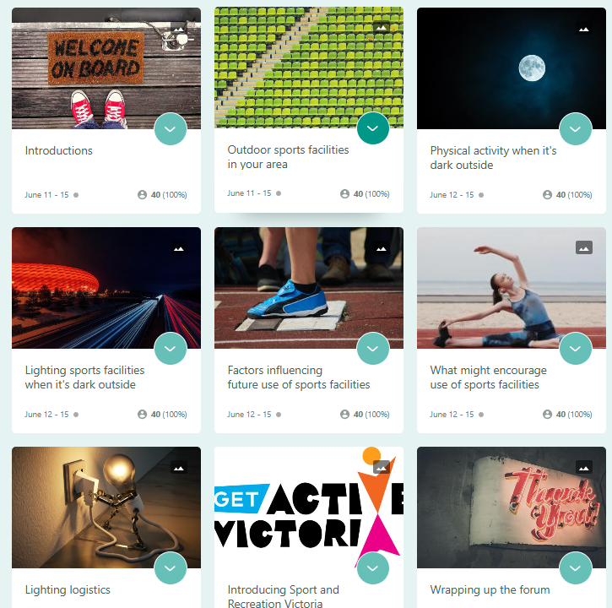
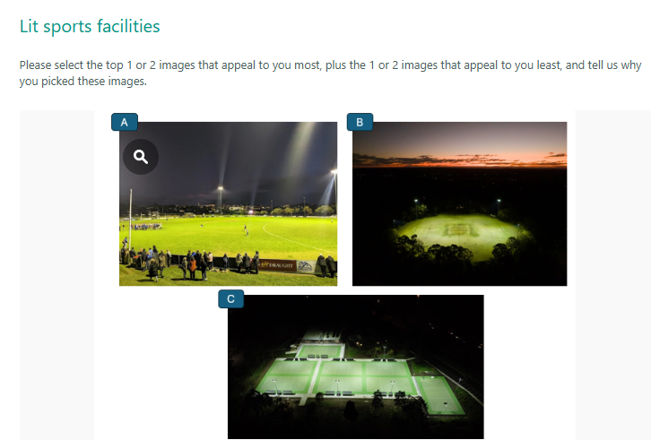

Participant snapshot
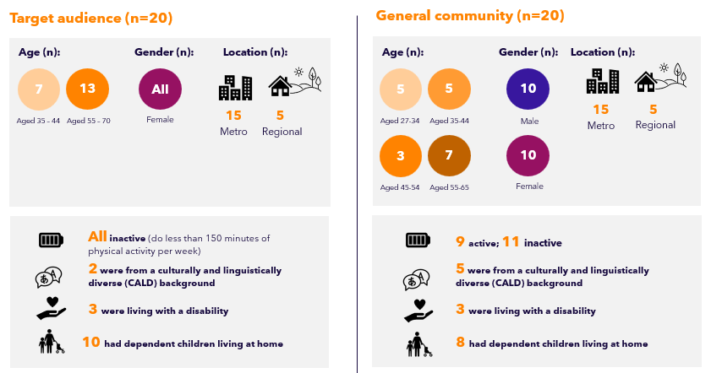
Target audience (n=20)
Age (n): 35 -44 | 7 | Age (n): 55-70 | 13
Gender (n): Female | 20
Location (n): Metro | 15 | Location (n): Regional | 5

All inactive (do less than 150 minutes of physical activity per week)
2 were from a culturally and linguistically diverse (CALD) background
3 were living with a disability
10 had dependent children living at home

General community (n=20)
Age (n): 27-34 | 5 | Age (n): 35 -44 | 5
Age (n): 45-54 | 3 | Age (n): 55-70 | 7
Gender (n): Female | 10 | Gender (n): Male | 10
Location (n): Metro | 15 | Location (n): Regional | 5

9 active; 11 inactive
5 were from a culturally and linguistically diverse (CALD) background
3 were living with a disability
8 had dependent children living at home

Over half (n=25) of the total sample were dissatisfied with their current activity levels, rating this 0-4 out of 10, while n=8 were reasonably satisfied, rating 7-9 out of 10, and the remainder were neutral.
Participant snapshot cont’d
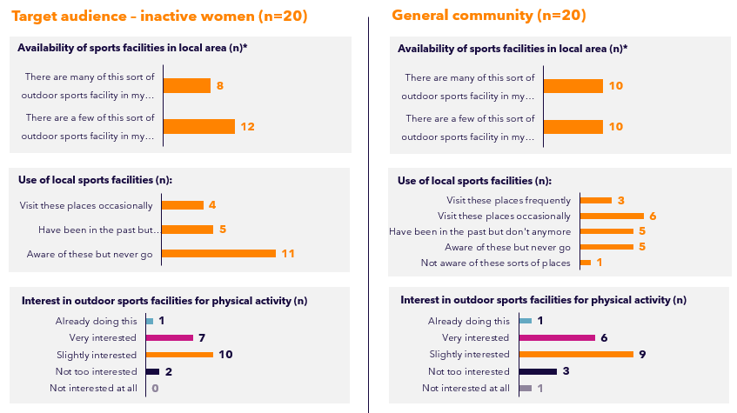

Target audience – inactive women (n=20)
Availability of sports facilities in local area (n)*
There are many of this sort of outdoor sports facility in my… 8
There are a few of this sort of outdoor sports facility in my… 12

Use of local sports facilities (n):
Visit these places occasionally 4
Have been in the past but… 4
Aware of these but never go 11

Interest in outdoor sports facilities for physical activity (n)
Already doing this 1
Very interested 7
Slightly interested 10
Not too interested 2
Not interested at all 0

General community (n=20)
Availability of sports facilities in local area (n)*
There are many of this sort of outdoor sports facility in my… 10
There are a few of this sort of outdoor sports facility in my… 10

Use of local sports facilities (n):
Visit these places frequently 3
Visit these places occasionally 6
Have been in the past but… 5
Aware of these but never go 5
Not aware of these sorts of 1

Interest in outdoor sports facilities for physical activity (n)
Already doing this 1
Very interested 6
Slightly interested 9
Not too interested 3
Not interested at all 1

*Note: We did not recruit people who didn’t have any of these facilities available in their local area

Key Findings

Motivators and barriers to being active at facilities in general
Barriers to use included a sense that these facilities are “not for me”, a preference for other types of outdoor spaces, a lack of salience of these facilities as an option, and the lack of protection from the elements
The motivators and barriers to using outdoor sports facility for physical activity in general (i.e. not specifically after dark) appeared to be similar between target and general population, and active and inactive participants. They often related to subjective factors (how people see and feel about these areas).

Factors contributing to interest in future use
    - Already familiar and comfortable with the facility – typically due to location of the facility (particularly if it was near their home, a main street, schools, or residential areas), having lived in their neighbourhood for a while, or previous personal experience and usage of the area (e.g. being part of a club, watching a game, socially for picnics or BBQs, walks, bringing their kids there to play or for games/training, exercising there on occasion, etc.)
    - Seeing others around and using the space in different ways (walking, running, dog-walking etc.) made people feel more comfortable using these spaces for physical activity in the future
Barriers to use
    - Not seeing it as a location they were interested in being active in (as non-team sports players) – a tendency to prefer other places like the park or gym, and a sense that there’s nothing at outdoor sports facilities to interest them
    - Not feeling it was a place they belonged – i.e. because they don’t play team sports, or felt it was a space for younger people
    - Feeling awkward being at sports facilities alone / having no one to go with
    - Simply never thinking of exercising at these sorts of locations
    - Weather – sports facilities are typically unshaded or can be muddy if it has rained

Notably, the first two barriers appear to be more prevalent amongst women, with men more likely to attribute not using sports facilities for physical activity to not having anyone to go with, lack of motivation to be active overall, and time/weather constraints.

“I was comfortable at the facility [when I visited for the pre-task] as there were many different types of people using it.”
- Female, Inactive, Inner Melbourne, 55-64 (Target)

“I would have to go alone and might feel awkward. I am not afraid to go alone but it is harder because I would feel different if there were groupinner Melbournere, and you need more self-motivation when you go alone.”
- Female, Inactive, Inner Melbourne, 55-64 (Target)

“I haven’t used these before, mostly because I hadn’t thought to do so.”
- Female, Inactive, Regional, 35-44 (Target)

Preference for type of outdoor sports facilities
Across the sample, people preferred to be active at outdoor sports facilities that felt inviting to everyone, rather than those clearly designed solely for organised sport
What they liked or found appealing
The most appealing types of outdoor sports facilities were those which:
    - Had a pleasant environment, particularly for walking – well maintained, visibility in all directions, open and inviting, large grassy areas, trees/leafy (shade)
    - Had paths for walking/cycling – dedicated paths, paved surfaces, more stable, less likelihood for falling
    - Felt suitable for kids (some see this as being open sports fields, others as enclosed areas to ensure the kids can’t wander off)
    - Had resting areas

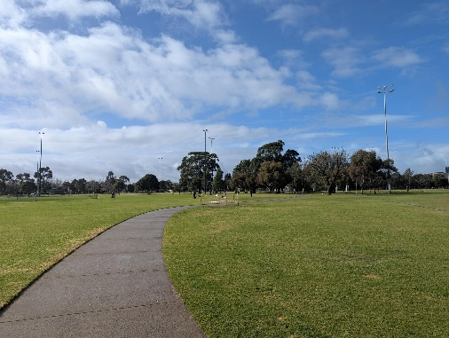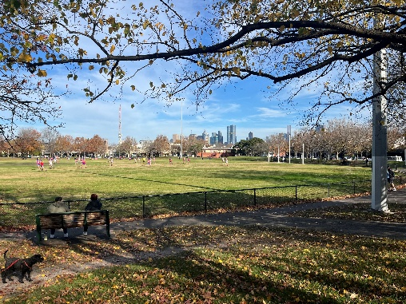
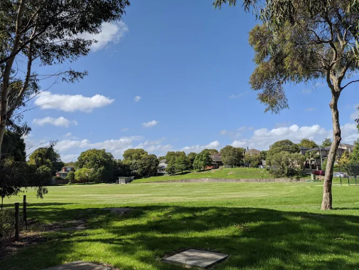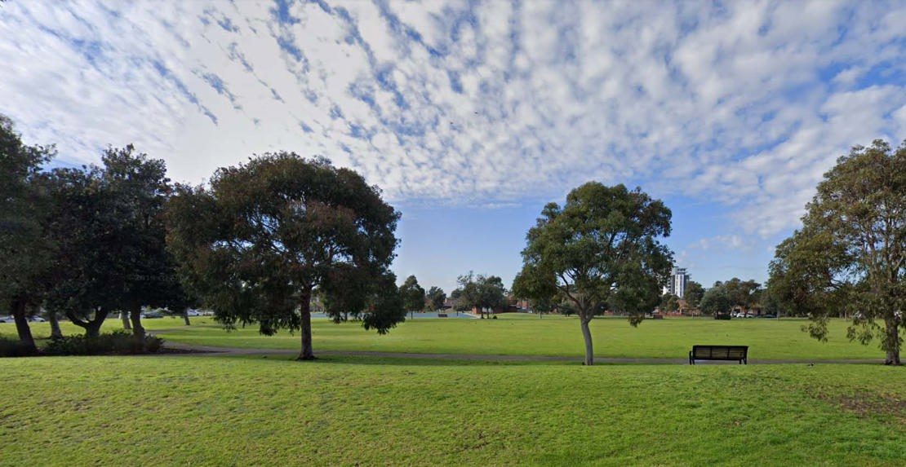

What they disliked or found unappealing
The least appealing types of outdoor sports facilities were those which:
    - Seemed designed purely for organised sport/a specific type of sport – they felt they don’t have a reason to be at these facilities, less comfortable being there, and/or aren’t interested in the sport
    - (Related to above point) felt like they would be too busy/crowded
    - Doubled as off-leash dog parks – for those with a fear of dogs or who wanted to take their kids along
    - Had dry grassland that may be a tripping hazard

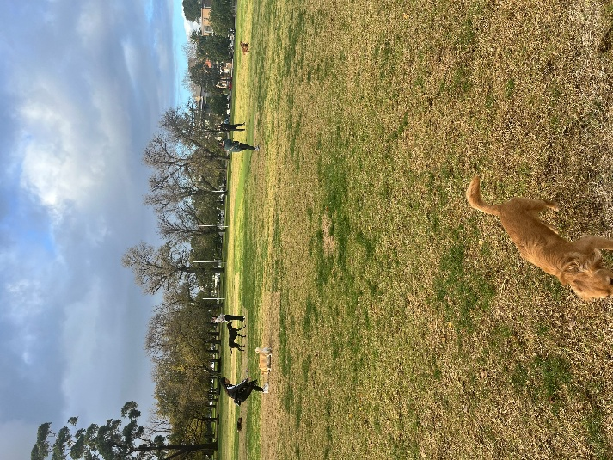
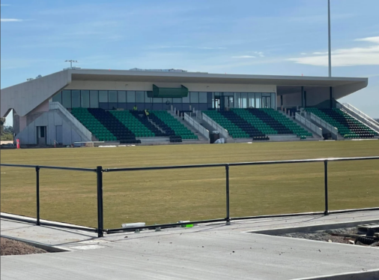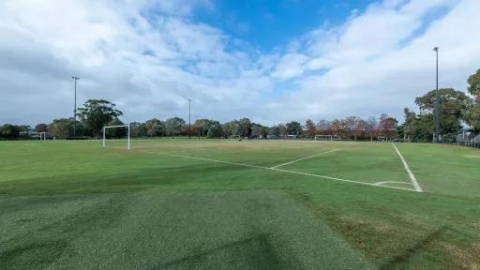
Images presented to participants were selected to show a variety of Victorian facilities, and came from three sources: images sourced online by SEC Newgate; photos taken by SEC Newgate; photos taken by participants in their pre-task.

Exercising after dark
Safety and cold were the main barriers to being active outside at night, with safety as a major concern amongst women
Of our sample, 12 were currently active outdoors when it’s dark outside, with varying frequency, and 28 were not. We note that the research was conducted in winter, and a number of participants were more active in the evenings in warmer and lighter months – both dark and cold are barriers.

Who’s active outdoors after dark, how and why?
- Some in the target and some in general community; proportionately more males than females.
- Typically due to not having time in the day, but for some also due to genuine enjoyment of doing so at this time of day.
- Most tended to do so in the evening/at night rather than the morning.
- Mostly walking (though also included tennis competitions/training, kicking a footy around, or a group fitness class).
- Women more frequently caveated this as only on main roads that are well lit or busy, or if someone else was joining them; men overall appeared to be less reliant on external factors and more comfortable just going out if they felt like it (though this is not universal).

Who isn’t active outdoors after dark?
- Most of the target and general community; proportionally more females than males.
- People who are able to be active in the daytime (e.g. retired); they see this as preferable to being out when it’s dark if they don’t need to be.
- People with young children / who work full-time hours, who tend to have family commitments in the evening or prefer to relax after work.
- Amongst women in particular, there were very high levels of fear of being outdoors when it’s dark. While this was largely about being attacked or something bad happening to them, for some this was also about tripping and falling.

Barriers*
- Lack of motivation
- Injury or disability
- Lack of time/competing priorities
- Can’t be bothered
- Poor fitness

Motivators*
- Mental health benefits
- Prevent injury or certain diseases
- Improve energy levels
- Be able to do everyday tasks
- Have fun, enjoy myself

Additional considerations when it is dark outside
- Safety (i.e. fear of being attacked)
- Cold
- Less visibility (risk of tripping, falling)
- Not close enough to visit at night (additional safety concerns of walking there and back; driving can feel effortful)
- Not being a morning person / not wanting to be active close to bedtime
- A few concerns about disturbing local wildlife
- Relaxing, fun, peaceful
- Suits current schedule better
Similar motivators and barriers to exercising outdoors when it’s dark outside were expressed by both target and general population, both genders, and differing current activity levels. However, safety emerged as a very strong theme amongst women in particular.
*Barriers and motivators to being more active in general, already known from previous research

Exercising after dark: in their own words
Prior to seeing and discussing the concept in more detail, these quotes illustrate the instinctive initial reaction

“I don’t think I would ever exercise in the dark. I’d be too worried about getting assaulted even though I live in a safe area.”
- Female, Inactive, Outer North-East, 35-44 (Target)

“I would not be as comfortable being active after dark, especially in winter time in Melbourne. There is not just the safety issue but unless the place you are walking or running is floodlit, the possibility of tripping over something is far greater.”
- Male, Active, inner Melbourne, 55-65 (General Community)

“I'm worried about running into someone who is unpleasant. I often hear yelling and foul language from the Lilydale Lake Reserve at night as I live so close.”
- Female, Inactive, Outer East, 35-44 (Target)

“In summer I’m definitely more active, as there’s more time in the evening to get outside after work.”
- Male, Inactive, Regional, 35-44 (General Community)

“I'm not comfortable exercising in the dark with all the crime about, it’s asking for trouble. And with daylight savings and cold, winter just isn't a great time.”
- Male, Inactive, Outer North-East, 27-34
(General Community)

“ At the moment the weather is just not suitable to be active outdoors when it's dark, not only is it cold it is also wet most nights. If there is a well-lit undercover area, then maybe I would consider trying it.”
- Female, Active, Outer West, 55-65 (Target)

Initial and considered response to lighting concept
The instinctive response to the concept of being active at lit sports facilities after dark was quite negative and fearful, but interest and positivity increased after discussion, including seeing council promotional material and lighting images

Initial response to concept (end of Day 1):
What 3 words come to mind when you think about using sports facilities to be active when it is dark outside?
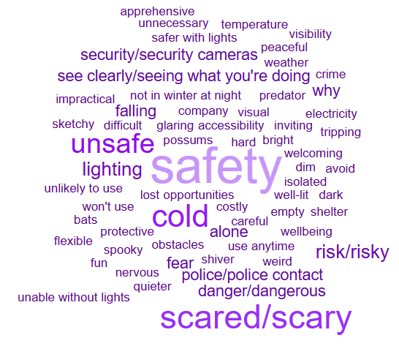
Key themes:
- Need to be lit – visibility, safety
- Temperature in winter may still be a barrier
- Fear and unease
- Unnecessary and risky

Considered responses to concept (end of Day 2)
Based on everything we’ve discussed throughout the forum, what 1-3 words best describes how you feel about the concept of lighting outdoor sports facilities when it’s dark for physical activity?
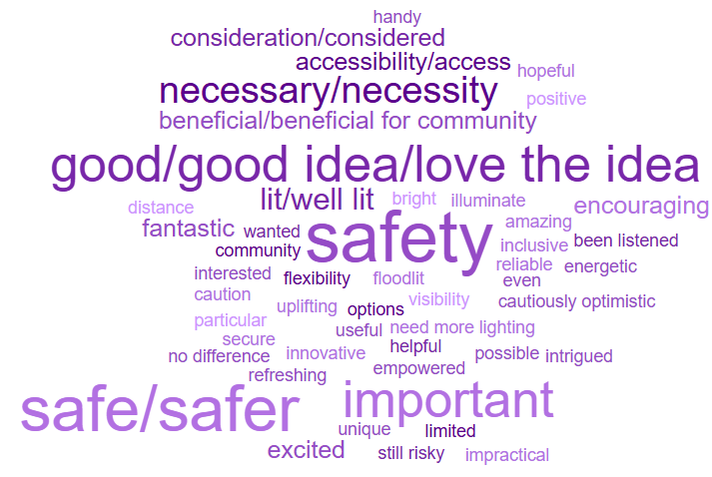
Key themes:
- Positively received
- Important for safety
- Necessary and beneficial for many
- Provides flexibility and options

Will this initiative drive behaviour change?
Indicatively, based on this research and the anecdotal observations of councils who’ve trialled the programmes, lighting sports facilities at night offers an appealing opportunity for the community to be more active – with certain other provisos

Amongst women (and some men), the instinctive response to the concept of being active at lit sports facilities after dark was quite negative and fearful. However, interest and positivity increased after discussion, particularly for the target audience and other currently inactive people, influenced especially by seeing council promotional material and lighting image options. Having someone to go with or a good number of people around appears to mitigate safety concerns and provide reassurance that someone will be able to help if needed.

At the end of the discussion with the target audience (n=20):
    - 5 appeared very likely to use lit facilities at night to assist in them being active.
    - 4 appeared quite likely to use, with certain provisos which centred around there being other people there to help them feel safe e.g. starting by going along with someone else they knew until they felt comfortable; organised group activities; or simply the confidence that there would be other people like them doing the same thing.
    - 6 seemed unlikely (but arguably interest could be created) – this cohort also had concerns about whether enough people would be there, but the barrier seemed stronger than the group above (less solution-focussed); some were put-off by organised sports being on (even though they did want other people to be around), while others wanted sport to be on for this reason. Other barriers included: it has to be dog-friendly; lack of motivation after work; and already walking on the streets at night so this didn’t open up an opportunity for them to be more active (just a different setting).
    - 5 would definitely not use – for a couple, they had the option to be active in the daytime and preferred this to night-time; for others the cold was a significant barrier along with making time around household commitments in the mornings/evenings. Being in a regional area also created less confidence around the guarantee of “safety in numbers”.

For the general community (n=20) i.e. anyone aged 18-65 outside of the target:
    - There was much greater interest from women than men.
    - The 5 inactive women all felt this would be a good option to help them be more physically active, with provisos similar to the target audience
    - The 5 already-active women had mixed levels of interest, with some feeling this wasn’t needed to help them, others appreciating another option to be active for use on occasion, and one particularly keen.
    - Six of the 10 male participants were highly unlikely to avail themselves of this option: some were completely unbothered by exercising at night or would prefer the gym or a daytime activity to avoid the cold; the others had more interest, though a couple said family responsibilities (e.g. single parenting) precluded this for now but that they would be keen in the future.

What else is needed?
A number of factors will influence an interested person’s likelihood to actually use lit facilities, beyond the presence of lighting

As with other research which has focused on helping people to be more active, it is not simply a case of “if you light it, they will come”!
Other things to bear in mind:
- Expressed interest was higher than expressed likelihood – how to convert interest into desire and motivation? e.g. ‘social proof’ showing people like them enjoying the activity, and communications which address key issues (head-on or implicitly) re isolation, safety, cold…?
- The type of lighting is important – most critically, the coverage. Lighting can illuminate all areas, including pathways and car parks – or it can create extra-dark and sinister pockets.
- Participants responded better to the advertised council programmes than to simply knowing sports facilities were available and lit to use when it’s dark – it helped them to feel welcome and more confident that other people like them would be there. Set hours also appear to be more likely to drive behaviour change than the option to go any time: it makes it easier to set a routine, creates a greater sense of commitment, and removes the need to have to really think about it each week.
- There are two important contradictory needs/desires that will need careful handling:
  - Some definitely don’t want organised sport to be on while they’re getting active due to crowds (including a busy car park) and noise, or a sense of feeling invasive in sharing the space and “getting in the way”; others feel safer with the guaranteed numbers that brings.
  - For some, being able to take their dog is essential, because they need the exercise too, and also potentially for a sense of safety for some; for others it was off-putting, due to not liking dogs or concern about standing in dog poo in the dark.

The next section of this report covers logistics in more detail.

Case Studies
Case studies: target audience
From ‘Enthusiastic’ to ‘Disinterested’

Aadhya, 43, inactive, outer west Melbourne, CALD
Aadhya lives with her husband and two teenagers, and works casually. She rates her satisfaction with her physical activity currently at a 4 out of 10, feeling that weather and household chores are the main barriers to doing more.
She already walks at her local sports facility during the daytime. She prefers to walk to these sorts of places rather than worrying about whether she can get a park there.
She finds that other people being out and about gives her the extra motivation to be active, and doesn’t like it when there is no one around. She also has a fear of dogs so would avoid off-leash dog areas.
She feels she would be able to schedule some time for activity at lit sporting venues when it’s dark outside, and might actually enjoy being active then. She would plan to go with a group of friends. She believes such a programme would be well-used.
“I would love to be part of this program! Personally I am done with all my responsibilities by then and would love to be outside and give myself a break and be active at the same time.”

Lexi, 35, inactive, regional Vic
Lexi is a busy working mum with three children aged from 2 to 12. She rates her satisfaction with her current activity levels at a 3 out of 10, and wishes she had more time for physical activity (and baking!). Caring for a toddler and older kids’ sports take up a lot of time, and she only manages to be active once or twice a week, walking or taking her son for a bike ride.
She doesn’t enjoy being outside in winter and does not feel safe in dark or isolated areas.
The concept of lighting outdoor sports facilities held some appeal, enabling her to go for a walk after work in the darker months. She liked the council-provided images shown in the research discussion that showed groups of people and implied there would be lots of users there. She also liked the idea of walking groups or organised groups using the outdoor fitness equipment.
Lexi also noted that open space (like an oval) feels safer at night than pathways. But she wouldn’t want to be there when organised sport is being played, feeling like she would be “in the way.”
“I would only feel safe it was well lit and if I was with a group of other people. Even if it was well lit and I was by myself I wouldn't feel safe.”

Michaela, 55, inactive, regional Vic
Michaela lives with her partner in a very small regional town (population less than 600). She works night-shifts two times a week. She notes that she has quite a bit of free time, but rates her satisfaction with her current activity levels at 0 out of 10. She struggles significantly with motivation, energy and mental health issues.
She’s familiar with and comfortable at her local oval. It’s not well-used at all, which she personally likes, but she does feel it’s boring just walking round the oval in circles. There’s nothing else in her local area in terms of sports facilities – the closest alternative is a 30-minute drive.
She notes that it’s often rainy and very cold where she lives, which puts her off being active outside. The isolation of her local oval would also completely discourage her from being active there at night – she doesn’t have anyone to go with, and the risk of crime is just not worth it. If anything, she would like the option of an indoor area instead.
“The lighting is a great idea, but it’s very cold here and it’s very isolated, it’s still very unsafe to go there at night. Personally I still wouldn’t go there… But in areas with a proper facility that has more people around this could be very beneficial.”

Case studies: general community
From ‘Enthusiastic’ to ‘Disinterested’

Hamish, 41, inactive, regional Vic
Hamish is married with two children under 5. He works full-time, often commuting into the city by train, and his weekends are focused on family activities - leaving him with little free time for physical activity. He rates his satisfaction with his current activity levels at a 3 out of 10.
He’s familiar with and comfortable at his local oval, which is at the end of this street. It’s used by the community for many purposes, and Hamish personally spends some time there on his hobby of kite-flying.
He’s not active after dark at the moment – it doesn’t appear to have crossed his mind as an option, since he notes there is “more time” to be active in summer. But he’s very interested in the concept of using a local facility at night, if it was well-lit.
He feels it would be more empty (less organised sport and fewer dog-walkers to avoid) which appeals for flying kites in particular; he doesn’t appear at all concerned about personal safety, even if it was dark. It’s finding (or making) the time around his young family that will be his main challenge.
“I didn't know that some councils were doing this already - and now I'm excited about the idea of lobbying my local council to do the same!”

Anita, 27, inactive, outer south-east Melbourne
Anita lives in a sharehouse with friends. She works full-time and in her free time after work likes to go on walks, paint, or work on crafts. She rates her satisfaction with current activity levels at 3 out of 10.
She wants to be more active in the week, but finds herself less active in winter, preferring to stay indoors where it’s warm and comfortable rather than being out in the cold.
Her local outdoor sports facility has two ovals, a basketball/netball court, skate park, outdoor gym, and walking tracks, and is walking distance from her house. The facility is used by the community in a range of ways, and Anita feels comfortable here.
She’s not active (or outside in general) after dark, primarily due to concerns about safety. While she knows her local facility is lit at night and feels this helps increase a sense of safety, she would need people around to feel confident and safe being here after dark.
“My main concern that keeps me from being active outside at night is safety. I don't feel safe going out by myself. While good lighting can help somewhat, if the facility is empty, there won't be anyone available to help in a worst-case situation.”

Fiona, 60, active, inner Melbourne
Fiona lives with her husband and two adult daughters. She typically does a couple of exercise physiology sessions a week and tries to get at least 7500 steps in a day, but finds it harder to stay motivated during winter in the cold.
In the evenings, she will occasionally walk after dinner to get her steps up, doing so on the main road as it is well lit. She wouldn’t go out of her way to do this at her outdoor sports facility in winter.
“I can’t really see me doing night or early morning exercise in colder months.”

Darsh, 32, active, outer north Melbourne, CALD
Darsh is an engineer who has a 1-year-old daughter.
While it’s important to him to keep fit, mostly through gym sessions a few times a week, work and family priorities come first.
He doesn’t see himself utilising lit facilities after dark as he needs downtime in the evening and generally prefers being active indoors (at the gym) to avoid cold and windy weather.
“When it’s dark it’s usually close to time for bed. I’ll be winding down rather than looking to engage in activity that’ll wake me up.”

Execution

Preference for lit sports facilities
Bright lighting that covered the entire facility and its surroundings was appealing to participants, with option K* considered the optimum example.

What they liked or found appealing
Images K, D, and A were the most appealing types of lit sports facilities amongst participants, who attributed this to:
    - Bright lights that provide a well-lit space, visibility of hazards and people approaching
    - Sufficient coverage: lighting extends beyond the sports ground, providing visibility of the whole area and no ‘pools of darkness’
    - Efficient and practical: walking paths are well-lit and would encourage use, and lighting does not appear to be wasteful or too strong
    - More natural environment due to warmer lighting used, greenery/trees, and the types of paths (particularly D / K)

K 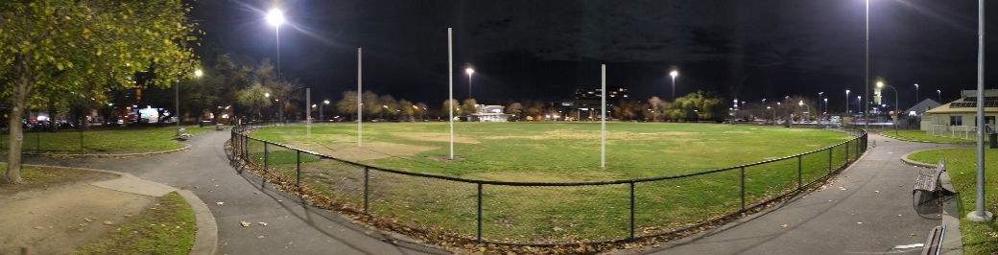
D 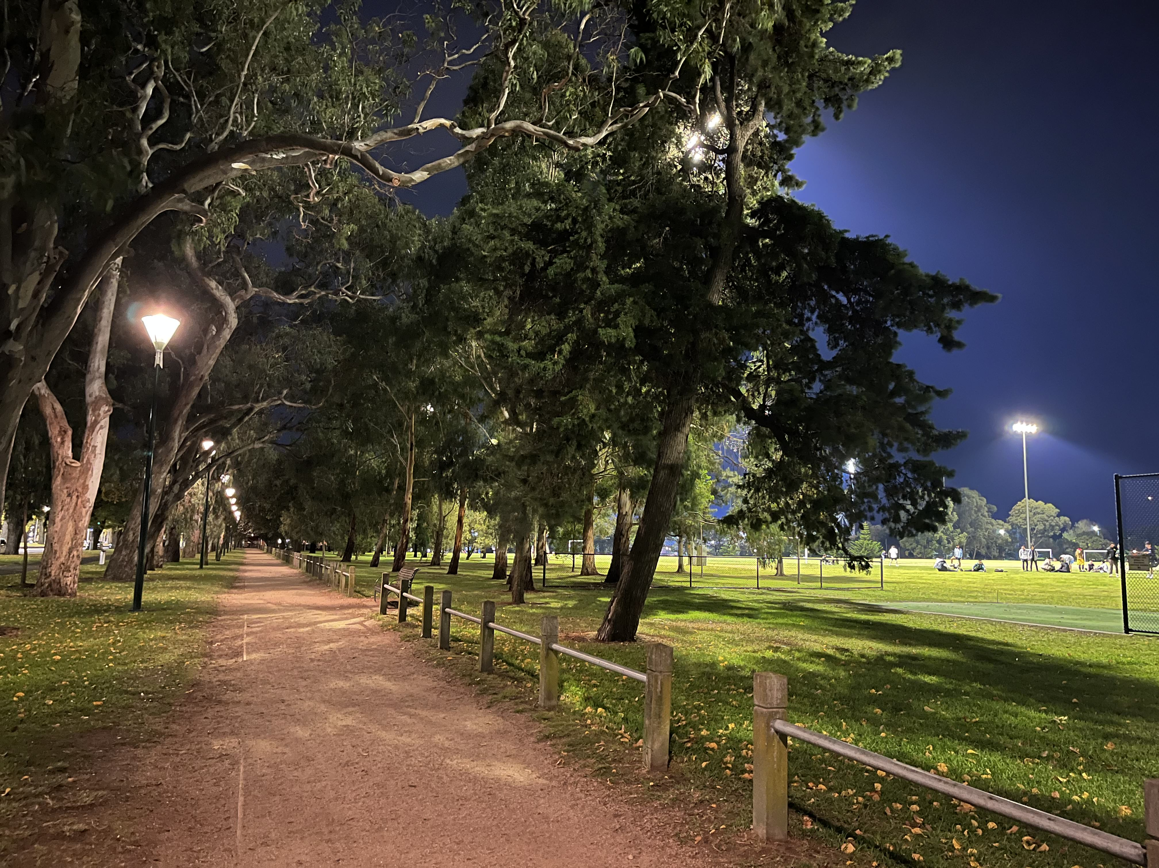
A 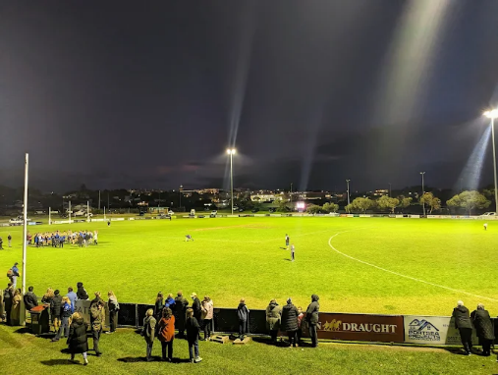

What they disliked or found unappealing
Images B, C, and M were the least appealing types of lit sports facilities amongst participants, who attributed this to:
    - Lighting solely focused on the sports oval/ground: lack of lighting of surrounding areas, pathways, and entry points makes the area look too isolated, resulting in people feeling unsafe as they can’t see what or who is around, and making them feel they would have to drive there
    - Strong floodlights that may impact other residents and wildlife
    - Insufficient, unnatural or glaring lights (particularly M)
    - Less relevant for their usage due to facilities being sports venues rather than walking areas (particularly B/C)

B 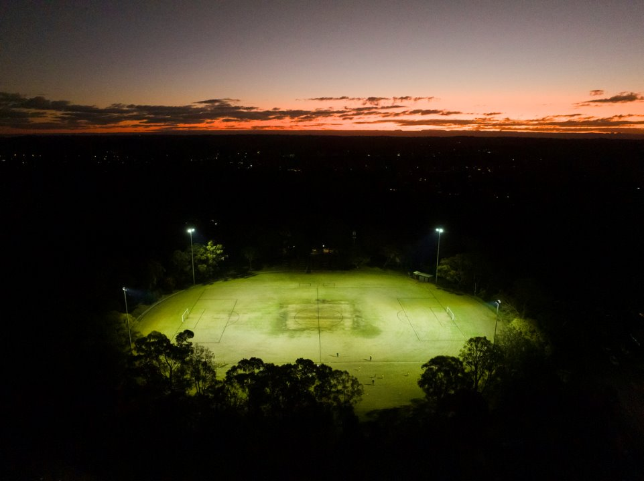
C 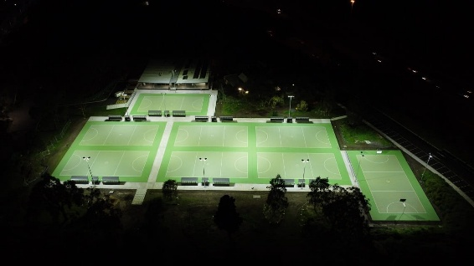
M 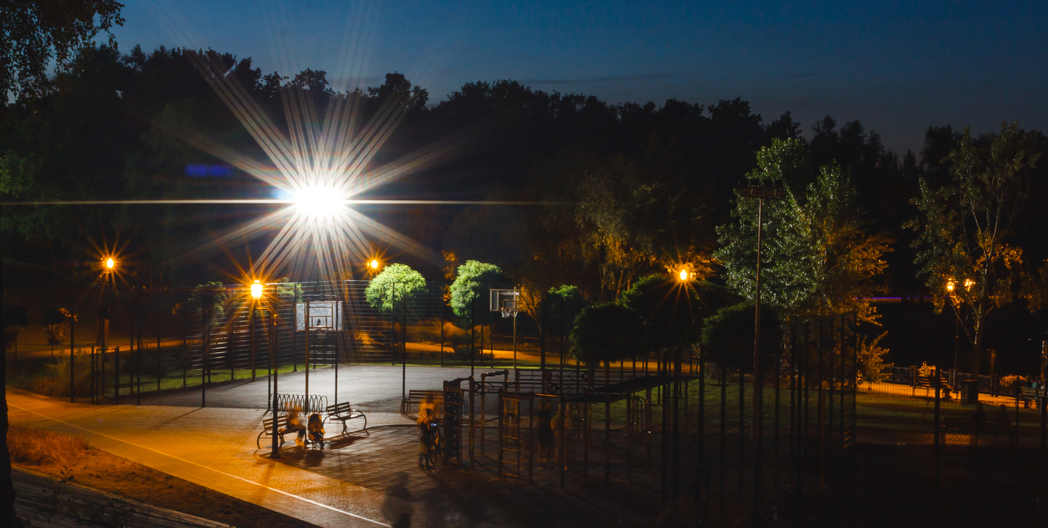

Images presented to participants were intended to provoke thought and discussion about exactly what types of lighting would work best for them. Images were selected to show a variety of lighting styles, and came from three sources: images supplied by SRV; images sourced online by SEC Newgate of local Victorian facilities; photos taken by SEC Newgate.

Specific types of lights
Warmer lights appealed over colder/whiter options

What they liked or found appealing
Images D and C were the most appealing types of lighting, due to:
    - Broad coverage of the area: lighting is powerful, illuminates the entire area well
    - Warmer lighting which feels more natural

D 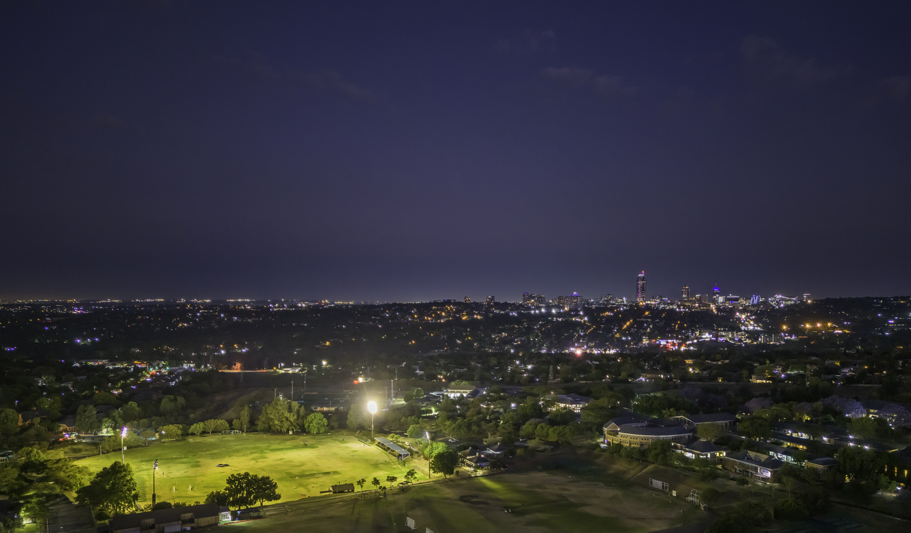
C 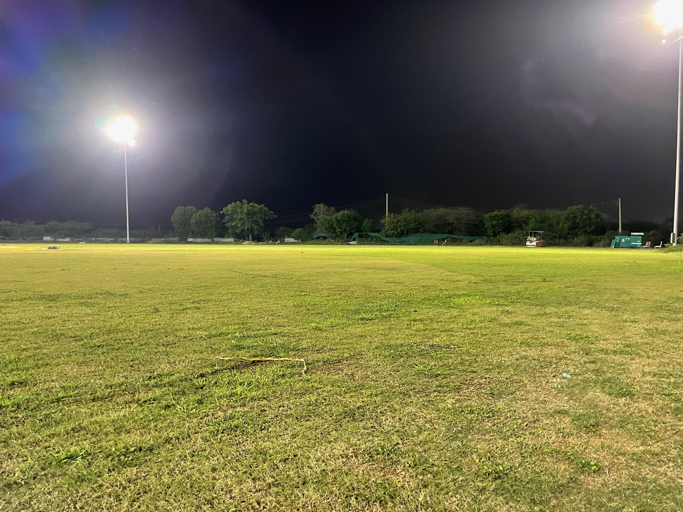

What they disliked or found unappealing
Stimuli F and E were the least appealing types of lighting, due to:
    - Lighting too focused on the sports oval/ground, perceived to be inadequate as leaving surrounding areas and edges dark and shadowy
    - White light that feels a bit too intense

F 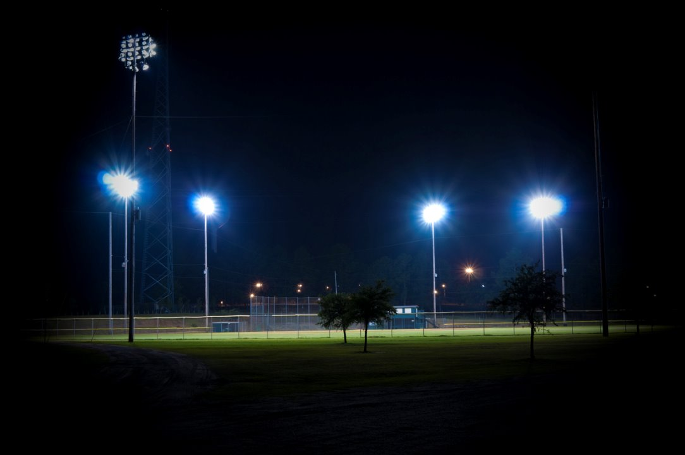
E 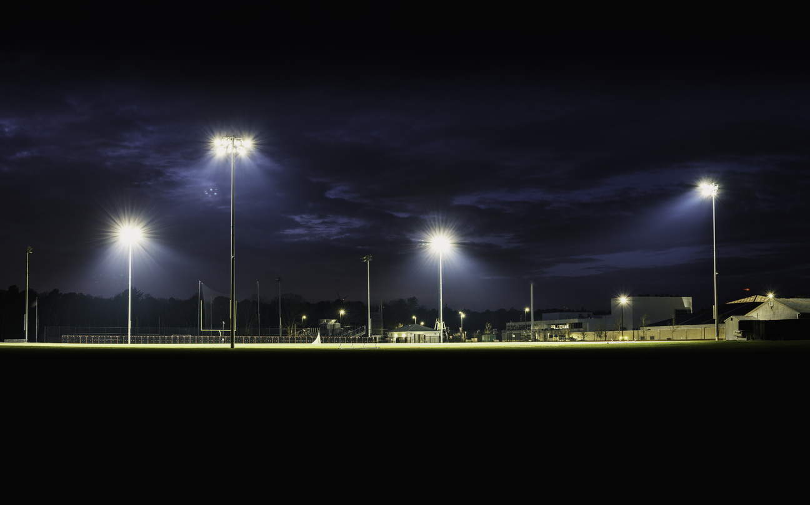

Lighting logistics
When presented with three options about how lights could be switched on, automatic timers were the preferred option, creating reassurance and assisting with foot traffic and planning.

Most preferred lighting option (n=)
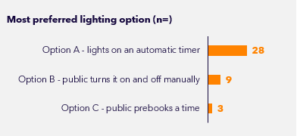
Option A | Lights on an automatic timer | 28
Option B | Public turns it on and off manually | 9
Option C | Public prebooks a time | 3

Most participants would prefer if lights were run on an automatic timer, with days and times set by the local council:
What they liked or found appealing about Option A
    - Regular hours means people will know when the lights are on, helps people schedule it in
    - Facility already being lit upon arrival allows people to assess the safety and appropriateness of using it at that time
    - More likely to be busy / seeing lights on may encourage more people to use the facility

What they disliked or found unappealing about Option A
    - While some feel this an energy-efficient option, others feel it might lead to power waste
    - Might be too busy if people are forced to use it at the same time

Concerns around energy-efficiency were raised by these participants: Options B and C tended to seem as if they would reduce the likelihood of unnecessary energy waste, compared to Option A (though they do rely on people remembering to switch the lights off / turn up for their booking). However, having predictability and reliability of lighting outweighs environmental preferences.
With Option B, people liked the flexibility of being able to use the facility when they wanted to, but were concerned about safety (darkness) getting to the light switch, or the switches being vandalised or misused. Some made suggestions that this should still work on a timer (e.g. once you turn it on it stays on for an hour, and you can reset the timer as needed) as this reduces the chance of lights being kept on accidentally and is safer than anyone being able to turn the lights off manually.
Option C was not favoured by many. Booking felt stressful (too much commitment), strange and/or effortful, and doesn’t allow people to use the facilities spontaneously. Some also felt that this way of using the space might make them feel like they are inconveniencing others or stopping others from using it.

“With A you would know when it is available. I don’t like B because you have to get through the dark to turn it on yourself. With C I don’t like having to book as it ties you in and you’d feel like you might be stopping others from using it.”
- Female, Inactive, Regional, 55-64 (General Community)

“I wouldn’t want someone to have the ability to turn the lights off whilst I’m there (Option B). Pre-booking sounds like too much of a hassle.”
- Female, Inactive, Regional, 35-44 (General Community)

Lighting of pathways
The availability of multiple bright lights consistently spaced along walking paths and a lack of dark spots is important to make people feel safe and comfortable.

What they liked or found appealing
Images A, G, and D were the most appealing types lit pathways, with reasons for this being:
    - Presence of many, bright lights that light up the area well and provide broad coverage, making it easier to be aware of surroundings and making the area feel safer and more inviting. A lack of dark spots.
    - Well-lit walking paths (both sides of the path) without being overkill
    - Wide paths, and separate paths for pedestrians and bikes
*While G and D were popular amongst many, a few found these lights clinical and cold
A 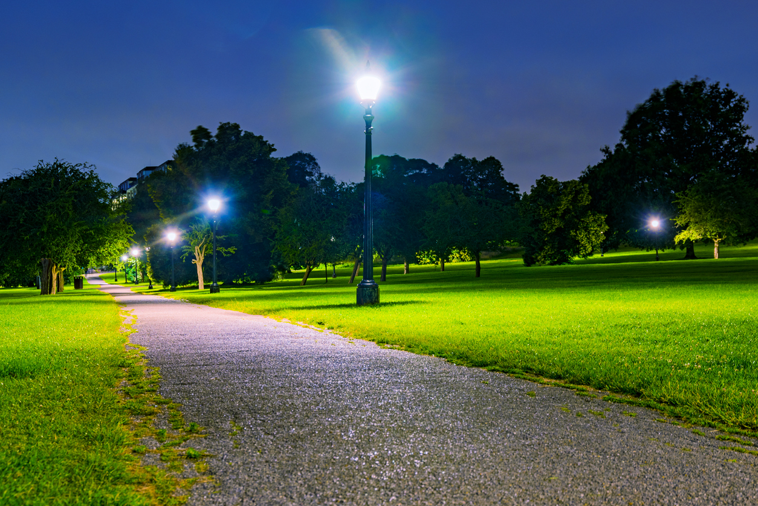
G 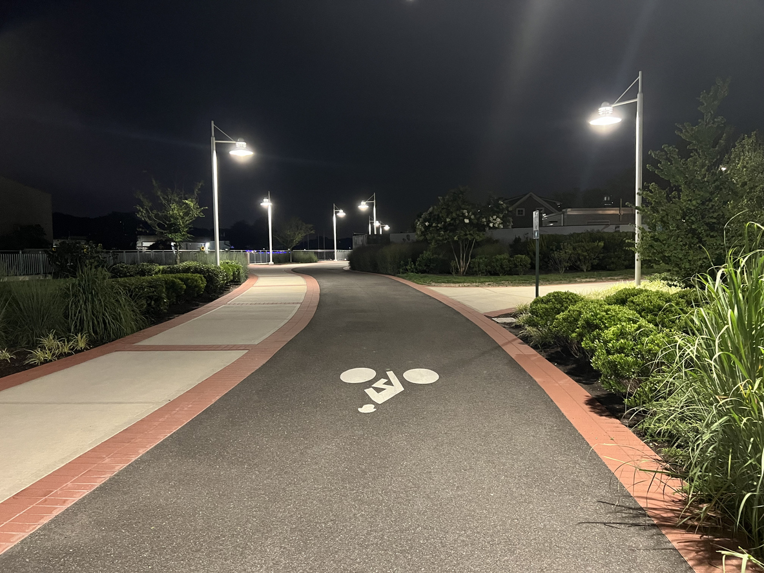
D 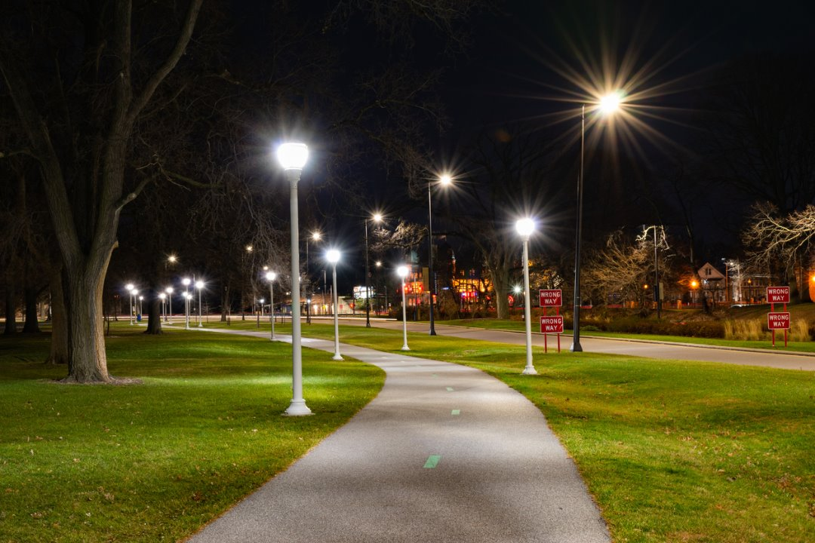

What they disliked or found unappealing
Images C and E were the least appealing types of lit pathways, with reasons for this being:
    - Insufficient amount of light: Lights themselves are dim (particularly C), only lights up the path, too widely spaced out or only on one side, and so still leaves the overall area with low visibility, dark and unsafe
    - An uninviting atmosphere: Dull pathways/environments and yellow lights creating gloomy effect (particularly E)
    - Dark and shadowy environment which can look deserted or where people could be lurking
C 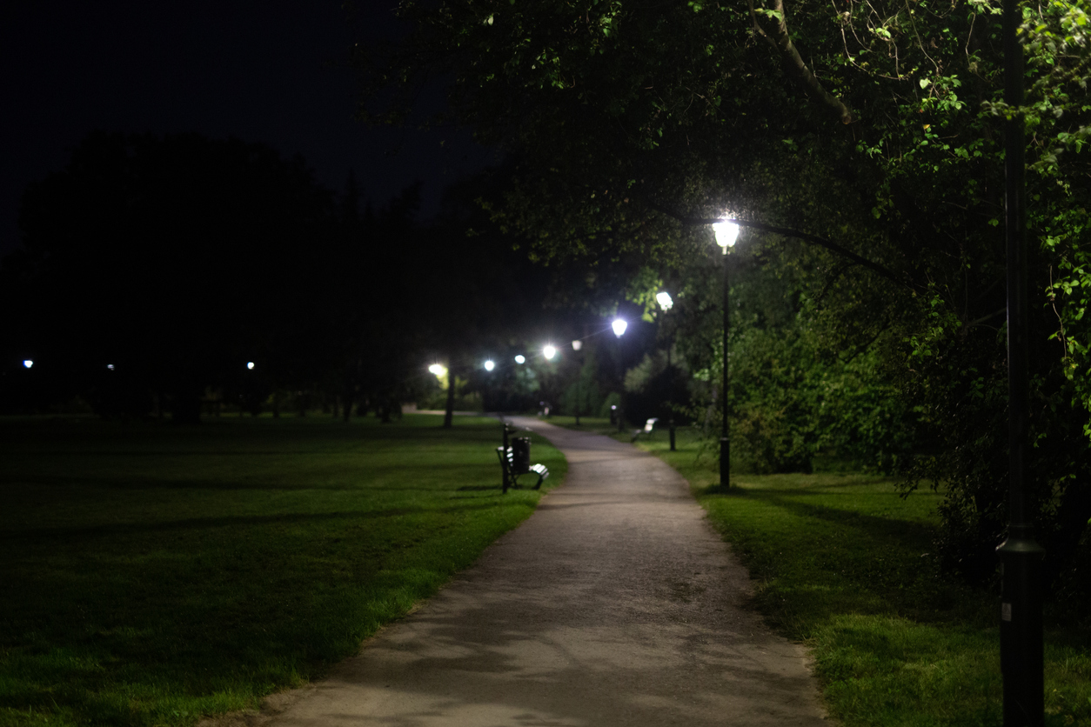
E 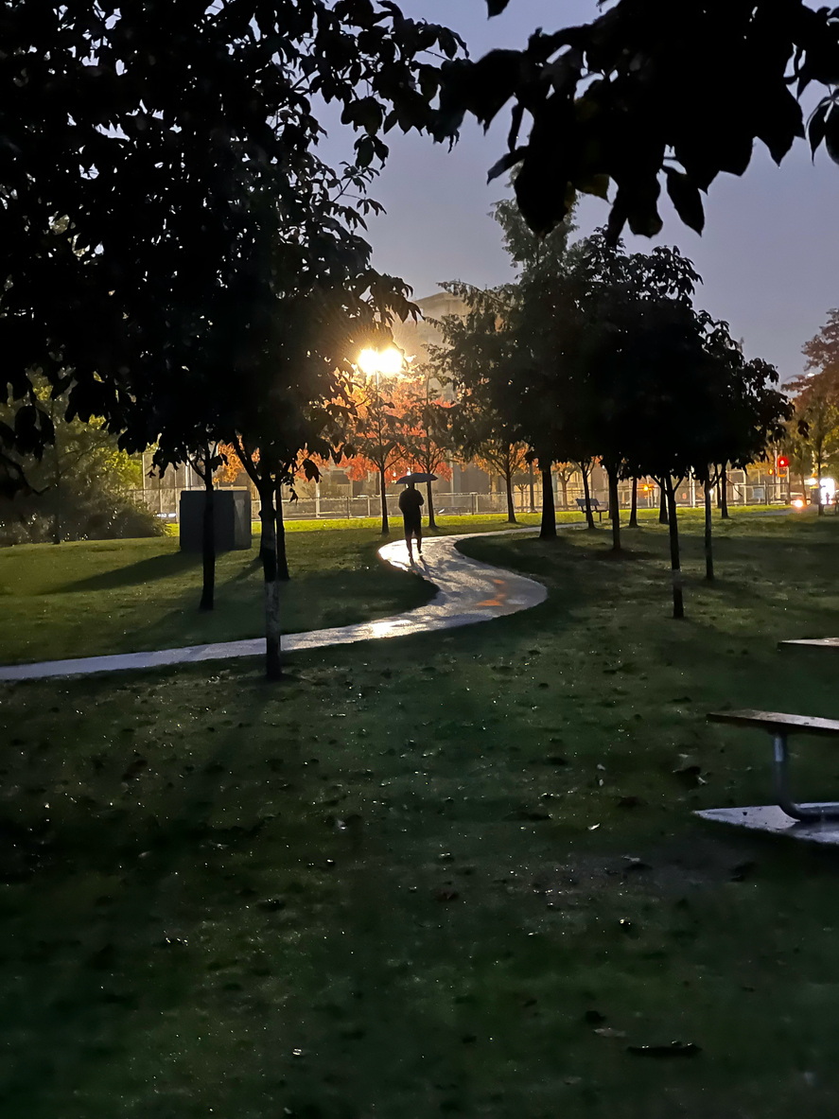

Lighting of car parks
A fully lit car park helps enhance feelings of safety, with many feeling image C was a good example of this.

What they liked or found appealing
The large majority found car park C the most appealing, followed by A
    - Brighter lights overall and an area that is visible and feels safe (from hazards and attacks)
    - An appropriate amount of light covering the area without being overkill
    - C appears to be better lit have slightly more lights, is more evenly lit and covers a broader area than A
C 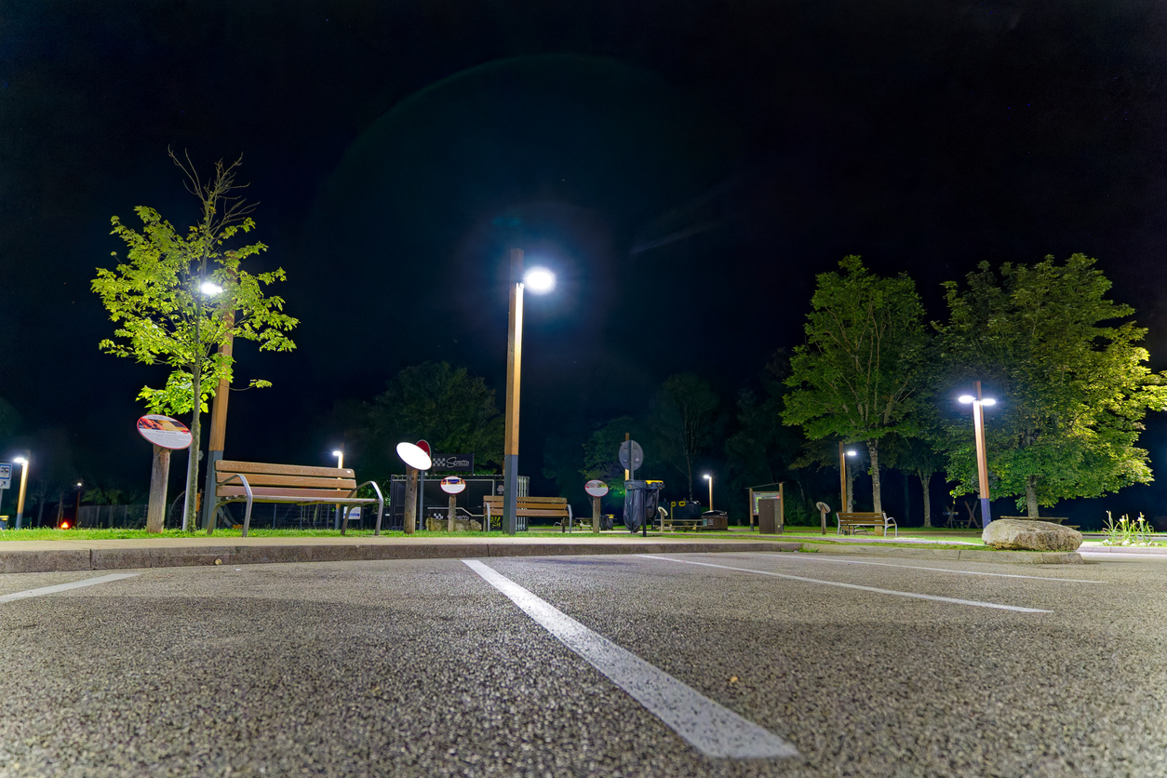
A 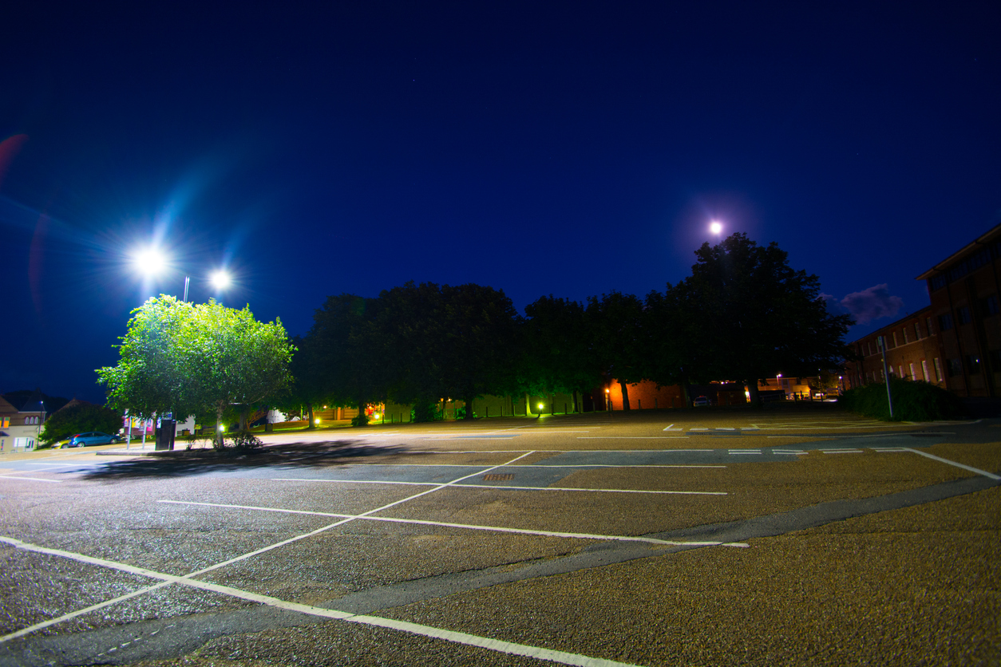

What they disliked or found unappealing
Car park B was unappealing for most, with no one selecting it as the best example of lighting
    - Dark patches and lights only on one side would make people feel uneasy getting back to their car
B 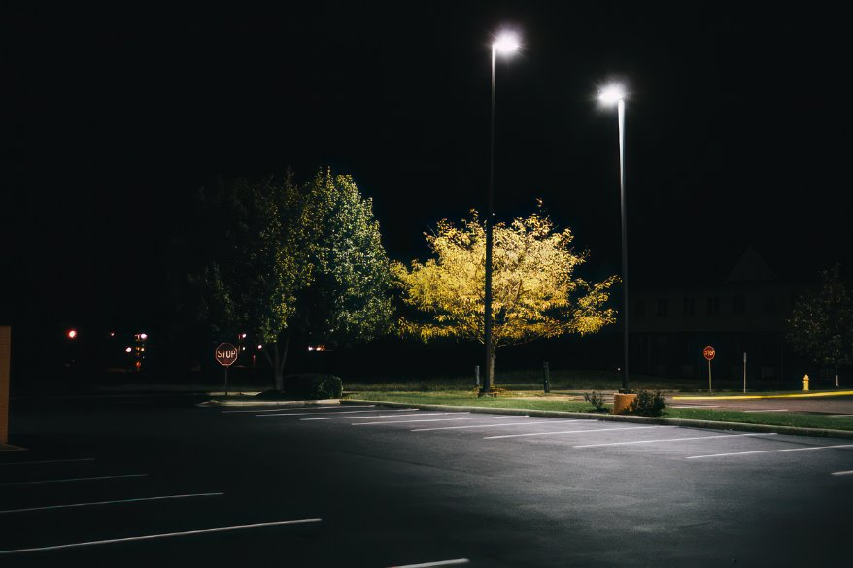

Priority features for accessing lit outdoor facilities
Ensuring good lighting of sports facilities and surrounding areas is crucial to encourage use of these facilities when it is dark outside. Evening lighting was more of a priority than early morning lighting, though both were considered important

High priority (considered very important by over half the sample)
- Good lighting of the area for physical activity at night
- Lighting of car park
- Well-lit path from car park/public transport stop to facility
- Line of sight between road / car park and the area for physical activity
- Lighting that is automatically switched on every night/early morning
- Lit facilities available to use on weekdays
- Lit facilities available to use on weekends
- Good lighting of the area for physical activity in the early morning
- Car parking
- Toilets
- Ability to be active when no one is playing organised sports at the facility
The high priority factor tended to be consistent across our sample.
On balance, good lighting (directly in the area and its surroundings) were the most important features when it comes to using outdoor sports facilities when it’s dark outside.

Medium priority
- Proper (surfaced) walking path around an oval
- Ability to walk there from your home / place of work
- Other members of the public around (i.e. for social / general use)
- Signage saying public are welcome to use the facility for physical activity/recreation
- Having a friend or family member who will come with me
- Grass surface
- Separation between the general public doing personal physical activity and organised teams playing
A proper, surfaced walking path is particularly important in winter when it is rainy and ovals can be muddy.
Notably, having other members of the public around or someone come with them was far more important for females than males

Lower priority
- Dogs allowed
- Ability to be active when people are playing/spectating organised sports at the facility
- Organised activity groups (e.g. walking group) for the general public
- Other people using the facility for personal physical activity rather than organised sport
- Drinking fountain/s
- Sealed surface (such as concrete)
- Public transport availability (e.g. buses, trains)
- Organised times for the general public to use the facility
- Gravel surface
- Dogs not allowed
Those with dogs appear to be more likely to be active outdoors at night if they are able to bring their dog (due to an increased sense of safety, and ability to exercise their dog too). However, it is also important for bins to be available to dispose of poo bags. Those without dogs need to feel safe in areas dogs are allowed (e.g. having a separate off-leash dog area).
Public transport availability was less important for our sample; most were within walking distance to their local facility or able to drive/cycle there easily.

*See Appendix page 32-33 for a full breakdown of how features were ranked by participants in determining the importance of each for outdoor sports facilities when it is dark.

Final thoughts on lighting and advice to SRV

“I think areas being well lit is not enough. There also needs to be other people, security cameras for added extra safety. A community space and signage and advertising to make larger groups of people go.“
- Female, Active, Metro, 35-44 (General Community)

“It will certainly add value to the community and help improve anti-social behaviour and assist with those that suffer mental health issues in particular in the winter months. Even if it does a trial it could further down the track improve businesses and vendors open at night hours and bring more life back to the community after dark.”
- Female, Inactive, Outer East, 45-54 (General Community)

“What a great initiative. I really think it is a positive idea, and it is good to see some councils have already started with this. Hopefully the cost of lighting is not too expensive as my rates are already so expensive and I feel the ratepayer might be picking up the bill! If there is a big need and much interest, it would benefit a lot of people.”
- Female, Inactive, Inner Melbourne, 55-64 (Target)

“This made me think of how many cultures are much more active at night. I teach international students and they are often quite surprised that everything is so sleepy at night here. So, having lit-up areas and activities at night could be a real game changer. I also thought about teenagers. I imagine they may find lit-up parks appealing when there's not much to do, or they don't have spare cash to go to the movies, etc.”
- Female, Inactive, Inner Melbourne, 55-64 (Target)

“If you want to get individuals or small groups to use these facilities, you need to focus on how they can be used either separately or in conjunction with larger groups who will inevitably dominate these spaces.”
- Male, Inactive, Inner Melbourne, 35-44 (General Community)

“Do not play organised sport off against recreational park users. Everyone can co-exist. Make sure the people running the park have experience in both areas.”
- Male, Active, Inner Melbourne, 55-64 (General Community)

“Whilst I still couldn’t see myself likely to use a facility at night-time in this phase of life besides a few one-off occasions, I think it’s an amazing idea and very important to do this for the members of the public who would really benefit from these spaces being well lit and made much more safe by appropriate lighting.”
- Female, Inactive, Regional, 35-44 (Target)

“We lead busy lives in Melbourne, but we also like an opportunity to get out and get active. What helps is where can do so flexibly, close to home, and in a location that feels safe to use. What really encourages us is when it is also a space we feel nice in and lighting can go a long way in playing a role for that. […] If you're really trying to incentivise people, why not combine certain spaces with specific light displays during the winter, to make it not only inviting, but attractive to access?”
- Female, Inactive, Inner Melbourne, 35-44 (Target)

Appendix

Interest/likelihood to use ratings

Interest in outdoor sports facilities when dark – BEFORE STIMULUS Day 2

Likelihood using outdoor sports facilities when dark – BEFORE STIMULUS Day 2

Interest in outdoor sports facilities when dark – AFTER STIMULUS Day 2

Likelihood using outdoor sports facilities when dark AFTER STIMULUS Day 2

*Full ratings included for interest. Please note this is qualitative research and these proportions cannot be extrapolated to the general population (due to small sample size and specific recruitment specifications used).

Important features for accessing outdoor sports facilities when it is dark
A list of features were presented to participants in in a prioritisation exercise to determine their importance for outdoor sports facilities. The table below presents the number of participants who placed the feature in each category and it’s clear that features relating to good lighting are high priorities. Please note that due to the small sample size, the way our sample was recruited, and how discussions were framed, results should be treated as indicative only.
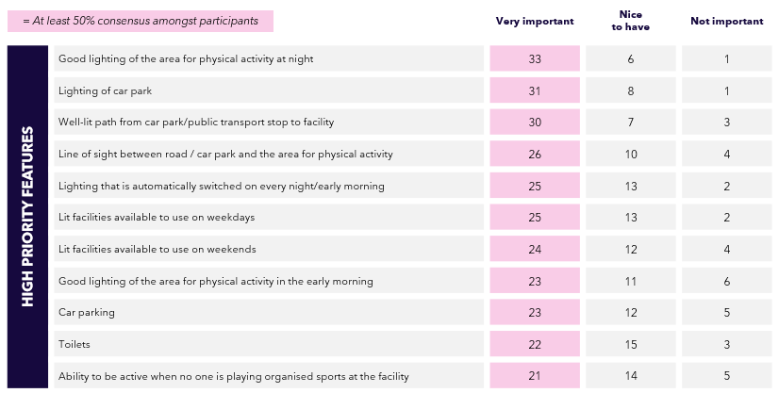
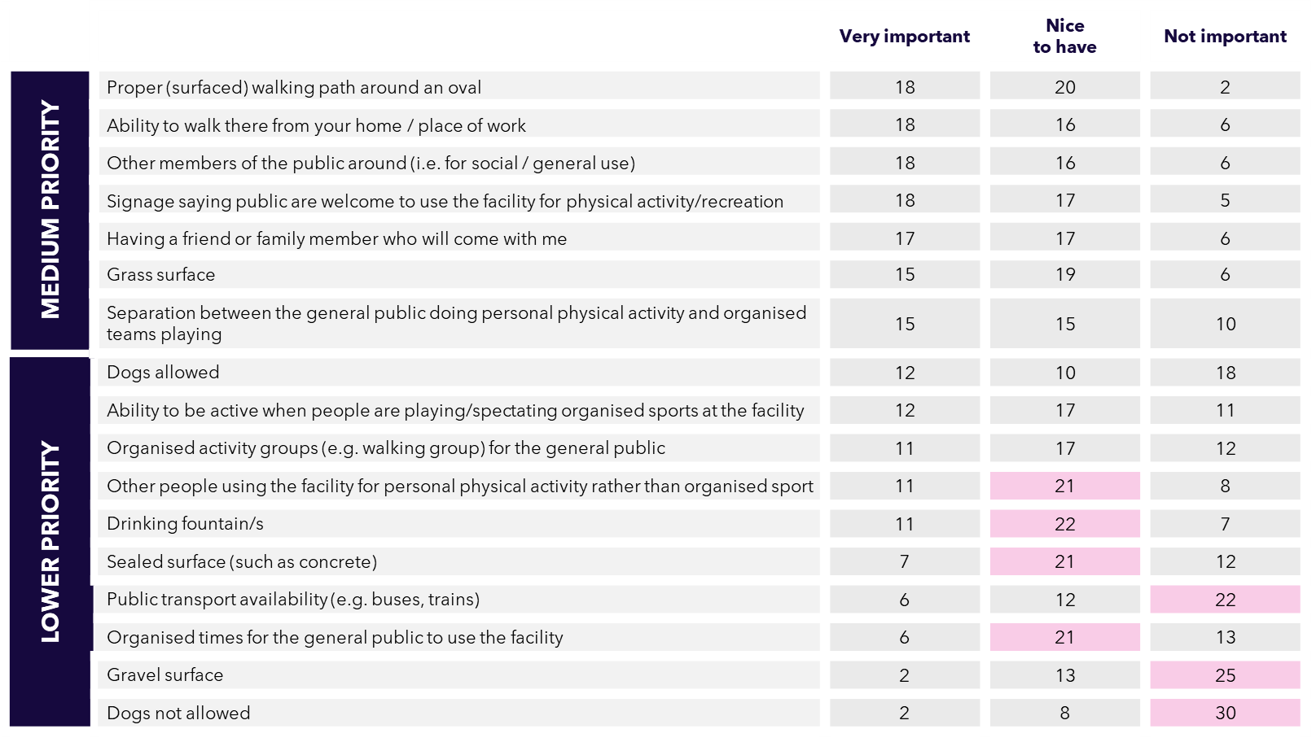
*Full ratings included for interest. Please note this is qualitative research and these proportions cannot be extrapolated to the general population (due to small sample size and specific recruitment specifications used).

Images of Outdoor Sports Facilities
A: Caulfield Park (path between two ovals)
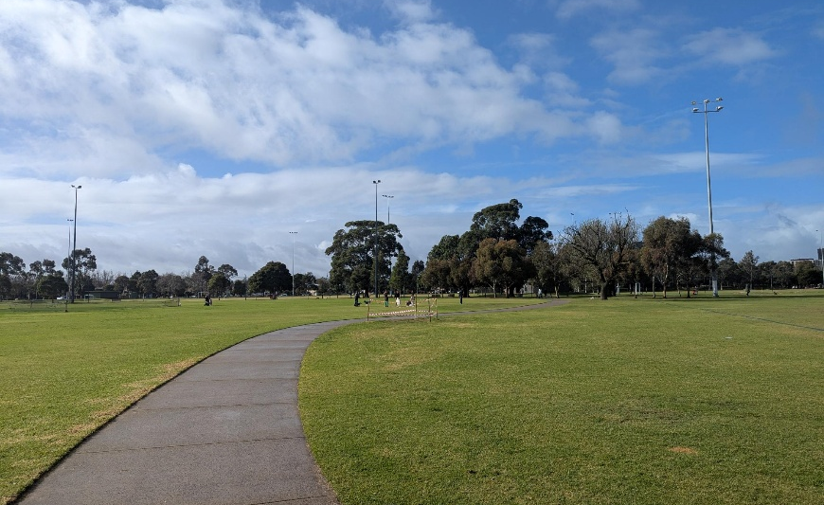
B: Macleay Park, Balwyn North (Oval 1 – soccer and cricket field)
C: Lewin Reserve, Glen Iris (grass area used for rugby/football/cricket and an off-lead dog area)
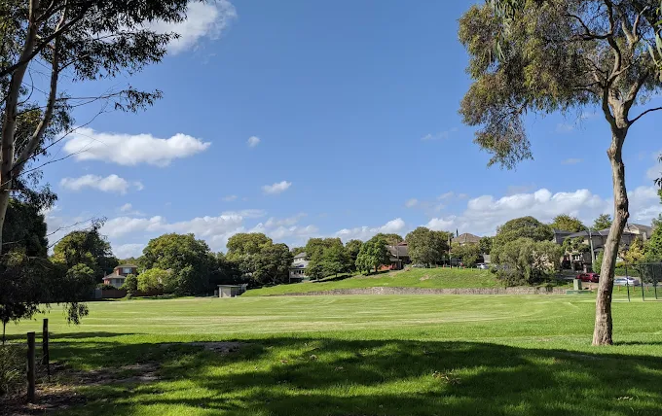
D: Macleay Park, Balwyn North (cricket/soccer/general sports field)
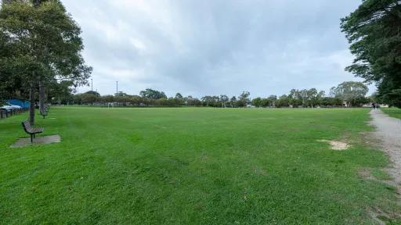
E: Edinburgh Gardens, Fitzroy North (smaller oval and off-lead dog area)
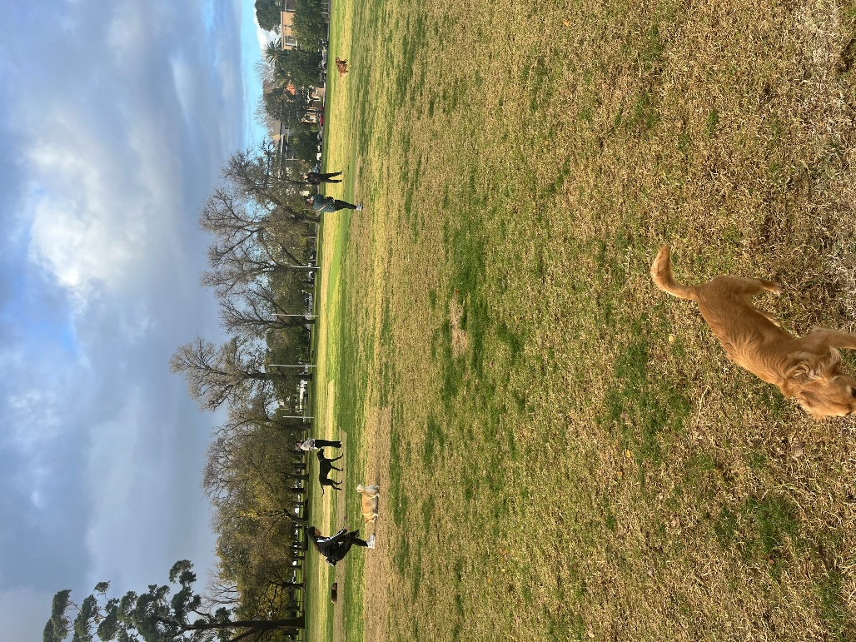
F: Edinburgh Gardens, Fitzroy North (bigger oval – no dogs allowed)
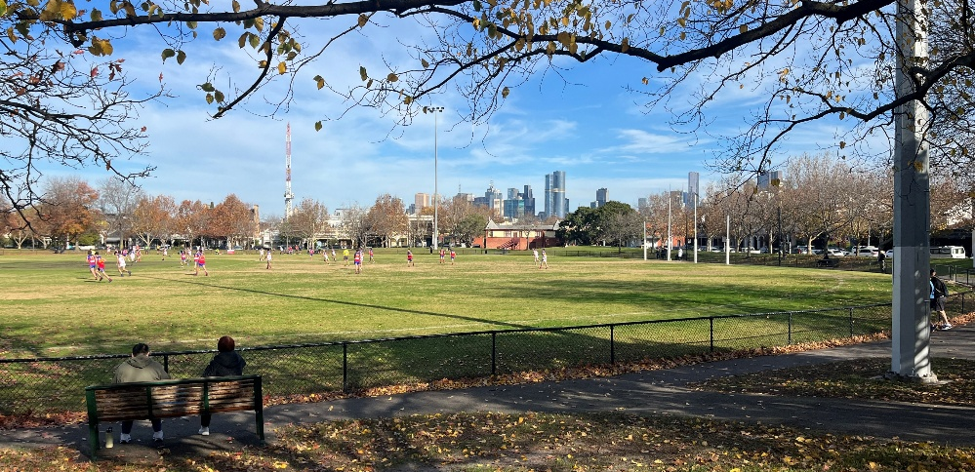
G: Fairlea Netball Precinct
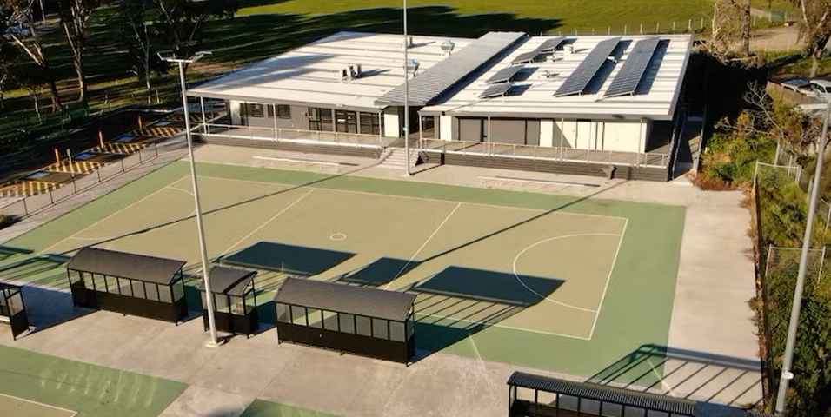
H: RF Julier Reserve, Port Philip
I: RF Julier Reserve, Port Philip (outdoor basketball and netball)
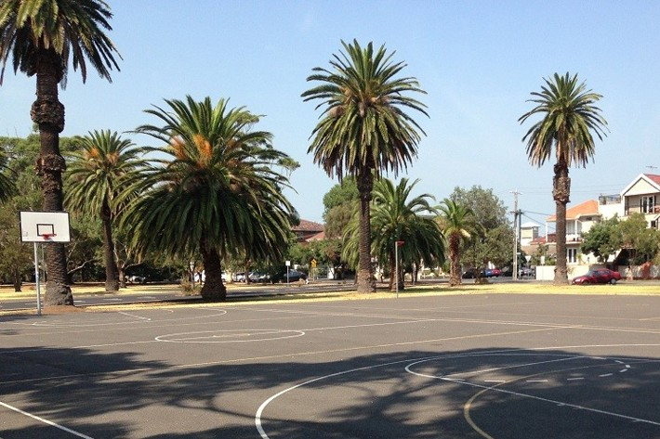
J: Bridgewater Recreation Reserve
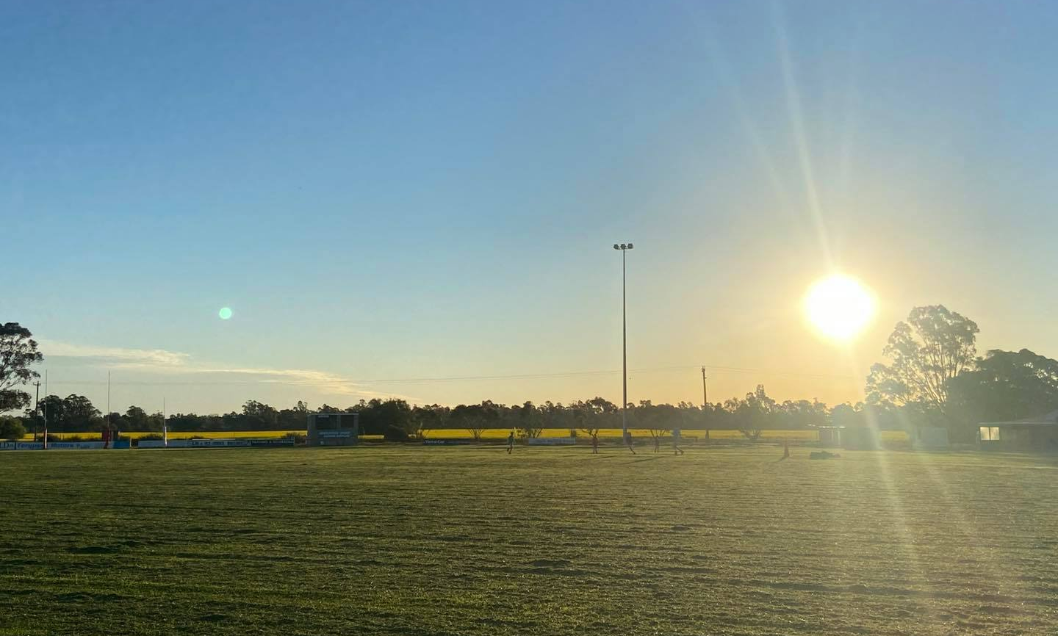
K: Wyndham Regional Football Facility, Tarneit
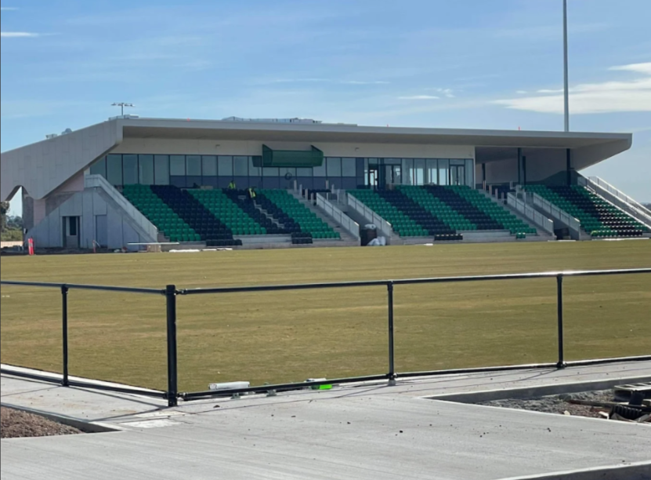

Images of Lit Sports Facilities

A: Sorrento Football Netball Club
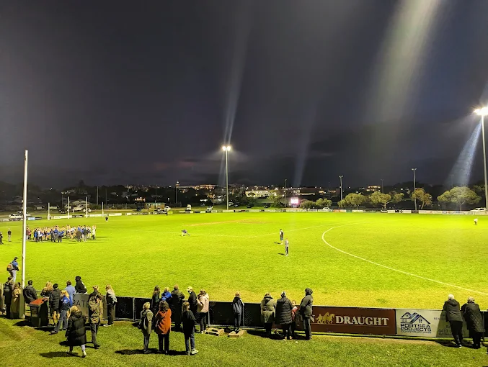
B Image supplied by SRV (iStock)
C: Fairlea Netball Precinct
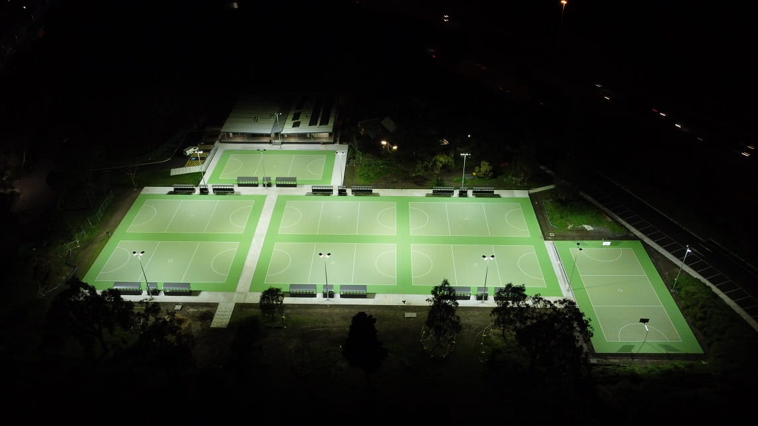
D: Princes Park (Parkville)
E Image supplied by SRV (iStock)
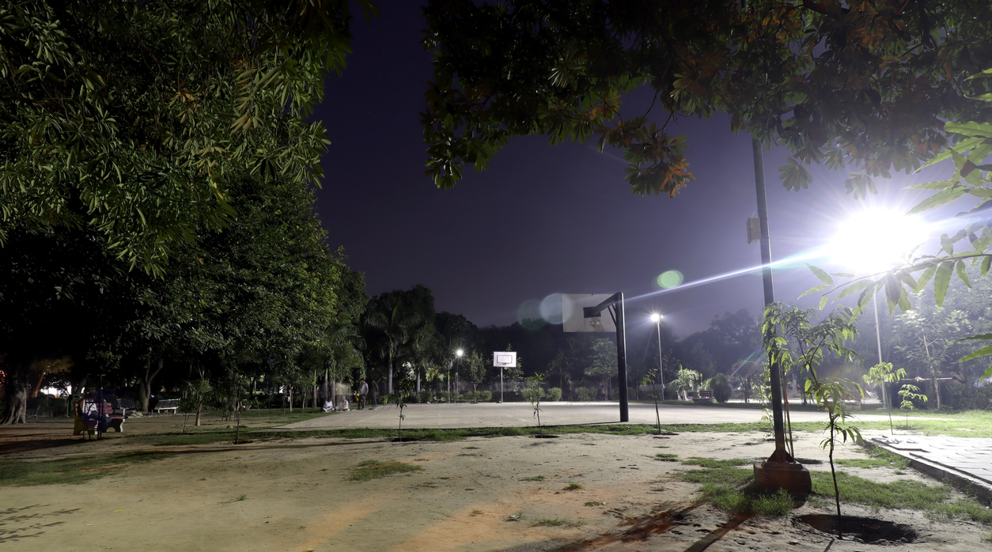
F Image supplied by SRV (iStock)
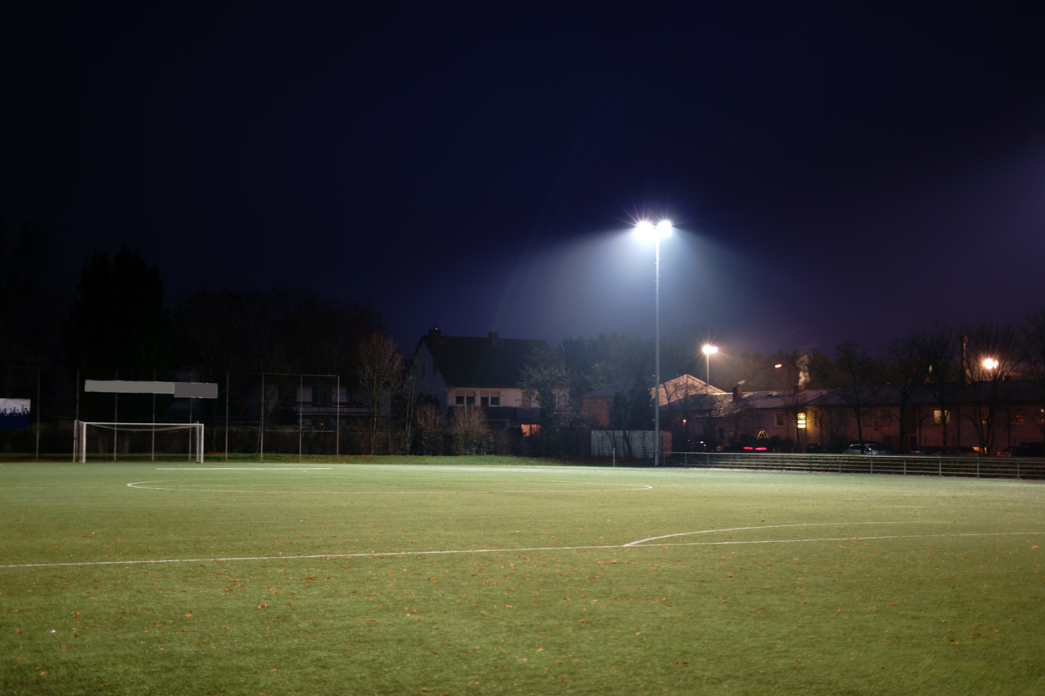
G Image supplied by SRV (iStock)
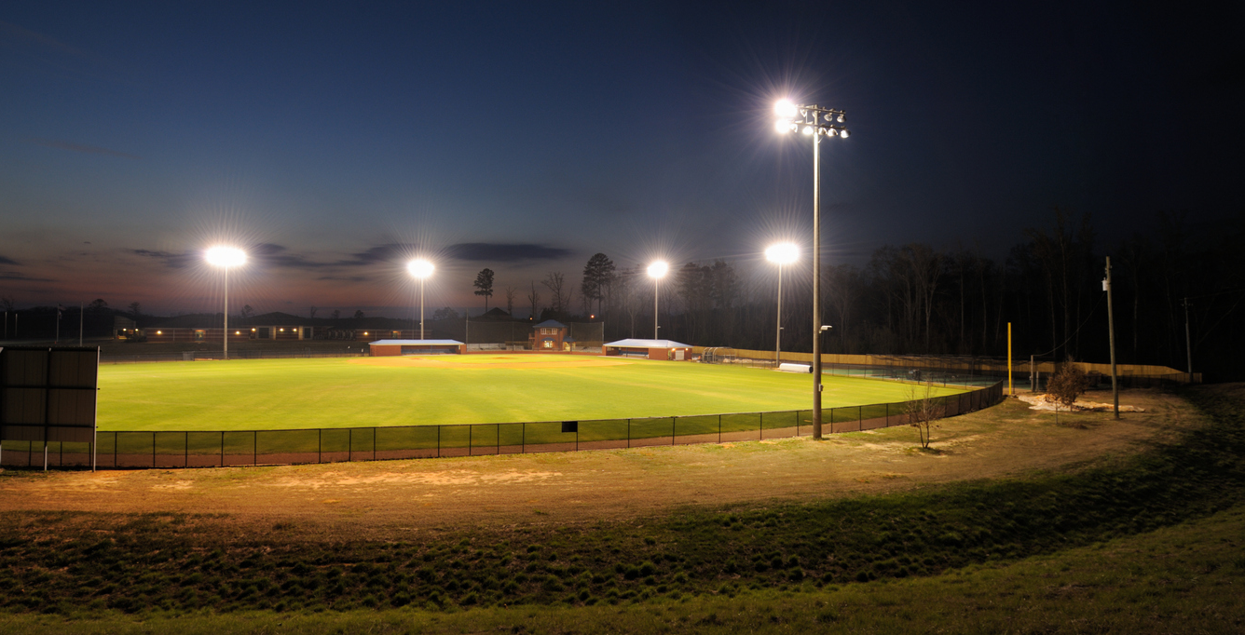
H: Wootten Road Reserve, Tarneit (supplied by Wyndham Council)
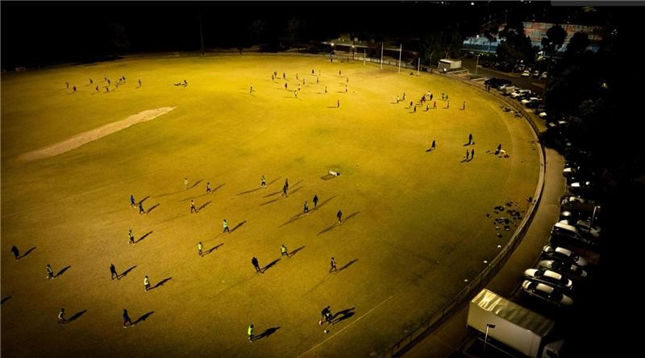
I Image supplied by SRV (iStock)
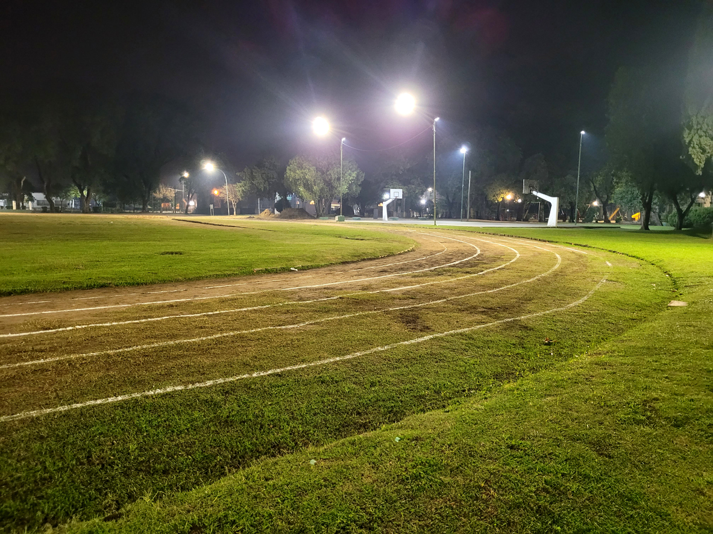
J Image supplied by SRV (iStock)
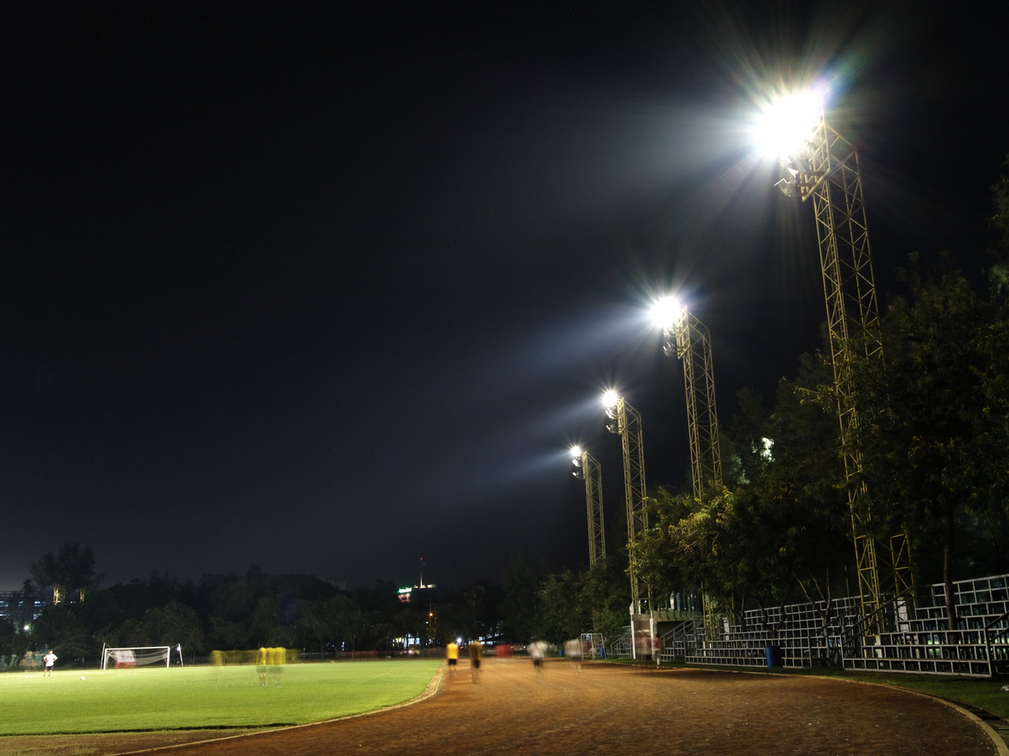
K Image supplied by SRV (iStock)
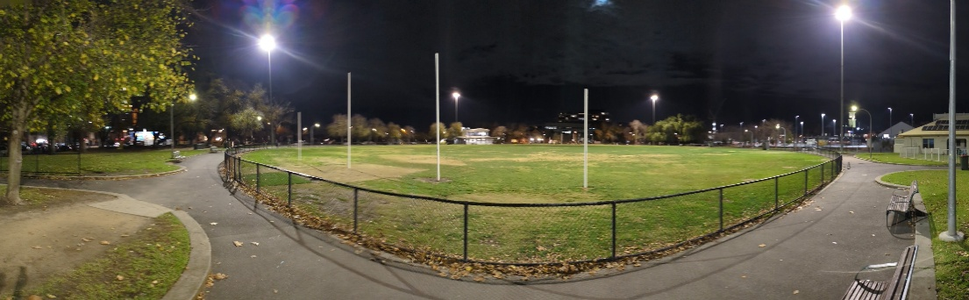
L Image supplied by SRV (iStock)
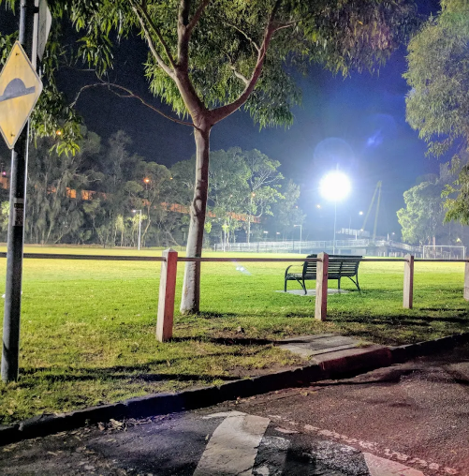
M Image supplied by SRV (iStock)

Specific types of lights
Images supplied by SRV (iStock)
A 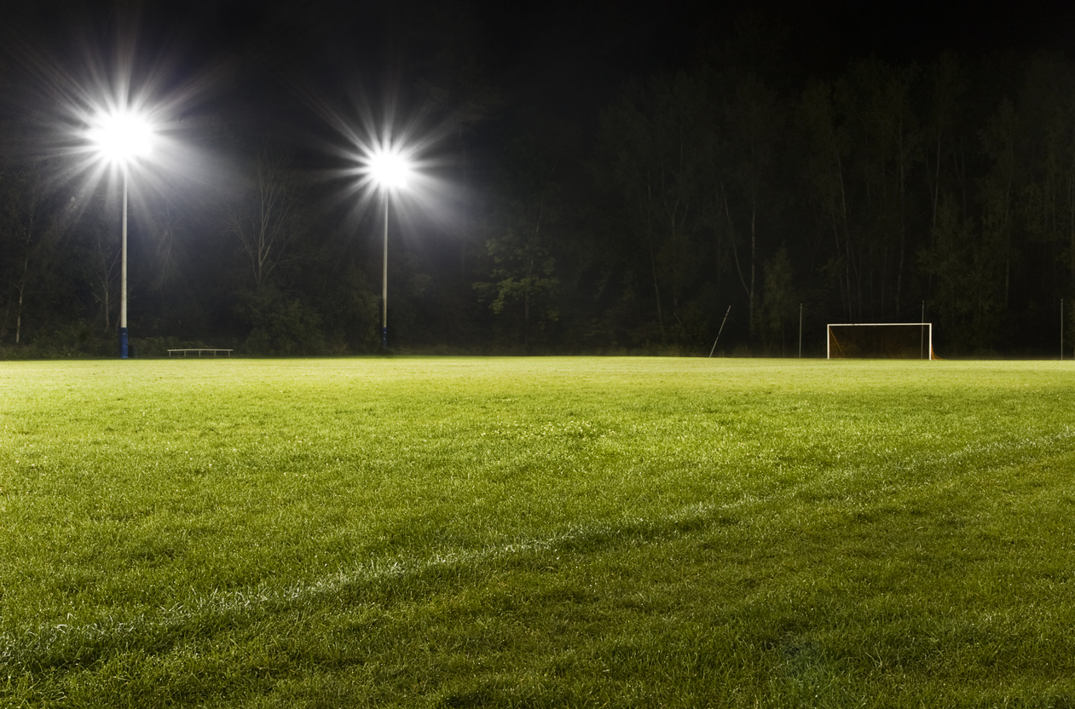
B 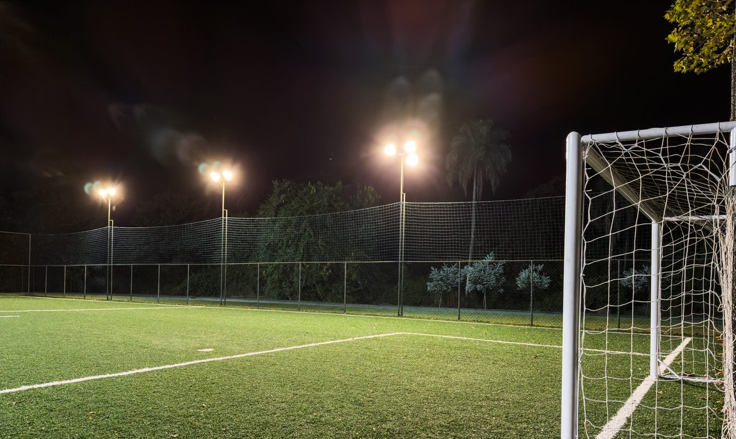
C
D
E
F

Lighting of pathways
Images supplied by SRV (iStock)
A
B 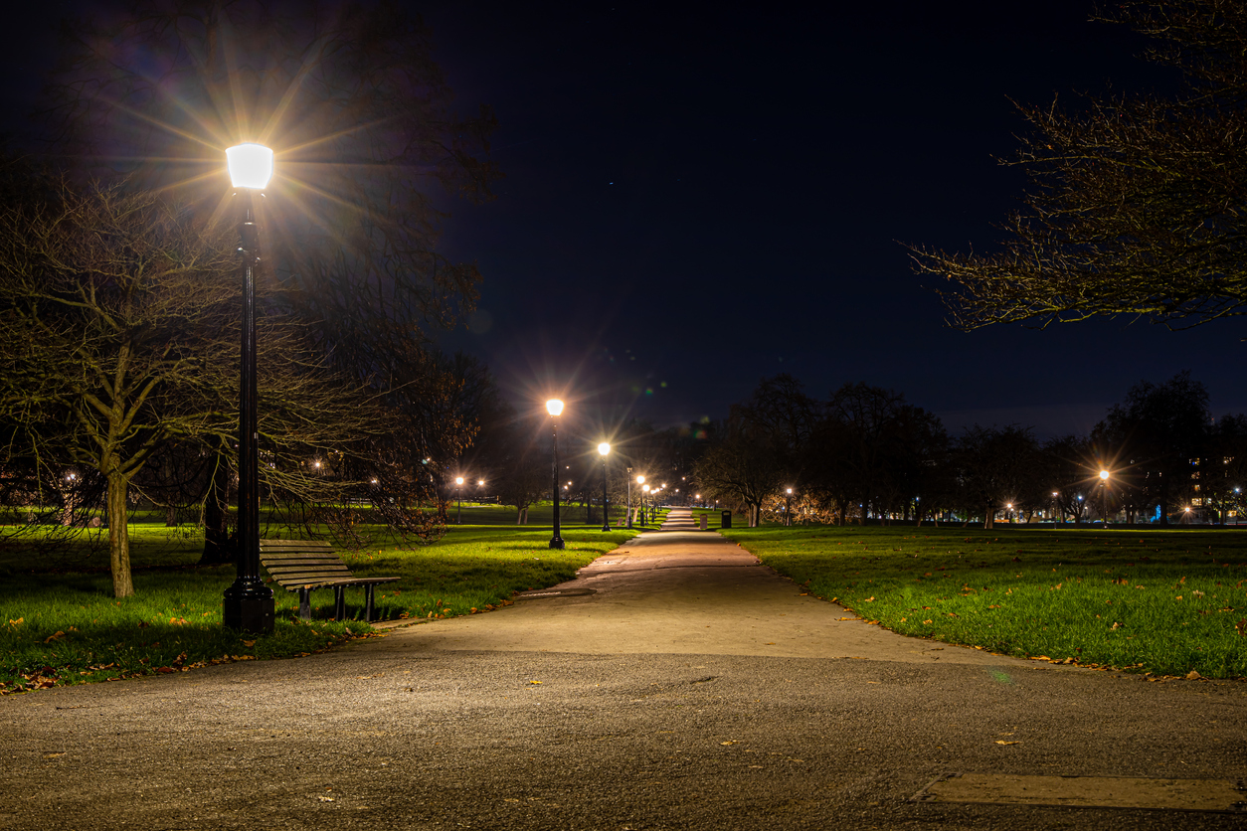
C
D
E
F 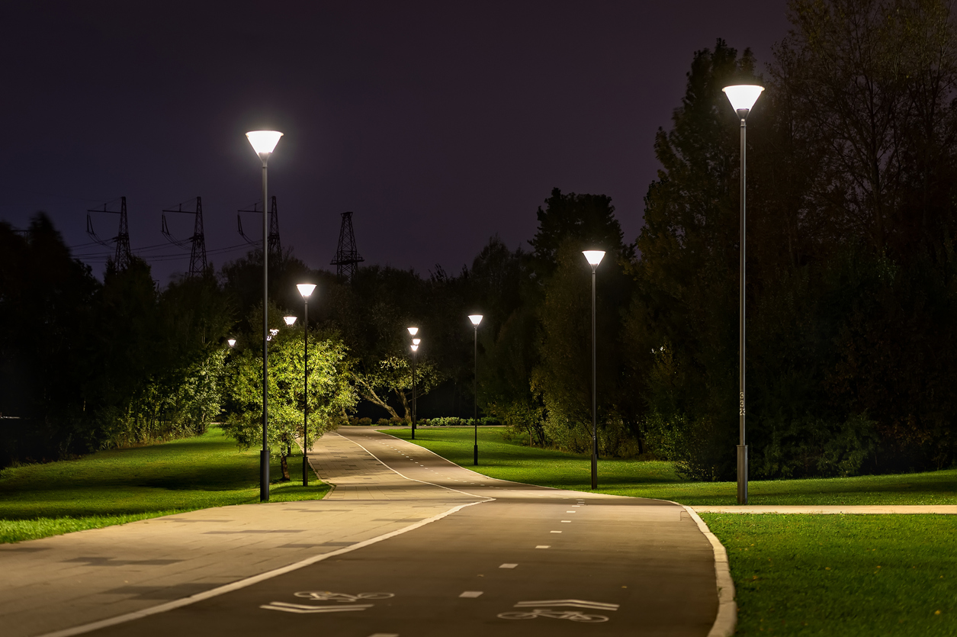
G
H 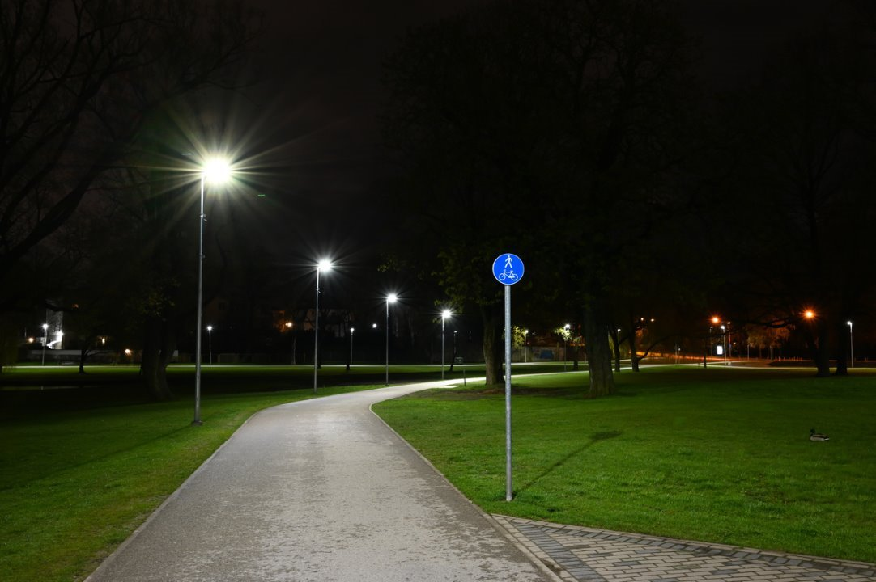

Lighting of car parks
Images supplied by SRV (iStock)
A
B
C

Contact
SEC Newgate Australia Pty Ltd ABN 38 162 366 056
Level 17, 35 Collins Street
Melbourne VIC 3000
T +61 3 9611 1800
E: melbourne@secnewgate.com.au
W: secnewgate.com.au

