What is a Project Management Framework?

A Project Management Framework is a detailed breakdown of all the required tasks that need to be undertaken as part of a project, as well as a timeline for each task and who is responsible for its implementation.

Why is a Project Management Framework important?

A Project Management Framework is used to assist in tracking, evaluating and communicating the progress of a project. It is important for the Project Manager to know at what stage the project is at any given time. A Project Management Framework is useful to assist in keeping the project on track and determining how long it will take to complete the project.

How do I create a Project Management Framework?

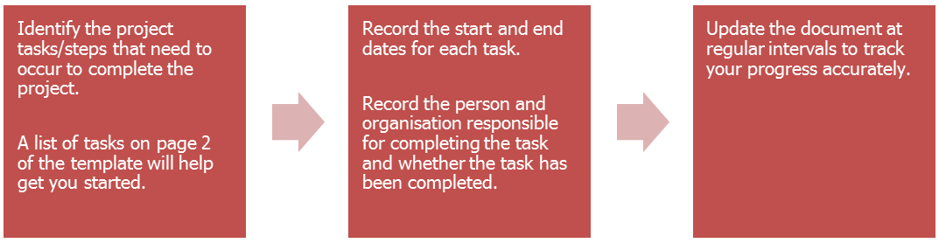
The following steps accompany the template Project Management Framework provided by Sport and Recreation Victoria. This is a guide only and you are free to use/modify the template or use your own.

Project Variations: If there is a need to vary any aspect of the project, please discuss these changes with Sport and Recreation Victoria as early as possible.

Who do I contact for further clarification?
For further information on the Project Management Framework please contact your Sport and Recreation Victoria representative.

Infrastructure Projects: Task examples for inclusion
The table on the following page contains example inclusions for a Project Management Framework. This table and its contents is not an exhaustive list and should be used as a guide only. Council is encouraged to include any additional steps relevant to their project. Some steps in this list may not be relevant to your project.

Task Examples for Inclusion
Form Project Steering Group | Issue planning permit | Appoint contractor
Recruit project manager | Issue building permit | Works commence on-site
Engage stakeholders | Design & consultants brief | Site preparation
Consult industry bodies | Project board review approval brief | Construction by contractor
Appoint design consultants | Report to council | Works completed on-site
Prepare concept design drawings | SRV outcome advised | Inspect & Issue practical completion certificate
Obtain cost plan A | Approve concept design & project cost estimates | Occupancy permit
Signoff from stakeholders | Activity Schedule signed | Inspect & issue final completion certificate
Prepare planning permit application documents | Prepare drawing specification | Acknowledgement plaque
Submit planning permit application documents | Advertise tenders | Official opening
Advertise planning permit application | Receive & evaluate tenders | Final claim with supporting documents to SRV
Prepare & submit building permit application | Prepare tender contract documents
Planning Projects: Task examples for inclusion
Project brief finalised | Community engagement and consultation | Draft plan released for public review
Literature review | Draft plan developed | Plan endorsed/adopted by Council
To receive this publication in an accessible format please phone the National Relay Service on 13 36 77.
Authorised and published by the Victorian Government.
© State of Victoria, 2019. Except where otherwise indicated, the images in this publication show models and illustrative settings only, and do not necessarily depict actual services, facilities or recipients of services. This publication may contain images of deceased Aboriginal and Torres Strait Islander peoples.

Project Details:
Project title
Council name |  | PMF version date
Project Manager Details:
Name: |  | Address
Position |  | Phone number
Organisation |  | Email

Project task | Start date | End date | Task responsibility | Responsible organisation | Task Complete (Y/N)
Eg: Design & consultants brief | 12/06/2012 | 12/07/2012 | John Citizen | Example City Council | N
Note: All minutes and agendas of project meetings should be forwarded to your SRV representative. Please add tasks as appropriate.
Summation of project issues and challenges
(Note variation in proposed and actual timeframes)

