

The Conversation of Sport

Representation of women in sports news coverage

FIFA Women’s World Cup 2023 Case Study
Contents
The FIFA Women’s World Cup 2023 elevated the visibility of women’s
sport through sports news coverage. 3
News coverage of women’s sport increased during
FIFA Women’s World Cup 2023 4
Coverage of women in sports news more than doubled during the
FIFA Women’s World Cup 2023. 5
Coverage of women’s sport overtook men’s sport on 3 days 6
1 in 5 of all sports stories were about women’s football (soccer) 9
The Matildas were the most mentioned athletes and sporting team 10
Shifting the narrative 11
More women covering sport 12
Storytellers – the sources 14
Scope of study 17

The Victorian Government proudly acknowledges Aboriginal people as the First Peoples and Traditional Owners and custodians of the land and water on which we rely.
We acknowledge the ongoing leadership role of the Aboriginal community on gender equality and the prevention of violence against women. As First Peoples, Aboriginal Victorians are best placed to determine a culturally appropriate path to gender equality in their communities.
Authorised by the Victorian Government
© Copyright State of Victoria 2024
ISBN 978-1-76090-671-9
Except for any logos, emblems, trademarks, artwork and photography this document is made available under the terms of the Creative Commons Attribution 3.0 Australia license.

The FIFA Women’s World Cup 2023 elevated the visibility of women’s sport through sports news coverage.
The purpose of this study is to analyse the coverage of women’s sport, and women in sport, in Victoria during the FIFA Women’s World Cup 2023.
The Matildas’ performance at the tournament marked the most successful achievement by any Australian Senior National Team in a FIFA tournament. The tournament saw a spike in fan engagement, with almost 2 million fans attending matches – 500,000 more than initial targets and projections. Australia’s 7 matches during the tournament attracted an average of 57,591 attendees for each match, accounting for 99.92% of capacity at each venue (across Melbourne, Brisbane and Sydney). Seven’s coverage of the FIFA Women’s World Cup 2023 reached 18.6 million broadcast viewers with an additional 3.82 million on 7plus.
This study provides comparisons to the analysis of sports news coverage for 2022-23, which created a baseline of the coverage of women’s sport in Victoria. Throughout this summary, this initial research is referred to as the baseline year. Read the Conversation of Sport: Representation of Women in Sports News Coverage 2022-23.
Throughout the report football (soccer) is referenced.

News coverage of women’s sport increased during FIFA Women’s World Cup 2023
Balance of coverage 2022-23
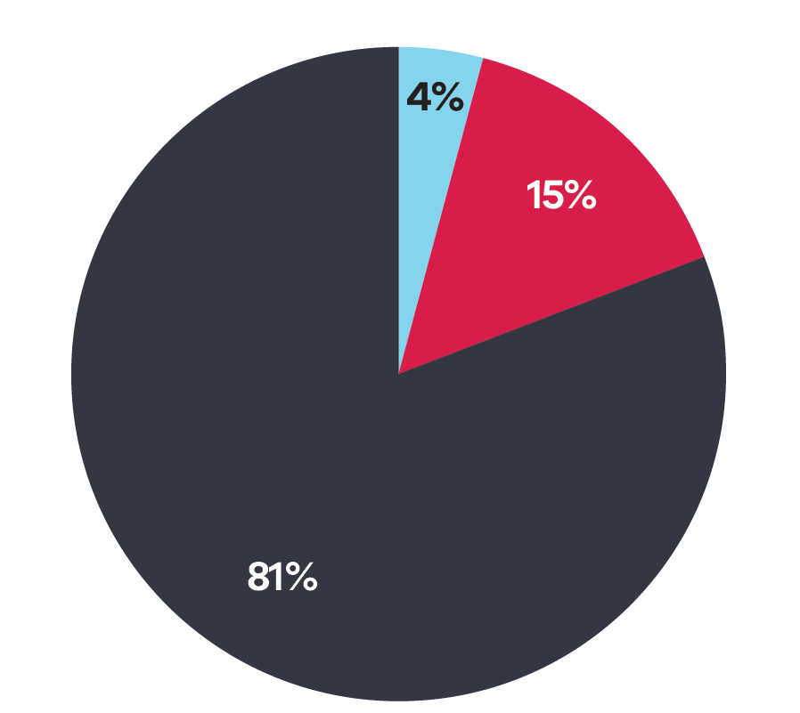
Women | Men | Other
15% | 81% | 4%

Balance of coverage 2022-23
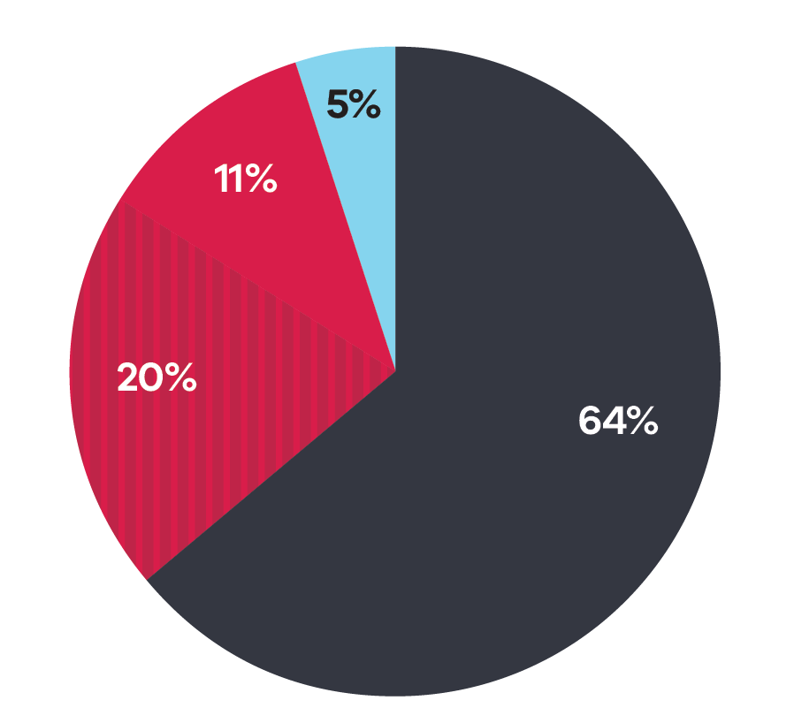
Women | WWC | Men | Other
11% | 20% | 64% | 5%
Other includes No Gender (for example a sportwide focus), Multiple Genders (for example AFL and AFLW are mentioned), Transgender (if mentioned or self-identified) and Non-Binary (if mentioned or self-identified).

Coverage of women in sports news more than doubled during the FIFA Women’s World Cup 2023.
31% of sports news was focused on women’s sport, with 20% specifically on the FIFA Women’s World Cup 2023.
The coverage of women in sports news outside of football remained similar to the baseline year (13% to 11%), whereas coverage of men in sports media decreased from the baseline (81% to 64%).

Coverage of women’s sport overtook men’s sport on 3 days
The 3 days where women’s sport coverage overtook men’s coincided with key moments for the Matildas during the FIFA Women’s World Cup 2023.
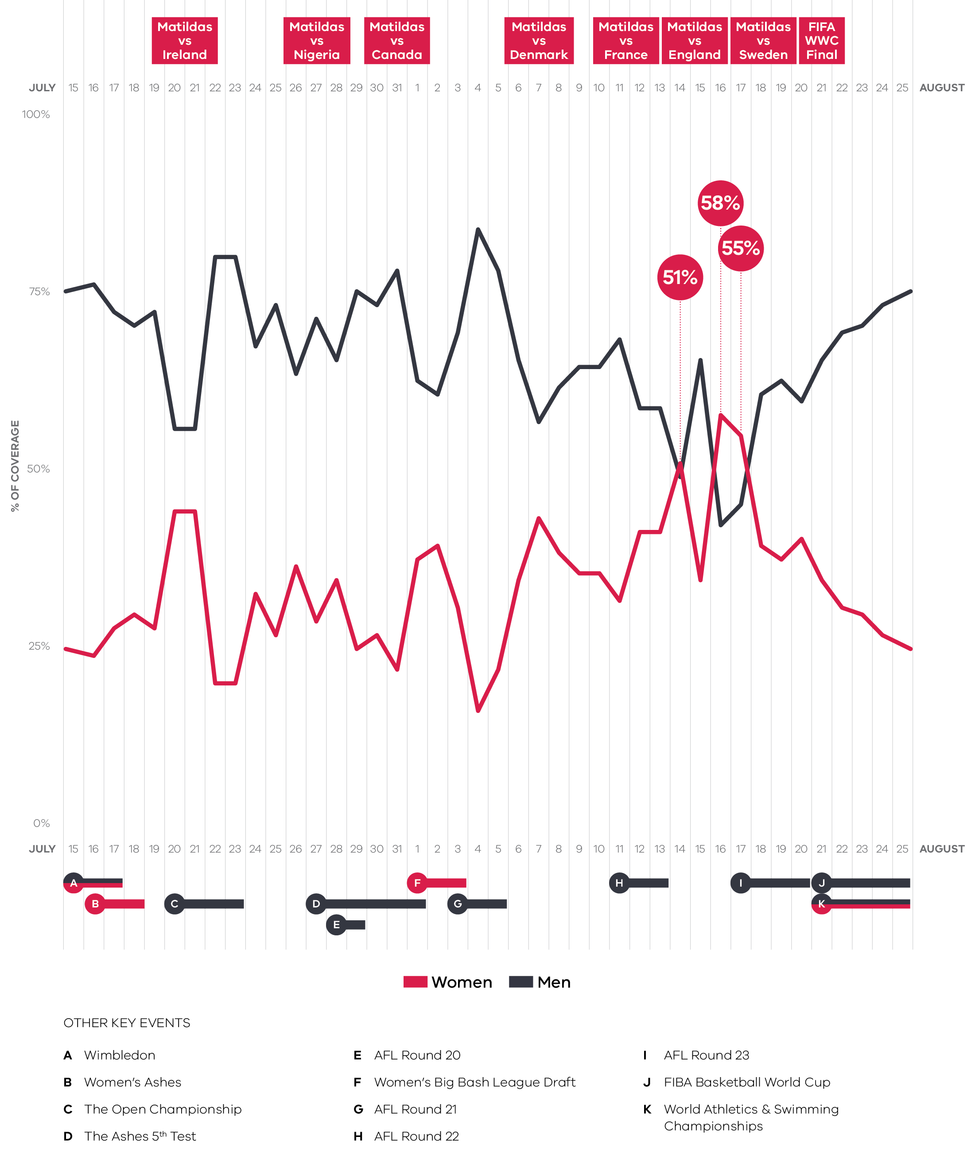
Balance % Date | Men % | Women %
15-Jul | 76% | 24%
16-Jul | 77% | 23%
17-Jul | 73% | 27%
18-Jul | 71% | 29%
19-Jul | 73% | 27%
20-Jul | 56% | 44%
21-Jul | 56% | 44%
22-Jul | 81% | 19%
23-Jul | 81% | 19%
24-Jul | 68% | 32%
25-Jul | 74% | 26%
26-Jul | 64% | 36%
27-Jul | 72% | 28%
28-Jul | 66% | 34%
29-Jul | 76% | 24%
30-Jul | 74% | 26%
31-Jul | 79% | 21%
01-Aug | 63% | 37%
02-Aug | 61% | 39%
03-Aug | 70% | 30%
04-Aug | 85% | 15%
05-Aug | 79% | 21%
06-Aug | 66% | 34%
07-Aug | 57% | 43%
08-Aug | 62% | 38%
09-Aug | 65% | 35%
10-Aug | 65% | 35%
11-Aug | 69% | 31%
12-Aug | 59% | 41%
13-Aug | 59% | 41%
14-Aug | 49% | 51%
15-Aug | 66% | 34%
16-Aug | 42% | 58%
17-Aug | 45% | 55%
18-Aug | 61% | 39%
19-Aug | 63% | 37%
20-Aug | 60% | 40%
21-Aug | 66% | 34%
22-Aug | 70% | 30%
23-Aug | 71% | 29%
24-Aug | 74% | 26%
25-Aug | 76% | 24%

1 in 5 of all sports stories were about women’s football (soccer)
Gender balance of football (soccer) coverage
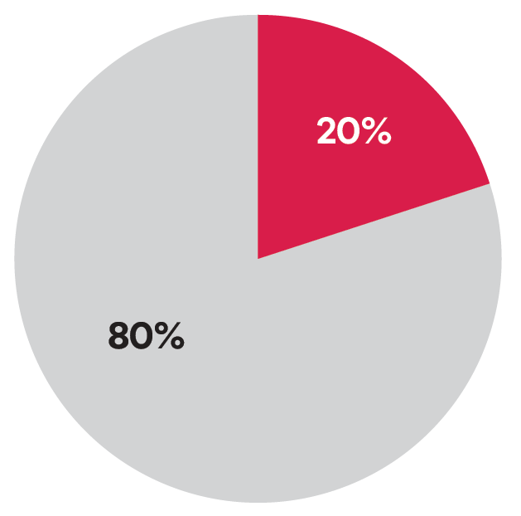
13% share of overall coverage
FIFA Women’s World Cup 2023
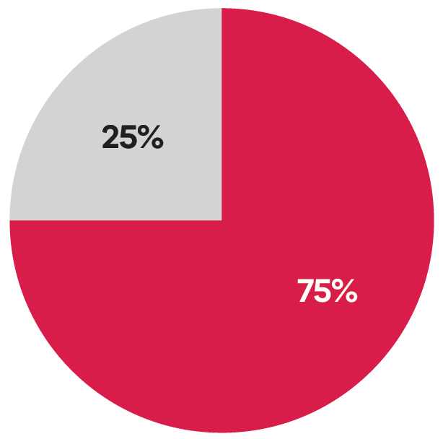
29% share of overall coverage
Data for ‘other’, including no gender or multiple genders, is excluded from this data.
This is an increase from 1 in 39 in 2022-23.
Football (soccer) overtook Australian Rules Football to be the leading sport in Victoria on 10 days over the period.
Australian Rules Football refers to the sport in its entirety, not solely the AFL elite competition.

The Matildas were the most mentioned athletes and sporting team
Sam Kerr was covered 4.5 times more than any other athlete.
The Matildas received 2.6 times as many mentions as the next leading team, the Australian Men’s Cricket Team, who were playing 2 Ashes tests over the period.

Shifting the narrative
Women athletes and teams were almost twice as likely to receive negative messaging regarding performance during the Women’s World Cup period than 2022-23.
Positive messaging regarding performance also increased, but it rose to a far lesser extent (38% increase).

More women covering sport
Women journalists had 1 in 3 sports news bylines during the FIFA Women’s World Cup 2023.
2022-23 | FIFA Women’s World Cup 2023
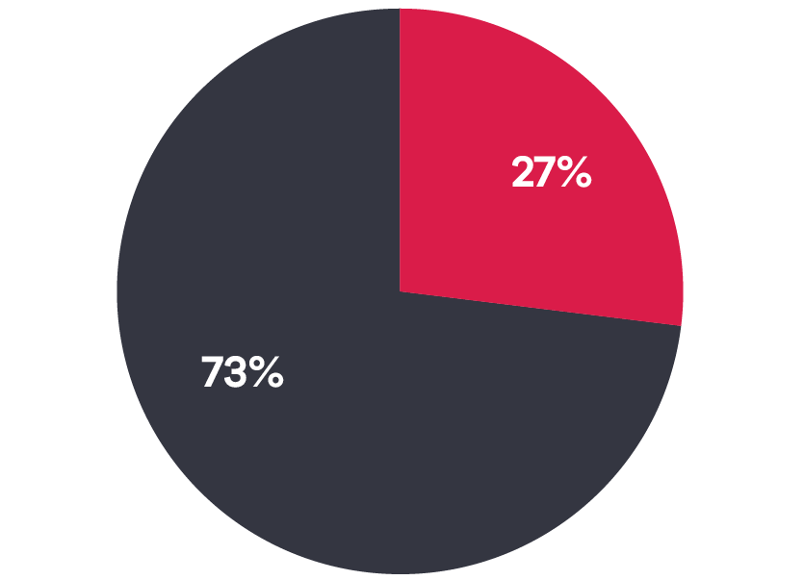 | 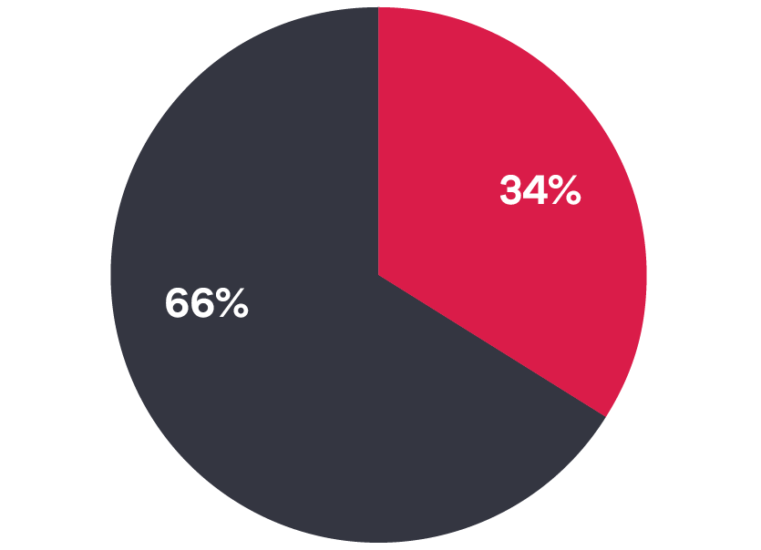

Men’s and women’s sports content by gender byline
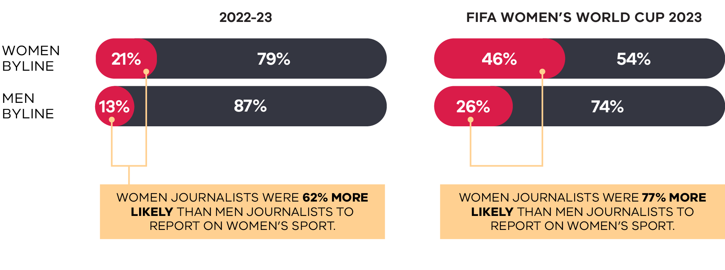
 | 2022-23  Women byline | 2022-23  Men byline | FIFA Women’s World Cup 2023  Women byline | FIFA Women’s World Cup 2023  Men byline
Women byline | 21% | 79% | 46% | 54%
Men byline | 13% | 87% | 26% | 74%
Data for ‘other’, including no gender or multiple genders, is excluded from this data. Byline includes the author of print or online articles, as well as reporter, newsreader or presenter of broadcast programs. A byline is not attributed for all media items, with this data only reflecting items with a named byline.
Women journalists were 62% more likely than men journalists to report on women’s sport.
Women journalists were 77% more likely than men journalists to report on women’s sport.

Storytellers – the sources
The Women’s World Cup caused a significant shift in the sources of comments toward athletes, teams and the sport overall. Coaches became far more prominent spokespeople, as did experts and former athletes and spectators.
Percentage change of top 10 sources in women’s sport coverage from 2022-23 to the Women’s World Cup period
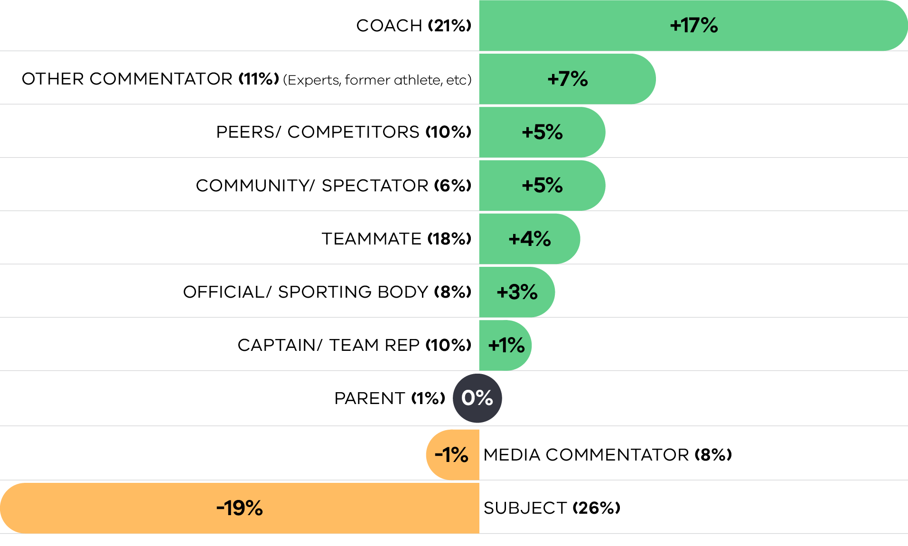
(% in bracket) denotes % of total sources during the Women’s World Cup.
Source | % Change
Coach (21%) | +17%
Other Commentator (11%) (Experts, former athletes, etc.) | +7%
Peers/Competitors (10%) | +5%
Community/Spectator (6%) | +5%
Teammate (18%) | +4%
Official/Sporting Body (8%) | +3%
Captain/Team Rep (10%) | +1%
Parent (1%) | 0%
Media Commentator (8%) | -1%
Subject (26%) | -19%

The strong rise of coaches as a source of comment means, during the FIFA Women’s World Cup 2023, women’s sports coverage was more comparable to typical men’s sport reporting. 21% of sources in women’s sports coverage were coaches, compared to just 4% in 2022-23. The Matildas Head Coach Tony Gustavsson was the most quoted source during the period. This could be in part due to the speaking requirements of football coaches during this time.
In 2022-23, 19% of sources in men’s sports coverage were coaches.
Gender of sources (excluding athletes)
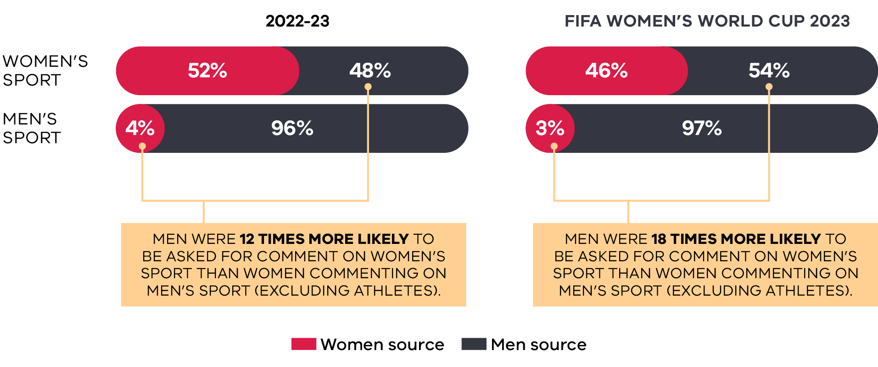
Data for ‘other’, including no gender or multiple genders, is excluded from this data. Byline includes the author of print or online articles, as well as reporter, newsreader or presenter of broadcsat programs. A byline is not attributed for all media items, with this data only reflecting items with a named byline.
 | 2022-23  Women source | 2022-23  Men source | FIFA Women’s World Cup 2023  Women source | FIFA Women’s World Cup 2023  Men source
Women’s sport | 52% | 48% | 46% | 54%
Men’s sport | 4% | 96% | 3% | 97%

Top 10 media organisations – sport news coverage by gender balance
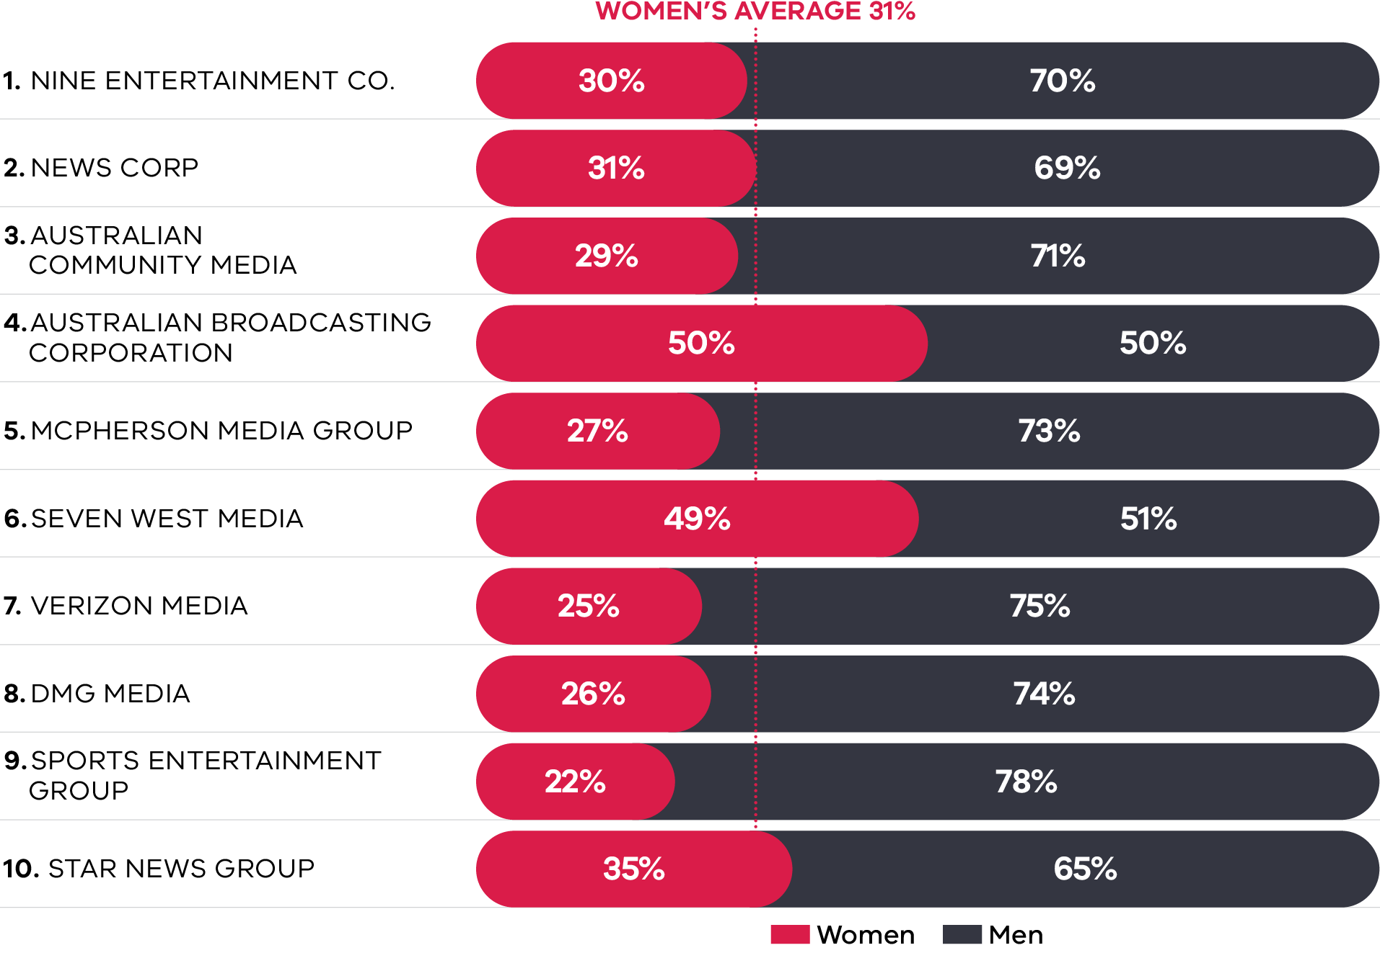
Data for ‘Other’, including No Gender or Multiple Genders is excluded from this data. Top 10 media networks/owners ranked by volume of analysed coverage. They accounted for approximately 70% of media coverage in this study. Please refer to The Conversation of Sport 2022-23 Report for previous data on media organisations.
Media Network | Women % | Men %
Nine Entertainment Co. | 30% | 70%
News Corp | 31% | 69%
Australian Community Media (ACM) | 29% | 71%
Australian Broadcasting Corporation | 50% | 50%
McPherson Media Group | 27% | 73%
Seven West Media | 49% | 51%
Verizon Media | 25% | 75%
DMG Media | 26% | 74%
Sports Entertainment Group | 22% | 78%
Star News Group | 35% | 65%

Scope of study
Completed by global media monitoring firm Isentia, this study is based on a randomised sample comprises 100 sports news items per day, with a focus on Victorian media only and select national broadcast programming.
This research covered data across the period 15 July 2023 to 25 Aug 2023, which covers the period of the FIFA Women’s World Cup 2023.
This study involved human analysis of media coverage mentioning sport that was aired or published in Victoria during the sample period. The study excluded the live broadcast of sport, social media coverage, owned publications of sporting organisations, subscription TV news and coverage relating to the racing of horses and other animals.
Balance is the main measure used throughout the report, which is the percentage of sports news stories that is focused on women’s sport.
Visibility is a further measure used, which looks who is featured in coverage, including athletes, coaches, administrators and fans, and the percentage of these who are women.
News media type
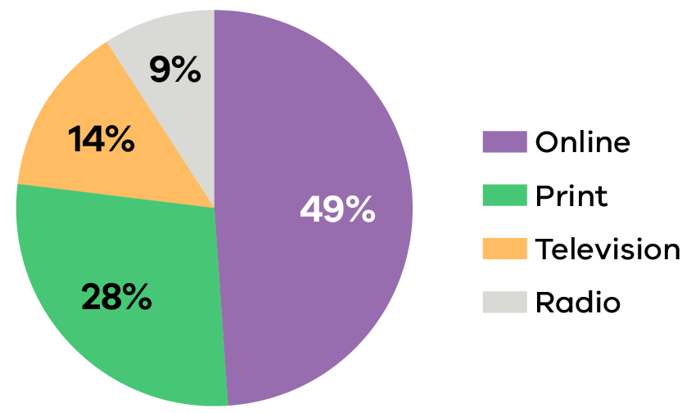
News media location
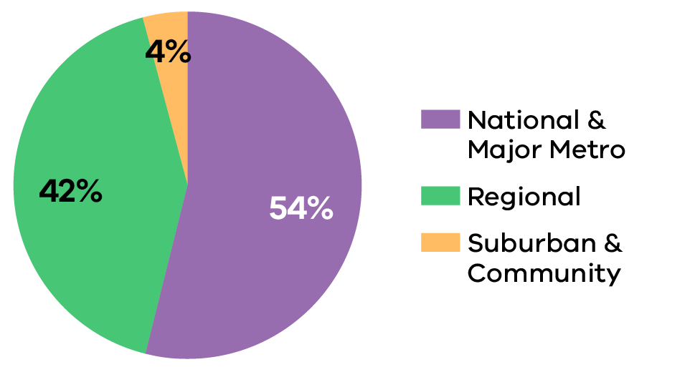
Major Metropolitan includes highly circulated outlets based in Greater Melbourne. National includes national press and online media, as well as online-only outlets. Suburban is limited to smaller outlets in Greater Melbourne.
Volumes will not exactly total overall volume as some outlets do not have an assigned region.

. Football Australia Legacy ‘23 Post-Tournament Report February 2024.

