

|  |
| --- |
| Guidelines for planning, installing and activating outdoor fitness equipment |
|  |

|  |
| --- |
|  |
| To receive this publication in an accessible format phone 1300 650 172, using the National Relay Service 13 36 77 if required, or email info@sport.vic.gov.au  Authorised and published by the Victorian Government, 1 Treasury Place, Melbourne.  © State of Victoria, Department of Health and Human Services May, 2018.  Available at [www.sport.vic.gov.au](http://www.sport.vic.gov.au) |
|  |

# Acknowledgements

The development of the *Guidelines for the planning, installation and activation of outdoor fitness equipment* was the result of a collaborative approach between the Victorian Government, Parks and Leisure Australia (Victoria and Tasmania), local councils, suppliers of outdoor fitness equipment, fitness industry bodies and other training professionals.

A project steering committee comprising of representatives from the following organisations was responsible for the development and delivery of the guidelines.

* a_space
* Banyule City Council
* Greater Shepparton City Council
* Melbourne City Council
* Parks and Leisure Australia (Victorian and Tasmania)
* Play Australia
* Sport and Recreation Victoria
  + Wellington Shire Council

The steering committee was supported by sport and recreation consultants *insideEDGE* Sport and Leisure Planning.

The project steering committee would like to acknowledge and thank the following government agencies, equipment suppliers, industry organisations and councils for their valuable contribution.

* Darebin City Council
* Fitness Australia
* Kompan
* Latrobe City Council
* Manningham City Council
* MJH Fitness
* Moduplay
* Playce
* Port Phillip City Council
* Step into Life
* Stonnington City Council
* Swan Hill Rural City Council
* The Great Outdoor Gym Company
* VicHealth
* Wodonga City Council
* Yarra City Council

Contents

Acknowledgements 5

Introduction 7

The need for outdoor fitness equipment guidelines 7

Overview of the guidelines 7

The outdoor fitness equipment life cycle 8

Research context 9

The evolution of outdoor fitness equipment 11

Benefits of outdoor fitness equipment 11

Definitions 12

Planning and determining need 13

Authority planning 13

Needs assessment and market analysis 13

Masterplanning and design considerations 15

Financial considerations 16

Section 2: Design considerations 21

Equipment types and suitability 21

Equipment configurations 25

Selecting a location 26

Site features and supporting amenities 28

Under-surfacing 29

Suppliers 30

Section 3: Activation and programming 32

Equipment use 32

Programming 32

Promotion 34

Section 4: Maintenance 36

Maintenance responsibility and frequency 36

Risk management 38

Section 5: Evaluation 40

Evaluating the success of outdoor fitness equipment 40

Resources 44

Appendix 1: Outdoor fitness equipment routine maintenance checklist 46

Appendix 2: Outdoor fitness equipment site evaluation checklist 47

# Introduction

## The need for outdoor fitness equipment guidelines

The popularity and demand for outdoor fitness equipment (OFE) will continue to grow as people place more emphasis on free-to-use, unstructured physical activity opportunities, and governments continue to invest in the promotion and implementation of policies supporting active lifestyles and community connection with a focus on health prevention.

These guidelines are designed to inform the decision-making processes to plan, design, install, maintain and activate outdoor fitness equipment in our communities.

The key objectives of the guidelines are to provide:

* a comprehensive resource for industry stakeholders
  + an evidence-based approach for industry professionals for the provision of outdoor fitness equipment
  + provide information to promote innovation and accessibility to all future projects.

It is important to note that these guidelines are not industry standards, but a collection of information and best practice case studies developed from extensive research and stakeholder consultation.

## Overview of the guidelines

The *Guidelines for the planning, installation and maintenance of outdoor fitness equipment* have been developed to provide information and recommendations to the broader industry. The guidelines focus on five key areas:

* planning and determining need
* design considerations
* activation and programming
* maintenance
  + evaluation.

They also provide case studies and examples, and two checklists.

### Planning and determining need

This section highlights the importance of undertaking a thorough planning process before installing OFE.

Considering financial and design issues will assist you in the early stages of an outdoor fitness equipment project.

This section also reflects on methods for determining the community need for OFE.

### Design considerations

This section provides information on the different types of OFE. It outlines a process and criteria for selecting the most appropriate equipment and location to support an installation.

It also provides Information on appropriate support amenities and infrastructure for successful installations and their use is provided, and as well as details on OFE suppliers.

### Activation and programming

This section focuses on the different methods used to activate and promote OFE to maximise community use.

Areas covered in this section include how OFE is being used by a range of stakeholders, how it is being programmed to cater for different demographics, and how technology is driving awareness and the benefits of OFE.

### Maintenance

This section provides information on the maintenance requirements of OFE, and different methods being used to evaluate its success.

Given its exposure to the elements, OFE presents additional maintenance challenges. This section provides stakeholders with an understanding of the responsibilities associated with providing OFE to the community. It also discusses risk management.

### Evaluation

Evaluating OFE use is an important part of the project process. This section focuses on the various methods used to assess OFE use, and to gather community feedback.

### Case study examples

A number of relevant case studies regarding the planning, installation, activation and maintenance of OFE are provided throughout the guidelines.

These case studies not only provide information on OFE success stories and lessons learnt, but also highlight issues and challenges experienced by some stakeholders, and the innovative strategies being used to overcome these.

### Checklists

Two checklists will assist and enable stakeholders to make informed decisions on key areas that support the delivery of OFE.

The checklists are included as appendices, and cover the key areas of site selection and maintenance inspection.

## The outdoor fitness equipment life cycle

The OFE lifecycle has been developed to assist local government and land owners with the process surrounding the planning, installation, activation, maintenance and evaluation of equipment.

When planning for OFE, this simple and easy-to-follow project lifecycle will ensure major considerations in the various stages are incorporated into the planning process.

1. Strategy – incorporate OFE in broader open space and recreation strategies, master plans and policies.
2. Need – determine the need, type and location of OFE through community consultation processes to ensure equipment is a valued and well-used asset.
3. Funding – explore funding opportunities from a wide range of sources.
4. Design and location – ensure the OFE design meets the requirements of the community. Complete the OFE site selection checklist before confirming a location and selecting equipment.
5. Product procurement – invest time in the procurement process to appoint a reliable supplier that meets budget expectations.
6. Activation – ensure the OFE is marketed and promoted extensively to ensure community awareness.
7. Maintenance – incorporate maintenance and cleaning schedules into existing asset maintenance and renewal programs.
8. Evaluation – ensure evaluation of OFE occurs in order to encourage ongoing community use.

Figure 1: Lifecycle of an OFE project

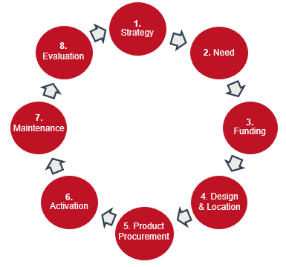

## Research context

Sport and recreation participation data released by the Australian Sports Commission (Ausplay 2016) identified that over 17 million Australians aged 15 or over (87 per cent) participated in a sport or physical activity in the last 12 months.

Recreational walking is the most popular physical activity, with approximately 42 per cent of the population participating, followed by fitness based gym activities (32 per cent) and athletics, jogging and running (16 per cent).

The research also identified that while sport remains an important form of activity, non-sport related physical activity is becoming more important as we age, with the participation gap between sport and non-sport related activity widening from the age of 25 upwards.

The most significant gap is in the 65+ age cohort, where approximately 72 per cent of participants choose non-sport related activities over sport related activities (37 per cent).

Further evidence to support the trend towards unstructured physical activity is highlighted in the Australian Sports Commission report, *The future of Australian sport: megatrends shaping the sports sector in the coming decades* (2013)*.* This research identified that individual sport and recreation activities are on the rise, with participation rates in aerobics, running, walking and gym memberships all rising sharply. On the other hand, participation rates for many organised and team sports, with the exception of soccer, have held constant or declined.

The benefits of exercise are endless, and investment in community infrastructure that supports participation in physical activity is an investment into preventive measures that assist to combat chronic diseases and sedentary behaviour.

Research verifies that regular exercise reduces the chances of developing chronic diseases such as type 2 diabetes, cardiovascular disease and certain cancers.

In addition to the abundant benefits provided by regular exercise, global research identifies the further positive impacts of exercising outdoors, in a natural environment. A 2014 study (Pasanen et al.) found that ‘nature provides an added value to the known benefits of physical activity’.

Further, international, national and local research (see appendices) into the positive effects of OFE on an individual and the broader community identified the following trends:

* Regular usage of OFE has increased health, social and physiological benefits for an individual.
* Exercising in a natural outdoor environment promotes greater feelings of revitalisation and positive engagement.
* OFE provides an easily accessible option for physical activity for people of all ages, abilities and fitness levels.
* OFE provides a free option for participation in physical activity, and removes a key barrier to participation: cost.
  + OFE provides an opportunity for social interaction between residents and promotes community cohesion.

The benefits of physical activity in an outdoor environment continue to be recognised as the popularity of OFE continues to grow across the globe. Despite this, there are significant gaps in the knowledge and processes associated with equipment planning, installation, programming and maintenance in Australia.

These guidelines aim to address those gaps and provide information to better inform the provision of outdoor equipment to ensure it continues to prosper in our communities.

### Victorian context

In late 2016, Victorian local government areas (LGAs) were surveyed to confirm the number, locations and types of OFE installations currently available throughout the state.

Of the 79 Victorian LGAs, 65 responded.

* 90 per cent of LGAs have at least one OFE installation within their municipality.
* 92 installations were identified within the LGAs that responded, with 40 OFE installations configured as an equipment cluster, 32 as an equipment trail, and 20 as a combination of both.
* Of existing OFE installations, 53 per cent are a combination of both static and dynamic equipment, followed by static only (32 per cent) and dynamic only (15 per cent).
* LGAs were asked who mainly used their OFE: ‘all comers’ (38 per cent), ‘older adults’ (36 per cent) and ‘unsure’ (22 per cent).
* LGAs were asked how popular or frequently used their OFE were: ‘heavily used’ (15 per cent), ‘moderately used’ (47 per cent), ‘not used very often’ (22 per cent), ‘not used at all’ (2 per cent), and ‘unsure’ (14 per cent).
* At the time the survey was administered, 75 per cent of LGAs were planning a future installation of OFE.

## The evolution of outdoor fitness equipment

Outdoor fitness equipment comprises exercise facilities located in an outdoor environment, generally in a park setting, along walking paths or in other community activity points such as sporting precincts.

It can be single pieces grouped together in a cluster, or a linear trail along paths and tracks. OFE is considered a community asset, and is therefore free and accessible to the whole the community.

The prevalence of OFE is relatively recent, although certain elements of OFE have been present for some time. China is considered to be the contemporary pioneer in bringing OFE to the forefront through an innovative program encouraging the Chinese population to become more physically active and interested in exercise, prior to and post the 2008 Olympic Games in Beijing. Although the program itself was a success, the equipment was not.

As a result, most recent OFE has come through suppliers of playground equipment. These companies have well-developed and proven safety and maintenance standards, as well as the factories to produce OFE.

This has resulted in many indoor fitness equipment providers and playground manufacturers customising their products or introducing new ranges to meet the growing outdoor fitness marketplace.

From traditional, basic and easy-to-maintain static equipment largely involving bars and boards, the equipment has evolved into an extension of the advanced indoor fitness environment. Cardiovascular and strength machines using bodyweight as resistance and interactive options are also now available.

Education has also improved dramatically through visual aids connected to the equipment, and today’s mobile internet can provide QR codes that link to video demonstrations and maps to show equipment located along walking and bikes paths.

With the current trend of functional and classic training methods through CrossFit, F45 and other providers, a reversal has occurred in the expectations of the public. Suppliers are now developing OFE that resembles indoor fitness equipment.

A current trend in classic fitness training methods has also seen many OFE users gravitate towards static OFE installations.

## Benefits of outdoor fitness equipment

OFE plays a vital role in the community, allowing access to installations that provide an opportunity to improve personal fitness and mental wellbeing. Members of the community who experience financial constraints can greatly benefit from the free and unrestricted access in their local environment.

With the evolution of the private fitness market and an ever-increasing range of services being offered, OFE provides councils and other land managers with an alternative to traditional recreation and leisure centres, further meeting health and fitness participation goals of the community.

OFE can further encourage exercise participation when located along frequently accessed walking paths or near playgrounds and other activated public spaces. Successful promotion of these spaces can further encourage OFE use for people already participating in individual or group exercise routines in the area.

Where personal trainers and group training is permitted, OFE can provide a valued addition. These groups will also introduce participants to new equipment opportunities, which in turn will provide confidence to return outside the structured class environment to utilise alone. Passive viewing of these groups by community members will also further educate individuals on equipment usage and may provide an opportunity for participation to those who haven't previously engaged in OFE usage.

OFE installations can be purchased at a range of price points, and with careful planning and good maintenance practices they can be an asset for the local community for many years.

The benefits to participants regularly using OFE depend on the equipment used and intensity. Regular OFE use has been found to assist in improving performance in areas such as aerobic activity, strength, balance and flexibility.

With increased health concerns placing further demand on Australia’s healthcare system, opportunities to increase participation in physical activity through a cross-section of public infrastructure will have a noticeable impact on the health and wellbeing of a community.

Significant evidence also shows the benefits of outdoor exercise in the area of mental health, in comparison with indoor exercise. Some of the benefits of outdoor exercise include improved socialisation, sense of community and incidental exercise through curiosity.

A systematic review of studies comparing indoor and outdoor physical activity conducted in a natural environment suggests that the latter causes greater feelings of revitalisation and positive engagement (Galdwell et al. 2013). Outdoor physical activity has also been shown to relieve tension, anger, and depression, and to improve self-esteem (Barton et al. 2009).

The combination of improved physical health and the reduction in mental health issues will have an increasingly positive effect on the lifestyle of our communities.

## Definitions

The table below provides an explanation of language and terminology used throughout the guidelines.

|  |  |
| --- | --- |
| Reference | Definition |
| OFE | Outdoor fitness equipment |
| Physical activity | Any bodily movement produced by skeletal muscles that requires energy expenditure |
| Exercise | Exercise is a subcategory of physical activity that is planned, structured, repetitive and purposeful in the sense that the improvement or maintenance of one or more components of physical fitness is the objective |
| Equipment cluster | A collection of outdoor fitness equipment placed a single location |
| Equipment trail | Small groupings of fitness equipment separated along a track or trail |
| Static equipment | Stationary equipment without moving parts |
| Dynamic equipment | Equipment with moving parts providing a guided range of movement |
| Equipment | Where a combination of both static and dynamic equipment is provided |

# Planning and determining need

## Authority planning

Given the benefits of OFE, land owners, planners and developers should give it equal consideration for investment as other types of recreation and leisure.

During the development of these guidelines, we found that responsible authorities were either not prioritising or not directly planning OFE development. OFE has not received the same level of priority as things like community playgrounds or skate parks, which are generally the first inclusions when planning and activating public spaces.

Increasing participation opportunities and providing health and wellbeing outcomes for communities is a priority for most responsible authorities, particularly state and local government agencies. Meeting the needs of communities through the provision of a range of accessible recreation and leisure facilities and services is generally identified in key planning documents such as a municipal recreation strategy, participation needs assessments, open space plans and recreation reserve master plans.

The process associated with the development of these key planning documents generally involves targeted consultation with residents, key users and identified stakeholder groups. Recommendations and outcomes for the provision of recreation and leisure services is based on evidence, and prioritised to address identified need. Rarely do authorities consider the benefits and potential of installing OFE.

To remove the guesswork and ensure OFE will be used to its full potential, responsible authorities must promote the benefits and ask their communities about their needs and requirements. Within local government, the responsibility for planning OFE can vary across different departments including recreation, parks, strategic planning, open space and infrastructure. Developing a collaborative approach to providing OFE is crucial in order to ensure equipment is strategically planned and given every chance of success.

|  |
| --- |
| **Tips for planning your outdoor fitness equipment**   * Recognise OFE as a vehicle to increase physical activity in your community. * Align the benefits of OFE with organisational objectives. * Ensure planning is integrated and collaborative. |

## Needs assessment and market analysis

While there is broad evidence to support the growing trend of unstructured physical activity and individual sport and recreation, and local authorities must provide evidence to justify funding and investment.

Local government organisations are experts in engaging and understanding their local communities, and they recognise the importance of undertaking evidence-based planning to inform future decision making. This is generally done by conducting ongoing and detailed community needs assessments to understand the population and demographic changes likely to affect communities.

Once the need or interest in OFE is identified at a strategic level, the next step for responsible authorities and land owners is to undertake more detailed planning to further determine the level of provision required.

Determining the location and type of OFE to be installed can be done in a number of ways:

* direct engagement via community focus groups
* promoting and seeking feedback on OFE at community events
* targeted online surveys and website questionnaires
* park master plan or precinct plan consultation
* growth area authority planning
  + recreation strategies and health and wellbeing plans.

In Victoria, Swan Hill Rural City Council used their Riverfront Masterplan (2013) to identify the need for free and unstructured physical activity opportunities in well-used public spaces. The masterplan made detailed recommendations for OFE in specified locations across the municipality. These recommendations were based on evidence collected via community surveys and focus groups undertaken as part of the development of the masterplan.

OFE is free to use, so understanding and recognising which communities will benefit most from this equipment is important. Detailed planning should consider known barriers to participation, such as cost, lack of time and motivation, and should inform the future provision of OFE.

|  |
| --- |
| **Tips for planning your outdoor fitness equipment**   * Know your community. * Understand and promote the benefits of OFE. * Use community events to test the market. * Include OFE in community and stakeholder surveys. |

### Case study: Swan Hill Rural City Council’s Riverside Park

#### Determining the need for outdoor fitness equipment

The regional hub of Swan Hill lies 340 kilometres north-west of Melbourne on the mighty Murray River and the border with New South Wales. With a population exceeding 20,000 residents, the Swan Hill Rural City Council prides itself on investing in community infrastructure to continue its regional growth.

Swan Hill Rural City Council identified the need for outdoor fitness equipment for its popular Riverside Park precinct as part of the 2013 Swan Hill Riverfront Masterplan. During the masterplan consultation process, the council found that local residents expressed a strong desire for OFE.

The Riverside Park precinct was identified as a prime location by both the community and the council. Riverside Park is a busy thoroughfare all year round, but particularly in the warmer months, with its picturesque river frontage, and long, mostly shaded, riverside walking track.

The track presented the perfect opportunity to install a linear trail of OFE that could be used by not only local residents, but also those holidaying in the Swan Hill region. The installation of OFE was recommended as a key development priority in the Riverfront Masterplan.

In 2014, the council secured funding of $80,000 for OFE through Sport and Recreation Victoria, and issued a tender to secure a supplier. Shortly after, the council and the supplier together initiated the planning process. The result was the construction of six small pods scattered along a 4-kilometre linear track.

The equipment consists of both static and dynamic pieces to capture the needs of a greater variety of users.

The council’s aim was to engage as many participants as possible. This included active community members who already used the walking track, the visiting tourist demographic, and members of the community who did not currently participate in physical activity.

To capture new users, the council offered several free come-and-try sessions through the community health program Eat.Move.Smile. A local exercise physiologist conducted two 30-minute sessions to introduce participants to the new equipment and demonstrate how to use it correctly.

The total cost of equipment planning and installation was $221,505, and it has an expected life of well over 20 years. The council confirmed the installation was a worthwhile investment by installing counters along the trail, and establishing that on average, more than 200 people use the shared trail per day, and a considerable number are also using the OFE.

Figure 2: Swan Hill Rural City Council’s Riverside Park

|  |  |
| --- | --- |
| Outdoor fitness equipment at Swan Hil | Outdoor fitness equipment at Swan Hill |

## Masterplanning and design considerations

Considered and careful planning for the provision of OFE can help identify the most suitable location and style of equipment. To do this, land owners and responsible authorities often use public park and reserve masterplans that seek to identify priorities for both structured and unstructured recreation activities, supported by design concepts.

Including OFE in the masterplan process and providing illustrations that are supported by previously identified need can help to prioritise and secure funding. A recent example of this can be seen in the development of the Maribyrnong River Masterplan, located within Moonee Valley City Council. The project involved detailed consultation with residents and the wider community, and resulted in specific recommendations and concepts for additional OFE.

When selecting and identifying indicative locations for OFE during this phase of planning, consider using key Universal Design and Crime Prevention Through Environmental Design (CPTED) principles. These include the following questions:

* Is the proposed location easily accessible?
* Is the surrounding landscape relatively flat?
* Is there a continuous accessible pathway from the principle point of entry to the OFE?
* Are there clear sight lines into and through the proposed site from key vantage points, for example car park, seaside, parklands?
* What are the prevailing environmental conditions, such as seaside, arid, parklands?
* Will equipment cater for a range of abilities, age groups and backgrounds?
* Is there equipment that can be used by both seated and standing users?
* How will information on the safe usage and operation of equipment be presented (images, words, braille, scan codes)?
* How will the selection of the preferred surface type (for example, rubber, soft fall, sand, rubber) take into account accessibility, cost and functionality?
  + Is the equipment safe and free of crush points?

Further information on the location of OFE and the types of equipment currently available is provided in Section 2.

|  |
| --- |
| **Tips for planning your outdoor fitness equipment**   * Consider OFE in future reserve master planning. * Use these guidelines to suitably locate OFE. * Apply Universal Design and CPTED principles. * Develop indicative concepts and illustrations to showcase OFE. |

## Financial considerations

Identifying the likely costs and financial implications associated with the development of OFE is an essential component of the planning process. The following information provides an overview of financial considerations for procuring equipment, maintenance and replacement costs, and potential funding opportunities.

The cost of OFE can vary based on the standard and type of equipment selected, and the number of components that are required to make up an outdoor fitness installation. The table below provides a percentage breakdown of the key components that are involved in the design, development and delivery of OFE. Please note these percentages should be used as a guide when preparing an overall budget for OFE, and will vary from project to project.

Table 1: Outdoor fitness equipment total project cost estimates

|  |  |
| --- | --- |
| Project component | Total project percentage % |
| Design | 5–10% |
| Under surfacing | 15–50% |
| Equipment and instructional signage | 50–75% |
| Construction | 10–25% |
| Supporting infrastructure (e.g. signage, drinks fountains, paths, shade) | 5–15% |
| Activation and programming | 5–10% |
| Maintenance and repair (first five years) | 5–15% |

To provide a clearer picture of the costs associated with OFE, the actual cost of an installation undertaken by Darebin City Council in 2016 is included in the case study below. The total cost for key components including design, under-surfacing, equipment, signage, construction, programming, maintenance and evaluation covers the full lifecycle of the OFE.

It is worth noting that additional expenses were incurred by Council for this project through the development of a Cultural Management Plan. The plan was completed prior to construction commencement, and was required as it was discovered that the site holds Aboriginal cultural significance. This highlights the importance of undertaking a detailed site assessment as part of the planning process, and ensuring all costs are identified early and factored into the overall project budget.

Table 2: Darebin City Council total project cost

|  |  |
| --- | --- |
| Project component | Project cost (ex. GST) |
| Design | *\*included in equipment cost* |
| Under-surfacing (wet-pour rubber) | $25,639 |
| Equipment and instructional signage | $25,029 |
| Construction | $11,332 |
| Supporting infrastructure (for example, signage, drinks fountains, paths, shade) | Nil |
| Activation and programming | Nil |
| Maintenance and repair (since May 2016) | Nil |
| Cultural management plan | $18,208 |
| **TOTAL** | **$80,208** |

Figure 3: City of Darebin, Bundoora Park installation

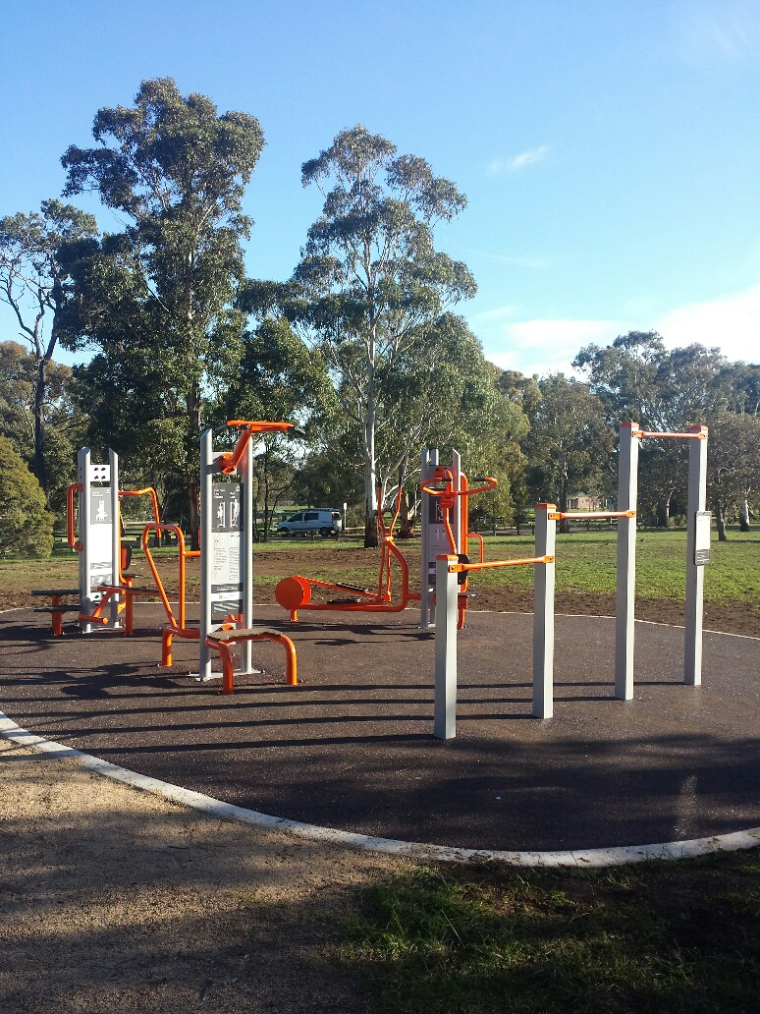

Funding for OFE can come from a range of different sources including state government, local government, developers and service clubs. The characteristics and benefits derived from the use of OFE, such as increased participation and physical activity, access for all, and providing unstructured casual use, makes this type of activity attractive to external funding providers.

Local government allocates capital funding each year for community sport and recreation projects that enhance participation opportunities, maximise use and contribute to the physical health and wellbeing of communities. Due to the high costs associated with these projects, councils are at times required to seek external funding.

Sport and Recreation Victoria (SRV) provides funding to develop or upgrade community sport and recreation facilities through its Community Sports Infrastructure Fund. Since 2010, SRV has funded a number of OFE projects across Victoria.

Service clubs such as Rotary Lions and the RSL also regularly contribute to the delivery of community projects through voluntary labour, direct grant funding and procurement.

Landowners are encouraged to explore all external funding opportunities and have a clear understanding of the conditions and criteria for funding prior to commencing the planning process.

|  |
| --- |
| **Tips for planning your outdoor fitness equipment**   * Develop a budget that includes all known costs. * Seek and compare quotes from reputable suppliers. * Consider whole-of-life costs. * Explore external funding opportunities. |

### Case study: Darebin City Council Bundoora Park

#### Funding and the planning process

After 11 months of planning, community consultation, procuring and construction, Darebin City Council successfully installed Outdoor Fitness Equipment (OFE) cluster at Bundoora Park.

The idea of installing OFE at Bundoora Park first gained traction in 2014 after research and consultation involved in the development of the council’s Bundoora Park Masterplan revealed that community members were seeking OFE.

The desire for OFE was also voiced to the council directly by many residents through a citizen jury participative governance process, and via email and phone and through the council’s online feedback tool, Local Solutions Local Issues forms. (Council also received positive feedback on existing OFE installations at regional parks at Edwardes Lake Park in Reservoir and All Nations Park in Northcote.)

Research undertaken by La Trobe University in 2014 found OFE a key motivation for residents to participate in physical activity. This provided the basis for the council to pursue funding to install additional equipment in the municipality to meet demand.

The process for planning and installing OFE can be lengthy. It is important to ensure all aspects of the planning process are completed to ensure all bases are covered.

The following key project stages were completed by the council as part of the Bundoora Park OFE installation.

##### Location

Upon project confirmation, the council needed to identify a suitable location for the OFE to ensure maximum community use. Bundoora Park was selected, based on feedback from previous community consultation, and the exact location within the park (by the playground) was approved due to its close proximity to the following amenities:

* public toilets
* existing path network
* drinking water fountain
* good passive surveillance
* shaded area close by
* easily accessible from the adjacent road
  + close to established cross country running course.

This provided the perfect location for the new installation.

##### Community consultation

The community was invited to comment on proposed designsdisplayed on site and on the council’s website.

##### Procurement

Council requested a quotation for an OFE supplier through the Municipal Association of Victoria’s (MAV) procurement process.

##### Equipment selection

The equipment making up the OFE cluster was selected to provide a range of strength, stretching and cardio exercise options, and to be accessible to a wide range of the community.

This included older people, young people and people with impaired mobility.In selecting equipment, the council considered price, equipment range, functionality and quality (including vulnerability to vandalism), ease of maintenance, availability of replacement parts, conforms to relevant safety standards, ease/accessibility of use, warranties, functional features, range of equipment and instructional signage.

The community was invited to comment on designsdisplayed on site and on the council’s website.

##### Cultural and Heritage Management Plan (CHMP)

Completing a CHMP can be a complex and lengthy process. Checks should be undertaken to ascertain the requirements for particular locations along with planning and other management permit requirements.

In Darebin’s OFE planning process, the following stages of the CHMP were completed:

* appointment of an archaeologist as a Cultural Heritage Advisor for the project
* formal notification to the Department of Premier and Cabinet
  + discussions with the Registered Aboriginal Party (RAP) of the proposed site.

A site assessment was undertaken by the archaeologist, and heritage protection measures were put in place.

##### Construction

Construction began in May 2016. This phase of the project was completed in approximately two weeks.

##### Evaluation and maintenance

Darebin Council staff regularly monitor usage by conducting random site observations, and community feedback on OFE installations is undertaken through phone, email, online and social media sources. The council is currently undertaking further research to determine and confirm usage numbers, to guide future OFE developments. The council ensured its newest OFE site at Bundoora Park was added to its Parks Maintenance Team schedule to ensure equipment is inspected every month.

After careful planning, including the strict adherence to local land policies and procedures, the new OFE station was ready for community use. At a total cost of $80,208, of which $40,000 was funded by the Victorian Government through the former Community Facilities funding program, and a further $40,208 contributed by the council, the OFE was opened to an enthusiastic community of exercisers.

Heritage Victoria’s website provides more information about developing and implementing a [Cultural and Heritage Management Plan](https://www.vic.gov.au/aboriginalvictoria/heritage/heritage-tools-and-publications.html) <https://www.vic.gov.au/aboriginalvictoria/heritage/heritage-tools-and-publications.html>.

# Section 2: Design considerations

## Equipment types and suitability

The popularity and use of OFE has increased in recent years, as has the number of equipment suppliers entering the market with new products. The two main types of OFE that are the most recognisable in the industry are static and dynamic. Definitions and illustrations for both types of equipment are provided below.

### Static equipment

Static equipment is defined as stationary equipment without moving parts.

Figure 4: Static equipment

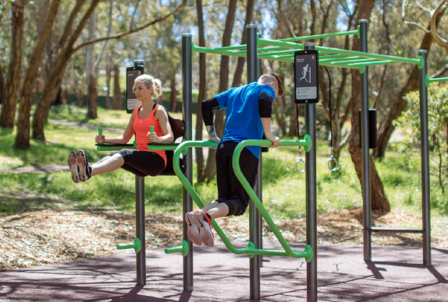

#### Static equipment pros

* Offers wide ranging exercise options
* Fewer moving parts, resulting in less maintenance
* Basic and versatile
* Attractive to new users due to its simplicity
* No crush points
* Ergonomically sound
* Attractive and functional for experienced gym users
* Equipment can be customised to suit the individual
* Additional equipment such as ropes and bands can be added to offer an even greater range of exercise opportunities
* Provides greater flexibility in the user’s range of movement
* Cost effective
* Longer shelf life
* Can be used by children for play rather that fitness

#### Static equipment cons

* Can require advanced knowledge of appropriate exercises to use the equipment
* Usually requires the user to have advanced fitness levels to use effectively, such as pull-up bars
* Does not offer guided range of movement, leading to greater risk of injury

### Dynamic equipment

Dynamic equipment is equipment with moving parts, providing a guided range of motion.

Figure 5: Dynamic equipment

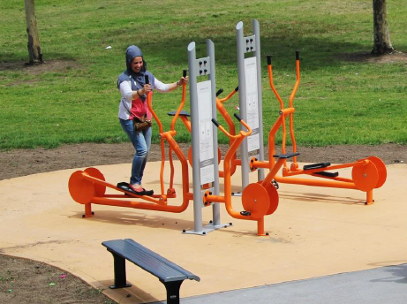

#### Dynamic equipment pros

* Provides a guided range of movement for the user
* Opportunity for more innovative equipment options to provide access for a range of ages and abilities
* Can include common equipment such as exercise bikes, which most people know how to use
* Easy to use
* Provides an opportunity to perform cardiovascular exercise in a fixed location
* Suitable for beginners

#### Dynamic equipment cons

* Can be restrictive in its use
* Requires increased maintenance due to the number of moving parts
* Equipment can be intimidating to new users due to its visual complexity
* Majority of dynamic OFE equipment does not have the option to readjust equipment settings to suit individual needs
* Can be used by young children for play rather than fitness, and without proper knowledge on how to use the equipment effectively
* Exposure to weather generally gives the moveable parts a shorter lifespan
* Equipment does not usually offer users the chance to adapt for exercise and fitness progression
  + Equipment may not be as challenging for experienced users

More recently, there has been a shift towards combination equipment and hybrid versions incorporating both static and dynamic components, offering users a broader range of movement and exercise options.

A list of standard components provided with static and dynamic equipment is provided in Table 3.

Table 3: Outdoor fitness equipment example list

|  |  |
| --- | --- |
| Static | Dynamic |
| Step-up boxes | Elliptical trainer / cross trainer |
| Pull-up bars | Aerobic bike |
| Workout bench | Spin bike |
| Box jumps | Pull-down machine |
| Dip bars | Leg-press machine |
| Parallel bars | Lat pull-down machine |
| Sit-up bench | Chest-press machine |
| Sit-up plank | Hand bike |
| Pull-up racks | Rowing machine |
| Multi-stretch and balance ladder | Shoulder-press machine |
| Incline/decline benches | Stepper |
| Push-up bars | Abdominal machine |
| Balance beams | Upright-row machine |
| Bench dip | Multi-exercise stations |

Note: Equipment example list courtesy of suppliers a_space, Moduplay and Kompan.

Drawing out themes and preferences from the consultation process will guide the type and configuration of OFE to enable optimal use.

### Case study: Port Phillip City Council Moran Reserve, Elwood

#### Upgrading outdated outdoor fitness equipment

The City of Port Phillip recognises the importance of offering no-cost physical activity opportunities to their community. The Council offers six outdoor fitness installations across the local government area, however only three are directly managed by the council (Moran Reserve, Peanut Farm Reserve and Middle Park Beach). The remaining three installations are managed by Parks Victoria (Morris Reserve and two in the Albert Park Lake precinct).

Early in 2015, the council identified that one of the existing OFE cluster installations, Moran Reserve in Elwood, was no longer being used by the community. The original installation was constructed in 2004, and included static pieces such as a balance beam, incline benches, parallel bars, vertical bars, and pull-up, chin-up and monkey bars.

The reasons for lack of community participation at the site were identified as:

* old and outdated equipment
* lack of supporting amenities including pathway access and seating
* damaged equipment
  + inappropriate under-surfacing.

To re-engage community participation at the site, the equipment and supporting infrastructure would need to be upgraded to meet the current needs of OFE users. The planning process began in June 2015 and an equipment supplier was selected.

Specific site plans were then prepared incorporating the latest outdoor fitness trends. After much consideration, it was determined that only static equipment would be included at the site.

This was mainly due to the fact that a greater range of exercises could be performed on stationary equipment as opposed to dynamic equipment, which usually only aligns one specified exercise per piece. The council was also informed that the environment conditions associated with the site location (being adjacent to Port Phillip Bay) would likely lead to increased levels of corrosion. Therefore, to increase equipment longevity it was decided that only static equipment would be reinstalled.

The outdoor fitness installation at Moran Reserve was completed in November 2016 at a total cost of $100,000. This included equipment costs of $50,000, an installation cost of $20,000 and additional landscaping costs of $30,000. The project was funded entirely by the City of Port Phillip. The new 272-square-metre site includes:

* incline benches
* push-up bars
* monkey bars
* parallel bars
* pull-up bars
* work-out bench
* squat pole
* balance rail
* Swedish bars
  + plyometric steppers.

Supporting amenities were also incorporated as part of the upgrade, and included concrete pathway access to the site, seating provision, a drinking fountain, bike racks, rubbish bins and detailed instructional signage (toilet facilities are a short walk from the site).

The council provides a printable map of the municipality, with the specific locations of the fitness equipment – a useful, easily accessible resource to have available to residents.

## Equipment configurations

Outdoor fitness equipment can be configured and installed in different ways to suit the location and needs of the end user. The two main types of configuration and installation identifiable within the market place are equipment clusters and equipment trails.

A range of equipment pieces can be selected to make up a cluster or trail installation. Variety in the equipment selection assists in attracting a greater range of participants, and can facilitate a full-body circuit workout.

### Equipment clusters

Equipment clustersare a collection of outdoor fitness equipment placed in a single location.

Figure 6: Equipment clusters

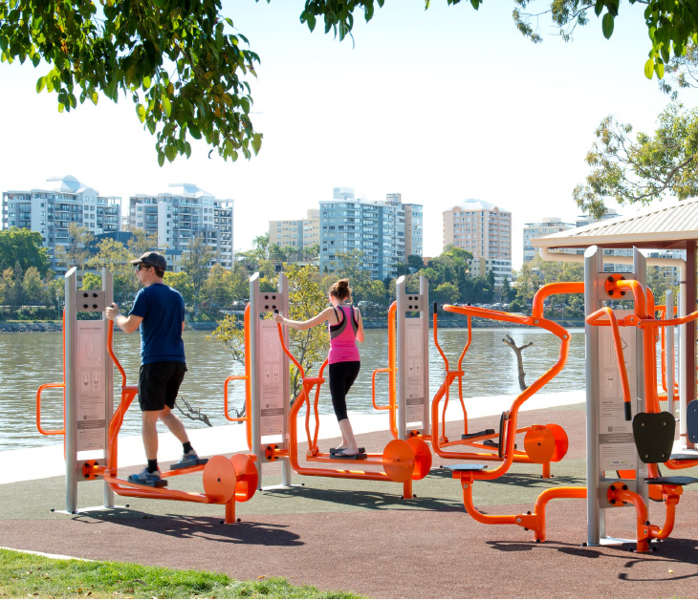

#### Equipment cluster pros

* Provide options for circuit training (moving from one piece of equipment to the next) for a full body workout
* Offer a variety of equipment in a single location
* Can be provided more efficiently where space is limited
* Suit a variety of locations (linear paths, foreshore, urban, parklands)
* Allow multiple users at the one time and greater social interaction
* Maintenance is more effective when equipment is clustered
* More attractive to groups of people training together

#### Equipment cluster cons

The disadvantages of equipment clusters include:

* If one piece of equipment fails, it may affect multiple pieces in the cluster.

### Equipment trails

**Equipment Trails** are small groupings of fitness equipment separated along a trail or track, typically laid out to provide a progression of exercise activity

Figure 7: Equipment trails

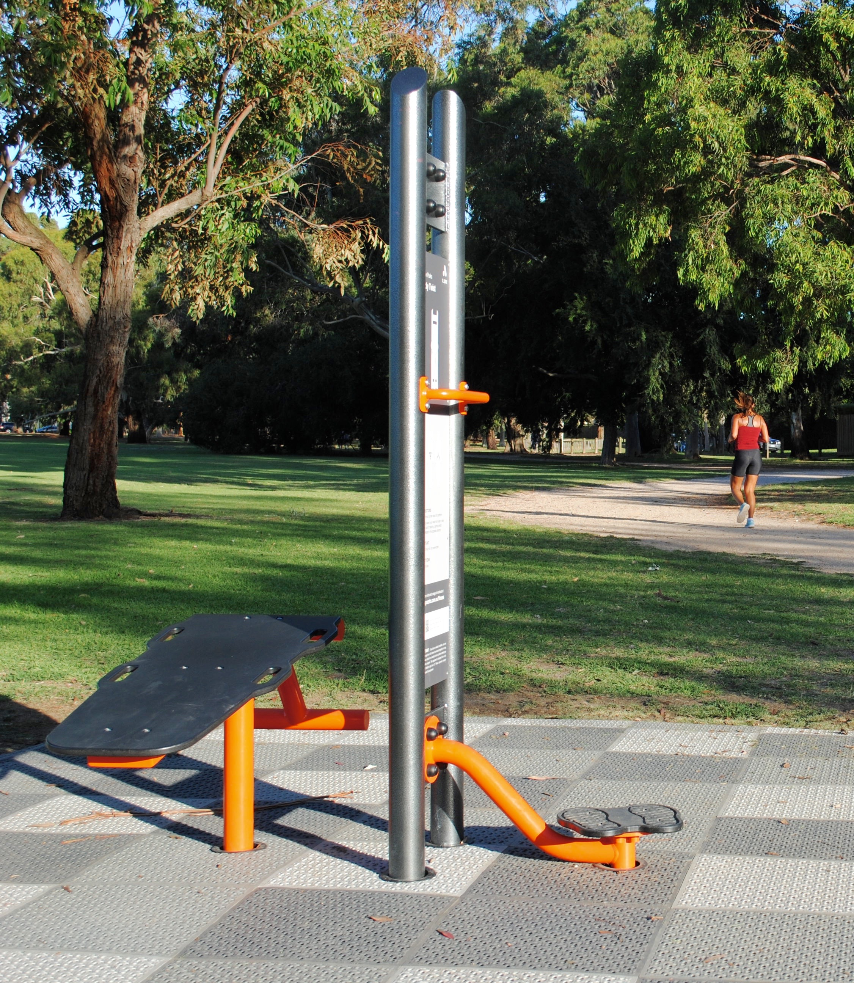

#### Equipment trail pros

* Appeal to people who exercise regularly due to higher levels of fitness that are required
* Best suited to parklands and recreational spaces of a regional scale that can promote longer training programs
* The user has more of a journey in their workout, and thus greater variety
* Combines aerobic workout (trail) with strength and conditioning (equipment)
  + Has multiple entry points and greater accessibility

#### Equipment trail cons

* Equipment is not provided in a single location, which can limit the user experience
* Generally requires an already active trail network to be effective
* Supporting amenities may not be accessible from individual equipment pieces
* Equipment supporting popular running tracks or loops may not be a priority for the more serious athletes
  + Perception of safety along sections of the trail may be a factor for users (for example, trails with limited passive surveillance)

Selecting the right configuration and installation type will be determined by factors including the level of supporting infrastructure required, availability of space, and the target demographic of the end user. Use the site selection checklist in Appendix 1 to select the best location and equipment configuration for an outdoor fitness installation.

## Selecting a location

It is important to remember that the type of equipment selected will be affected by the environment into which it is to be installed.

Selecting the right location for OFE is a key component to ensuring that it is a practical and well used investment. The location of the OFE significantly impacts other important aspects of the planning and design process, including the installation configuration (cluster or trail) and equipment type (dynamic or static). A detailed site assessment should be undertaken to ensure it is appropriate for an OFE installation.

An important component of selecting the right location is to understand how the community is or will use the space, and to match site characteristics with local demographics. The following questions will help identify a suitable location for an OFE installation during the early stages of planning.

* How often is the site used? This can be answered by conducting visual observations at the site and recording findings.
* Who are the primary users and what are their demographics? This will assist in matching equipment to the end user.
* Are there plans to enhance or develop the space? This will assist in determining if the site may have increased usage in the future, or have capacity to accommodate a further outdoor fitness installation.
* What recreational infrastructure exists at the site? Providing OFE in close proximity to skate parks, playgrounds, leisure centres et cetera will ensure that OFE is visible, further promoting use.
* What supporting amenities are currently available on site? Existing amenities such as public toilets, shade and drink fountains will reduce overall project cost and provide convenience to users.
* How easy is it to access the OFE? Consider whether the equipment can be easily accessed from connecting pathways, and whether it is close to community infrastructure such as public transport and car parking.
  + When selecting a location for your OFE, the safety of the end user is paramount. Apply the Crime Prevention Through Environmental Design (CPTED) principles.

CPTED principles consider five aspects of design with crime prevention the primary objective.

1. Natural access control – reducing the potential for criminal activity through effective surveillance. The site should be clearly visible and preferably in a high-profile location. Sensor lighting could be considered to prevent anti-social behaviour and damage to equipment after daylight hours.
2. Activity support – ensuring natural surveillance methods are evident during times of high activity use.
3. Maintenance – sustaining the surrounding environment and landscape areas and removing graffiti can deter ongoing vandalism and antisocial behaviour.
4. Natural surveillance – designing the area to maximise visibility at all times. This requires ensuring that signage, seating and other physical obstructions are not placed in observational lines of sight.
5. Territorial reinforcement – promotes the use of signing, screening and fences to define ownership of the site and deter antisocial behaviour.

Additional aspects to consider when identifying the most appropriate location for OFE include:

* Ensure a site assessment is conducted at the beginning of the planning process.
* Conduct a risk benefit analysis. Do the probable impacts of community benefit outweigh the possible risks?
* Ensure the OFE is installed in a prominent location with significant passing traffic (both pedestrian and vehicle) to ensure a greater reach of potential users and improve passive surveillance. However, avoid major roads because this can deter people who wish to exercise out of public view.
* Installing OFE in a major or highly used recreational area may further reach those community members already exercising, and will provide a perception of a safe environment for users.
  + Complete a cultural heritage management assessment.

Direct links to further information that will assist in choosing the right location for OFE are provided below:

* Victoria Police (2015), [Crime prevention through environmental design](http://sport.vic.gov.au/design-for-everyone-guide/overview-of-universal-design) <http://www.police.vic.gov.au/content.asp?document_id=10444>
* Sport and Recreation Victoria (2016), [Design for everyone guide](http://sport.vic.gov.au/design-for-everyone-guide/overview-of-universal-design) <http://sport.vic.gov.au/design-for-everyone-guide/overview-of-universal-design>
  + Victorian Government (2017), Heritage tools and publications <https://www.vic.gov.au/aboriginalvictoria/heritage/heritage-tools-and-publications.html>.

See Appendix 2 for an OFE location checklist.

## Site features and supporting amenities

In addition to site location, considering other features and amenities will ensure the installation is accessible for the community and is a worthwhile investment.

Various factors influence a person’s desire to access OFE, but providing a safe environment for users is a high priority. Applying CPTED principles to selecting a site is important to ensuring the community feel safe while using OFE. In addition, key site features for OFE and supporting amenities should consider usage by the broader community.

There are a range of site features and amenities that will enhance an OFE installation. Some are considered more important, or versatile than others.

Table 4: Characteristics of mandatory site features

| Mandatory site features | Characteristics | Priority |
| --- | --- | --- |
| Signage | Detailed instructional signage on how to use equipment  Consider pictures and braille  QR codes can link to videos demonstrating exercises | High |
| Drinkable water access | Water fountains with a tap option to refill bottles | High |
| Path access | Sealed pathway access supporting all abilities  Close to an existing path network that is highly used | High |
| Public transport access | At least one option for access to the site via public transport should be provided (train, tram or bus) | Medium |
| Toilets | Male/female and wheelchair accessible  Ideally within easily walkable distance | Medium |
| Shade protection | Natural shading options should be considered to encourage use during the warmer months  Shade cloth can be considered if natural shading options are not available | Medium |
| Car parking | Should be available in close proximity | Medium |
| Proximity to other community recreational areas | Options for supporting recreational facilities include:  skate parks  community centres  leisure centres  playgrounds  walking/cycling tracks  sports grounds | Medium |
| Vegetation | An inviting environment will promote usage  Supporting green vegetation will encourage participation | Medium |
| Seating | Ideally in a shaded area with full view of equipment  Provides a resting place for users  Provides a seated option for supervisors | Medium |
| Lighting | Auto-timed lighting can be provided to ensure equipment is accessible after dark  Lighting extends usage during the winter months | Low |
| Bike racks | Should be available in close proximity  Reduces the risk of bikes being left inside the installation | Low |

## Under-surfacing

There are various options available for under-surfacing.

Table 5: Characteristics of under-surfacing types

| Under-surfacing type | Characteristics | Cost |
| --- | --- | --- |
| Natural turf | Unstable surface  Nice look and feel  Prone to wear and tear  Can become muddy  Poor drainage  High maintenance | Low |
| Mulch | Easy to install  Unstable surface  Requires topping up  Could impact dynamic equipment | Low |
| Concrete | Stable surface  Long service life  Low maintenance  Hard impact on user’s body  Increased risk of injury | Medium |
| Synthetic grass / turf | Nice look and feel  Low maintenance  Stable surface  Requires a sub-base underlay | Medium / High |
| Wet-pour rubber | Nice look and feel  Stable surface  Low maintenance  Requires suitable sub-base | High |

Source: a_space and Moduplay

## Suppliers

The expansion and popularity of OFE has seen many new suppliers enter the market from the playground industry. Selecting the right supplier is an important component of the OFE planning process, and research into the background and experience of suppliers is essential.

Choosing a supplier that will assist with site and equipment selection and provide full support for the duration of the equipment warranty will add value to the project. The equipment warranty should also cover a significant portion of its lifespan. Consider using a supplier that is flexible and innovative in their equipment design to meet the changing needs of the community.

As part of the selection process, visit existing OFE installations to assess layout, structural integrity, under-surfacing and instructional signage. Seek feedback from the land owner and gather further information on their experience with suppliers, and their level of satisfaction, including post-construction follow up.

Before you commission a supplier, you should have clear expectations of their role and performance.

### Suggested questions for a previous client of a supplier

* How was the support during the planning and installation process?
* Were project timelines met?
* Was the equipment cost reasonable?
* How do you rate the quality of the equipment? Have there been any issues?
* What kind of warranties were offered with the equipment?
* Is the OFE well used?
  + Would the same supplier be used if another OFE project was undertaken?

### What you should expect from your supplier

* Ongoing support and advice for the duration of the equipment warranty
* An easy project planning and delivery process
* Knowledge of equipment types to support different users and level of experience
* Quality concept designs to support project development

|  |
| --- |
| **Tips for selecting and working with suppliers**   * Shop around. Contact several suppliers and find the right fit. * Visit existing sites and use equipment. * Check the warranties and negotiate longer terms with the supplier if necessary. * Develop and maintain a positive and effective working relationship with your supplier. * Use the knowledge and advice of your supplier. * Have the supplier review your proposed maintenance schedule. * Check the policy associated with spare parts. What is the delivery time frame? * Contact organisations that have previously purchased and installed equipment from the supplier. |

A list of OFE suppliers offering equipment to the Australian market is provided in the Resources section.

# Section 3: Activation and programming

## Equipment use

Once OFE has been installed and is operational, the focus shifts towards maximising its use. A common issue with many OFE projects we researched is that they did not target the activation and use of OFE once the installation was completed.

### Use by fitness professionals

The use of OFE by fitness professionals operating group fitness classes and boot camps for commercial gain is a contentious issue, and outside the scope of these guidelines. However, we note that permitting fitness professionals to use OFE in safe and structured training programs can be an effective way to activate and promote better use of the equipment.

### Promoting engagement

You can promote engagement among a wide group of users by using simple methods such as providing signage with clear and concise pictorial instructions.

The considerations discussed in the ‘Site features and amenities’ section, such as auto-timed lighting, will also help to encourage use.

Some OFE installations also promote engagement through technology, such as adding a phone-charging capability to cardiovascular equipment which is powered through use of the equipment.

QR codes on signage can also help to activate the equipment by providing links to online video demonstrations.

### Evaluating use

Given the casual and unstructured nature of OFE, methods for evaluating usage are somewhat limited. Options will depend on budget, with some known methods for gauging community use of OFE including:

* dynamic equipment automatic exercise counters
* physical observations and participant counts
* field interviews and surveys
  + assessment of equipment (whether it looks well used).

Evaluation methods are discussed in more detail in the ‘Evaluation’ section.

|  |
| --- |
| **Tips for outdoor fitness equipment usage**   * Develop a specific OFE usage policy to ensure consistency and resolve questions concerning insurance, permits and hours of usage. * If the budget allows and location suits, consider adding auto-timed lighting to facilitate increased usage outside of daylight hours. * Embrace technological advances in the design process. |

## Programming

A key driver for providing OFE is to offer an unstructured and free activity that can positively influence the overall health and fitness of communities, and reduce issues of obesity and sedentary behaviour. A major advantage that OFE has over other forms of physical activity is its potential to serve almost everyone in a community, without restriction.

The provision of OFE addresses two key barriers to participation: cost (there is no charge to use the equipment) and access (equipment is readily available). These key factors should be used to generate enthusiasm and interest in OFE, and to leverage programming opportunities.

When it comes to activating OFE, structured and effective programming is a fundamental consideration to ensure its ongoing popularity and use. Programming OFE should deliver multiple and wide-ranging opportunities for community participation. Offering specific programs for different age groups can support activations. For example, offering an ‘over 50s come and try group fitness session’ will be more attractive to older adults then a general ‘come and try group fitness session’, as participants feel comfortable exercising with others of the same age and fitness levels.

Community consultation during the planning process also presents an opportunity to collect information and assess opportunities for future programming. Programming must be tailored to the type and range of equipment provided, and be accessible to a range user groups for it be successful. Providing educational and instructional signage targeting beginner, intermediate and advanced use is one way to enhance participation and activate your OFE.

Responding to current trends will further activate participation through programming. For example, boot camps and group fitness style classes are popular, and are a way to increase the use of OFE.

|  |
| --- |
| **Tips for programming outdoor fitness equipment**   * Offer a wide range of programming opportunities, specifically targeted at different age groups. * Assess and respond to current industry trends, such as CrossFit, boot camps, yoga, high-intensity interval training. * Provide programming opportunities by offering ‘come and try’ sessions with a fitness professional. * Employ industry professionals to deliver quality programming options and detailed equipment usage instructions. * Consult with the community to find out what sort of programs they want. * Look at the population area and demographic of the community, and take into account any further considerations that may make the OFE more appealing to different groups. * Offer beginner, intermediate and advanced workout options using interactive signage |

Figure 8: The City of Wodonga engaged professional fitness trainers from the local YMCA to run free training sessions at their OFE to engage with the community and activate use

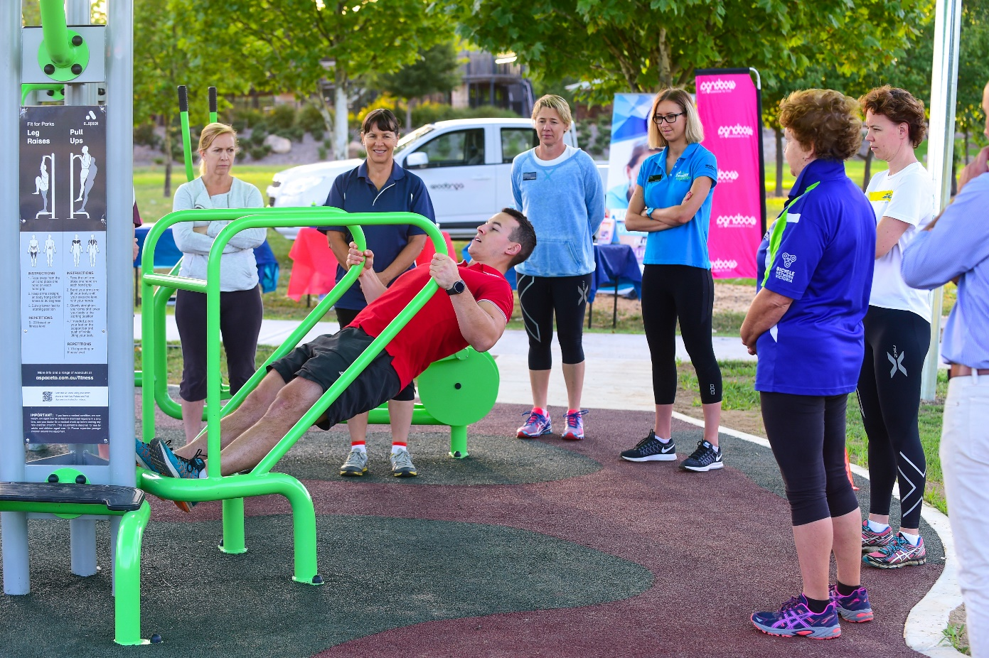

## Promotion

Investing in free and accessible community infrastructure such as OFE demonstrates a commitment to improving the health and wellbeing of residents, but the commitment shouldn’t stop there.

A key ingredient to activation is ensuring the local community and potential users are aware of the equipment and the health and fitness benefits it provides.

The first step is to ensure the promotion and marketing component of your OFE is included as part of the overall project budget. You should have a marketing plan to target key user groups using a variety of strategies and promotional techniques.

One proven way of promoting your OFE project is to organise an official opening that creates awareness and generates enthusiasm for the new installation.

Leveraging an established and successful community event or festival can be a good way to promote new OFE installations, and to generate media exposure. ‘Come and try’ sessions at the official opening can encourage people to use the equipment, and to generate interest.

Tips for promoting your OFE at an official opening include:

* Use a qualified fitness professional to demonstrate proper equipment use and technique.
* Use flyers and brochures to promote the benefits of using the equipment.
* Invite a local health food store to donate a healthy snack/drink to attract interest.
* Invite elected members, relevant sporting clubs and community groups.
* Invite local print media to maximise coverage.
  + Incorporate a local celebrity into the official opening. Have them use the equipment to create photo opportunities for local media.

It is important to consider the likely demographics of the end user of your OFE, and to target your marketing and promotions campaign accordingly. For example, the use of print media and community centres would be appropriate to promote OFE to the older adult population. Younger people are more in tune with social media platforms such as Facebook, Twitter and Instagram, and logging onto a council website to discover what is new in their community.

The trick is to be creative in how you market and promote your OFE, and to prioritise the development of key stakeholder relationships to ensure long-term equipment use. This could mean partnering with fitness professionals, community clubs and sporting clubs to increase promotional reach.

|  |
| --- |
| **Tips for promoting outdoor fitness equipment**   * Allocate funds in the budget for promotion. * Develop a community engagement strategy to ensure continued community interest in the space. * Target marketing that highlights physical activity benefits and preventative health measures. * Consider your target market and what form of promotion will best reach that demographic. * Use social media to promote new installations. * Promote through local newspapers and at key community centres. * Map outdoor fitness locations online. * Continuously promote the benefits of OFE post opening. |

The City of Port Phillip promotes the location of OFE on its website. Online maps pinpoint the exact location of OFE within the municipality.

Figure 9: Online map of OFE in the City of Port Phillip

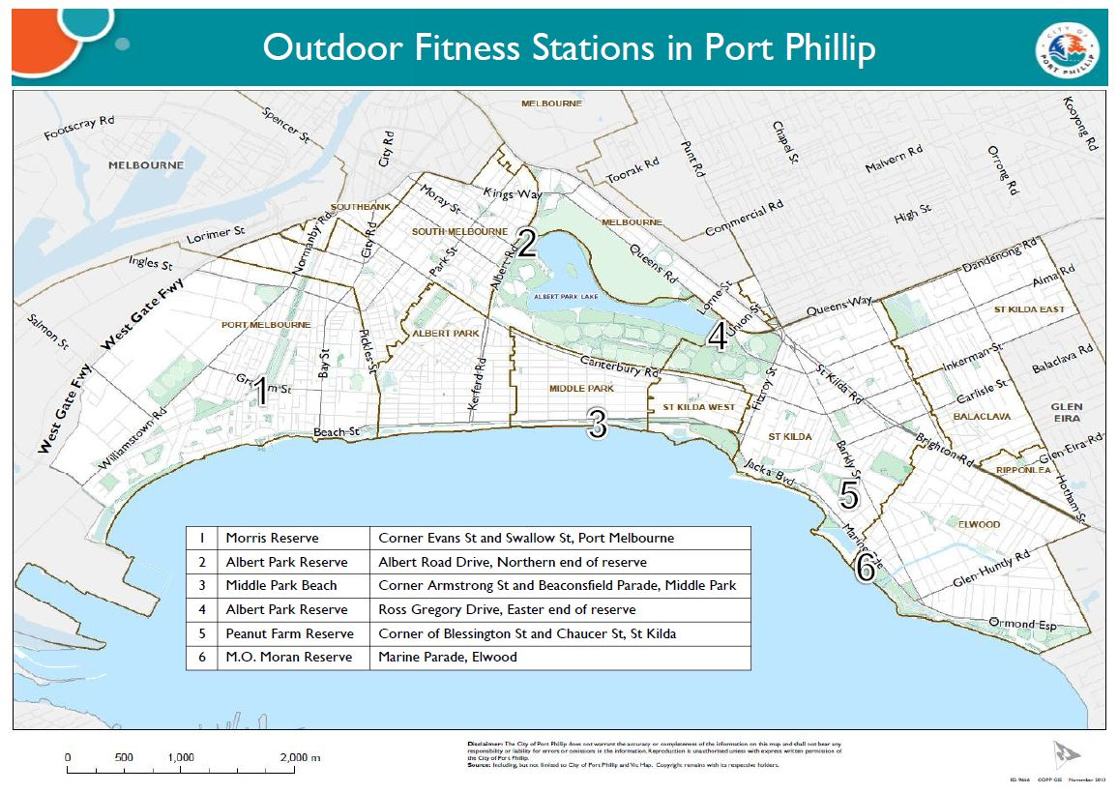

# Section 4: Maintenance

## Maintenance responsibility and frequency

The ongoing maintenance, management and presentation of OFE will influence participation levels, and is crucial to the ongoing success of the facility.

Maintenance schedules and service agreements are an important consideration when determining the right outdoor fitness supplier. Negotiate a formal agreement outlining the frequency and duration of the maintenance period prior to planning approval.

It is important to make use of the supplier’s knowledge, and to implement a structured maintenance program that keeps the equipment in good working order. The age and type of OFE will determine how often safety and maintenance checks should be conducted.

Fortnightly to monthly checks are recommended as a minimum to ensure equipment remains well presented and safe to use.

A collaborative approach to equipment maintenance between the land owner and the supplier is important. Key things to consider when determining your maintenance program include:

* duration of the equipment warranty
* spare parts availability and turnaround time
* equipment cleaning
* proposed maintenance frequency
* ongoing support and service levels (after the warranty period)
* routine maintenance checklist
  + propensity for vandalism within the local community.

The following case study of OFE in the City of Wodonga highlights the importance of regular inspections and how a maintenance issue affecting use of the equipment was identified and addressed.

### Case study: Wodonga City Council, Julia Ronan Park

#### Maintaining outdoor fitness equipment

A key priority for the City of Wodonga is to provide high-quality and accessible OFE to the community with opportunities to participate in physical activity at no cost.

In 2015, the City of Wodonga successfully secured state government funding for the installation of OFE in Julia Ronan Park (part of Felltimber Park) and Belvoir Park. The partnership saw the Victorian Government provide $100,000, with a further $50,000 contributed by the City of Wodonga. The total project cost for the two sites also included the installation of shade sails, seating and landscaping works.

OFE was initially identified in two of the council’s precinct masterplans (Belvoir Park 2012 and Felltimber Park 2013), due to the areas experiencing high levels of cycling, walking and general exercise activities. Julia Ronan Park was selected as an ideal location for OFE due to its close proximity to the Felltimber Community Centre and considerable network of well-used pathways.

Council decided to proceed with the installations after numerous requests for OFE from personal fitness trainers and the general community. After several months of planning and stakeholder consultation, a funding application to the 2015–16 Community Facilities Funding Program was submitted to Sport and Recreation Victoria.

Shortly after the successful application was announced, an official tender was released and a_space was engaged as the successful supplier.

Further consultation with the supplier, project stakeholders and users determined the equipment range. It was decided that both static and dynamic pieces would be included at the two sites to encourage participation from a wider range of users. The Julia Ronan Park installation includes a cardiovascular cross trainer, pull-up/leg-raise machine and a shoulder and body-twist machine. This range of equipment promotes fitness, strength and mobility in an open and picturesque environment by the lake.

Again, in order to reach a greater target group, the council implemented two different forms of equipment instruction methods. The site has step-by-step instructional board pictorial signage, as well as QR scanning codes to allow smartphone users to view instructional videos online.

In order to activate the equipment and gain initial community interest, the council appointed a qualified YMCA personal trainer from the Wodonga Sports and Leisure Centre to conduct several free fitness sessions at the site shortly after construction. The main purpose of these group fitness sessions was to educate community members on how to use the equipment safely and effectively. The sessions proved a success with over 30 attendees.

Council applies a regular maintenance regime for the OFE, undertaken by their parks team. This includes weekly visual site visits and inspections and an annual full equipment check as part of the council’s playground inspection program.

It was during a routine weekly equipment inspection that staff noticed damage to some equipment and the rubber under-surfacing. It was not the usual sort of damage expected in a community park. Ducks from the nearby lake were entering the area and leaving droppings on and around the equipment, which was impacting use. To solve this issue, the council sought expert advice, which recommended that the area and equipment be sprayed with a repellent to deter the ducks from entering the space. The repellent approach was unsuccessful, and following further advice it was agreed that a small 1.2-metre high fence be constructed to eliminate further damage. At a cost of $5,000, the fence was installed and it has prevented their entry to the area.

The successful implementation of this strategy has ensured no further issues with ducks and the council has witnessed the community using the equipment again.

Figure 10: Wodonga City Council’s OFE at Julia Ronan Park after installation of the fence

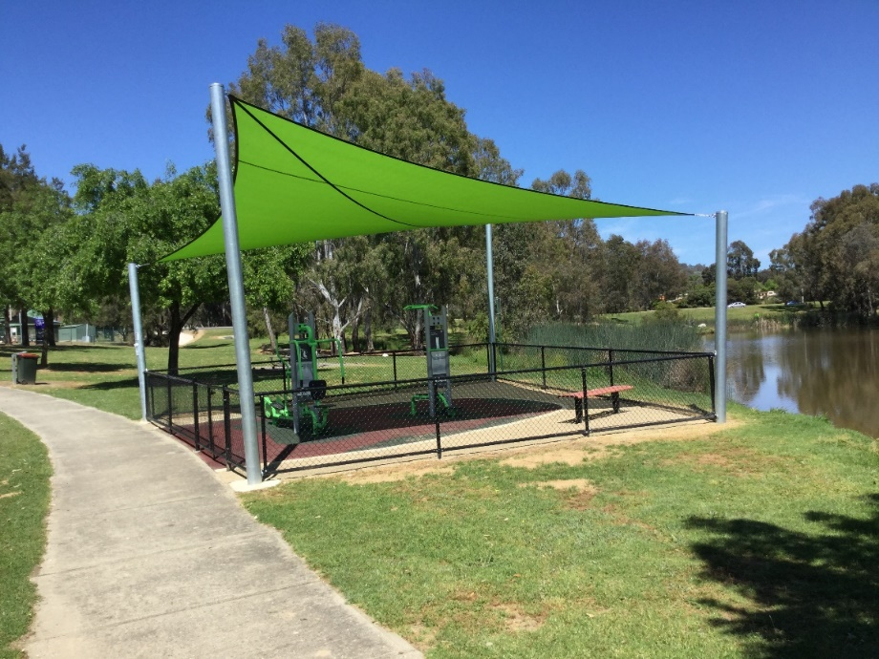

|  |
| --- |
| **Tips for maintaining outdoor fitness equipment**   * Utilise supplier knowledge to develop a maintenance program for the life of the equipment. * Understand supplier warranty periods. * Ask for a copy of the supplier’s equipment maintenance checklist. * Integrate OFE maintenance into existing maintenance plans for similar outdoor recreation infrastructure. * Ensure a contact phone number is provided on site to enable self-reporting of equipment faults or damage. * Ensure regular cleaning is incorporated into the maintenance program. |

## Risk management

Programs and activities that support the management and ongoing maintenance of OFE should aim to minimise risk of injury to users. Regular inspections, programmed and reactive maintenance, damaged parts and graffiti removal policies, and appropriate signage are all important effective methods of minimising risk.

There are no Australian standards for the installation and maintenance of OFE for owners to use as a reference point. Currently, OFE suppliers apply the same standards as playground suppliers (Playground Equipment, AS4685:2014).

These standards consider various safety requirements relevant to OFE, such as UV and environmental factors and existence of crush points. However, it is important to note that these standards do not specifically cover the requirements of exercise equipment.

The increasing popularity of OFE has led to demand for a set of specific standards to support the industry. In response, Standards Australia has appointed a task force consisting of industry professionals and stakeholders from various organisations to develop new standards. Until these new standards are released, there are several precautions for land owners can take to minimise risk.

In conjunction with the approved supplier, develop a formal risk management plan for the proposed site and equipment that considers:

* findings from the site assessment and any identified hazards or risks and strategies to mitigate or eliminate them
* environmental factors to ensure there is no impact to the surrounding environment
* appropriate clearance/circulation space between equipment
* removing and/or rectifying crush points in equipment with moveable parts, and ensuring appropriate signage is provided
* Using equipment inspection checklists and monitoring schedule to ensure equipment is operational and safe for users
* ensure insurance covers equipment theft, damage and injury
* ensure ongoing maintenance costs are incorporated into future budgets and equipment is included in asset maintenance plans.

|  |
| --- |
| **Tips for managing risk**   * Refer to Australian Standard for Playground Equipment (AS4685:2014). * Conduct a full and detailed site risk assessment. * Develop and implement a risk management plan. * Use supplier knowledge and resources to manage risk. * Understand your insurance policies to ensure all potential risks are included. * Conduct regular routine inspections. |

# Section 5: Evaluation

## Evaluating the success of outdoor fitness equipment

To effectively evaluate the success of your OFE, it is important to obtain baseline quantitative data on the levels of use and satisfaction of users where possible, and prioritise the evaluation process to ensure continuous improvement.

Collecting quantitative data on current users can provide insight into what promotional methods should be considered to engage non-users, inform future maintenance policies and practices, and activate additional programming options. Evaluation should be undertaken on an annual basis or more frequently, if necessary.

Evaluating the level of use for OFE is extremely valuable, but it also can be challenging, particularly if there is no formal process in place. The following evaluation methods are provided as a guide to evaluating the success of your OFE.

### Visual observations

This includes onsite data collection thatrecords the following elements:

* location, time, date, observer name, number or users and weather conditions
* participant details such as age, gender, equipment usage type, time spent at the site, first time or advanced user, and if an industry professional is present
  + site provisions and supporting amenities at the time of the observation should be recorded, for example, shade, rain protection, seating, signage, accessibility, lighting, toilet amenities.

Consider undertaking a partnership with a university or similar tertiary institution that would benefit from data collection, as it may alleviate the cost of employing a consultant as an observer.

### Site and equipment condition assessments

Assess general equipment wear and tear to determine level of use. Considerations for this type of evaluation may include:

* obvious signs of use, such as worn seat pads or rubber hand grips or under-surfacing
  + site cleanliness, such as whether rubbish bins regularly used.

### Undertake onsite and online surveys

Gauge the community’s satisfaction with the OFE. Survey questions may cover user satisfaction in the following key areas:

* whether the site location, equipment type and supporting amenities are adequate
* frequency of use and any barriers affecting ongoing participation
  + activation and type of programs to increase use.

|  |
| --- |
| **Tips for evaluating use**   * Develop a strategy that outlines proposed methods of evaluation. * Undertake visual counts of users annually. * Consult the community via online and onsite surveys and questionnaires. * Ensure data is appropriately stored and maintained. * Create partnerships with other organisations that can also utilise data. |

The following international case study of the Copenhagen City Council provides detailed information on the effectiveness of using onsite surveys to collect both qualitative and quantitative data on OFE.

### Case study:Copenhagen City Council (Denmark), Sundby Sports Park

#### Evaluating outdoor fitness usage

Worldwide Play and Outdoor Fitness supplier Kompan conducted a detailed evaluation of the usage of one of its major outdoor fitness installations in Copenhagen, Denmark.

Copenhagen has vast open spaces that encourage outdoor participation in physical activity. It is also one of the most cycle-friendly cities in the world and city leaders are continuously searching for innovative approaches to creating further opportunities for outdoor activity.

Research identified that 59 per cent of the Danish population wished to increase their exercise habits, however, there were several barriers to participation. These were identified as lack of time, lack of exercise equipment availability, cost, and lack of motivation.

The city decided that the installation of OFE in some of Copenhagen’s best open space parks would directly assist in removing some of these barriers. The city initiated the process of having several outdoor fitness stations installed across the capital, with the largest and most prominent in Sundby Sports Park.

Sundby Sports Park is one of the most central parks in Copenhagen and covers more than 150,000 square metres. The site offers a vast range of both indoor and outdoor activities, including tennis, volleyball, handball, badminton and a network of walking/running tracks.

The newest addition to the park is the outdoor fitness station installed by Kompan. The size and variation of the equipment allows for multiple individuals and group fitness classes to be conducted at the same time. The installation offers standard exercise signage, but also incorporates new technology by allowing users to connect to a Kompan smartphone application that further guides them on additional exercise options.

The popularity of the Sundby Sports Park installation with the community was immediately evident. Kompan decided to further investigate the reasons behind this. The objective of the study was to investigate what type of users were using the equipment, and if the installation had succeeded in attracting new users to lead a more active lifestyle.

The study incorporated both qualitative and quantitative methods in direct-contact questionnaires conducted on tablet devices, as well as user data observations. The survey and data collection was conducted over an eight-day period in September 2016. The observations found that 388 people used the Sundry Sports Park outdoor fitness station during that period. The observers also conducted 106 interviews to further understand the drivers behind participation.

The study found several key points:

* The outdoor fitness site attracted a mixed group of users.
* Fourteen per cent of the interviewees were teenagers, meaning that OFE appeals to specific target groups.
* The OFE successfully engaged 23 per cent of previously inactive users.
* Fifty-seven per cent of OFE users already exercised at another location, but added training at the Sundby Sports Park installation to their regime.
  + Eighty-five per cent of users lived within a 3-kilometre radius of the installation.

OFE appeals to people of all ages, but its location is paramount in ensuring it is used by the community. To engage with those members of the community who are not currently active, marketing through the right channels is vital.

Encouraging participation from an inactive community will further ensure that OFE is assisting in combating the global health issues of sedentary behavior and chronic disease.

Figure 11: Proportion of active and inactive users at Sundby Sports Park

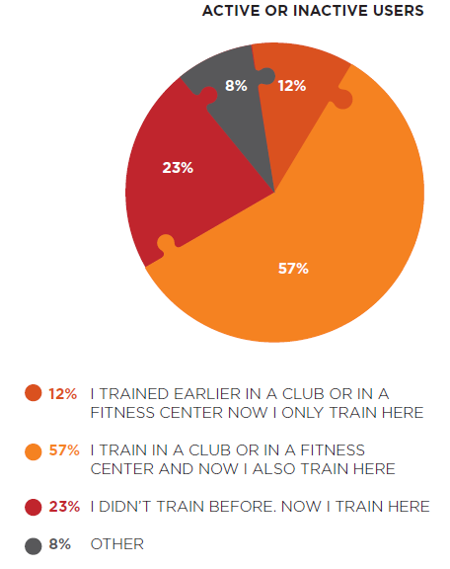

Figure 12: Age mix of active and inactive users at Sunby Sports Park

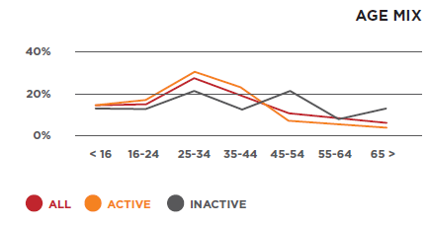

Figure 13: The OFE installation at Sunby Sports Park in Copenhagen

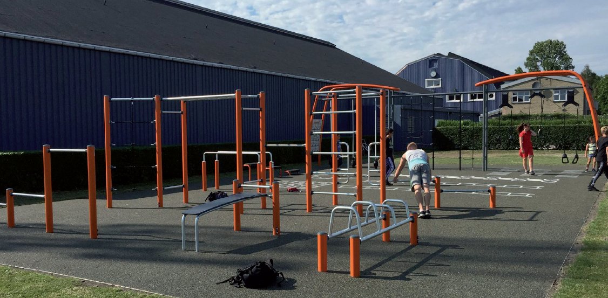

# Resources

Australian Bureau of Statistics 2011, [Physical activity in Australia: a snapshot](http://www.abs.gov.au/ausstats/abs@.nsf/Lookup/4835.0.55.001main+features22007-08) <http://www.abs.gov.au/ausstats/abs@.nsf/Lookup/4835.0.55.001main+features22007-08>.

Australian Institute of Health and Welfare 2012, [Risk factors contributing to chronic diseases](http://www.aihw.gov.au/WorkArea/DownloadAsset.aspx?id=10737421546) <https://www.aihw.gov.au/reports-statistics>

Australian Sports Commission 2013, [Megatrends in sport](https://www.clearinghouseforsport.gov.au/__data/assets/pdf_file/0007/564073/The_Future_of_Australian_Sport_-_Full_Report.pdf) <https://www.clearinghouseforsport.gov.au/__data/assets/pdf_file/0007/564073/The_Future_of_Australian_Sport_-_Full_Report.pdf>.

Australian Sports Commission 2016, [Participation data for the sports sector](http://www.ausport.gov.au/__data/assets/pdf_file/0007/653875/34648_AusPlay_summary_report_accessible_FINAL_7.12.2016.pdf) <https://www.ausport.gov.au/__data/assets/pdf_file/0007/653875/34648_AusPlay_summary_report_accessible_FINAL_updated_211216.pdf>.

Chow HW 2013, [Outdoor fitness equipment in parks: a qualitative study from older adults' perceptions](http://bmcpublichealth.biomedcentral.com/articles/10.1186/1471-2458-13-1216) <https://bmcpublichealth.biomedcentral.com/articles/10.1186/1471-2458-13-1216>.

City of Port Phillip 2017, [Outdoor fitness stations <](http://www.portphillip.vic.gov.au/outdoor-fitness-stations.htm)http://www.portphillip.vic.gov.au/outdoor-fitness-stations.htm>.

City of Sydney 2015, Park fitness equipment plan <http://www.cityofsydney.nsw.gov.au/__data/assets/pdf_file/0008/257228/Park-Fitness-Equipment-Plan-v3.pdf>.

Commonwealth Government Department of Health 2014, [Australia's physical activity and sedentary behaviour guidelines](http://www.health.gov.au/internet/main/publishing.nsf/content/F01F92328EDADA5BCA257BF0001E720D/$File/brochure%20PA%20Guidelines_A5_18-64yrs.PDF) <http://www.health.gov.au/internet/main/publishing.nsf/content/F01F92328EDADA5BCA257BF0001E720D/$File/brochure PA Guidelines_A5_18-64yrs.PDF>.

Gladwell VF, Brown DK, Wood C, Sandercock GR and Barton JL 2013, [The great outdoors: how a green exercise environment can benefit all](https://extremephysiolmed.biomedcentral.com/articles/10.1186/2046-7648-2-3) <https://extremephysiolmed.biomedcentral.com/articles/10.1186/2046-7648-2-3>.

Liverpool John Moores University 2013, [Evaluating the provision of outdoor gym equipment](http://www.cph.org.uk/wp-content/uploads/2013/10/Evaluating-the-provision-of-outdoor-gym-equipment-Summary-revised.pdf) <http://www.cph.org.uk/wp-content/uploads/2013/10/Evaluating-the-provision-of-outdoor-gym-equipment-Summary-revised.pdf>.

Pasanen TP, Tyrvainen L and Korpela KM 2014, [The Relationship between Perceived Health and Physical Activity Indoors](http://onlinelibrary.wiley.com/doi/10.1111/aphw.12031/full) <https://onlinelibrary.wiley.com/doi/full/10.1111/aphw.12031>.

Playcore Research Centre 2017, [Outdoor adult fitness](https://www.gametime.com/uploads/media/Outdoor_Adult_Fitness_Parks_ES.pdf) <https://www.gametime.com/uploads/media/Outdoor_Adult_Fitness_Parks_ES.pdf>.

Public Fitness Sydney 2010, [Let’s get physical: planning for outdoor gyms in Sydney](https://publicfitnesssydney.wordpress.com/about/) <https://publicfitnesssydney.wordpress.com/about/>.

Sport and Recreation Victoria 2016, [Design for everyone guide](http://sport.vic.gov.au/design-for-everyone-guide/overview-of-universal-design) <http://sport.vic.gov.au/design-for-everyone-guide/overview-of-universal-design>

State Government of South Australia 2011, [Community gyms: a step by step guide](http://www.ors.sa.gov.au/__data/assets/file/0008/145772/Community-Gyms.pdf) <http://www.ors.sa.gov.au/__data/assets/file/0008/145772/Community-Gyms.pdf>.

State Government of Victoria 2017, Heritage tools and publications <https://www.vic.gov.au/aboriginalvictoria/heritage/heritage-tools-and-publications.html>.

VicHealth 2014, [Physical activity, sport and walking: VicHealth’s investment plan](https://www.vichealth.vic.gov.au/our-work/encouraging-regular-physical-activity) <https://www.vichealth.vic.gov.au/our-work/encouraging-regular-physical-activity>.

VicHealth 2016, [Participation in physical activity summary](https://www.vichealth.vic.gov.au/media-and-resources/publications/participation-in-physical-activity) <https://www.vichealth.vic.gov.au/media-and-resources/publications/participation-in-physical-activity>.

Victoria Police 2015, [Crime prevention through environmental design](http://sport.vic.gov.au/design-for-everyone-guide/overview-of-universal-design) <http://www.police.vic.gov.au/content.asp?document_id=10444>.

World Health Organization 2016, [Physical activity](http://www.who.int/mediacentre/factsheets/fs385/en/) <http://www.who.int/mediacentre/factsheets/fs385/en/>.

# Appendix 1: Outdoor fitness equipment routine maintenance checklist

This checklist will assist those responsible for maintaining outdoor fitness equipment to identify current equipment issues or faults, and to eliminate future potential liabilities. This checklist should be completed on a monthly basis, or more frequently if the site is subject to heavy use or is located in an area prone to vandalism.

|  |  |
| --- | --- |
| Site name: |  |
| Inspector name: |  |
| Inspection date: |  |
| Supplier warranty valid | Y/N |
| Are equipment surfaces clean and undamaged? | Y/N |
| Are equipment structures free of bending, warping, cracking and breaking? | Y/N |
| Is equipment paintwork free of chips and cracks? | Y/N |
| Are equipment welding joints undamaged and free of corrosion? | Y/N |
| Is the equipment and surrounding area free of sharp points and protrusions? | Y/N |
| Is the flooring/ under-surfacing clean and undamaged? | Y/N |
| Are foundations free from exposure? | Y/N |
| Is all equipment in full working order? | Y/N |
| Are equipment fastenings secure? | Y/N |
| Is the area free of all hazards? | Y/N |
| Is instructional signage undamaged and clearly visible? | Y/N |
| Are equipment guards and protective devices visible and undamaged? | Y/N |
| Is equipment structurally sound? | Y/N |
| Are clearance levels maintained? | Y/N |
| Is the site free of vandalism? | Y/N |
| Are equipment mechanisms and moving parts moving freely? | Y/N |
| Is the area free of trip hazards? | Y/N |
| Are crush points clearly identified with appropriate signage? | Y/N |
| Actions required: |  |

# Appendix 2: Outdoor fitness equipment site evaluation checklist

This checklist will assist in determining if the selected location for outdoor fitness equipment is suitable. It will also identify key areas for consideration and further investigation before confirming a location for outdoor fitness equipment.

|  |  |
| --- | --- |
| Is the site large enough to accommodate an outdoor fitness installation (average size of a OFE installation is 150–200m2) | Y/N |
| Is the site wheelchair accessible? | Y/N |
| If ‘No’, is there provision to install formed pathways? | Y/N |
| Are there public toilets within a reasonable distance? | Y/N |
| Does the site have additional supporting amenities, such as a jogging/ walking path, drinking fountains, or a playground? | Y/N |
| Is the site shaded? | Y/N |
| If ‘No’, is there potential for tree plantings or shade sails to be installed? | Y/N |
| Has a soil test been conducted? | Y/N |
| If ‘Yes’, is the soil suitable for OFE construction? | Y/N |
| Have heritage/cultural site considerations been considered? | Y/N |
| Does the site, or the area immediately surrounding it, currently have high levels of community use? | Y/N |
| Have community activities that already exist in the area been considered? | Y/N |
| Has the community been consulted in their preference for the OFE location? | Y/N |
| Is the site visible from nearby roadways? | Y/N |
| Is there vehicle parking within a reasonable distance? | Y/N |
| Is the site accessible by public transport? | Y/N |
| Is the site and surrounding areas considered safe and free of vandalism? | Y/N |
| Is there opportunity for auto-timed lighting at the location? (site power) | Y/N |
| Has a SWOT (Strengths, Weaknesses, Opportunities, Threats) analysis been conducted on the site? | Y/N |
| Have CPTED principles been considered to enhance the safety of users? | Y/N |
| Have Universal Design considerations been assessed? | Y/N |
| Site notes / considerations: |  |

Upon completion, if the majority of questions were answered with ‘Yes’ proceed with site planning.