

Shaping attitudes: Exposure to women coaches and officials influences children and parent perceptions

RESEARCH SUMMARY

Introduction
Women represented in coaching and officiating roles in community sport can assist to reshape attitudes and gender bias towards leadership roles in sport.

What we know
Women are underrepresented as coaches and officials¹, which are important leadership roles at a community sport level.
Approaches that encourage women into these roles are at times diminished because of societal views that coaching and officiating are typically conducted by men².
Exposure to women as coaches and officials at an early age, along with supportive attitudes from parents, could positively influence children’s perceptions towards women in these roles^{5,6}.
Knowledge and biases are formed through social interactions³. For children, early social experiences begin to shape preconceived ideas about the world around them⁴.

Research scope
This research sought to understand attitudes towards women in coaching and officiating roles amongst children (aged 4 – 17 years) involved in community sport, and their parents in Victoria.

Research aims
The aims of this project were to investigate:
- Existing attitudes: towards women as coaches and officials
- Factors influencing attitudes: towards women as coaches and officials
- Differences in attitudes: towards women as coaches and officials between children and their parents who have and have not been exposed to women in these roles.
Each participant completed an online survey and a cognitive assessment measuring association bias towards women in coaching and officiating roles.
The Women in Sport research team at the Institute of Health and Sport, Victoria University conducted this research, with funding from the Victorian Government, through the Office for Women in Sport and Recreation’s Change Our Game Research Grants Program.

Research respondents
A total of 75 parents/carers and 75 children provided insights into their experiences and attitudes of women as coaches and officials.

Parents were aged between 34-62 years
84% were women
77% had played sports

Children were aged between 4-17 years
73% were boys
Every child played sport
Children had predominantly participated in eight sports (refer Figure 1). Overall, the top three were:
Australian rules football (53%)
Basketball (45%)
Swimming (29%)
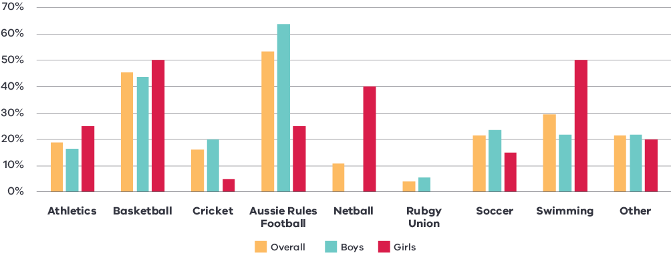
Figure 1. Child’s participation in sport

Research findings
The research findings are presented under four themes and are visually presented in Figure 2 relating to children’s satisfaction with women coaches and officials:
- Exposure to women as coaches and officials – children are more likely to have exposure to men as coaches and officials.
- Children’s satisfaction with women as coaches and officials – increased exposure to women in these roles leads to greater satisfaction amongst children.
- Parental influence on children’s satisfaction with women as coaches and officials – parents have a direct impact on their child’s satisfaction.
- Social norms on women as coaches and officials – greater satisfaction amongst children decreases their unconscious bias in associating men in these roles.
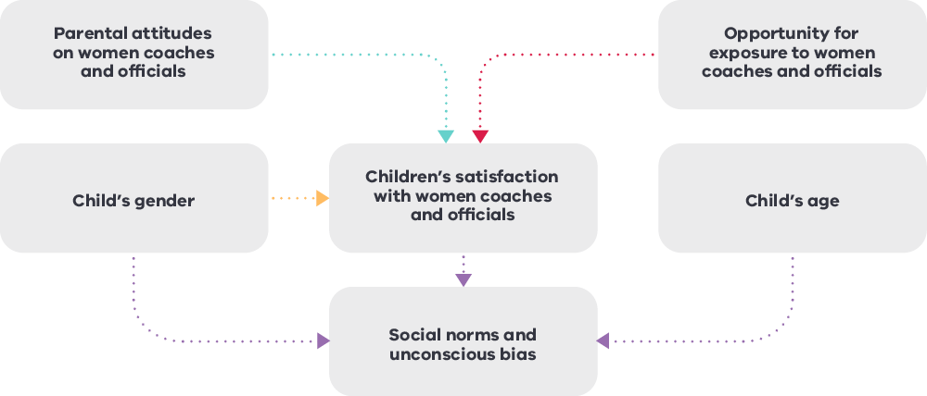
Figure 2. Children’s satisfaction with women coaches and officials
Note: Satisfaction in this context refers to the children's overall happiness of women being their coach or official in the various sports they participate or have participated in.

THEME 1: Exposure to women as coaches and officials
Across different sports, coaching and officiating roles were dominated by either men or women in particular sports, which limits children’s exposure to men and women in these roles.

Key Findings
- Coaches and officials were dominated by women in netball and swimming, compared to being dominated by men in cricket, Australian rules football, rugby union and football (soccer).
- Across all sports, children were more exposed to having men as coaches (96% of children compared to 65% having women coaches) and having men as an official (100% compared to 90% for women).
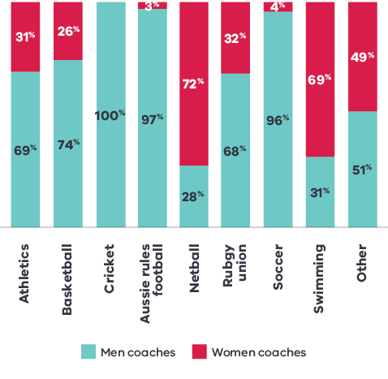
Figure 3. Exposure to women and men coaches
Three in ten coaches that children were exposed to were women.
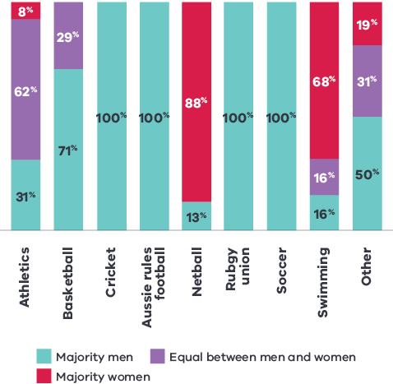
Figure 4. Exposure to women and men officials
Two in ten children experienced a majority of women officials.

THEME 2: Children’s satisfaction with women as coaches and officials
Children were more satisfied with women as coaches and officials when they had experienced women in these roles.

Key Findings
- Children’s satisfaction with having a man or woman as their coach was influenced by their previous experience of these roles – with a clear preference for having a woman coach in netball and swimming, and a man in cricket, Australian rules football and basketball.
- Previous experiences with having a woman coach positively influenced children’s belief that women can be great coaches.
- Children with exposure to predominantly women officials showed higher satisfaction with women in these roles.
- Girls’ satisfaction levels with having a woman coach and/or official was higher than boys.
Children who experienced at least one woman as a coach were 3 times more likely to associate a woman as “looking” like a coach or an official, compared to those without any experience.

THEME 3: Parental influence on children’s satisfaction with women as coaches and officials
Children’s satisfaction with women as coaches and/or officials closely aligned with their parent’s satisfaction levels, demonstrating the important influence of parents on their children.

Key Findings
Parents’ satisfaction levels with men and/or women as coaches and officials varied based on the sport – with a clear preference for women in netball, and men in cricket, Australian rules football and rugby union.
- Parental attitudes significantly influence their children’s attitudes – as children’s choices in associating women as coaches or officials closely aligned to their parents.
- Children whose parent associated a woman as “looking” like a coach were 6 times more likely to also associate a woman as being a coach (compared to children whose parents did not associate a woman being a coach).

THEME 4: Social norms on women as coaches and officials
There is a bias towards associating men as being coaches and officials more readily than women for the same position.

Key Findings
- Children and their parents were more likely to believe that men make great coaches and officials, compared to women.
- Children were quicker to identify men as coaches and officials, compared to women.
- Children were 2 times more likely to select a man compared to a woman as “looking” like a coach or an official.

HOWEVER
- This bias was less prevalent in girls compared to boys.
- The older children become, the more likely they were to believe that women can make great coaches and officials. This finding highlights the importance of young players being coached and officiated by women. Such early exposure could be pivotal in shaping more inclusive views of what it means to be a coach or an official in sport from a young age.
- Children with a higher satisfaction in having a woman coach showed less unconscious bias towards associating men with coaching and officiating roles.

Recommendations and questions for community sporting clubs

Recommendation 1: Expose children to women coaches and officials
What is the gender balance of coaches and officials at your club, and how are women represented across all junior and senior level teams/competitions? Do you have targets you are looking to achieve?
Do children continually experience having a woman or a man as their coach throughout their junior pathway? If so, how can you provide them experiences of having both women and men coaches?
Do your existing women coaches and officials include representation from diverse backgrounds e.g. women from culturally and linguistically diverse backgrounds?

Recommendation 2: Influence positive parental attitudes towards women as coaches and officials
Does your club, and sport, equally promote women and men in coaching and officiating roles to the wider community – including on your website, social media and club newsletters?
Does your club celebrate the achievements and milestones of women coaches and officials, including to the same extent as men in those roles?
Does your club actively build parental support for having women as coaches and officials in junior sport?

Recommendation 3: Support more women to become and remain as coaches and officials
Does your club have a commitment to having more women in coaching and officiating roles?
How does your club provide an inclusive and welcoming environment for women to become and remain coaches and officials?
Do you have a targeted plan to attract, develop and retain women as coaches and officials?

References
- Palmer, K. (2019, March 8). The dial is shifting for gender equality in sport – just not fast enough. Sport Australia. https://www.sportaus.gov.au/media_centre/news/the_dial_is_shifting_for_gender_equality_in_sport_just_not_fast_enough
- Burton, L.J., & LaVoi, N.M. (2016). An ecological/multisystem approach to understanding and examining women coaches. In N.M. LaVoi (Ed.), Women in Sports Coaching (pp. 49–62). London, UK: Routledge.
- Bandura, A. (1977). Self-efficacy: toward a unifying theory of behavioural change, Psychological Review, 84, 191-215.
- Canevello, A. (2020). Gender Schema Theory. In: Zeigler-Hill, V., Shackelford, T.K. (eds) Encyclopedia of Personality and Individual Differences. Springer, Cham. https://doi.org/10.1007/978-3-319-24612-3_978
- Jeanes, R., Spaaij, R., Farquharson, K., McGrath, G., Magee, J., Lusher, D., & Gorman, S. (2021). Gender Relations, Gender Equity, and Community Sports Spaces. Journal of Sport and Social Issues, 45(6), 545–567. https://doi.org/10.1177/0193723520962955
- Drummond, M., Drummond, C., Elliott, S., Prichard, I., Pennesi, J. L., Lewis, L. K., Bailey, C., & Bevan, N. (2022). Girls and Young Women in Community Sport: A South Australian Perspective. Frontiers in sports and active living, 3, 803487. https://doi.org/10.3389/fspor.2021.803487

Acknowledgements
The Victorian Government proudly acknowledges Aboriginal people as the First Peoples and Traditional Owners and custodians of the land and water on which we rely. We acknowledge the ongoing leadership role of the Aboriginal community on gender equality and the prevention of violence against women. As First Peoples, Aboriginal Victorians are best placed to determine a culturally appropriate path to gender equality in their communities.
This is a summary from research conducted in 2023 by the Women in Sport research team from the Institute of Health and Sport, Victoria University, focused on ‘Perceptions of children and their parents on women as coaches and officials in community sport’ (Dadswell, K., Sambol, S., & Hanlon, C.).
The research was funded by the Victorian Government through the Change Our Game Research Grants Program.

