Sport and Recreation Victoria

STATE SPORTING ASSOCIATION
RECOGNITION

Guidelines

Authorised and published by the Victorian Government, 1 Treasury Place, Melbourne.

© State of Victoria, Department of Jobs, Skills, Industry and Regions, January 2025.

Available at Sport and Recreation Victoria website.

Introduction
Sport and active recreation play an important role in the lives of Victorians. It provides a setting for physical activity, social interaction, sharing common interests, achieving personal bests and community cohesion.

State sporting associations are vital in ensuring Victorians have access to sport and participation opportunities. They govern all levels of the sport, from grassroots through to high performance and are responsible for the administration, promotion and development of the sport in Victoria.

Governance of Australian sport
In Australia, sport is governed through a hierarchy of organisations at national, state and local level.
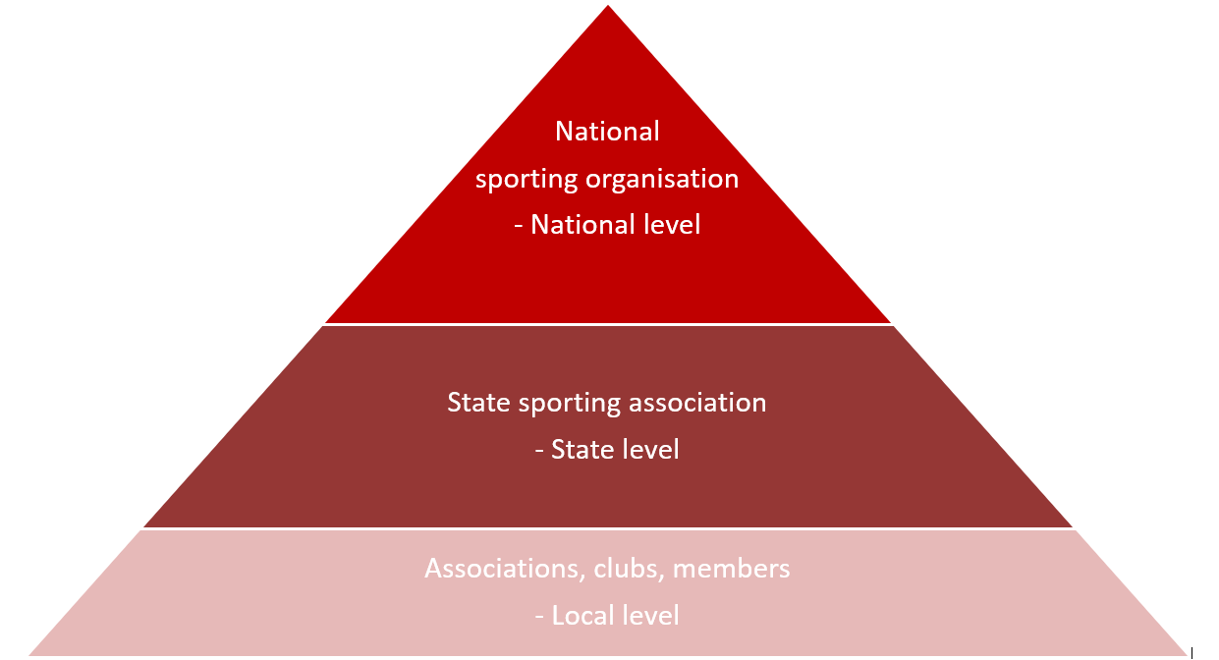

Figure 1: Sport governance hierarchy

What is a state sporting association?
A state sporting association is the governing body for a sport at state level. They represent affiliated member leagues, associations, clubs and participants. State sporting associations are responsible for the development of their sport within Victoria, from community participation through to high performance level and can represent all Victorians participating in the sport.

Recognition as a state sporting association by Sport and Recreation Victoria acknowledges an organisation as the pre-eminent governing body for the sport in Victoria.

State sporting association recognition status is limited to a single organisation for each sporting type to enable cohesive relationships between government and the sports sector and prevent fragmentation of sports.

A current list of recognised Sport and Recreation Victoria State sporting associations is available on the Sport and Recreation Victoria website.

What is a national sporting organisation?
A national sporting organisation is the pre-eminent Australian sporting body recognised by the international federation for the sport. A national sporting organisation is responsible for the development of the sport and is accountable at the national level for providing its members with technically and ethically sound sport programs, policies, and services.

National sporting organisations are national governing bodies recognised by the Australian Sports Commission.

A current list of Australian Sports Commission recognised national sporting organisations can be found on the Australian Sports Commission website.

Governance models
Sport and Recreation Victoria acknowledge that sports have varying governance models.
Organisations operating under a unitary or federated governance structure will be considered for recognition provided they:

- deliver outcomes in Victoria for Victorians
- have a physical presence within the state, for example a state manager, dedicated resources, office
- are a member of Vicsport.

Who can apply for state sporting association recognition?
Non-government not for profit organisations who are the pre-eminent governing body for the sport in Victoria. They must deliver sport participation opportunities and be capable of representing all Victorians. They must be able to demonstrate that they are responsible for the development of the sport from community participation through to high performance level and are responsible for providing members with technically and ethically sound sports programs, policies and services.

To be eligible to apply for recognition, organisations must:

  - be non-government, legally constituted and not-for-profit
  - possess an Australian Business Number (ABN)
  - have sport as its core business
  - be capable of representing all Victorians participating in the sport
  - be able to demonstrate they are the pre-eminent governing body for the sport in Victoria
  - have been operational for a minimum of 3 years and are financially solvent
  - have a current strategic plan
  - have sound financial and governance policies and practices
  - have and maintain policies relating to the Fair Play Code of conduct, member protection and child safe standards.

Organisations that will not be recognised
Organisations are not eligible for recognition if they:
  - are not responsible for the development of the sport in Victoria from community participation through to high performance level
  - are not the pre-eminent governing body for the sport in Victoria
  - do not provide participation outcomes for all Victorians
  - do not have sport as their core business
  - are not determined to be a sporting activity (see sport definition under Criteria 1).

Criteria for recognition
Applications for recognition will be assessed against the below criteria based on the organisations’ response and evidence provided.

Criteria 1. Sport is the organisation’s core business
For the purposes of obtaining recognition, the described activity must meet the following: ‘A human activity involving physical exertion and skill as the primary focus of the activity, with elements of competition where rules and patterns of behaviour governing the activity exist formally through organisations and is generally recognised as a sport.’

Evidence required:

- Organisation’s Constitution.
- Strategic Plan.
- Rules of the sport.

Criteria 2. The organisation is the pre-eminent governing body for the sport in Victoria and represents all Victorians.

The organisation is responsible for the development of the sport in Victoria from community participation through to high performance level. They represent affiliated member leagues, associations, clubs and participants and are accountable at the state level for providing its members with technically and ethically sound sports programs, policies and services.

Evidence required:

- Membership policies and procedures.
- Policies relating to Child Safeguarding.
- Member Protection policy.
- Policies and practices that align to the Fair Play Code of conduct.
- Anti-doping Policy endorsed by Sport Integrity Australia.
Note: Where the pre-eminent governing body for the sport in Victoria is the national sporting organisation, capacity, and authority to deliver outcomes in Victoria must be demonstrated.

Criteria 3. The organisation is the Victorian state affiliated body of the national sporting organisation recognised by the Australian Sports Commission
The organisation can demonstrate it is the pre-eminent body representing all forms of the sport.

Evidence required:

- Letter of affiliation with the national sporting organisation.

A list of recognised national sporting organisations can be found on the Australian Sports Commission’s website.

Note: Where the pre-eminent governing body for the sport in Victoria is the national sporting organisation, they must still be recognised by the Australian Sports Commission.

In exceptional circumstances where the national sporting organisation is not recognised by the Australian Sports Commission, Sport and Recreation will consider why they are not recognised and determine from evidence provided as to whether the organisation is the governing body for the sport and can demonstrate the significance of their contribution to the Victorian Sport and Recreation sector.

Evidence required:

- the organisation can demonstrate the national organisation they are affiliated to is the single national entity representing all forms of the sport in Australia from grass roots/community through to high performance
- that the national organisation is affiliated with the International Federation which is a member of the Global Association of International Sports Federations.

Criteria 4. The organisation is non-government, legally constituted and not-for-profit

Evidence required:

- proof organisation is non-government, legally constituted and not for profit, for example, Certificate of Incorporation, company registration
- Australian Business Number (ABN).

Criteria 5. The organisation has been operational for a minimum of 3 years and is financially solvent.

Evidence required:

- past 3 years of the organisation’s annual reports
- past 3 years audited financial statements, prepared in accordance with the accounting standards relevant to the organisation, such as independent auditing.

Criteria 6. The organisation can provide evidence that demonstrates their commitment to contributing to the Victorian Sport and recreation sector by alignment to Victorian Government policies and outcomes.

Please provide statements of how your organisations strategic plan aligns with the priorities of Active Victoria and how you can contribute to strengthening the sport and recreation sector, boost participation and ensure every Victorian can be involved.

Documents required:
- organisation strategies – Diversity and Inclusion, Reconciliation Action Plan, Gender equity, high performance, coaching
- membership breakdown – members, clubs, associations (individual athlete competitor, coach or official who is registered with the organisation directly)
- Board member report - including structure, name, gender and voting rights of all members (provided with application form).

How applications will be assessed
Eligible applications will be assessed against the state sporting association recognition criteria by a Sport and Recreation Victoria panel. The panel will provide recommendations to the Minister for Community Sport taking into consideration the applicants response to each criterion.

Please note:

  - recognition as a state sporting association does not guarantee Victorian Government funding.
  - the recognition term will be for a minimum period of 2 years.
  - the assessment process may take up to 3 months from the round closing date.
  - applicants will receive written notification of the outcome of their application.

Sport and Recreation Victoria may apply discretion in determining recognition and may request additional evidence.

What are the benefits of recognition?
Recognised state sporting associations are:

  - acknowledgement by Sport and Recreation Victoria as the pre-eminent governing body for the sport in Victoria
  - eligible to apply for Victorian Government funding programs available that are available for recognised organisations
  - offered access to networking, workshops and professional development opportunities
  - invitations to participate in sector consultation activities conducted by Sport and Recreation Victoria and our partners.

What are the expectations of recognised organisations?
Recognised organisations are expected to play an important role in the Victorian Sport and Recreation sector, by making a significant contribution to delivering opportunities for Victorians to participate in safe inclusive environments.

As a recognised state sporting association, organisations are required to:

  - provide Sport and Recreation Victoria with a copy of your organisation’s annual report and financial statements, produced in accordance to your organisation’s legal requirements, for the year within 4 months of the end of each financial year for your organisation
  - within 30 days following your organisation’s annual general meeting each year, provide Sport and Recreation Victoria with written notice of updated contact details for principal contact of your organisation, and gender representation on your organisation’s governing board
- have and maintain policies that address issues relating to safe and inclusive sport, including codes of conduct that align with the Fair Play Code of conduct, Member Protection and Child Safeguarding
  - have a current strategic plan
  - adopt sound policies and practices in relation to your organisation’s corporate governance and financial management
  - advise Sport and Recreation Victoria promptly of any matter that might affect your organisation’s recognition status (for example, failing to continue to meet the Sport and Recreation Victoria’s recognition criteria for a state sporting association).

Sport and Recreation Victoria will monitor organisations against the recognition criteria and reserves the right to request further information if required and change the guidelines/criteria in future. Should an organisation not be able to provide satisfactory evidence that they still meet the criteria, recognition will become provisional with a set period provided for a rectification process. Failure to do so may result in the Minister for Community Sport removing recognition status, requiring the organisation to reapply to demonstrate they satisfy all recognition criteria.

Role and responsibilities
In 2011, all Australian governments committed to the principles and priorities outlined in the National Sport and Active Recreation Policy Framework and to working with our partners in sport and active recreation sector to achieve national outcomes for the benefit of all Australians.

The Framework is a guide for government activity and resource allocation. It provides a mechanism for engaging the whole sport and recreation industry in the achievement of national goals for sport and active recreation. It also sets out the agreed roles and responsibilities of governments and expectations of sport and active recreation system partners.

Opening dates for recognition as a state sporting association
Round 1
Opens: Monday 16 March 2026
Closes: Friday 24 April 2026
Round 2
Opens: Monday 17 August 2026
Closes: Friday 25 September 2026

How to apply
Step 1
Review the State Sporting Association Recognition Guidelines to ensure eligibility and ability to meet all recognition criteria.

Step 2
To arrange a time to discuss eligibility and receive the application form, email Sport and Recreation Victoria at sportprograms@sport.vic.gov.au.

Please note: Eligibility to apply does not guarantee recognition.

Step 3
Following discussion of recognition eligibility with the Manager, Recognition Program, Sport and Recreation Victoria, a copy of the application form will be provided via email.

Step 4
Complete the Victorian State Sporting Association Recognition Application Form and the State Sporting Association Recognition Eligibility Checklist.

Step 5
Send the completed application form, the completed recognition checklist and supporting documentation to the Manager, Recognition Program, Sport and Recreation Victoria (email address provided during initial discussion on eligibility).

Step 6
Sport and Recreation Victoria will advise of receipt of the application via return email.

Step 7
Applicants will receive written notification of the outcome of their application.

Assistance with applying
Should organisations require further information or have queries about the process for state sporting association recognition, please contact the Manager, Recognition Program, by emailing sportprograms@sport.vic.gov.au.

Privacy
The Department of Jobs, Skills, Industry and Regions (DJSIR) is committed to protecting your privacy. DJSIRR collects and handle any personal information about your organisation or a third party in your application, for the purpose of assessing the application and informing the public of successful applications.

Any personal information about your organisation or a third party in your correspondence will be collected, held, managed, used, disclosed or transferred in accordance with the provisions of the Privacy and Data Protection Act 2014 (Vic) and other applicable laws.

To obtain a copy of the Department’s privacy statement or for information about how to access information about you held by the Department, please email privacy@ecodev.vic.gov.au.

