

The Value of You Can Be What You Can See

Addressing the Sponsorship Gap for Women’s Elite Sport

Contents
1. Project background 1
2. Benefits of investing into the visibility of women’s elite sport 4
3. Addressing the sponsorship gap 7
4. Key Recommendations 8
5. Call to action 9

Acknowledgements
The Victorian Government proudly acknowledges Aboriginal people as the First Peoples and Traditional Owners and custodians of the land and water on which we rely.
We acknowledge the ongoing leadership role of the Aboriginal community on gender equality and the prevention of violence against women. As First Peoples, Aboriginal Victorians are best placed to determine a culturally appropriate path to gender equality in their communities.

Project background
Women’s elite sport in Victoria, and all of Australia, has seen incredible growth over the past decade.
This seismic shift has been driven off the back of new and expanded professional leagues, and the ongoing success on the world’s stage by national teams and athletes.
Opportunities to be professional athletes grew.
Visibility of women as professional athletes grew.
Investment into women as professional athletes grew.
And in the spirit of You Can Be What You Can See, participation by women and girls grew significantly, especially for sports where women and girls had historically been excluded.
Fan bases grew.
And yet, an investment gap between women’s and men’s elite sport remains.
This investment gap must close to fully realise the potential of women’s elite sport: the value of You Can Be What You Can See.
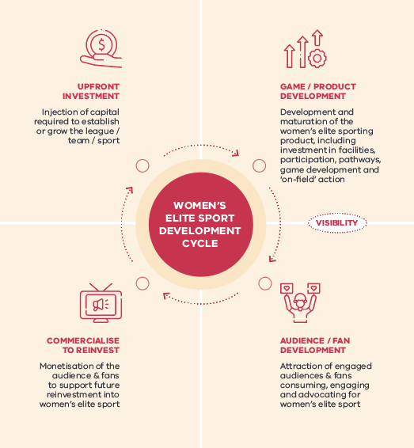
To quantify the opportunity of investing into the visibility of women’s elite sport, the Victorian Government’s Office for Women in Sport and Recreation (OWSR) commissioned a study delivered by Gemba in 2023. This analysis forms part of the Change Our Game Research and Insights Initiative, which aims to advance the conversation around gender equality in sport and active recreation in Victoria.
The study explored eight key sports in Australia, covering elite professional competitions, national teams and individual athletes, through consultations, public financial disclosures, consumer survey results and market insights.
Investment into women’s elite sport – whether through participation and pathways, infrastructure and facilities, exhibition matches and world championships, programs, product development or visibility – delivers a range of benefits. While these investment areas are all important, the focus of this analysis is investment by corporate sponsors into the visibility of women’s elite sport.


Benefits of investing into the visibility of women’s elite sport
The Game Plan: Corporates seek to increase commercial returns by aligning brand values with sporting properties through sponsorships, which in turn is pivotal in funding sporting organisations and enable investment into the visibility of women’s elite sport.
This investment mainly occurs through two mechanisms: direct sponsorship of leagues, clubs, programs, events and players, and/or through to the amplification of sponsorships through advertising, content creation, activations and other promotional activities.
Investment brings significant benefits, ranging from increased brand awareness to improved employee satisfaction.
So, what are the tangible value of these benefits?
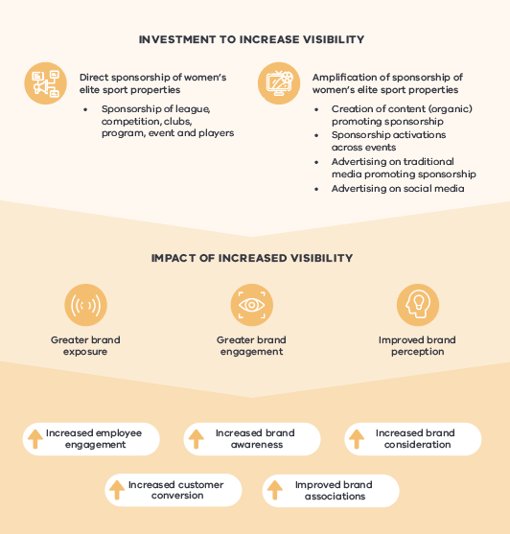
First serve: Corporate organisations that have invested into women’s elite sporting properties realise significant benefits. When comparing sport fanatics with the general population, there is an uplift across key brand metrics including brand awareness (+8%), brand consideration (+6%), and customer conversion (+5%).
Bigger bang for (sponsorship) buck: Sponsorships of women’s elite sporting properties outperform men’s elite sporting properties in brand awareness, brand consideration and customer conversion (see Figure 1).
Early movers are benefitting – and in a big way: Early corporate supporters of women’s elite sport in Australia are benefitting from more than $650 million in customer value each year.
Set point: Every $1 invested by a corporate sponsor into the visibility of women’s elite sport is supporting the realisation of, on average, $7.29 in customer value for that organisation.
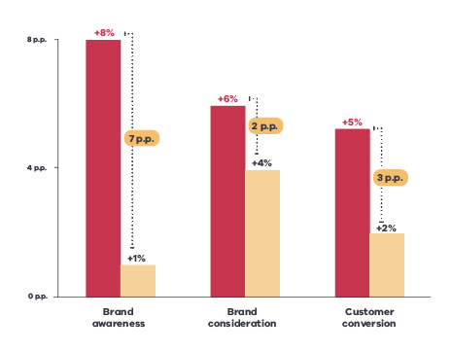
Figure 1. Uplift in key brand health metrics for women’s compared to men’s elite sport sponsors – Percentage point difference between fanatics of the sport and general population
The winning margin: Beyond the improvement in key brand metrics, corporate sponsors also realised improved brand attributes and increased employee satisfaction – these reasons were indicated as key differentiators between sponsoring men’s properties vs. women’s properties by current women’s elite sport sponsors.
Corporate sponsors of women’s elite sporting properties realised a stronger uplift across key brand attributes such as ‘quality’, ‘experts’, ‘supportive’, ‘community focused’ and ‘Australian’ amongst fanatics of the sport. In particular, sponsors of women’s elite sport have seen the biggest difference in ‘Australian’ and ‘innovative’ brand attributes when compared to sponsors of men’s elite sporting properties.
Translation: If brands are looking to strengthen and demonstrate their values to their customers, employees and the broader community, women’s elite sport presents a unique opportunity to support this objective.

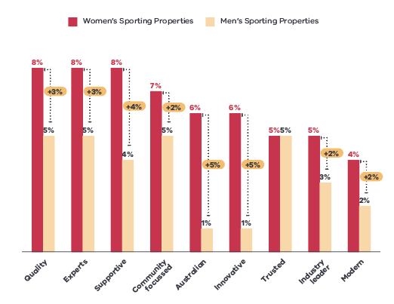
Figure 2. Uplift of sponsor brand attributes of fanatics vs total population
Survey sample: N=1,006

Addressing the sponsorship gap
Demand for partners will remain: Sporting organisations need to increase their investment into the visibility of women’s elite sport to 3-4 times current levels to equalise participation and fan bases between men’s and women’s sports. This means plenty of opportunities for interested corporate sponsors to support sporting organisations.
Women’s elite sport remains underappreciated: Domestic and international industry benchmarks indicate that the value of women’s elite sport properties is currently only 12% the level of men’s elite sport properties.
Towards gender parity: Achieving sponsorship parity in Australia would require an uplift of more than $125 million p.a. This significant uplift in investment will deliver major commercial and brand value for prospective sponsors based on the findings of this study.
The sooner this journey can be accelerated to reach parity, the greater the prize is on offer for corporate sponsors: High-level forecasting based on the results of this study indicate $49 billion in customer value to corporate sponsors is on the table over the next 15 years if sponsorship parity is reached by 2038 (15 years). This increases to more than $72 billion over 15 years if this milestone is reached by 2028 (5 years).
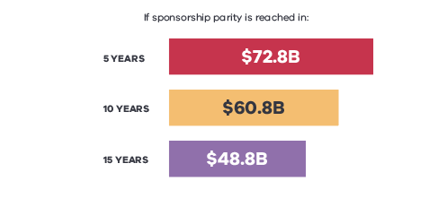
Figure 3. Customer value over 15 years based on speed of sponsorship gap closing

Key Recommendations

Get in early and grow with the women’s elite sporting property
Women’s elite sporting properties are on a significant growth journey, with greater upside potential than established men’s properties and significant room for audience growth
Sponsors that got in early have already realised significant gains in key brand attributes

Commit to long-term partnerships to realise the full value of women’s elite sport
The most successful and effective partnerships are typically longstanding partnerships that have grown over time
Brands that are yet to enter the women’s sport sponsorship landscape have a unique opportunity to commit to long-term partnerships and grow together to fully unlock sponsorship potential

Maximise sponsorship leverage to achieve greater brand exposure and improve return on investment from women’s elite sporting properties
Partners are set to benefit from greater ‘bang for buck’ from any amplification spend

5. Call to action
With a diversified media landscape, sponsorship leveraging has changed, but the opportunities to capitalise on sponsorship properties remain and are likely even greater than before.
The continued growth and demonstrated value proposition of women’s elite sport make it an appealing investment for corporate sponsors.
While sponsorship of men’s elite sport is a mature category, women’s elite sport sponsorship remains undervalued delivering existing and new sponsors with a range of attractive brand benefits, both short and long term.
These benefits are compelling business reasons to get in early and invest in the visibility of women’s elite sport.
The decision to sponsor women’s sport also delivers a less tangible, but incredibly powerful, legacy benefit: impacting the ongoing professionalisation of women’s elite sport, enabling more girls and women to realise their sporting dreams in the same way boys and men have for decades, and shaping the way our communities and nation view and celebrate women and men equally.
Corporate sponsorship of women’s elite sport has the power to help change the course of history. You can be what you can see.

