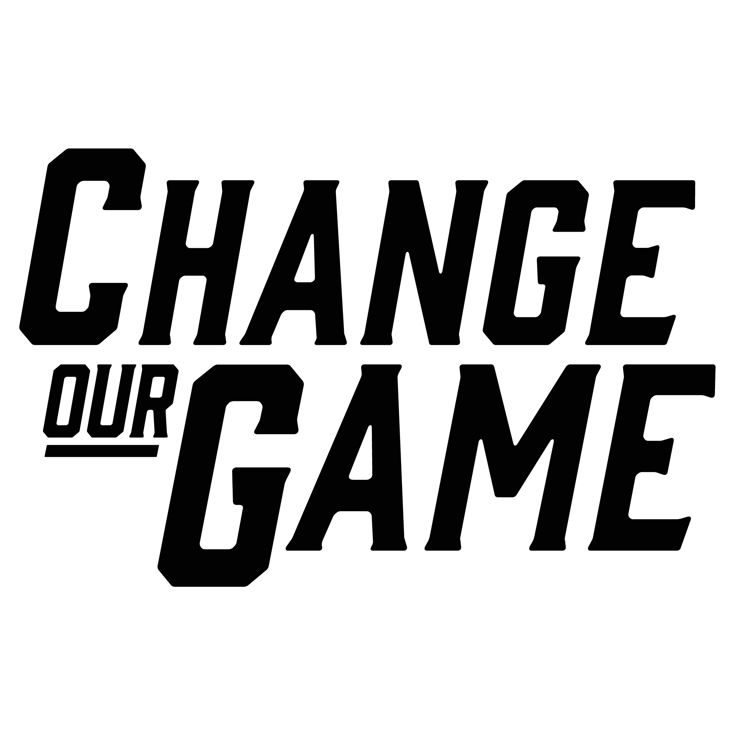
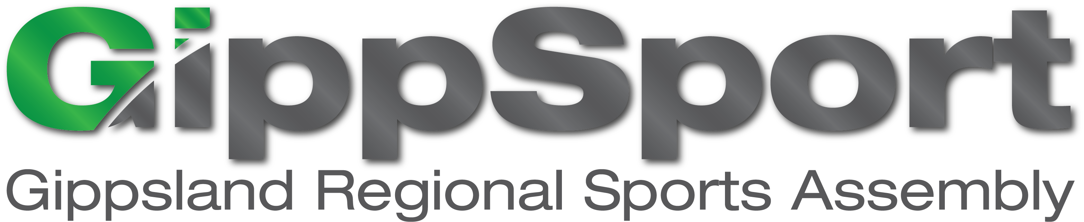

Men as allies: Supporting women and girls in community sport

RESEARCH SUMMARY

Men play an important role in driving and supporting gender equality in community sport.
A welcoming and inclusive community sporting club is one that recognises the inequities in sport and supports gender equality. Women and girls should be able to lead, engage and participate at all levels and in all roles of community sport.
People learn and replicate attitudes, behaviours and social norms through their involvement in community sport. Community sport has the power to influence these attitudes and behaviours, negatively and positively.
Challenging gender inequality in community sport helps create inclusive, equitable, healthy and safe environments for women, men, girls, boys and gender diverse people – not only in sport, but more broadly in society.

What it means for men to be allies
The sporting community is working hard to improve gender equality. Men, because of their power, influence and positions, have an important role as allies in levelling the playing field for women and girls.
An ally is any man willing to advocate for, and speak up in support of, women and girls; even though they may personally benefit from existing gender inequality.
Men may not realise they can play a role as an ally, so this research provides insights and direction to help men better understand their role and the impacts of their behaviour.
With this knowledge, men can become more confident and identify practical actions to be a more effective ally and to help other men on that journey.
Most importantly, men need to genuinely recognise gender inequality exists, and implement simple changes in their sphere of influence.
When men are allies, they will:
challenge gender stereotypes and bias within sporting clubs
be positive role models for other men and boys
help lead change, particularly as men often hold the power, influence and decision making in community sport
be trusted messengers around gender equality, including to other men
share and strengthen advocacy for gender equality, supporting women who do important work within community clubs.
This research provides practical tools to support men to be allies for gender equality in all aspects of community sport.

Understanding ally behaviours – research process
The research engaged stakeholders at all levels of community sport, across five key stages, to identify practical and relevant actions for men to be allies for gender equality.
La Trobe University’s Centre for Sport and Social Impact, in collaboration with GippSport, conducted this research with funding from the Victorian Government’s Office for Women in Sport and Recreation.

Five stage research design

What is an ally?
Understand the current literature around men as allies through an evidence review

Exploring the problem
Understand the context and problem by consulting stakeholders (N=40) from regional community sport

Identifying behaviours
Identify the behaviours of men as allies through a concept mapping activity with regional community sport members (N=38)

State of play
Understand how behaviours are currently perceived and how often they are seen using a state-based survey (N=235)

Engaging men in regional areas
Sense-check results and understand how to engage men, through two workshops in regional communities (N=20).

Engaging men to be allies: self-assessment
To be effective allies, and to engage other men to be allies, men must first recognise and acknowledge gender inequality. From there, they can take progressive steps to be an ally to women and girls in community sport.
Men’s honest self-reflection is crucial for assessing their current understanding of gender inequality. Without acknowledging its existence and recognising its problematic nature, as well as their potential role in promoting change, their other behaviours and actions will prove ineffective.
This diagram shows the different stages of allyship, serving as a tool for self-reflection to help men identify their current position and determine the steps they can take to progress.
3. Educate self
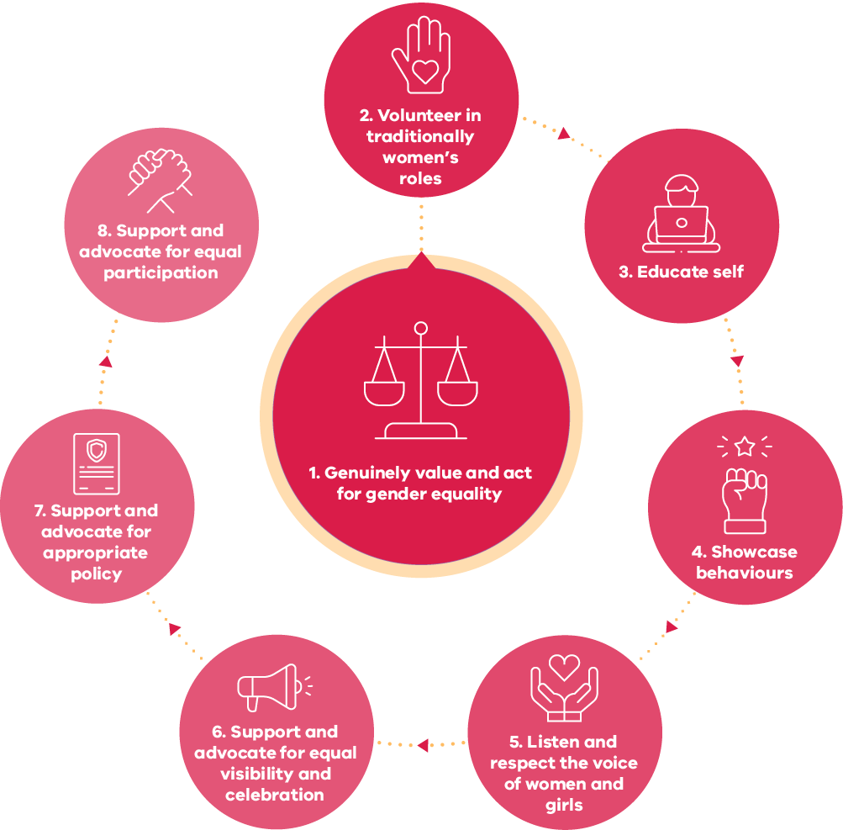

How men can be an ally for women and girls

Men can effectively support women and girls in community sport by displaying supportive behaviours
Supporting men to understand which practical behaviours can have the biggest impact, and that are easy to do, can build their knowledge and confidence in driving change.
For some men, this is about being aware of their own behaviours to start being an ally, or to encourage other men around them to consider their behaviours.
Below are important ally behaviours that can support women and girls, along with examples of how these behaviours can be demonstrated:

Individual behaviours
Behaviours men can do themselves | Examples
Be a role model | Show respect and equality in your own behaviour and interactions, inspiring boys and other men to do the same.
Champion good behaviour | Actively support the club, association or league to establish clear guidelines for acceptable behaviour, and encourage adherence to those standards.
Listen respectfully to women and girls | Give women and girls your full attention when they speak; value their opinions and experiences without interrupting or being dismissive.
Respect women and girls | Treat them with the same respect you would give to men and boys. Don’t belittle, dismiss or bully women or girls.
Watch women and girls play sport | Attend and watch women and girls participating in community sport, and show your support and enthusiasm for their achievements.
Don’t comment on women and girls’ bodies | Focus on character and abilities rather than commenting on women’s and girls’ bodies whether or not you think it is positive.
Welcome women and girls at the club | Create an inclusive and welcoming environment for women and girls who want to join the club and ensure they feel valued and supported.
Be a mentor for women | Offer guidance and support to women who aspire to leadership roles; help them develop their skills, confidence, and opportunities to advance and succeed.
Educate self | Take the initiative to learn about gender equality issues and the specific needs and challenges faced by women and girls; strive to become better informed and aware.
Volunteer in traditionally women’s roles | Contribute your time and effort to traditionally women’s roles within the club, such as working in the canteen, participating in the social committee, or assisting with fundraising activities.
Call out inappropriate language | Speak up against sexist comments, derogatory language, or jokes that perpetuate harmful stereotypes or demean women and girls.
Check on self | Reflect on your own beliefs, attitudes, and biases towards women; actively challenge and address any internalised views that may hinder gender equality and respectful behaviour.

Structural/organisational/club behaviours
Behaviours men can do themselves | Examples
Include women in decision making | Actively support and advocate for the appointment of women to decision making positions, such as on boards and advisory committees or in executive positions.
Promote women and girls | Highlight their achievements, feature them in media, social media, and around the club, and showcase their talents and contributions.
Encourage participation | Create inclusive environments, remove barriers to entry, and actively encourage their involvement.
Access to facilities | Support and advocate for dedicated spaces, restrooms, changing rooms and amenities that ensure privacy, safety and accessibility.
Develop policies | Support and advocate for policies that promote equal opportunities, fair recruitment and promotion, and proactive measures to address gender-based discrimination or harassment.
Invest financially | Support and advocate for funding scholarships, grants, mentorships and training programs, entrepreneurship support, and capacity-building initiatives that empower women and girls to thrive

How community sports clubs can lead change to be allies
Men being positive role models is the starting point for creating safe and inclusive environments for women and girls in community sports clubs.
Just as individual men should, it is important that clubs assess where they are at as organisations when it comes to attitudes and behaviours around and towards women and girls in sport.
To effectively provide allyship to women and girls and achieve meaningful change, clubs must assess their current position, progress through each stage of the process, and acknowledge that it takes time. Don’t try to jump ahead without setting a solid foundation.
To build a positive cycle for change, and advance gender equality in community sporting, start by…
- Supporting men who are role models and exemplify gender equality in sport, leading to…
- Engaging men and building relationships that motivate them to reflect on their own values and behaviours about gender equality, leading to…
- Developing awareness and understanding of gender equality through formal and informal education, leading to…
- Supporting individual behaviour change so men champion gender equality and become role models for other men and boys, influencing…
- Changing systems, shifting social norms and creating safe environments for other men who are allies, women and girls.

Build positive role models
Positive change starts with individuals willingly taking the lead in being positive role models. This builds connection, awareness and understanding among other men to develop positive behaviours for long-term sustainable change.
Role models actively promote gender equality and create environments that support others to do the same. Within a club, potential role models may include:
people who are closely connected to and respected by other men and boys within club
club leaders like presidents and committee members, coaches and elite athletes
parents or guardians, who influence their children through their own behaviour
fathers and husbands/partners who support engagement of their daughters and wives/partners.

Engage and build relationships with men
To connect and build positive relationships with other men within community sport:
connect with men and boys who are ready to engage in conversations on gender equality
highlight the positive role men can play (rather than focusing on them as the problem)
use club leaders and trusted voices that men will listen to
initiate specific activities (such as inviting them to attend and watch a women’s team play) to create further opportunities for future engagement
tailor approaches to effectively engage different target audience (e.g. adapt the approach when engaging coaches vs engaging parents).

Develop awareness and understanding of gender equality
To further educate men on gender equality:
listen to the experiences of women and girls to understand and co-design solutions to challenges
support role models to build awareness with other men and boys in the club about gender equality
gather evidence about club practices and present to the committee and/or members to influence decision making.

Encourage individual change
To encourage men to make changes to their individual behaviour:
encourage men to commit to change, one behaviour at a time, to gradually and sustainably shift towards gender equality
celebrate and support men’s positive behaviours and acknowledge the positive impact they have on promoting gender equality within the club
become a role model for other men and boys within the club; inspire them to replicate positive behaviours and actively contribute to gender equality.

Create a safe club environment
To create long-term change within a club that provides a safe and inclusive environment for women and girls:
advocate for wider change within the club and community, including implementing or modifying policies and practices, and developing gender equality action plans
become a role model to actively shift social norms within the club
become an ally to create a safe environment, not only for women and girls but also for other men who support gender equality.

Acknowledgements
The Victorian Government proudly acknowledges Aboriginal people as the First Peoples and Traditional Owners and custodians of the land and water on which we rely.
We acknowledge the ongoing leadership role of the Aboriginal community on gender equality and the prevention of violence against women. As First Peoples, Aboriginal Victorians are best placed to determine a culturally appropriate path to gender equality in their communities.
This is a summary of research conducted by La Trobe University’s Centre for Sport and Social Impact, in partnership with GippSport: Men as allies for gender equality in community sport in regional Victoria (Randle, E., Harris, M., Marshall, S., Denny, K., Donaldson, A., Dickson, G., Staley., K & O’Halloran, P (2022))
This research was funded by the Victorian Government through the Change Our Game Research Grants Program.

