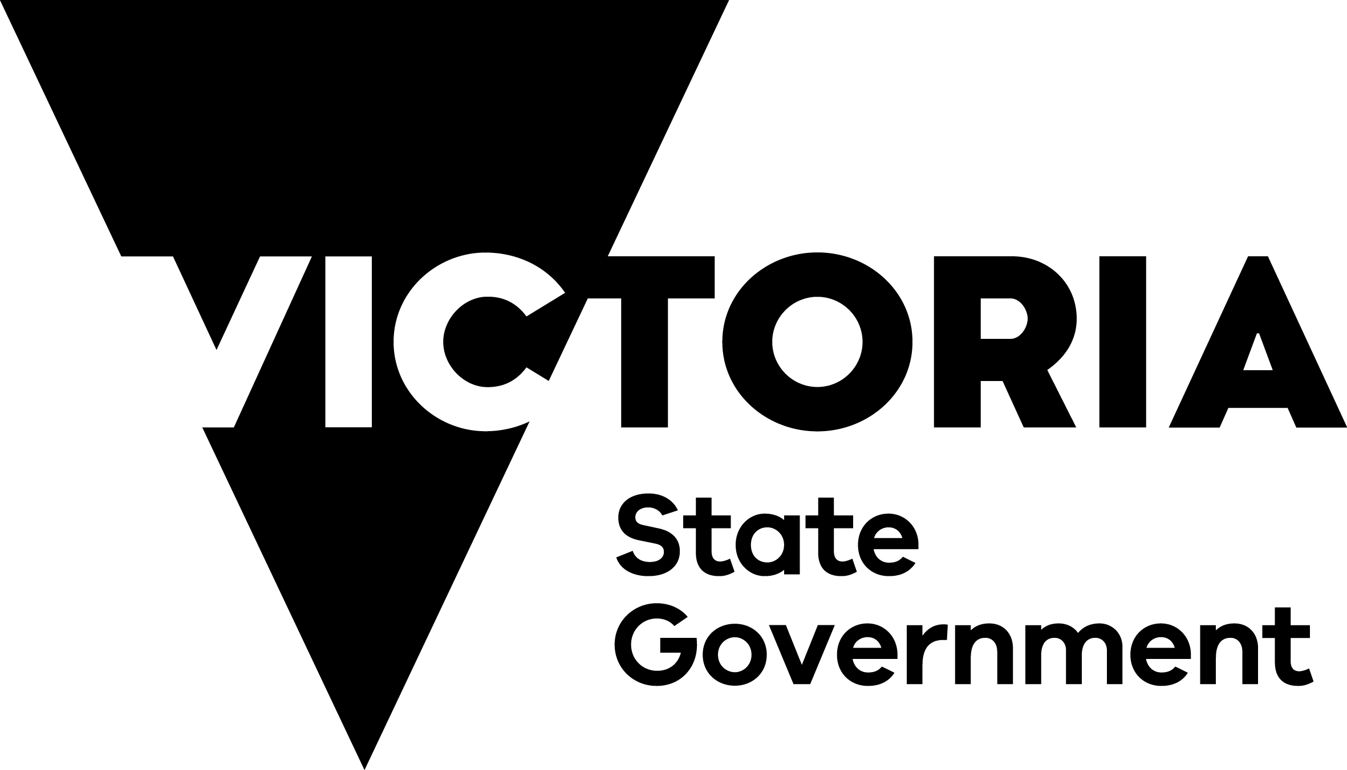

Sport and Recreation Victoria

Community Sports Infrastructure 2024 Outcomes Statement
Acknowledgement of Country
We acknowledge the traditional Aboriginal owners of country throughout Victoria, their ongoing connection to this land and we pay our respects to their culture and their Elders past, present and future.
Disclaimer
Unless indicated otherwise, this work is made available under the terms of the Creative Commons Attribution 3.0 Australia licence. To view a copy of this licence, visit creativecommons.org/licenses/by/3.0/au. It is a condition of this Creative Commons Attribution 3.0 Licence that you must give credit to the original author who is the State of Victoria.
You might find this publication useful but Victorian Government and its employees do not guarantee that this publication is without flaw of any kind or is wholly appropriate for your particular purposes. The Victorian Government disclaims all liability for any error, loss or other consequence which may arise from you relying on any information in this publication.
Authorised and published by the Victorian Government, 1 Treasury Place, Melbourne.

Overview 3
Participation Outcomes 4
Sport 4
Active Recreation 4
Case study 4
Activities Supported 5
Case study 5
Facility Standards 6
Case study 6
Addressing Barriers 7
Diversity and Inclusion 7
Gender Equity 7
Universal Design 7
Economy and Environment 8
Jobs and Partnerships 8
Sustainability 8
Case study 8

Overview
Providing high-quality, accessible community sports infrastructure* is a key aim of the Victorian Government and is integral to the health and wellbeing of Victorians.
To achieve this, Sport and Recreation Victoria (SRV) partners with Local Government Authorities, Alpine Resorts Victoria and various sport and recreation clubs and organisations to upgrade and develop community sports infrastructure across Victoria.
This helps fulfil the Active Victoria 2022 to 2026 strategic priority to encourage and facilitate sport and active recreation participation for all.
Over the past decade, SRV, along with other State Government departments and agencies, have invested more than $2.3 billion into community sports infrastructure.
A landmark report undertaken by KMPG (2020) on SRV’s behalf estimated the annual contribution of Victoria’s community sports infrastructure to the economy to be at least $7.04 billion.
While this information is important to understand the aggregate benefit of community sports infrastructure, it’s also critical that we measure and better understand outcomes at a project level and share this with our investment partners – to shape future policy, planning, and priorities.
To measure and better understand these outcomes, SRV introduced mandatory Outcomes Reporting for every funded project, 12 months after completion. For the 2022-23 and 2023-24 financial years, this has resulted in 337 completed Outcomes Reports across 11 different funding programs.
These Outcomes Reports have been aggregated to produce the 2024 Outcomes Statement to provide valuable insight into how SRV’s investment is delivering our strategic and investment priorities.
This Outcomes Statement summaries the impact on participation, activities, inclusion, the economy, and the environment.
* Note: community sports infrastructure encompasses both community sport and active recreation infrastructure.

Participation Outcomes
Across the reporting period, participation increased by 42.9% or 70,269 new participants at funded facilities, within the first 12 months.

Sport
163,140 people used funded sports facilities, including 22,079 new participants.
Projects in Regional Victoria experienced a 17% participation increase, compared to 15% in Metropolitan Melbourne.
Junior girls’ sport participation increased the most among all cohorts, rising by 19% to 40,204 participants.
Junior boys’ sport participation recorded 87,390 participants, the highest number of all cohorts.

Active Recreation
70,647 people used funded active recreation facilities, including 48,190 new participants, an increase of 215%.
More women (51%) than men (49%) participated at funded active recreation facilities.
Adult women recorded the highest increase in active recreation participation at 227% (12,467 new participants), mostly using aquatic recreation facilities.

Case study
Local Government Authority Glen Eira City Council
Project Name Duncan MacKinnon Reserve Community Fitness Facility
Funding Program Community Sports Infrastructure Stimulus Program
Project Scope Installation of outdoor training equipment at Duncan Mackinnon Reserve.
Outcomes The facility is catering for up to 100 participants for at least 90 hours per week. Enhanced accessibility and a range of equipment have boosted participation, especially for people with diverse abilities.

Activities Supported
Across the reporting period, 34 different sport and active recreation activities were supported through funded projects.
On average, each funded facility supported 3 different sport and active recreation activities, demonstrating flexible, multi-use benefits.
28.5% (96) of funded facilities delivered both sport and active recreation participation opportunities.
74.5% (251) of funded facilities were shared, supporting multiple sport and/or active recreation activities.
Funded facilities supported 16,199 participation hours per week for more than 550 user groups.

Case study
Local Government Authority Mitchell Shire Council
Project Name Harley Hammond Reserve Netball/ Tennis Amenities and Courts
Funding Program Community Support Fund
Project Scope Construction of a pavilion to meet the needs for netball/tennis users and the reconstruction of 2 netball/tennis courts and installation of competition standard lighting for netball.
Outcomes Junior netball has increased its weekly usage from 14 to 22 hours, welcoming more boys and girls. Netball membership has also grown, adding 2 new teams in the 2023 season. With courts now line-marked for tennis, 2 additional night competitions now run annually over 34 weeks.

Facility Standards
Of the funded facilities across the reporting period, 142 projects supported participants through new or upgraded pavilions and change rooms suitable for women and girls.
101 projects increased the capacity of fields of play through new or upgraded sports lighting.
94 projects increased usage time through 94 new or improved outdoor sports courts.
99.4% of sports facilities (319) met the standards of their respective sport.
100% of aquatic facilities and indoor stadiums (15) reported implementing at least one Healthy Choices initiative, as per funding requirements.

Case study
Local Government Authority Nillumbik Shire Council
Project Name Diamond Valley Sport and Fitness Centre Redevelopment
Funding Program Local Sports Grants initiative
Project Scope Construction of 4 new indoor multi-sport courts including one with seating for 500 spectators, upgraded change spaces/amenities, new double-storey administration building, kiosk, café, first aid and storage.
Outcomes Additional courts have expanded sports programming and community access, including for people with a disability. A 24-hour gym supports flexible participation, while upgraded ancillary facilities enables NBL1 games to be hosted. Participation rose by 27.5% (1545 participants), with Senior Women showing the greatest increase at 35.8% (307 participants). This growth was supported by the implementation of four gender equity initiatives.

Addressing Barriers
Across the reporting period, funded facilities included a range of initiatives to increase participation, particularly in disadvantaged communities and for people who participate less.

Diversity and Inclusion
54.6% (184) of funded facilities reported benefiting socio-economically disadvantaged cohorts.
29.4% (99) of funded facilities were delivered in Victoria’s most disadvantaged suburbs.
40.9% (138) of funded facilities reported benefiting CALD communities.
30.9% (104) of funded projects reported benefiting older adults (60+ years).
36.5% (123) of funded projects reported providing direct benefits to people with a disability.
33.2% (112) of funded projects reported directly benefiting LGBTIQ+ people.
30.9% (104) of projects reported directly benefiting Aboriginal Victorians.

Gender Equity
74.7% (252) of funded facilities increased women and girls’ participation in sport and active recreation.
67 women and girls’ funded facilities increased participation by 12.2% (3,375 new participants).
94.6% of funded facilities reported implementing at least one gender equity initiative, the most common being ‘equality through scheduling’ at 65.3% (220).

Universal Design
97.3% (328) of funded facilities reported implementing one or more Universal Design principles, with an average of 4.6 out of 7 principles being applied.
The most commonly applied Universal Design principle was ‘equitable use’, applied to 91.4% of funded facilities.

Economy and Environment
Across the reporting period, investment grew the Victorian economy by supporting planning, construction, management and operational employment, along with supply chain benefits. Our investment also seeks to minimise impacts on the environment.

Jobs and Partnerships
1,170 full time jobs were supported to deliver funded facilities worth more than $538 million.
Funded facilities in Metropolitan Melbourne (180) generated economic activity worth more than $394 million.
Funded facilities in Regional Victoria (157) generated economic activity worth more than $144 million.

Sustainability
94.9% of funded facilities implemented one or more environmentally sustainable design initiatives, the most common being upgrades to reduce operational costs such as LED lighting, recycling and energy efficiency measures.

Case study
Local Government Authority City of Greater Geelong
Project Name Geelong West Oval Pavilion
Funding Program Local Sports Grants initiative
Project Scope Construction of a new, 2-storey multi-purpose community facility to meet AFL Regional Facility Guidelines.
Outcomes The pavilion has created more inclusive participation opportunities, especially for women and girls with participation growing by 47.5% (114 participants). This has fostered a safer and more welcoming environment. Sustainability was also a key outcome with six environmentally sustainable design features applied to the pavilion including a rainwater harvesting tank, and solar panels to offset between 50-70% of the annual energy use of the pavilion, along with 2 electric vehicle charging stations.
This statement is subject to change.
Authorised and published by the Victorian Government, 1 Spring Street, Melbourne.
© State of Victoria, Department of Jobs, Skills, Industry and Regions. April 2025
Available at the Sport and Recreation Victoria website.

ABS Census 2021, SEIFA IRSD Decile 1 and 2.

