Project Management Framework (Factsheet)
Sport and Recreation Victoria | Community Infrastructure Programs

What is a Project Management Framework?
A Project Management Framework (PMF) is a detailed breakdown of all the required tasks that need to be undertaken as part of a project, as well as a timeline for each task and who is responsible for its implementation.

Why is a Project Management Framework important?
A PMF is used to assist in tracking, evaluating and communicating the progress of a project. It is important for the Project Manager to know at what stage the project is at any given time. A PMF is useful to assist in keeping the project on track and determining how long it will take to complete the project.

How do I create a Project Management Framework?
The following steps accompany the template PMF provided by Sport and Recreation Victoria (SRV). This is a guide only and you may use/modify the template or use your own.

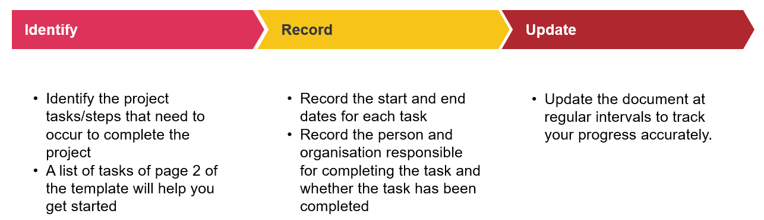

Who do I contact for further clarification?
For further information on the PMF please contact your SRV representative.

Infrastructure Projects: Task examples for inclusion
The table on the following page contains example inclusions for a PMF. This table and its contents is not an exhaustive list and should be used as a guide only. Council is encouraged to include any additional steps relevant to their project. Some steps in this list may not be relevant to your project

Task Examples for Inclusion
Form Project Steering Group | Issue planning permit | Appoint contractor
Recruit project manager | Issue building permit | Works commence on-site
Engage stakeholders | Design & consultants brief | Site preparation
Consult industry bodies | Project board review approval brief | Construction by contractor
Appoint design consultants | Report to council | Works completed on-site
Prepare concept design drawings | SRV outcome advised | Inspect & Issue practical completion certificate
Obtain cost plan A | Approve concept design & project cost estimates | Occupancy permit
Signoff from stakeholders | Activity Schedule signed | Inspect & issue final completion certificate
Prepare planning permit application documents | Prepare drawing specification | Acknowledgement plaque
Submit planning permit application documents | Advertise tenders | Official opening
Advertise planning permit application | Receive & evaluate tenders | Final claim with supporting documents to SRV
Prepare & submit building permit application | Prepare tender contract documents

Planning Projects: Task examples for inclusion
Project brief finalised | Community engagement and consultation | Draft plan released for public review
Literature review | Draft plan developed | Plan endorsed/adopted by Council

