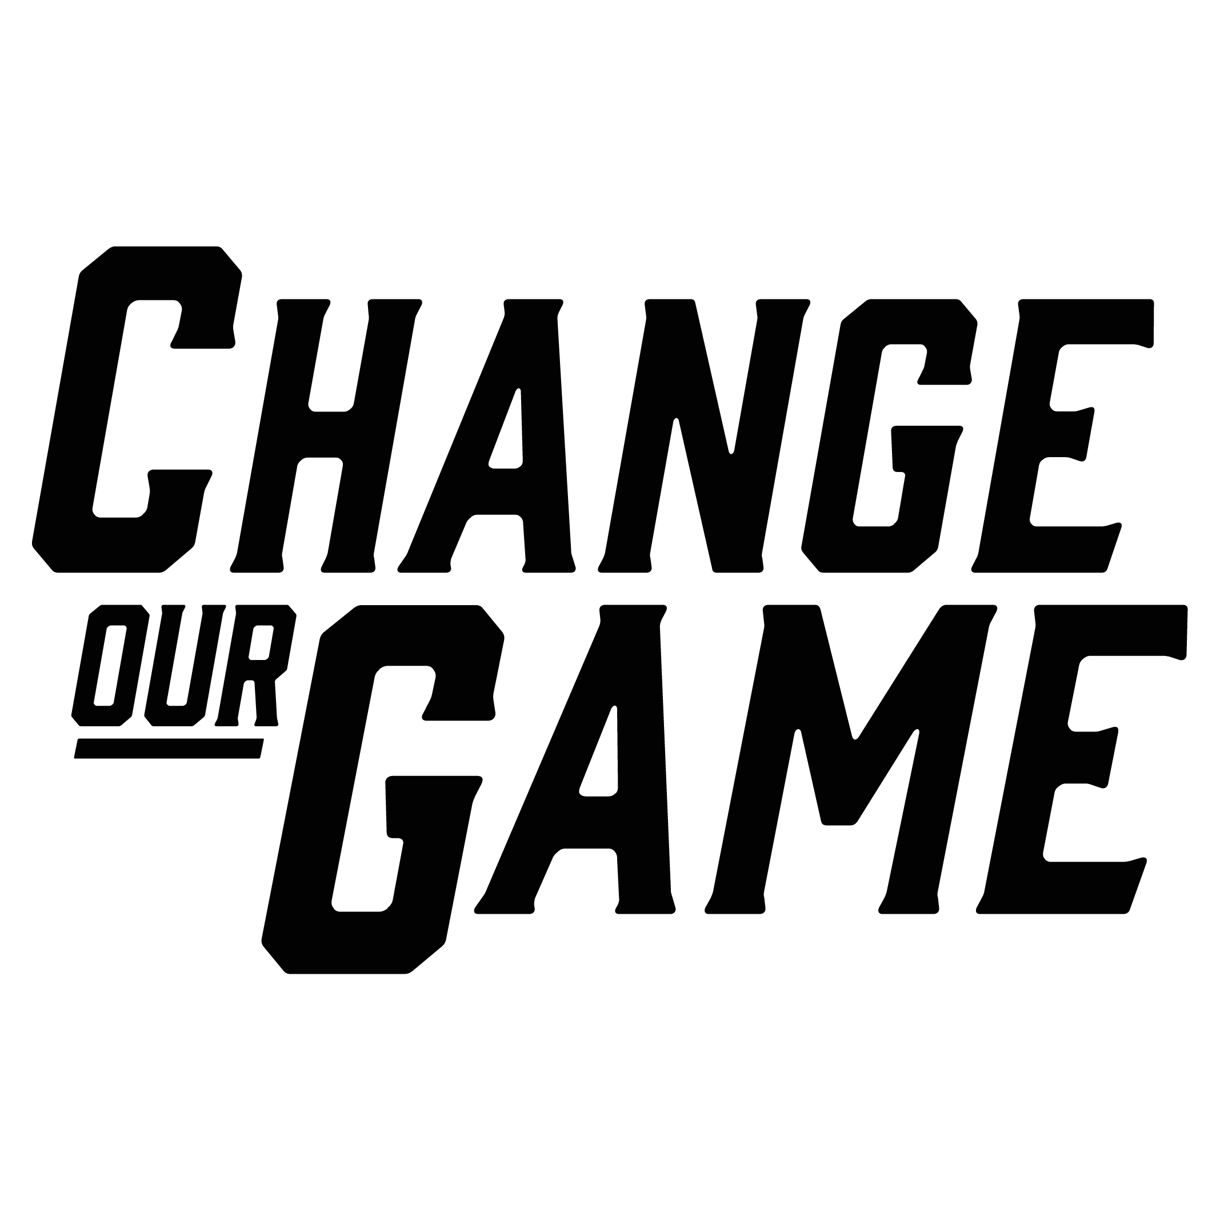

Enhancing Participation Pathways for Women Sport Officials

RESEARCH SUMMARY

Introduction
Women and girls bring unique strengths to officiating in sports, but they are currently underrepresented compared to men and boys. Women officials also experience a range of challenges and barriers at the community sport level.
These challenges often relate to the game day and training environment for officials, including the governance and pathways for officials through to the behaviours of spectators, players and coaches.
There is opportunity to help sports be more welcoming and inclusive, with officials a critical part of the sport and recreation workforce.
Research by La Trobe University, in partnership with AFL Victoria, Basketball Victoria, and Football Victoria, examined the experiences of women officials in football (soccer), basketball, and Australian rules football. The role of officials varies across sports, and includes tournament referees, lines judges and game umpires.
The research examined:
how sports design officiating pathways for women and girls
the promotion and recruitment practices for women officials
the education, training and support provided to enable women as officials.
This summary recommends a range of actions that can be taken to overcome barriers and support women to succeed as officials in community sport, for both sport governing bodies and community sporting clubs.
Through the research, here’s what was heard from women officials on their experiences or from sports administrators on their approaches.
“There are many different types of referees. There are those who are on the progression pathway so we have an academy and a talent pool and if you’re identified as someone with promise you might be put into those programs that fast-track development. But the largest portion of our referees are community referees.”
“In terms of recruitment, a lot of the recruitment for beginner level technical officials happens through association spaces, so it’s very much on the associations to be advertising when they’re running their education courses….so we decide when the education is going to be held for scoretable and stats and then it’s on the associations to jump on board and advertise that amongst their people so that we can get people coming to our state courses.”
“I do still hear the occasional remarks from spectators…Yeah, just random questions like why is she doing it? Or isn’t she too young? Shouldn’t it be all men for a men’s game and all women for a women’s game? That kind of idea that we can’t swap around.”
“It’s intimidating, there’s like a - sometimes there’s the, I guess, inappropriate comments made as well from male refs. So I honestly don’t know a female ref that hasn’t had another ref make them feel uncomfortable in that way.”
“But every time that I’m in the centre in an official capacity, I always have a mentor with me. I seem to have the same one which is really good. So he usually gives me feedback in the middle of the game and then stuff to work on for the second half of the game. Then usually I get a report at the end of that. So it’s a lot easier to continue working on what he’s said.”
“We share ref’s change rooms. That’s a big thing. I want change rooms that have a door in the middle, so you can slide the door across, you can get changed, and you can open it up and be together. But it was male dominance things like you need to get changed in front of me. You need to get changed here. We’re a team.”
“There are so many great female referees. Even at our domestic level, we do our best but there are female referees that won’t referee in our men’s comp because they’ve been abused, and those kinds of situations.”
“You kind of fall in and out of love with reffing when you get abused… Like, do I really want to be spending my time there getting yelled at by adults and being abused for things that I think that I have made the right call on? Because I know all the rules and getting paid $20 to be there and be abused and be yelled at by multiple people. You think is that really worth it?“
“I think that women need to be given more opportunities again. Like stop segregating the women into female only football, you need to have more options. It’s not going to be for everyone, like not all women are going to want to do men’s football but they need to have the choice. If they want to strive to climb the ranks, being pigeonholed into women’s football is not going to get them there.”
“…With the local associated, they also do mini awards and stuff for everyone, throughout the year, which is really good. It’s really good because they’ve separated it to – you can get officials of the year at the domestic level, but there’s a male and a female award now. So, you get one for both, which is good, it’s not just the one anymore.”

Suggested actions for state sporting associations and local leagues
To create a more inclusive environment and encourage more women to become sports officials, requires addressing challenges and building a supportive culture.
State sporting associations can help open pathways and create opportunities for women to succeed in officiating roles. This requires working with all levels of a sporting organisation.
The table below outlines key challenges faced by women officials and recommends actions that can support progress. Pick what feels most relevant to your organisation and start from there.

Actions to improve environments and pathways for women officials in community sport
Theme | Context/challenge | Suggested Actions
Governance | The officials’ workforce within a sport can be governed at different levels, such as the local club or association, regional or state level. | Ensure women officials are represented in decision‑making for officials, for example through sub-committees.  Promote an inclusive culture by ensuring women’s representation within leadership roles.  Conduct regular surveys and/or focus groups to understand the experiences and needs of women officials and use this data to inform policy and program development.
Organisational culture | Sport organisations can have a culture that threatens safety and security for women officials. Example: not having appropriate measures for handling sexual assault, harassment, and violence towards women officials. | Conduct workshops and seminars to educate all stakeholders about the importance of diversity and inclusion.  Run awareness campaigns highlighting the challenges faced by women officials and promoting a culture of respect and inclusivity.  Provide access to counselling, legal advice, and other support services for women facing challenges in their roles.
Pathways | Pathway design often limits women from officiating outside of women’s sport.  It can be linear with a focus on supporting elite level officials, despite the largest group of referees being at the community level. | Develop and enforce policies promoting gender equity in recruitment, retention, and promotion of women sport officials.  Develop clear and accessible pathways for women in officiating, including progression plans and professional development opportunities provided by your organisation.  Collaborate with schools, universities, and other organisations to create pathways and opportunities for women and girls interested in becoming sport officials.  Allocate funding specifically for programs aimed at supporting and developing women in sport officiating.  Provide leadership and management training specifically designed for women officials to prepare them for higher roles within officiating ie. Lead Official, or sports leadership such as member of board sub-committee.
Recruitment | Delegated responsibility to local associations to drive recruitment of women and girls – with no principles, guidelines or support to do so. | Consider specific recruitment strategies for officials roles – see our resource on recruiting women and girls officials.
Operating environment | Scheduling of an official’s commitments don’t always consider their availability. | Offer flexible scheduling or part-time roles to accommodate women with other commitments.  Use scheduling software to allow officials to easily advise of their availability.  Create and distribute officiating resources, such as guides and toolkits, to assist women officials in their roles.  Create networks and forums for women officials to share experiences, challenges, and solutions.
Spectator behaviour | Officials can experience negative behaviour, including harassment and discrimination from spectators during game day. | Develop and enforce a spectator code of conduct that outlines acceptable behaviour and consequences for violations.  Conduct campaigns to educate spectators on the importance of sportsmanship and the impact of negative behaviour.  Enforce strict penalties for bad behaviour, such as ejections, bans, or fines, with clear communication of these policies.
Player and coach behaviour | Officials can experience negative behaviour, including harassment and discrimination from players and coaches. | Reinforce policies on player and coach behaviour at the association or league level, to reduce negative behaviour towards women officials.  Partner with clubs and teams to encourage players and coaches to advocate for respectful spectator behaviour.  Ensure strong policies against harassment and discrimination are in place and actively enforced.
Peer officials | Men officials can belittle the experiences and knowledge of women officials. Example: men taking over situations that women officials can handle.  Women officials can face harassment and abuse from men officials. Example: men officials making inappropriate comments about women officials. | Mandate regular training on gender sensitivity, respect, and inclusion for all officials.  Develop confidential and accessible reporting channels for women officials to report incidents of bad behaviour from other officials without fear of retaliation.  Establish mentorship programs where experienced women officials can guide and support newcomers.
Recognition | Women officials may not receive strong recognition of their contribution to the sport. | Establish awards and recognition programs specifically for outstanding women officials.  Promote stories and achievements of women officials in media and organisational communications.

Suggested actions for community sporting clubs
To create a more inclusive environment and encourage more women to become sports officials, we need to take a grassroots approach to address specific barriers and encourage a culture of inclusion.
Community sporting clubs can create a more welcoming and supportive environment for women sport officials, encouraging more women to take up and continue in these important roles.
The table below outlines key challenges faced by women officials and recommends actions that can support progress. Pick what feels most relevant to your club and start from there. The capacity of community clubs to implement these recommendations may vary, so start where you can.

Actions to improve environments and pathways for women officials in community sport
Theme | Context/challenge | Suggested Actions
Governance | Clubs can lack clear, effective policies that ensure a safe and supportive environment for women officials. Without strong governance and protective measures in place, women may face discrimination, harassment, or exclusion, which can hinder their participation and retention as sports officials. | Ensure women officials are represented in decision-making for officials, for example through sub-committees.  Promote an inclusive culture by ensuring women’s representation within leadership roles.  Create policies that promote gender equity in all aspects of the club, including recruitment, training, and promotion of sport officials.
Organisational culture | The culture within local sport clubs impacts the treatment of officials. Example: having clear behaviour guidelines towards officials. | Role model appropriate behaviour towards officials by club committee, coaches and players.  Introduce awards and incentives for women officials who demonstrate excellence and commitment.  Feature stories and interviews with women sport officials on social media platforms to highlight their achievements and journeys.
Pathways | Pathways for officials have a focus on supporting progression to elite level, whilst the majority of officials are content at the community level. Example: academy programs or talent pools that progress development. | Implement a buddy system pairing new women officials with more experienced ones for guidance and support.  Offer scholarships or grants for women to attend training courses, conferences and other professional development opportunities.  Partner with local businesses to secure funding for initiatives and programs that support and promote women in sports officiating.
Operating environment | Officials can lack support to manage game day misconduct from participants despite reporting structures. Example: reports of misconduct not being heard at a tribunal.  Changeroom facilities are not designed to make women and girls feel safe. Example: officials sharing change rooms. | Organise interactive workshops and clinics where women can learn officiating skills in a supportive and engaging environment.  Invite experienced women officials and sports personalities to speak at club training and events, providing inspiration and practical advice.  Organise women-only events on officiating to provide practical experience in a supportive environment.  Create access schedules for changerooms for officials that provide a safe environment on game and training days.  Review changerooms to identify what options are available to improve access and safety, such as cleanliness, lighting, individual showers/toilets, hygiene disposal units.  Seek feedback from officials on their use of changeroom facilities.  Read the Sport and Recreation Victoria Female Friendly Sport Infrastructure Guidelines for further ideas and insights on how to create and maintain an environment where women and girl officials feel safe and welcome.
Spectator behaviour | Officials can experience abuse from spectators. Example: being yelled out for making a call.  Women and girls face gender discrimination from spectators. Example: being asked why she is an umpire or why is she umpiring a men’s game. | Develop and enforce a spectator code of conduct that outlines acceptable behaviour and consequences for violations.  Conduct campaigns to educate spectators on the importance of sportsmanship and the impact of negative behaviour.  Enforce strict penalties for bad behaviour, such as ejections, bans, or fines, with clear communication of these policies.
Player and coach behaviour | Abuse towards officials is normalised behaviour amongst players and officials leading to burnout and drop-out amongst some officials. Example: umpiring at multiple competitions each week increases exposure to behaviour.  Women officials face gendered discrimination from players and coaches. Example: being questioned about being an official or being called gendered names.  Women officials face micro-aggressions and gendered bias. Example: getting more criticism for a wrong decision than a man official. | Ensure strong policies against harassment and discrimination are in place and actively enforced.  Partner with teams to encourage players and coaches to advocate for respectful spectator behaviour.
Peer officials | Women and girl officials can experience abuse from peer officials. Example: being told to step aside to allow men officials to make a call. | Highlight women role models in officiating to inspire and motivate others.  Mandate regular training on gender sensitivity, respect, and inclusion for all officials.

Acknowledgements
The Victorian Government proudly acknowledges Aboriginal people as the First Peoples and Traditional Owners and custodians of the land and water on which we rely.
We acknowledge the ongoing leadership role of the Aboriginal community on gender equality and the prevention of violence against women. As First Peoples, Aboriginal Victorians are best placed to determine a culturally appropriate path to gender equality in their communities.
This is a summary of research carried out by La Trobe University, Enhancing Participation Pathways for Female Sport Officials (Hoye., R, Kappelides., P, Baxter., H, Grant., M, 2024).
The research design had 3 stages; a detailed content analysis of the policies and practices of each sport organisation related to officiating, structured interviews of managers and staff from each sport organisation focused on officials and semi‑structured interviews with 32 women officials from each sport focused on their individual experiences.
This research was conducted by La Trobe University, in partnership with AFL Victoria, Basketball Victoria and Football Victoria, with funding from the Victorian Government, through the Change Our Game Research Grants Program.

