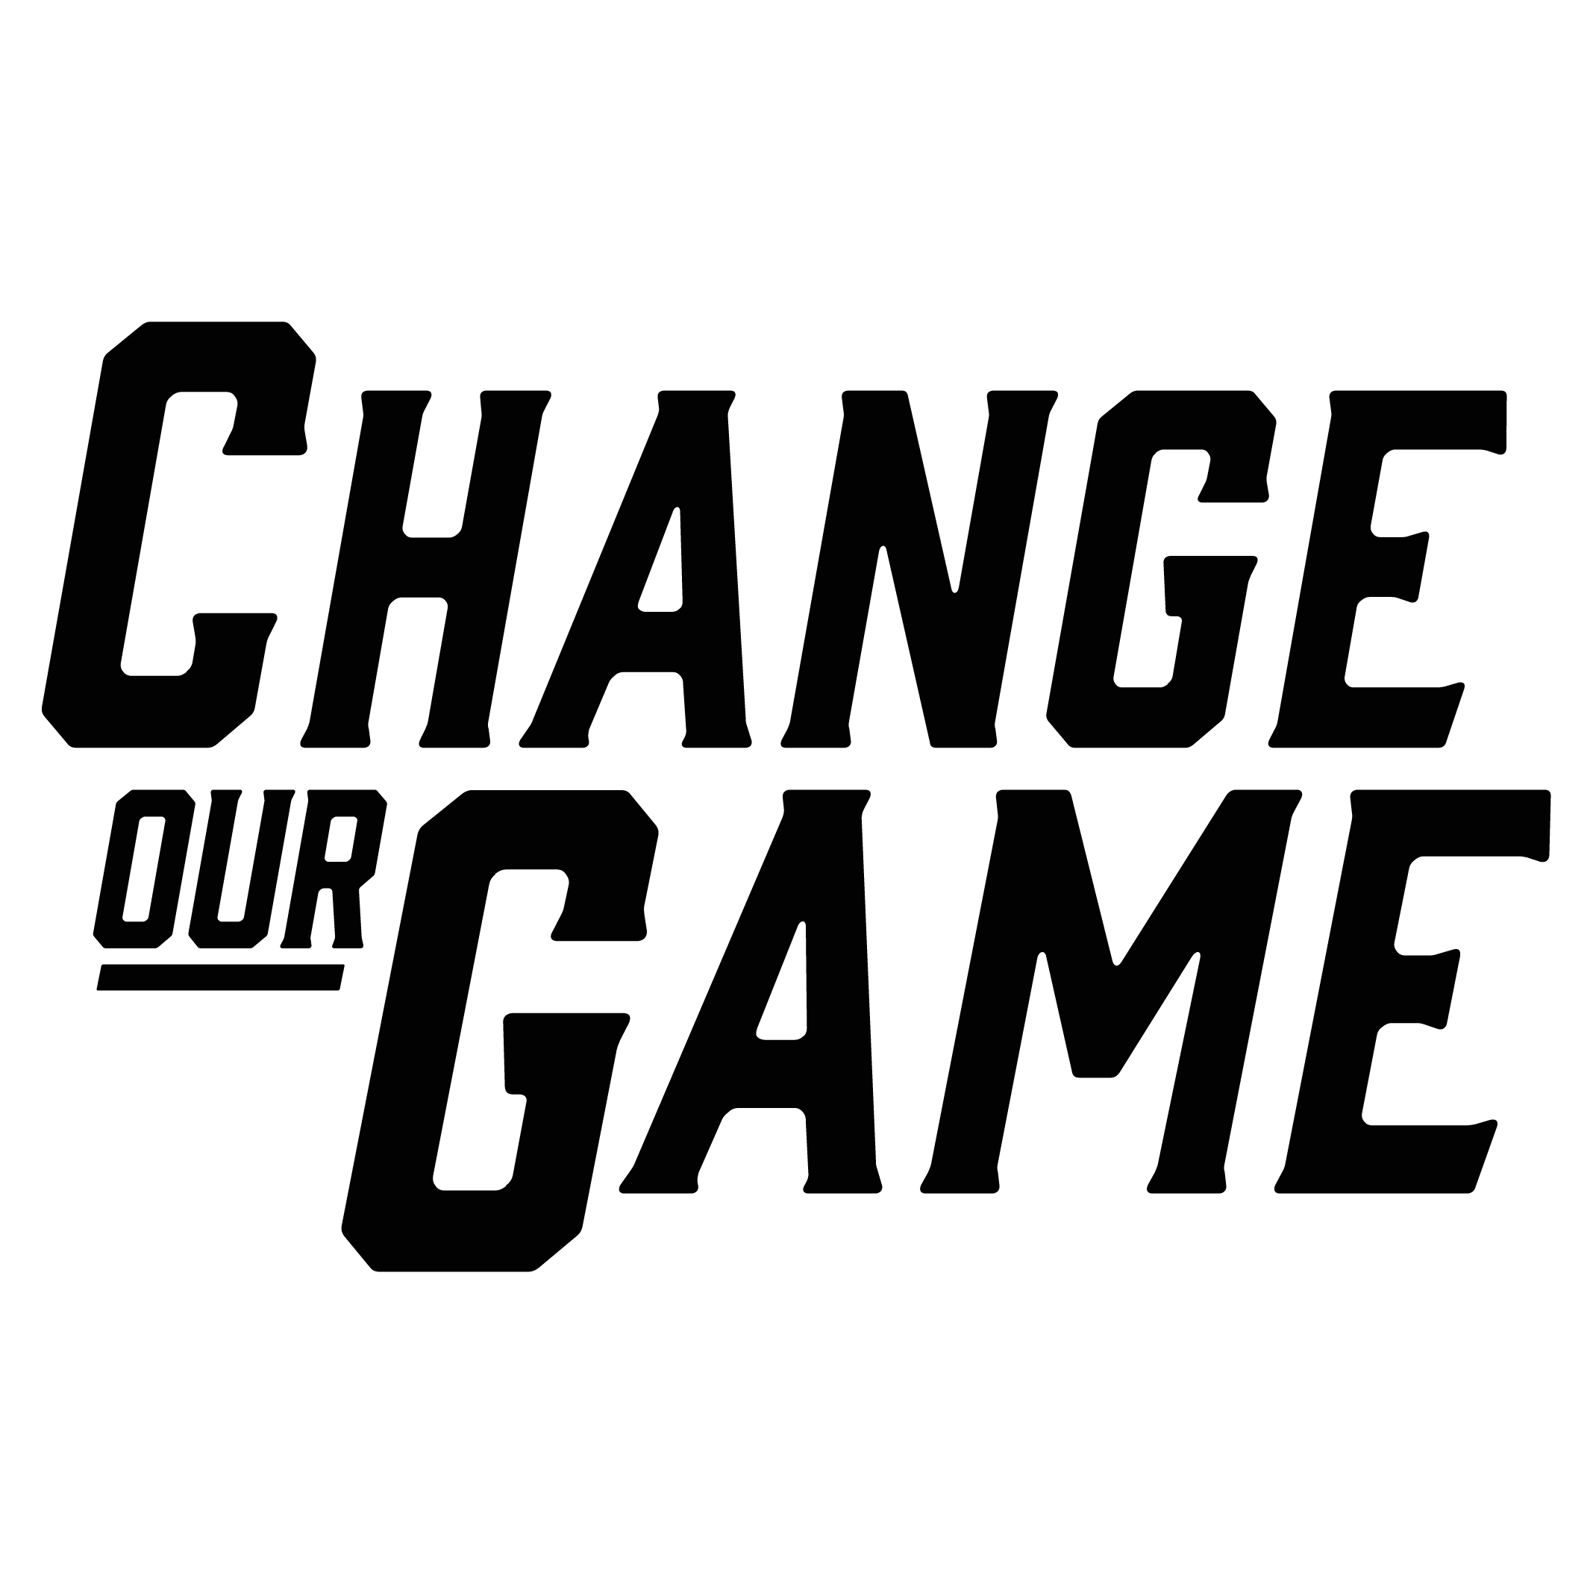

Strategies to increase women’s representation on community sporting club committees

For local councils
Suggested actions for councils to support community sporting clubs improve women’s representation on club committees include:

Invest in gender, diversity and inclusion training
Provide training and resources: that address both gender equity and broader inclusivity, including LGBTIQA+ inclusion, to assist clubs to understand the importance of creating an inclusive environment for all genders, not just promoting women and girls’ participation. Within this, ensure the following factors are considered:
Challenge gender norms: support clubs to adopt gender-neutral language in committee roles and aim for gender balanced representation in all positions, avoiding traditional gendered roles.
Seek feedback: encourage clubs to gather feedback on gender equity, including the accessibility and safety of facilities, motivations for participation, club culture, and overall safety.
Establish leadership networks and mentorship opportunities: create networks for women in sport to support one another and exchange leadership strategies. Fund and promote mentorship programs to help women and girls advance into leadership positions within clubs.
Promote youth representation: encourage youth engagement on club committees by offering advisory roles, appointing team captains to provide guidance to the committee, or establishing dedicated youth roles. In addition, mentorship programs can help ensure that young people have a meaningful voice in decision‑making processes.
Clarify roles and distribute workload evenly: assist clubs to define clear, gender‑neutral roles and ensuring the workload is evenly shared, such as through providing adaptable position descriptions and tools to help manage workloads.
Offer flexible meeting options: encourage clubs to offer flexible meeting schedules, including hybrid or virtual formats, to accommodate members with caregiving or other duties, and allow participants to engage without being restricted by time or location.

Support knowledge sharing and leadership transition
Provide governance resources: ensure governance resources are easily accessible to club leaders to facilitate smooth transitions and continuity in leadership positions and introduce regular induction programs (annually or bi-annually) for new club committee members.

Encourage cross-sport collaboration
Club collaboration and networking: create opportunities for clubs from various sports to collaborate, share experiences and learn from each other. Organise workshops, forums and networking events where clubs can discuss challenges and strategies for improving gender diversity on their committees.

Provide programs that engage women and girls as players
Offer financial support for sport programs that address barriers to participation: such as providing regular non-competitive sport sessions that focus on social connection, introduction to sport programs and modified sport programs to engage women and girls from all abilities and increase their representation as players within the club.

Ensure equal access to facilities and conduct safety audits
Assist clubs in conducting audits: gender‑focused safety audits assess the suitability of amenities such as lighting, restrooms and changing areas for diverse groups. In addition, access audits examine whether women and girls’ teams have equitable access to training times and facilities compared to men and boys’ teams.
This is a summary of recommendations is from research conducted by Deakin University, Beyond Balanced Boards (Bakhsh, J., Rowe, K., Phillips, P., Raw, K., Faulkner, E., Redden, S.; 2024).
This research was funded by the Victorian Government, through the Change Our Game Research Grants Program.
ISBN: 978-1-76090-685-6

