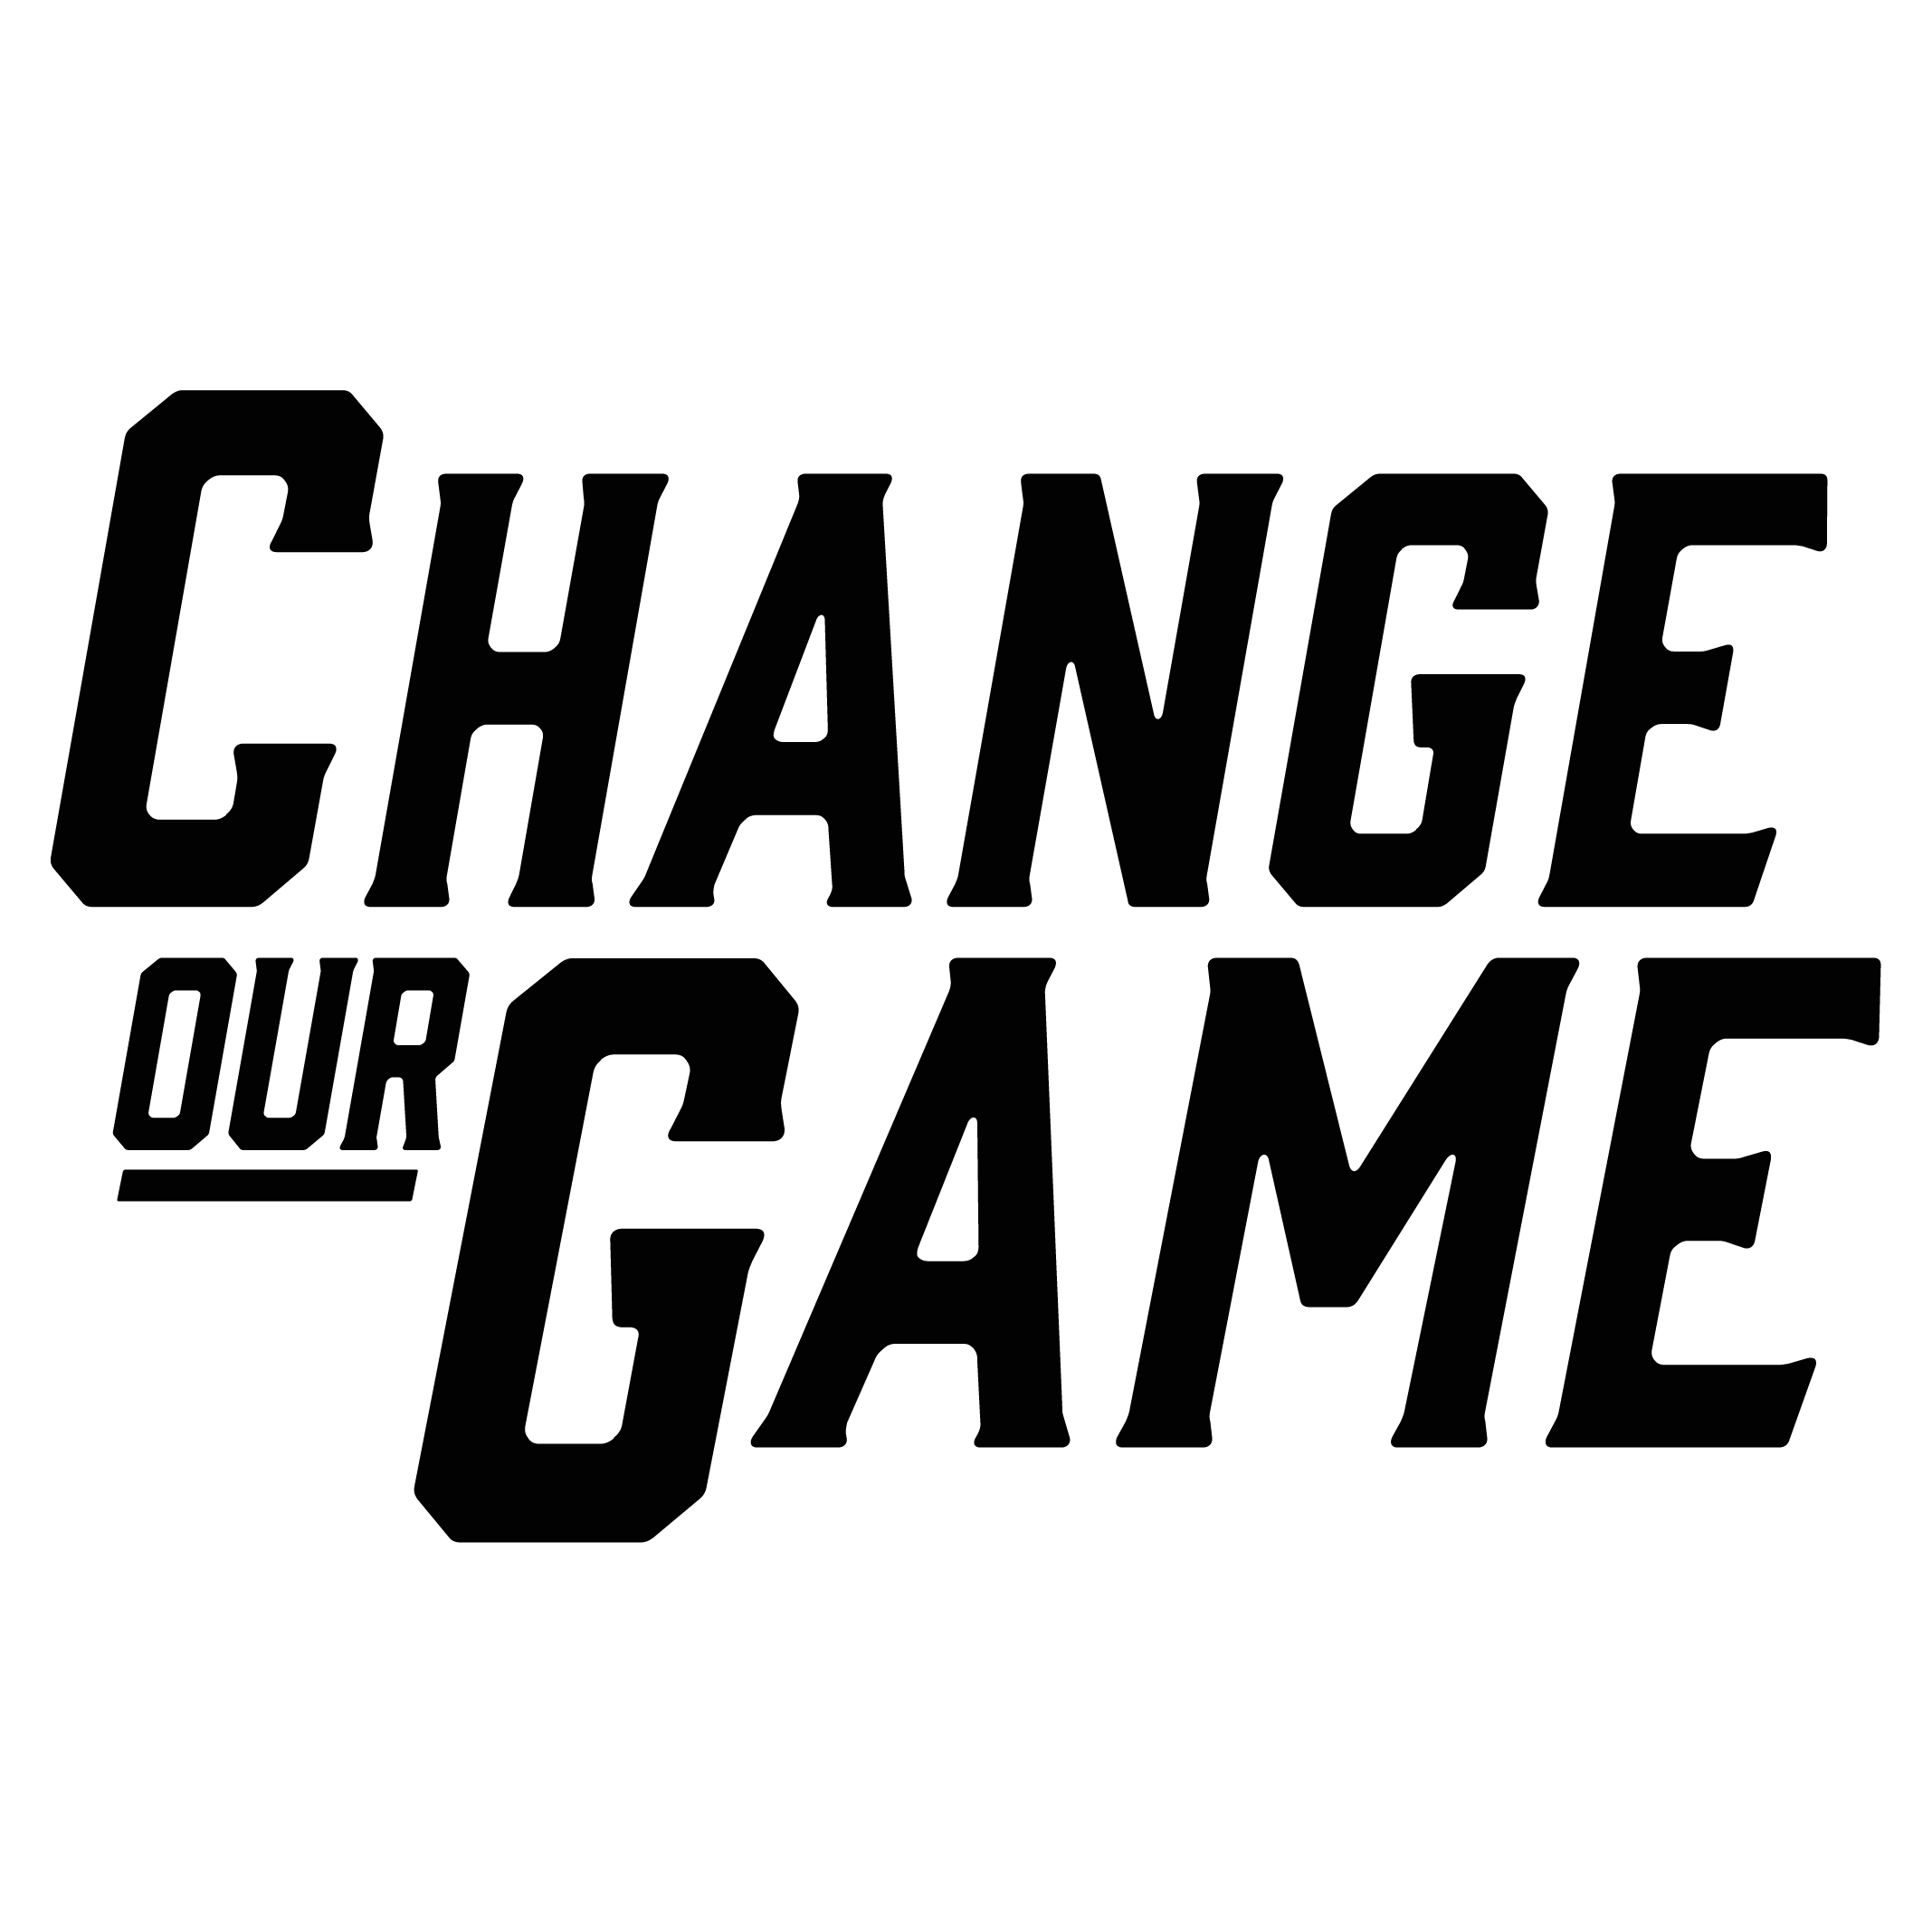

Strategies to increase women’s representation on community sporting club committees

For community sporting clubs
Suggested actions for community sporting clubs to improve women’s representation on their club committee include:

Promote women’s representation within the club
Identify and develop women leaders: actively identify and recruit women members into leadership positions on your club committees. Support these women with development opportunities and create clear pathways for them to take on other leadership roles within the club.
Implement gender-inclusive club policies: adopt policies that promote gender balance within the club, such as having a dual vice-president role with equal gender representation, ensuring gender balance on your club committee or including gender quotas in the club’s constitution.
“Our gender policy led to the election of a female president.”
Increase women’s representation among coaches and officials: encourage the recruitment of women into coaching and officiating roles to enhance women’s representation within the club beyond the committee level.
“Our school-based club doesn’t have a traditional committee, but we’ve achieved 60% female representation among our coaches and officials.”
Encourage women as players in the club: actively working to increase the number of women players within your club helps to expand the potential pool of future committee members.
Promote male allyship: encourage men club members to support opportunities for women and girls, fostering a culture of gender equality and helping increase women and girls’ involvement in the club.
“We encouraged male members to invite their partners, which led to more women joining our club.”

Challenge gender norms within the club
Adopt gender-neutral language and practices: encourage the club to use gender-neutral language in committee roles and leadership titles, strive for equal representation of men and women in all roles, and work to dismantle traditional gendered responsibilities, such as women being responsible for the club canteen or events.
Collect feedback on gender equity: regularly gather feedback from club members on gender equity issues, including the accessibility and safety of facilities, motivations for playing, and the overall club culture and safety.

Foster intersectional representation within the club
Adopt an intersectional recruitment strategy: focus on recruiting individuals from diverse backgrounds, ensuring your club engages members of varying ages, ethnicities and cultural identities, which may consider:
Youth engagement: actively recruit younger members to balance an aging membership base and bring fresh perspectives to the club.
Cultural representation: ensure leadership roles reflect the ethnic diversity of both your club and its surrounding community.
“Our club is located in a culturally diverse area, so it’s important that our leadership reflects that diversity.”
“We’ve been focusing on supporting younger voices, both male and female, to ensure different perspectives are heard.”

Establish leadership networks and mentorship opportunities for women
Create leadership networks for women: develop networks for women club leaders to share leadership strategies, offer support and empower one another, including those on club committees, coaches and officials.
Promote mentorship: offer mentorship programs or partner with a mentor that can support women and girls as they progress toward leadership roles within the club, helping to create pathways for future leaders.
Promote youth representation: provide opportunities for young people to engage in decision-making of the club by offering advisory roles, appointing team captains to provide guidance to the committee, or establishing dedicated youth roles. In addition, mentorship programs can ensure that youth representatives are heard and actively involved in shaping the direction of the club.

Clarify committee roles and distributing workload evenly
Define clear, gender-neutral roles within the club and ensure the workload is shared fairly: provide tools and position descriptions to clarify roles and support to distribute tasks evenly, ensuring that no individual is overburdened.

Offer flexible options for club meetings
Offer flexible meeting schedules and options: consider when meetings are schedule and have hybrid or virtual formats to accommodate members with caregiving or other duties to allow participants to engage without being restricted by time or location.
This is a summary of recommendations is from research conducted by Deakin University, Beyond Balanced Boards (Bakhsh, J., Rowe, K., Phillips, P., Raw, K., Faulkner, E., Redden, S.; 2024).
This research was funded by the Victorian Government, through the Change Our Game Research Grants Program.
ISBN: 978-1-76090-686-3

