Acknowledgment and publicity guidelines
For Sport and Recreation Victoria grant recipients
Contents
Introduction 2
Confidentiality of funding until a public announcement is made 2
Opportunities to open or launch the funded activity and attendance at events 2
Prominent display of Victorian Government signage at openings, launches and events 2
Acknowledging the Victorian Government’s funding support 3
Written acknowledgement statement of Victorian Government funding 3
Brand Victoria logo 4
Official colours and correct logo usage 4
Logo usage and placement 5
Size 5
How to access the logo 6
Events/conferences/launches 6
More information 6

Introduction
A common condition that Sport and Recreation Victoria grant recipients need to adhere to is the acknowledgement of government funding support in publications, promotions, media and other forms of publicity. Sport and Recreation Victoria’s primary contact will outline the scope of acknowledgement required.

Confidentiality of funding until a public announcement is made
Once approved, many grants remain confidential until the relevant minister, or their representative has publicly announced funding has been approved. If that applies to an activity for which your organisation has been funded, you will have been advised of this in writing at the time you were offered funding.
Sport and Recreation Victoria is responsible for coordinating participation by the minister or their representative.
Sport and Recreation Victoria and/or the minister’s office will contact your organisation to make arrangements for the announcement. If you are aware of any upcoming events that might provide a good opportunity to make the announcement, let the Sport and Recreation Victoria’s primary contact know.

Opportunities to open or launch the funded activity and attendance at events
If your organisation will launch the activity at a public event or similar, you may be required to give the relevant minister the opportunity to officially open or launch the activity.
You may need to invite Sport and Recreation Victoria and the minister to significant events associated with the activity.
You will need to give adequate notice (Sport and Recreation Victoria recommends at least two months’ lead time) and work with Sport and Recreation Victoria to coordinate the minister’s and his or her representative’s role in an opening or launch, or their attendance at events.

Prominent display of Victorian Government signage at openings, launches and events
Sport and Recreation Victoria and/or Victorian Government signs or banners may be required to be displayed at openings, launches and events supported by or associated with government funding support.
Signs and banners can be borrowed through Sport and Recreation Victoria’s primary contact, with your organisation responsible for organising for their collection and prompt return.

Acknowledging the Victorian Government’s funding support
Organisations may be required to acknowledge the Victorian Government’s funding support for projects or initiatives funded through Sport and Recreation Victoria grants in published or printed materials, speeches, or other forms of presentations.
Examples include:
- annual report – logo and written acknowledgment statement to be included in the report, for example on an acknowledgment or supporter page rather than on the front page.
- research - written acknowledgement
- print and electronic documents, reports, brochures and the like – logo and written acknowledgement statement placed where appropriate
- posters – logo and written acknowledgement
- videos – logo and written acknowledgment in credits, end slides or another appropriate part of the production
- websites – written acknowledgment statement and logo (as relevant). The acknowledgement only needs to occur on relevant pages describing the funded initiatives. Websites developed with the Victorian Government’s funding support should also include a link to Sport and Recreation Victoria’s website. An organisation can contact its Sport and Recreation Victoria contact for the relevant URL.
- media releases – written acknowledgement statement
  - speeches/launches/conferences – verbal acknowledgment, display of banners (where practical) and signs and logo acknowledgment in programs/invites/websites.
In limited circumstances, an organisation may be exempt from using the Brand Victoria logo in particular publicity and publications related to projects or initiatives funded through grants. Please contact your Sport and Recreation Victoria contact for further advice if you feel there is a publication or printed materials which you believe should be exempt.

Written acknowledgement statement of Victorian Government funding
Any written acknowledgement statement in published or printed materials associated with the funded project or initiative should include one of the statements below:
The [name of program/s/projects/s/ initiative/s] was/were supported by the Victorian Government.
The [name of program/s/projects/s/ initiative/s] are/is supported by the Victorian Government.
[Name of organisation] acknowledges the support of the Victorian Government.
Please note: The Victorian Government is to be acknowledged, not the individual department.

Brand Victoria logo
The Brand Victoria logo is the primary branding device of the Victorian Government. It replaced the previous Victorian Government logo on 12 August 2015 and should be used for all new acknowledgements.
Where a logo acknowledgement by a funded organisation is required, the guidelines outlined below for using the Brand Victoria logo must be followed.
Under no circumstances should funded organisations alter these logos or copy and paste the logo from this or any other Victorian Government publication or website.
There are variations on how the logo is to be used depending on what an organisation is publishing or printing.

Official colours and correct logo usage
Black is the official colour of the logo. The web-safe equivalent is RGB (R = 0, G = 0, B =0).
The area surrounding the text and triangle should reveal the underlying background colour and should not default to white on a coloured background. It should never appear with a white box around it.
For reasons of clarity and impact, consideration should be given to the appropriate contrast between the background and the logo.
Where the background is a solid dark colour, use a white logo.
Logos cannot be stretched or distorted in any way – the ratio between width and height measurements should always be kept the same.
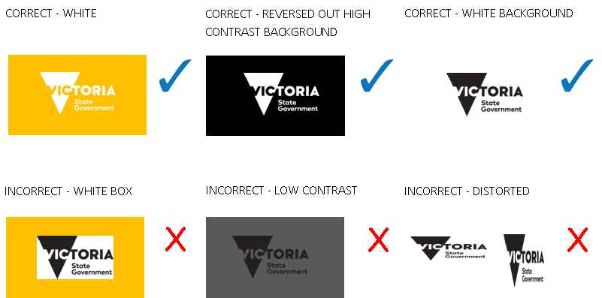

Logo usage and placement
The visual style of the organisation receiving the funding should be the primary brand of the publication or website.
The organisation’s logo should be placed to the left of the Brand Victoria logo, if possible, and clear space left around it.
Clear space is an exclusion zone surrounding a logo where no other text or graphic may appear and should allow enough space to visually separate logos.

Size
Document – minimum sizes for logo
Logo should be 14 mm (width) if the document is smaller than 99 x 210 mm
Logo should be 17 mm (width) if the document is between 99 x 210 mm and 297 x 210 mm
Logo should be 22 mm (width) for documents 297 x 210 mm and above

Digital – minimum sizes for logo
40 (h) x 70 (w) pixel

Digital – maximum sizes for logo
51 (h) x 90 (w) pixel

How to access the logo
To access the logo please contact your Sport and Recreation Victoria representative.
If an organisation is unsure about when and how the logo should be used, an organisation should contact your Sport and Recreation Victoria representative.

Events/conferences/launches
Where a conference supported by the Victorian Government or an event/launch has been organised in relation to a project or initiative funded by the Victorian Government:
- programs/invitations/websites should display the Brand Victoria logo (as relevant)
  - any speeches and presentations should include a verbal acknowledgement of Victorian Government support. Where appropriate the relevant Minister should be acknowledged together with the relevant program/project/initiative name.
Sport and Recreation Victoria or Victorian Government signs and banners may be available for use by organisations to display at relevant events/launches and conferences and can be used where practical. When organising an event or conference, an organisation can contact its Sport and Recreation Victoria contact to discuss the use of these signs and banners. If organisations have their own banners developed related to the project or initiative funded which includes the Brand Victoria logo a Sport and Recreation Victoria/Government banner may not be required in some cases.
If the minister/other government representative has agreed to launch the initiative/project/conference, Sport and Recreation Victoria will coordinate participation by the minister or representative and work with organisations on the details of the event, including ensuring that appropriate banners and signs are available for the event.

More information
Department of Jobs, Skills, Industry and Regions
Contact your Sport and Recreation Victoria representative if you require additional information on the funding acknowledgement requirements above.

To receive this publication in an accessible format please phone the National Relay Service on 13 36 77.
Authorised and published by the Victorian Government, 1 Treasury Place, Melbourne.
© State of Victoria, Department of Jobs, Skills, Industry and Regions January 2022.
Available at www.sport.vic.gov.au

A specific acknowledgment of Victorian Government grant support, such as: ‘Research reported in this [publication/press release] was supported by [name of the grant program] grant from the Victorian Government’.

